University of Salahaddin Chemistry Department
College of science 2nd stage
Date: 16/4 /2023 Time: 1hr
Question Bank
Q1/ a-Which tie-lin(c1,c2.c3 or c4)have the ratio of aqueous layer/ organic layer 2.5:1, if you know the mixture contain (20%A.A, 30%Toluene,50%H₂O). (10M)
b-Apply phase rule on point (B&D). (10M)
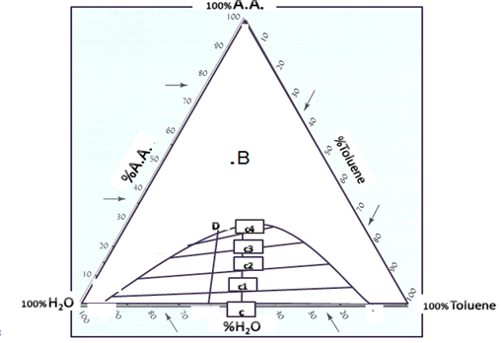
Q2/ In one of the practical experiments, (0.625 mol)N₂O₄ _{(g)}was entered into a container with a capacity of 5 L, at 25˚C. When the reaction reached the state of equilibrium, it was found that the remind concentration of N₂O₄ equals 0.025 mol / liter. Calculate the value of KC for this reaction: (20 M)
N₂O_{4(g)} ↔ NO_{2(g)}
Q3/Calculate the molecular weight of toluene, as it was mixed with water in a steam distillation apparatus, and it was found that the volume of water = 5 ml, volume of toluene = 25 ml, and the vapor pressure of the two substances = 101.4 mm / Hg. If you know that d. toluene= 0.8669g/ml,d. H₂O= 0.995gm/ml,V.P H₂O=53.409 mm / Hg.(20M)

Q4/ a- Drive the relation between (K & ΔG°)? (10M)
b-Explain by the diagram effect of pressure on water phenol binary system (15M)
c- Draw the cooling curve for the mixture at point Z . (15M)
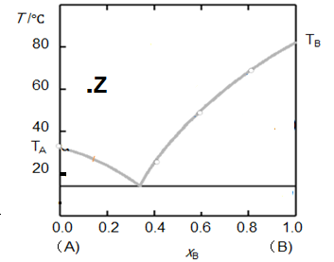

Good Luck

Aveen AL-Saka

