Astrophysics
Chapter Two
The Cosmic Distance Scale

The Cosmic Distance Scale:
- Measuring distances to stars and galaxies is a tough problem because of the vast scale of the universe. Even the closest star, for example, is 4.2 light-years away. That means that a beam of light from the star, traveling at 186,000 miles (300,000 km) per second, needs 4.2 years to reach Earth. The nearest large galaxy, M31, is about 2.5 million light-years away, while the most distant galaxies yet observed are thought to be about 12 billion light-years away.
- To measure these distances, astronomers use a variety of techniques. Each technique is like a step on a ladder, so you need all the steps to safely reach the top — in this case, the farthest reaches of the universe.
- The most accurate technique, called parallax, works only for the closest stars. Astronomers measure a tiny back-and-forth “wiggle” in the star’s position compared to other stars as they view it from different points in Earth’s orbit around the Sun.
- The next technique uses Cepheid variables. These stars pulse in and out, growing brighter and fainter as they do so. There is a relationship between the length of the pulsations and the star’s true brightness. Astronomers use parallax to determine the distances to nearby Cepheids, revealing their true brightnesses, then use that scale to determine the distances to Cepheids in other galaxies. So far, this technique has worked for galaxies as far as 60 million light-years away.
- Some of those galaxies also have the types of stars that form the next step in the cosmic distance ladder: exploding stars known as Type Ia supernovae. Such stars all peak at the same brightness (brighter than billions of normal stars), so measuring their apparent brightness allows astronomers to calculate their true brightness, which in turn reveals their distance. This technique works for galaxies that are up to a few billion light-years away.
- he final technique measures how fast galaxies are moving away from us, which is known as redshift. Because the universe is expanding as a result of the Big Bang, more-distant galaxies show a greater redshift, which means they’re moving away from us at a faster speed. Astronomers measure the redshifts of galaxies with Type Ia supernovae, and use that baseline to determine the distances to other galaxies. Redshift measurements reveal the distances to galaxies near the edge of the observable universe — about 12 billion light-years away.

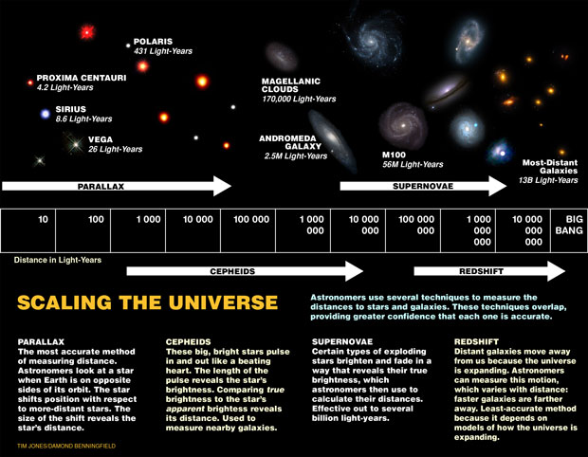
- Astronomical Units (AU)
1 AU is the distance from Earth to our Sun (150 000 000 km). This distance works well to measure objects within our Solar System but for distant stars and galaxies, it is too small of a distance unit.

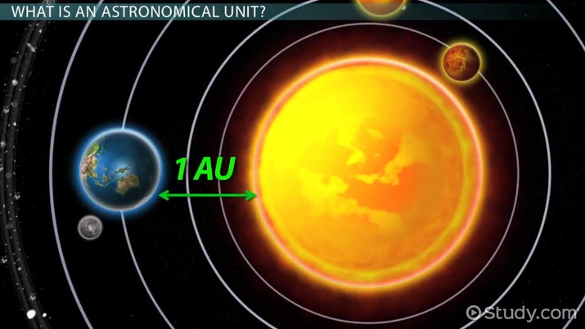
- The Light-Year
One light-year is the distance that light will travel in one year. It is 9 500 000 000 000 km or 9.5 trillion km. One light-year is about 63 000 AU. Distances to other stars and galaxies are measured in light-years.

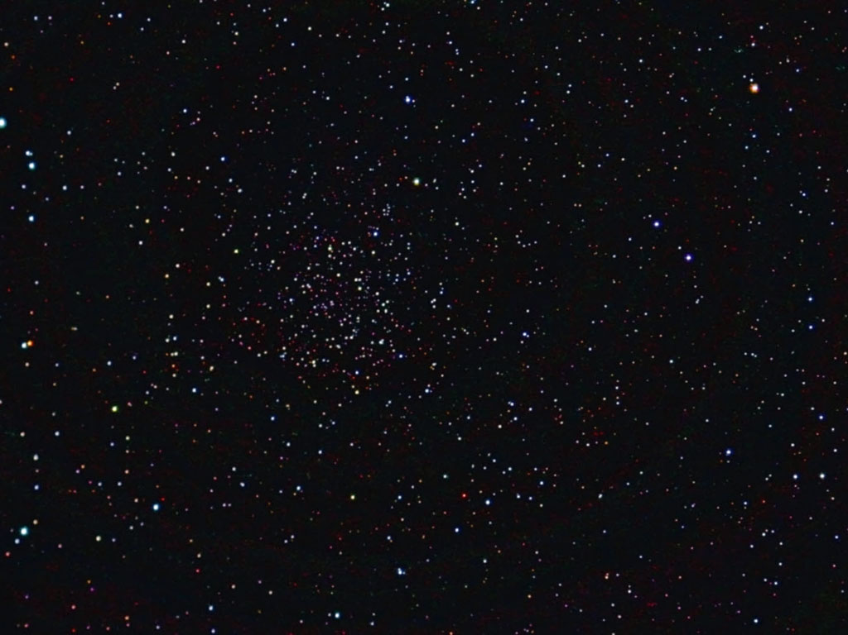

- Distance to Proxima Centauri
Proxima Centauri, a dim red dwarf, is the nearest star from our sun. It is 4.2 light-years away which means that the light we see from Proxima Centauri today started on its way 4.2 years ago (is 4.2 years old). This star is so dim it can only be seen through a telescope. It is the red object in the centre of the picture.
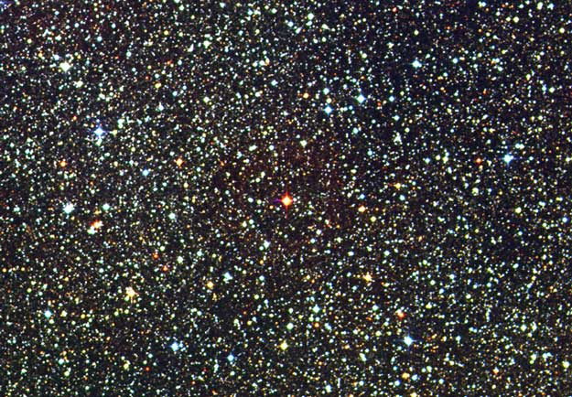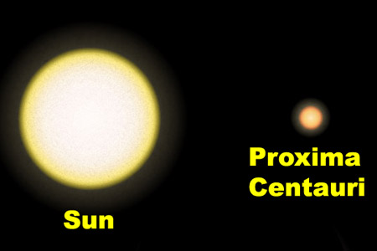
- Distances Within our Milky Way Galaxy
Our galaxy, the Milky Way Galaxy is about 100 000 light-years in diameter. It takes 100 000 years for light to cross from one side to the opposite side of our galaxy.
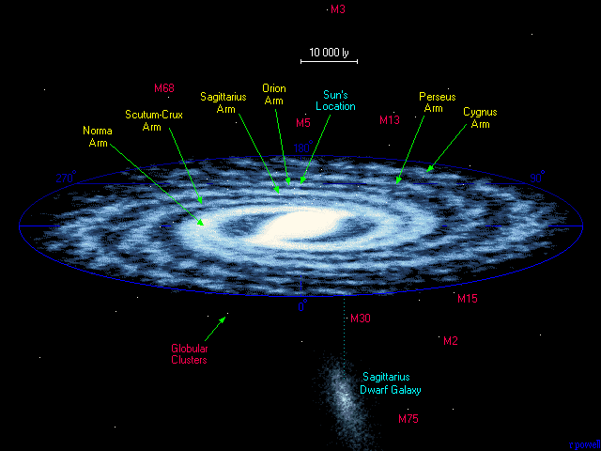
5-Andromeda Galaxy
The distance to Andromeda galaxy, the nearest spiral galaxy to our Milky Way galaxy is 3.5 million light-years. The light we see today from Andromeda took 3.5 million years to get here, it is 3.5 million years old.
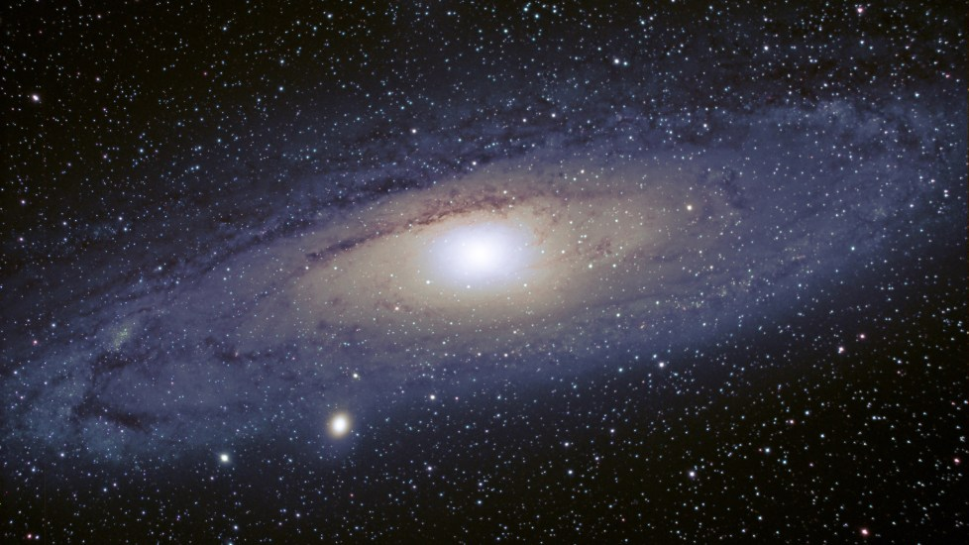

Astronomical Distance Units

Parallax
Parallax is the apparent difference in position of an object against a distant background due to a change in position of the observer.
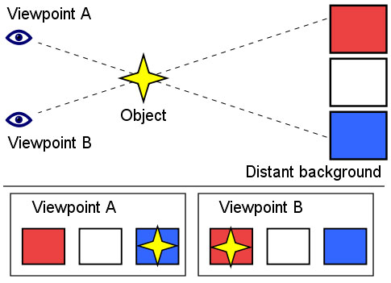
The Parallax Angle
Astronomers measure angle p as the parallax angle. The distance in parsecs is computed by the formula, d = 1/p (in arcseconds). One parsec is 3.26 light-years (about 31 trillion km) and one arc second is an angle of 1/3600 th of a degree.

For example, Proxima Centauri has a parallax angle of .7687 arc seconds. It’s distance is 1/.7687 = 1.3009 parsecs. 1.3009 parsecs X 3.26 light-years/parsec = 4.243 light-years.

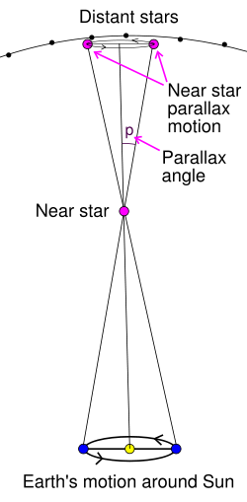
Definition of Astronomical Parallax
“half-angle” of triangle to foreground star is 1"
Recall that 1 radian = 206,265"
1" = (206,265)-1 radians =5×10-6 radians = 5 µradians
R = 206,265 AU = 2×105 AU = 3×1013 km
1 parsec = 3×1013 km =20 trillion miles = 3.26 light years

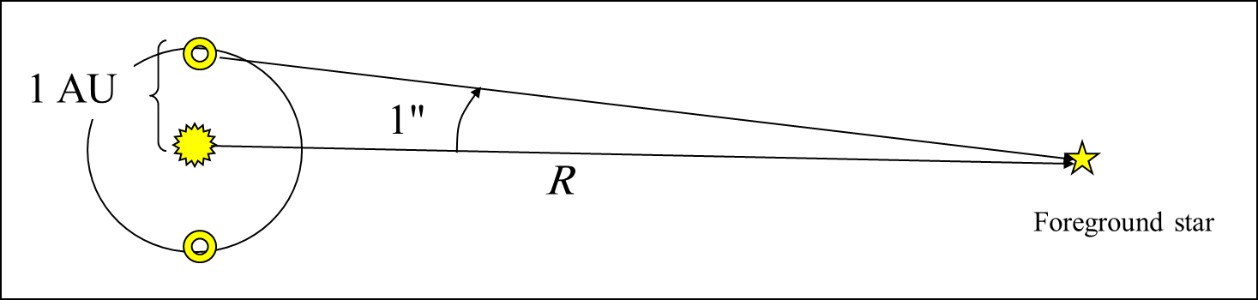

- Units of Length
1 ls = distance light travel in 1 second = 299792485 m ≈ 3x108 m
1 ly = distance light travels in 1 year ≈ 9.46x1015 m ≈ 1016 m
1 AU (astronomical unit) = mean distance between the Sun and Earth ≈ 1.49x1011 m
1 pc (parsec) = distance from which 1 AU extends 1 arcsec ≈ 3.26 ly ≈ 3.24x1016 m
1 Mpc = 10⁶ pc ≈ 3.26x10²² m

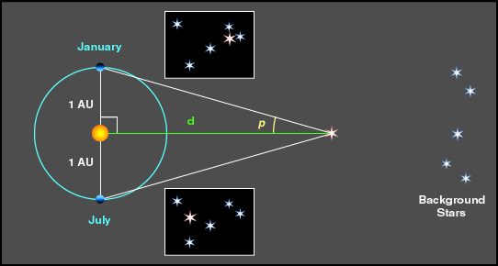
- Angles
Angles are measured in degree (°), arcmin ('), arcsec("); radians (rad, or no unit).
1° = 60' = 3600"
1 rad = 180°/π ≈ 57.3°.
Small angle approximation: angle = arc length/distance
The apparent diameter of the Sun and the Moon are about 0.5°.
Resolution limit of a 4" telescope ≈ 1".
Note: Do not confuse arcsec with inch, both use the same symbol.
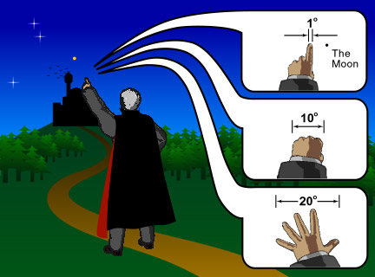
3-Astronomical Unit (AU) and light year
distance from Earth to Sun
1 AU=+ 93,000,000 miles =1.5 × 108 km
- Light-year:
  - The distance light travels (in vacuum) in one year.
  - one light-year is 10 trillion (10¹³) km
  - Light-year is the distance light travels in one year.

light year = distance light travels in 1 year

1 light year
= 60 sec/min × 60 min/hr × 24 hrs/day × 365.25 days/year × (3 × 10⁵) km/sec
≈ 9.5 × 10¹² km ≈ 5.9 × 10¹² miles ≈ 6 trillion miles

- Parsec: parallax & arcsecond
- a unit of distance used in astronomy, equal to about 3.26 light years (3.086 × 1013 kilometres). One parsec corresponds to the distance at which the mean radius of the earth's orbit subtends an angle of one second of arc.

  - One parsec: the distance to an object with a parallax angle of 1 arcsecond.
  - One parsec equals to 3.26 light-year.
  - kiloparsecs: 1,000 parsecs.
  - megaparsecs: 1,000,000 parsec.
- Astronomical distances are often measured in astronomical units, parsecs, or light-years
1-Astronomical Unit (AU)
One AU is the average distance between Earth and the Sun
1.496 X 108 km or 92.96 million miles
2-Light Year (ly)
One ly is the distance light can travel in one year at a speed of about 3 x 105 km/s or 186,000 miles/s
9.46 X 1012 km or 63,240 AU
3-Parsec (pc)
the distance at which 1 AU subtends an angle of 1 arcsec or the distance from which Earth would appear to be one arcsecond from the Sun
1 pc = 3.09 × 1013 km = 3.26 ly

lengthThe Universe is structured on different scales
Powers of Ten : – From Man to Universe –
10⁰ meters
=1 meter
Relative Sizes in astronomy From very small to very
large(meters)
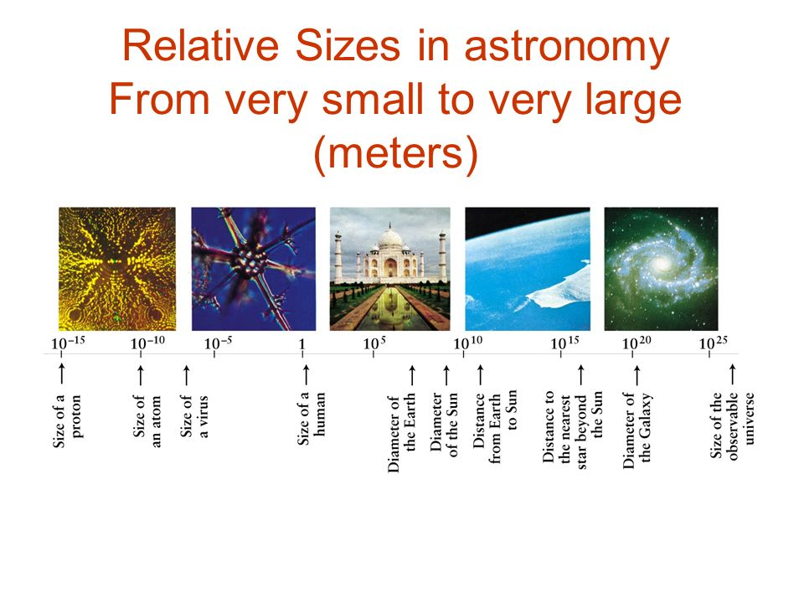
Man Dangles(swings) between two infinities
-______________________________+

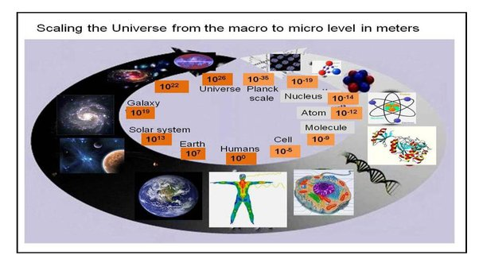
Length the universe is structured on different scales
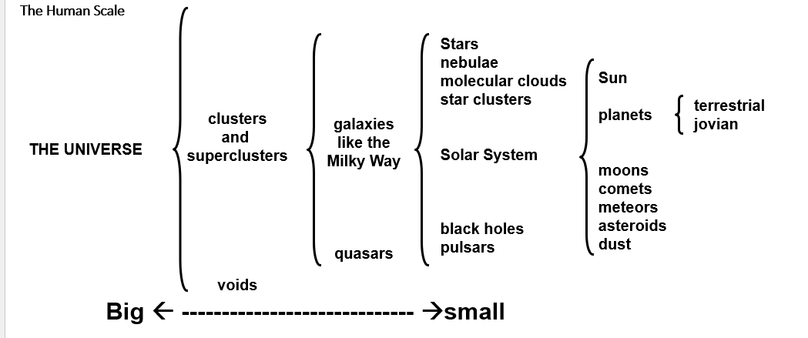

The Milky Way:
The Milky Way is the galaxy that includes our Solar System, with the name describing the galaxy's appearance from Earth: a hazy band of light seen in the night sky formed from stars that cannot be individually distinguished by the naked eye.

1 parsec (pc) = 3.26 LY = 205,000 AU
The stars are very far away
Nearest Star Alpha Centauri = 4.3 LY,
more than 1 pc ! The parallax angle a is less
than one arc second (“) That’s why the Greeks could not see the stars move. Galaxies have been seen up to more than 10 billion Lys away.

Without Distances …
We do not know the size of an object .This makes it hard to figure out the “inner workings” of an object. We can’t picture the structure of the solar system, galaxy, cosmos.
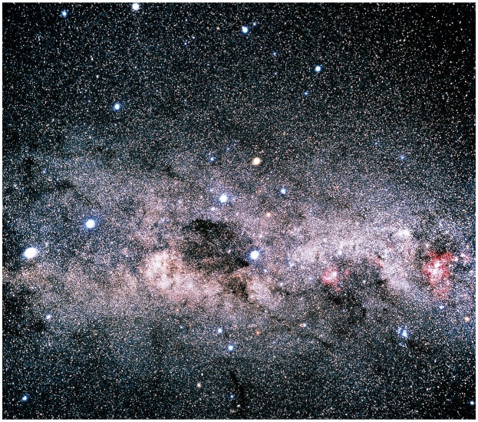
Solar System Scale
Venus, Earth, Mars Orbits
10¹¹ meters
=100,000,000,000m
=100,000,000 km
= about 1 A.U. (Astronomical Unit)
The Sun (a typical star): diameter 1.4 million km
Star Size: 1,000,000,000 m
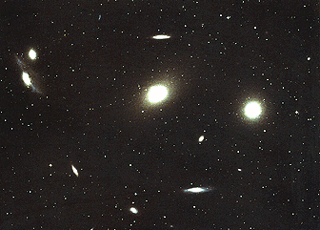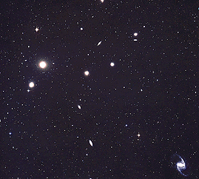
What is the distance between galaxies?
So what are the distances to the stars?
First measurements made in 1838 (Friedrich Bessel)
Closest star is Alpha Centauri, p=0.75 arc seconds,
d=1.33 parsecs= 4.35 light years.
Nearest stars are a few to many parsecs, 5 - 20 light years
The distances to the stars are truly enormous
If the distance between the Earth and Sun were shrunk to 1 cm (0.4 inches), Alpha Centauri would be 2.75 km (1.7 miles) away.
Stars we can see with our eyes that are relatively
close to the Sun.
Vega … 26 light years, Altair … 17 light years

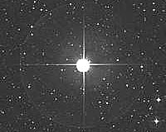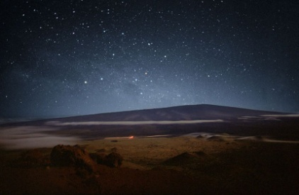
- Radius of the Earth = 6500 Km
- Speed of light – 300,000 Km/sec
- Astronomical distances are so large that we use the speed of light to measure them
- Mean Earth-Sun Distance – 150 million Km
- 1 Astronomical Unit (AU) = 8.3 Light Minutes
- 1 Light Year (Ly) = 9.5 trillion Km = 63,240 AU

Why do Astronomers use light-years to measure distances in space?
1-The movement of the stars makes it impossible to measure in Earth units.
2. The speed of light is slow enough to provide accurate measurements.
3. Equipment isn't sophisticated enough to measure any other way.
4. The distances are too great to measure in Earth units.
Due to the great effect and impact of solar wind activity.
Question
A new unit of length is chosen such that the speed of light in vacuum is unity. What is the distance between the sun and the earth in terms of the new unit if light takes 8 min and 20 sec to cover this distance?

Distance=speed×time

Speed is unity = 1 unit /sec
Time=8min and 20sec=8×60+20sec=500sec

Plug the values we get
Distance between Sun and Earth =1×500=500units
Q An astronomical unit (AU) is the average distance between Earth and the Sun, approximately 1.50×108km. The speed of light is about 3.0×108 m/s. Express the speed of light in astronomical units per minute.
Solution
We convert meters to astronomical unit, and seconds to minutes, using
1000 m=1 km
1 AU=1.50×108 km
60 s=1 min
Thus, 3.0×108 m/s becomes
(3.0×10^8 m​)/s * (1 km/1000m​) * (AU/1.50×10^8 km ) * (60 s​/ min)=0.12 AU/min
Q one light year is the distance travelled by the light in one year. So,1Parse =3.08×1016m
1 light year9.46×1015m
So
1 light year =9.46×1015 parsec
=3.08×1016
1 light year =0.306 parsec
=1/ 3.26​ parsec
Q What is Light year ?
One light year is defined as the the distance travelled by light in one year in vacuum.
A light year is the unit of :
light year is distance traveled by light in a year

Q parsec is bigger or small than light year?
A parsec is the same as 3.26 light-years so 1 parsec is indeed bigger than 1 light-year.

1. The distance to the star Sirius is 2.637 parsecs. How many light years is this distance?
- .9 light years
- 2.36 light years
- 1.1 light years
- 8.6 light years

2. The average distance from the earth to the sun is called an _____.
- angstrom
- amp second
- astronomical unit
- apogee
Question
One parsec is _____ light years.
Parsec in Light-Years:
Parsec is defined as the distance to an object with a parallax angle of
arcsecond.
Parsec is a mathematical unit of length.
A light-year is a distance covered by light in a duration of one year.
One parsec = 3×10¹⁶m
One light-year=9.46×10¹⁵m
So one parsec =3×10¹⁶m/9.46×10¹⁵m=3.26 light year
Hence, one parsec is 3.26 light years.
---------------------------------------------------------------------------------------
Question
If the distance between two stars in a galaxy is 16.3 light years, what is its value in the unit of parsec?
A.5
Solution

The correct option is A 5
Given:
The distance between the two stars, d=16.3 ly
One parsec is equal to 3.26 light years.
So, 1 ly=13.26 parsec
⟹16.3 ly=16.33.26 parsec
=16.3×1003.26×100=1630326=5 parsec

Question

A star is 1.45 parsec light years away. How much parallax would this star show when viewed from two locations of the earth six months apart in its orbit around the sun?
One light year = speed of light × one year
or 1ly=3×10⁸×(24×3600)=94608×10¹¹m
So, 4.29ly=4.29×(94608×10¹¹)=4.058×10¹⁶m
As 1 parsec =3.08×10¹⁶m
(Parsec is a unit of length used to measure large distances to objects outside our Solar System)
Thus, 4.29ly=4.058×10¹⁶/3.08×10¹⁶=1.32 parsec
Now angular displacement , θ=dD
where d= diameter of earth's orbit =3×10¹¹m and
D= distance of star from the earth =4.058×10¹⁶m
So, θ=3×10¹¹/4.058×10¹⁶=7.39×10⁻⁶ rad
As 1sec=4.85×10⁻⁶ rad so, 7.39×10⁻⁶ rad=7.39×10⁻⁶/4.85×10⁻⁶ =1.52sec

