Astrophysics
Chapter Four
Kepler's Laws
Kepler's Laws of Planetary Motion:
Kepler's three laws describe how planetary bodies orbit the Sun. They describe how (1) planets move in elliptical orbits with the Sun as a focus, (2) a planet covers the same area of space in the same amount of time no matter where it is in its orbit, and (3) a planet’s orbital period is proportional to the size of its orbit (its semi-major axis).
Kepler's First Law: each planet's orbit about the Sun is an ellipse. The Sun's center is always located at one focus of the orbital ellipse. The Sun is at one focus. The planet follows the ellipse in its orbit, meaning that the planet to Sun distance is constantly changing as the planet goes around its orbit.
Kepler's Second Law: the imaginary line joining a planet and the Sun sweeps equal areas of space during equal time intervals as the planet orbits. Basically, that planets do not move with constant speed along their orbits. Rather, their speed varies so that the line joining the centers of the Sun and the planet sweeps out equal parts of an area in equal times. The point of nearest approach of the planet to the Sun is termed perihelion. The point of greatest separation is aphelion, hence by Kepler's Second Law, a planet is moving fastest when it is at perihelion and slowest at aphelion.
Kepler's Third Law: the squares of the orbital periods of the planets are directly proportional to the cubes of the semi-major axes of their orbits. Kepler's Third Law implies that the period for a planet to orbit the Sun increases rapidly with the radius of its orbit. Thus we find that Mercury, the innermost planet, takes only 88 days to orbit the Sun. The earth takes 365 days, while Saturn requires 10,759 days to do the same. Though Kepler hadn't known about gravitation when he came up with his three laws, they were instrumental in Isaac Newton deriving his theory of universal gravitation, which explains the unknown force behind Kepler's Third Law. Kepler and his theories were crucial in the better understanding of our solar system dynamics and as a springboard to newer theories that more accurately approximate our planetary orbits.

- The Law of Orbits
Kepler’s 1st law: All planets in our Solar System orbit the Sun in an elliptical shape (the intensity of the elliptical shape is denoted by eccentricity $ε$) with the Sun at one focus. Where $ε=0$ is a circular orbit and $ε=1$ is a parabolic orbit.
So, for an elliptical orbit: $0<ε<1$ with eccentricity increasing towards 1.
The planets in our solar system orbit the Sun in a shape close to that of a circle, which means their eccentricities $(ε)$ are very low (whereas for bodies such as comets, it can vary up to very high eccentricities).
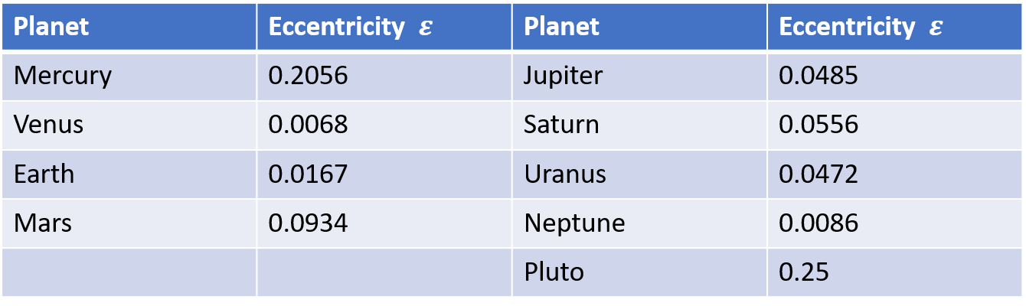

- The Law of Areas
Kepler’s 2nd Law: A line drawn from the centre of the Sun to the centre of an orbiting body will sweep out equal areas in equal intervals of time, in this case with a high eccentricity to demonstrate the concept.
As an orbiting object moves closer to the centre of mass it is orbiting, it speeds up. At the orbiting object’s farthest point from the body (aphelion) is when it is at its slowest. Thus, an object will travel a larger distance when it is at its closest point to the centre of mass (perihelion) than when it is at its farthest.

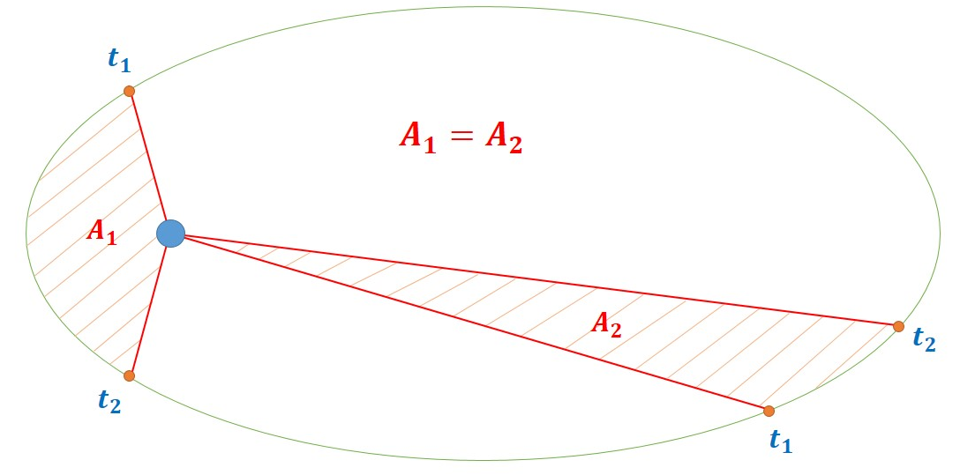
- The Law of Periods
- Kepler’s 3rd law: The ratio of the squares of the periods of any two planets is equal to the ratio of the cubes of their semi-major axis (a) of their elliptical orbit.
- The semi-major axis (a) is half of the major axis of an ellipse i.e. the longest diameter of an ellipse:
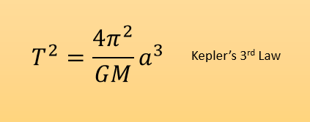

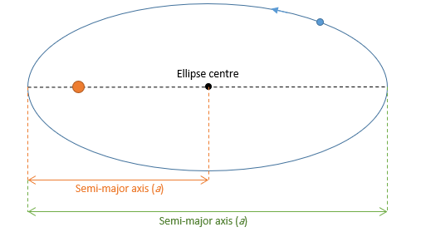

- The Law of Periods:
In the Solar System scenario, we have seen that the planets have close to circlular ellipses with eccentricities, $ε$, close to 0. This means that the above equation can be slightly simplified, as the semi-major axis of the ellipse is the same as the average distance from the Sun of a circular planetary orbit:
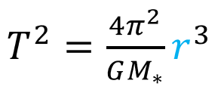
Given that we now have all of the variables for each planet,
𝑀_∗ (the mass of the Sun) the subject and fill in for each planet in the Solar System.

Note: For this you will be using 𝐺=6.67 ×10^⁻¹¹ 𝑚^3 𝑘𝑔^−¹ 𝑠^{^(−2)}
so be careful with your units (you may have chosen to work in units of AU so far.

Major and Minor Axis
Ellipse is defined by its two-axis along x and y-axis:
- Major axis
- Minor Axis
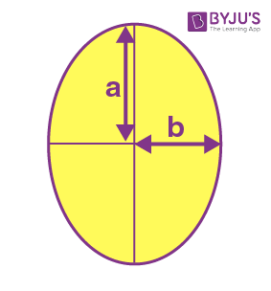
The major axis(a) is the longest diameter of the ellipse (usually denoted by ‘a’), going through the center from one end to the other, at the broad part of the ellipse.

The minor axis(b) is the shortest diameter of ellipse (denoted by ‘b’), crossing through the center at the narrowest part.
Half of major axis is called semi-major axis and half of minor axis is called semi-minor axis.
Properties
- Ellipse has two focal points, also called foci.
- The fixed distance is called a directrix.
- The eccentricity of ellipse lies between 0 to 1. 0≤e<1
- The total sum of each distance from the locus of an ellipse to the two focal points is constant
- Ellipse has one major axis and one minor axis and a center

Eccentricity of the Ellipse
The ratio of distances from the center of the ellipse from either focus to the semi-major axis of the ellipse is defined as the eccentricity of the ellipse.
The eccentricity of ellipse, e = c/a
Where c is the focal length and a is length of the semi-major axis.
Since c ≤ a the eccentricity is always greater than 1 in the case of an ellipse.
Also,
c² = a² – b²
Therefore, eccentricity becomes:
e = √(a² – b²)/a
e = √[(a² – b²)/a²] e = √[1-(b²/a²)]

Orbital Paths
Extending Kepler’s Law 1, Newton found that ellipses were not the only orbital paths. possible orbital paths
- ellipse (bound) e=0
- parabola (unbound) e = 1
- hyperbola (unbound) e > 1
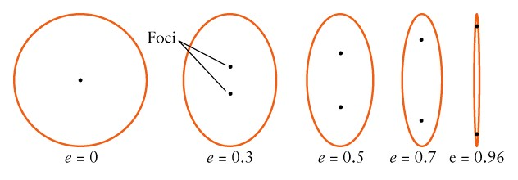

The Sun is at one focus
Nothing is located at the other focus
Aphelion is the point farthest away from the Sun
The distance for aphelion is a + c
For an orbit around the Earth, this point is called the apogee
Perihelion is the point nearest the Sun
The distance for perihelion is a – c
For an orbit around the Earth, this point is called the perigee

Planets move fastest when they are at their closest point to the Sun (called perihelion) and slowest when they are at their farthest point from the Sun (called aphelion).

Kepler’s law

1-Each planet orbits the Sun in an elliptical path with the Sun at one focus of the ellipse.

2-The straight line joining a planet and the Sun sweeps out equal areas in space in equal times.

3-The squares of the periods (P) of the revolution of the planets are in direct proportion to the cubes of the semimajor axes (a) of their orbits, or, P² = a³.

Q1: When a planet orbits the Sun, one of the foci of the elliptical orbit is

The axis
The perihelion
The centre
The Sun
Answer: (d) The Sun

Q2: What has an eccentricity of zero?

A straight line
A large ellipse
A circle
A small ellipse
Answer: (c) A circle

Q3: An Astronomical Unit, or AU, is the average distance between

The Sun and Neptune
The Sun and Earth
The Earth and the Moon
The Sun and Mercury
Answer: (b) The Sun and Earth

Q4: Kepler’s second law is known as

The Law of Orbits
The Law of Areas
The Law of Periods
The Law of Gravity
Answer: (b) The Law of Areas

Q5: Kepler’s 2nd law deals with

The shape of the planet’s orbits
The speed/area the planet travels
The length of time it takes the planet to orbit the sun
Time travel
Answer: (b) The speed/area the planet travels

Q6: Kepler’s third law is known as

The Law of orbits
The Law of Areas
The Law of periods
The Law of gravity
Answer: (c) The Law of periods

Q7: The formula for Kepler’s third law is

P3 ∝ a2
P3 ∝ a3
P2 ∝ a2
P2 ∝ a3
Answer: (d) P2 ∝ a3

Q8: Kepler’s first law states that the orbits of the planets are oval in shape or

Ellipses
Perfect circles
Squares
triangles
Answer: (a) Ellipses

Q9: The Kepler’s first law is known as

The law of orbits
The law of areas
The law of periods
The law of gravity
Answer: (a) The law of orbits

Q10: The farther away a planet is from the sun, the …………. it takes it to orbit the sun once

Longer
Shorter
Answer: (a) Longer

Q11From Kepler’s law of orbit, we can infer that the sun is located _____ of the planet’s orbit.
a) at the centre
b) at one of the foci
c) at both foci
d) anywhere along the semi-minor axis
Answer: b
Explanation: According to Kepler’s law of orbit, every planet revolves around the sun in an elliptical orbit and the sun is at one of the foci.
Q12Kepler’s laws of planetary motion replaced circular orbits with _____
a) elliptical orbits
b) parabolic orbits
c) conical orbits
d) hyperbolic orbits
Answer: a
Explanation: From the first law of Kepler’s laws of planetary motion, we can infer that the orbit of a planet is an ellipse with the sun at one of the foci.

Q13 Kepler’s laws of planetary motion were proposed only for _____
a) our sun
b) any star in our galaxy
c) any star in the universe
d) stars of other solar systems
Answer: a
Explanation: The Kepler’s laws of planetary motion were published by Johannes Kepler between 1609 and 1619. They are three scientific laws describing the motion of planets around the Sun.

Q14 What does Kepler’s law of period relate?
a) Time period and semi-minor axis

b) Time period and eccentricity

c) Time period and semi-major axis

d) Time period and area swept by the planet
Answer: c

Q15 What is the time taken by a planet to sweep an area of 2 million square km if the time taken by the same planet to cover an area of 1 million square km is 36 hours?
a) 18 hours

b) 36 hours

c) 72 hours

d) 144 hours

Answer: c

Q16 Kepler’s laws of planetary motion improved ______
a) the heliocentric theory

b) the geocentric theory

c) the big bang theory

d) the string theory

Answer: a

Q17The elliptical orbits of planets were indicated by calculations of the orbit of which astronomical body?
a) Mercury

b) Earth

c) Earth’s moon

d) Mars

Answer: d

Q18. If the eccentricities of the planetary orbits were taken as zero, then the sun is at the centre of the orbit.
a) True

b) False

Answer: a

Q19. From Kepler’s law of orbit, we can infer that the sun is located _____ of the planet’s orbit.
a) at the centre

b) at one of the foci

c) at both foci

d) anywhere along the semi-minor axis

Answer: b

Q20. Kepler’s laws of planetary motion replaced circular orbits with _____
a) elliptical orbits

b) parabolic orbits

c) conical orbits

d) hyperbolic orbits

Answer: a

Q21. Kepler’s laws of planetary motion were proposed only for _____
a) our sun

b) any star in our galaxy

c) any star in the universe

d) stars of other solar systems

Answer: a

