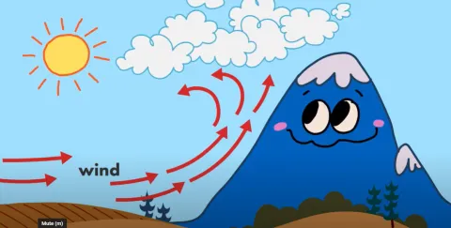

Metrology

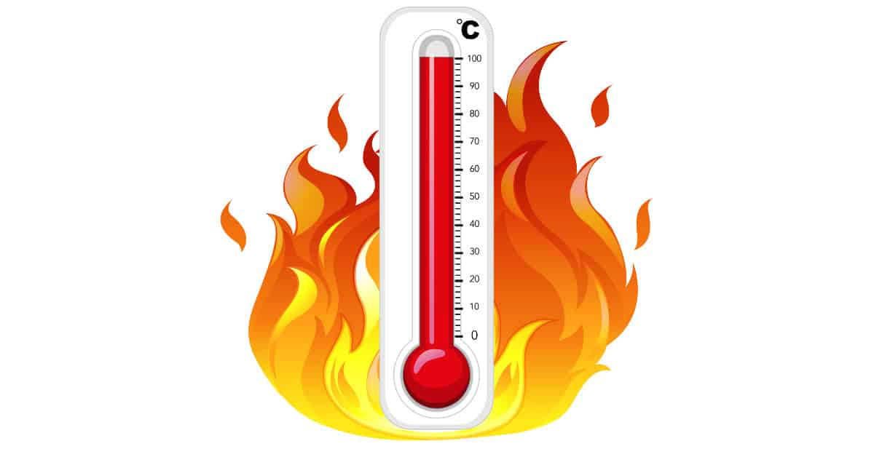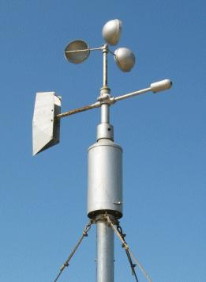

Metrology
Aven Maqded Hamad Amin
aven.m.hamadamen@su.edu.krd.

Chapter one
Introduction

What is meteorology?
Meteorology is the science of the atmosphere concerned with the physical, dynamical and chemical state of the earth's atmosphere.
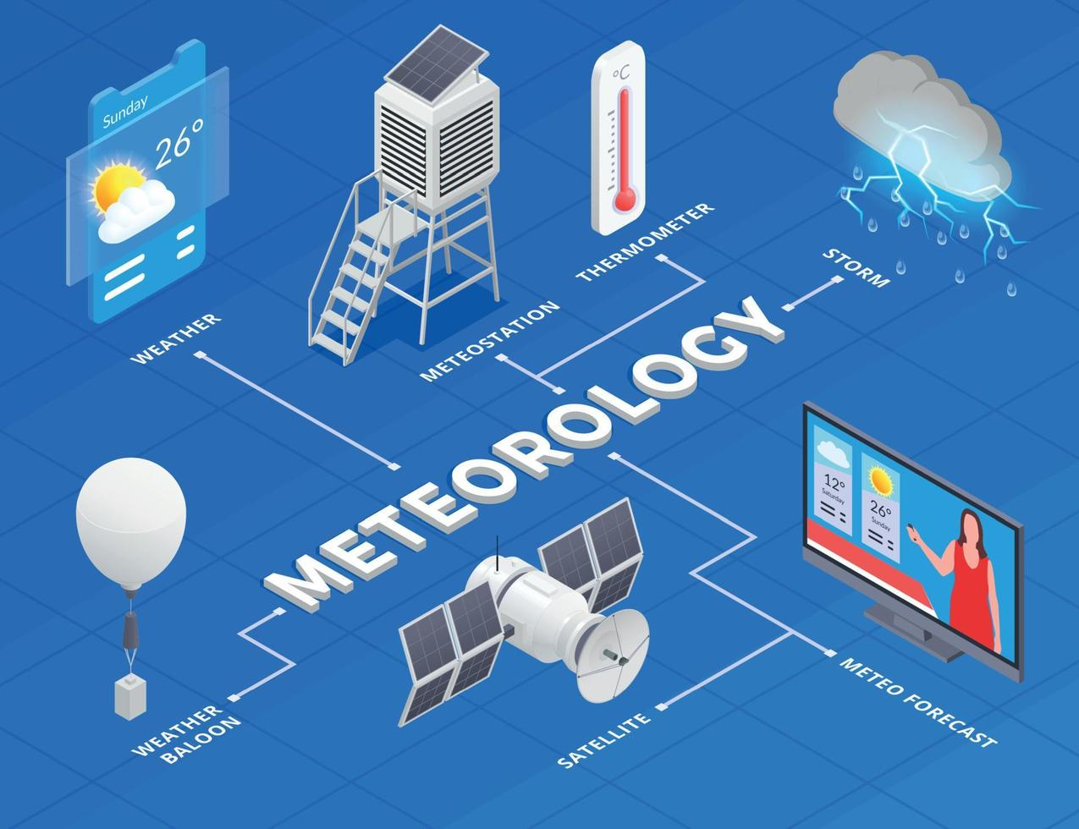
What is meteorological history?
The first meteorological treatise, Meteorologica, was written by Aristotle in the 4th century bc. It remained the standard work on the subject for 2,000 years. Throughout its modern history, meteorology has owed its periods of rapid advancement to developments in the physical sciences. The invention of scientific instruments, such as the wind vane and thermometer in the 16th century and the barometer in the 17th century, provided methods of systematic measurement. During the 17th and 18th centuries the discovery of Boyle’s law, Lavoisier’s description of the nature of atmospheric gases, Newton’s laws of motion, and Dalton’s discovery of the laws governing the role of water vapor in the air established the physical basis for modern meteorology.
In the 19th and 20th centuries the invention of the telegraph propelled the science of meteorology into a new age. The telegraph made possible the rapid collection and analysis of weather data over large regions of Earth. Wireless telegraphy allowed scientists to explore the upper atmosphere by attaching recording instruments to balloons, kites, and airplanes. It also provided the means to obtain weather observations from remote areas in the oceans, deserts, and jungles. Drifting buoys, weather satellites, and constant-level weather balloons provided supplementary data.

Numerical weather prediction became possible after World War II with the invention of the powerful electronic stored-program computer. By shifting the basis of weather analysis and prediction from a subjective to an objective footing, NWP proved to be a major advance in the field.
In 1963 the World Meteorological Organization, a specialized agency created by the United Nations to facilitate international cooperation in meteorology and hydrology, inaugurated the World Weather Watch (WWW). The WWW was designed to improve global atmospheric surveillance and provide for the rapid collection and exchange of weather data between centralized processing centers.
The Greek philosopher Aristotle is often cited as one of the founding fathers of meteorology with his treatise Meteorologica (written in 350 BC) commonly regarded as one of the earliest attempts to understand the earth's atmosphere and the water cycle.
Many weather sayings and proverbs that we use today are in some sense a preservation of early observed meteorology. Expressions such as 'red sky at night shepherd's delight' were simply based on anecdotal observations that a red sky in the evening was more often than not followed by good weather the next day, without any particular attention paid to the reason this might be so. Indeed more often than not, these expressions do not hold particularly tight but are evidence of people throughout history observing and recording the skies, elements of which are still key to meteorology today.

What is the study of meteorology?
Meteorology is the study of weather, climate, and the forces that cause change in our environment. It uses math and physics to understand the atmosphere, which consist of layers of gases and moisture surrounding the earth. Most weather takes place in the lowest level of the atmosphere, known as the troposphere.

This is why meteorology is of particular importance to us. The branches of meteorology are as follows:
- METEOROLOGY – The study of short and long-term weather/climate patterns including their effects on the biosphere.
- ATMOSPHERIC PHYSICS: Applying physical processes to meteorology such as aerodynamics, radiometry, and geomagnetism.
- LIFE SCIENCE: Understanding how living organisms interact with meteorology.
- WEATHER & CLIMATE: Studying weather and climate from past, present, and future.

WHAT IS SYNOPTIC METEOROLOGY?
Weather observations, taken on the ground or on ships, and in the upper atmosphere with the help of balloon soundings, represent the state of the atmosphere at a given time. When the data are plotted on a weather map, we get a synoptic view of the worlds weather. Hence day-to-day analysis and forecasting of weather has come to be known as synoptic meteorology. It is the study of the movement of low pressure areas, air masses, fronts, and other weather systems like depressions and tropical cyclones.

WHAT IS CLIMATOLOGY?
Climatology is a study of the climate of a place or region on the basis of weather records accumulated over long periods of time. The average values of meteorological parameters derived from a data base that extends over several decades are called climatological normals. Different regions of the world have different characteristic climates. However, it is now recognized that climate is not static and issues such as climate change and global warming are receiving increasing attention.

DYNAMIC METEOROLOGY
This particular branch of meteorology attempts to describe the atmospheric processes through mathematical equations which together are called a numerical model. After defining the initial state of the atmosphere and ocean, the equations are solved to derive a final state, thus enabling a weather prediction to be made. Dynamic meteorology deals with a wide range of hydrodynamical equations from a global scale to small turbulent eddies. The process of solving the equations is very complicated and requires powerful computers to accomplish.
PHYSICAL METEOROLOGY
In physical meteorology we study the physical processes of the atmosphere, such as solar radiation, its absorption and scattering in the earth-atmosphere system, the radiation back to space and the transformation of solar energy into kinetic energy of air. Cloud physics and the study of rain processes are a part of physical meteorology.
AGRICULTURE METEOROLOGY
In simple terms, agricultural meteorology is the application of meteorological information and data for the enhancement of crop yields and reduction of crop losses because of adverse weather. This has linkages with forestry, horticulture and animal husbandry. The agrometeorologist requires not only a sound knowledge of meteorology, but also of agronomy, plant physiology and plant and animal pathology, in addition to common agricultural practices. This branch of meteorology is of particular relevance to India because of the high dependence of our agriculture on monsoon rainfall which has its own vagaries.
APPLIED METEOROLOGY
Like agriculture, there are many human activities which are affected by weather and for which meteorologists can provide valuable inputs. Applied meteorologists use weather information and adopt the findings of theoretical research to suit a specific application; for example, design of aircraft, control of air pollution, architectural design, urban planning, exploitation of solar and wind energy, air-conditioning, development of tour.

The Earth’s Atmosphere (COMPOSITION OF THE ATMOSPHERE)
The earth’s Atmosphere is a thin, gaseous envelope comprised mostly of nitrogen (N2) and oxygen (O2), with small amounts of other gases, such as water vapor (H2O) and carbon dioxide (CO2). Almost 99% of the atmosphere lies within a mere 30 km of the earth’s surface.
Nitrogen (N2) occupies about 78 percent and Oxygen (O2) about 21 percent of the total volume. At the surface, there is a balance between destruction (output) and production (input) of these gases. For example, nitrogen is removed from the atmosphere primarily by biological processes that involve soil bacteria, it is returned to the atmosphere mainly through the decaying of plant and animal matter.
Oxygen, on the other hand, is removed from the atmosphere when organic matter decays and when oxygen combines with other substances, producing oxides. It is also taken from the atmosphere during breathing, as the lungs take in oxygen and release carbon dioxide. The addition of oxygen to the atmosphere occurs during photosynthesis, as plants, in the presence of sunlight, combine carbon dioxide and water to produce sugar and oxygen.
The concentration of the invisible gas Water vapor, however, varies greatly from place to place, and from time to time. Close to the surface in warm, steamy, tropical locations, water vapor may account for up to 4 percent of the atmospheric gases, whereas in colder arctic areas, its concentration may dwindle to a mere fraction of a percent. Water vapor molecules are, of course, invisible. Water vapor becomes visible only when they transform into larger liquid or solid particles, such as cloud droplets and ice crystals. The changing of water vapor into liquid water is called condensation, whereas the process of liquid water becoming water vapor is called evaporation. Water vapor is an extremely important gas in our atmosphere. Not only does it form into both liquid and solid cloud particles that grow in size and fall to earth as precipitation, but it also releases large amounts of heat called latent heat—when it changes from vapor into liquid water or ice. Water vapor is a potent greenhouse gas because it strongly absorbs a portion of the earth’s outgoing radiant energy thus; water vapor plays a significant role in the earth’s heat energy balance.
Table 1.1 Composition of the Atmosphere near the Earth’s Surface
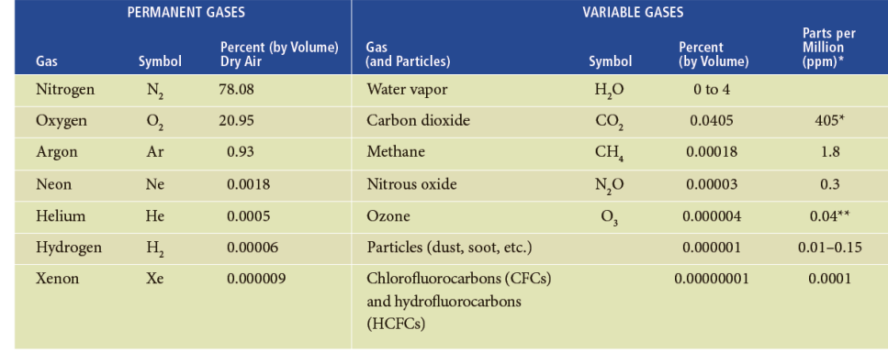

Carbon dioxide (CO2), a natural component of the atmosphere, occupies a small (but important) percent of a volume of air, about 0.037 percent. Carbon dioxide enters the atmosphere mainly from the decay of vegetation, but it also comes from volcanic eruptions, the exhalations of animal life, from the burning of fossil fuels (such as coal, oil, and natural gas), and from deforestation. The removal of CO2 from the atmosphere takes place during photosynthesis, as plants consume CO2 to produce green matter. The CO2 is then stored in roots, branches, and leaves. The oceans act as a huge reservoir for CO2, as phytoplankton (tiny drifting plants) in surface water fix CO2 into organic tissues. Atmospheric concentration of CO2 has risen more than 15 percent since 1958, Carbon dioxide is another important greenhouse gas because, like water vapor, it traps a portion of the earth’s outgoing energy.
Levels of Methane have been rising over the past century, increasing recently by about one half of one percent per year. Most methane appears to derive from the breakdown of plant material by certain bacteria in rice paddies, wet oxygen-poor soil, the biological activity of termites, and biochemical reactions in the stomachs of cows. Levels of nitrous oxide—commonly known as laughing gas—have been rising annually at the rate of about one-quarter of a percent. Nitrous oxide forms in the soil through a chemical process involving bacteria and certain microbes. Ultraviolet light from the sun destroys it.
Chlorofluorocarbons represent a group of greenhouse gases that, up until recently, had been increasing in concentration. At one time, they were the most widely used propellants in spray cans. Today, however, they are mainly used as refrigerants, as propellants for the blowing of plastic-foam insulation, and as solvents for cleaning electronic microcircuits. they have an important effect on our atmosphere as they not only have the potential for raising global temperatures, they also play a part in destroying the gas ozone in the stratosphere.
At the surface, Ozone (O3) is the primary ingredient of photochemical smog, which irritates the eyes and throat and damages vegetation. But the majority of atmospheric ozone (about 97 percent) is found in the upper atmosphere—in the stratosphere where it is formed naturally, as oxygen atoms combine with oxygen molecules. Here, the concentration of ozone averages less than 0.002 percent by volume. This small quantity is important, however, because it shields plants, animals, and humans from the sun’s harmful ultraviolet rays.
Impurities from both natural and human sources are also present in the atmosphere: Wind picks up dust and soil from the earth’s surface and carries it aloft. The tiny solid or liquid suspended particles of various composition are called aerosols. Most human-made impurities (and some natural ones) are a nuisance, as well as a health hazard, these we call Pollutants.
MODELING EARTH’S ATMOSPHERIC LAYERS The Earth is surrounded by the atmosphere :
The Atmosphere and Earth
• The atmosphere consists of layers of gases that surround the Earth.
• The 2 most abundance gases found throughout all the layers are oxygen and nitrogen.
• The earth is divided into 5 atmospheric layers
The atmosphere is the thin envelope of gas molecules surrounding the Earth; it is held down by Earth’s gravitational pull. The atmosphere is concentrated at the Earth’s surface and rapidly thins as you move upward, blending with space at about 100 miles above sea level. The atmosphere is actually very thin compared to the size of the earth. Its thickness can be compared to a piece of paper laid over a beach ball or the skin of an apple. The heat trapping ability it has helps to keep the Earth warm enough for life, and it also protects the Earth from harmful solar radiation and cosmic rays.
a body of air or gasses that protects the planet and enables life to exist. Most of our atmosphere is located close to the earth's surface where it is most dense. The air of our planet is 79% nitrogen and just under 21% oxygen; the small amount remaining is composed of carbon dioxide and other gases. There are five distinct layers of the Earth’s atmosphere:
Earth’s atmosphere has five major and several secondary layers. From lowest to highest, the major layers are the troposphere, stratosphere, mesosphere, thermosphere and exosphere.
Troposphere. Earth’s troposphere extends from Earth’s surface to, on average, about 12 kilometers (7.5 miles) in height, with its height lower at Earth’s poles and higher at the equator. Yet this very shallow layer is tasked with holding all the air plants need for photosynthesis and animals need to breathe, and also contains about 99 percent of all water vapor and aerosols (minute solid or liquid particles suspended in the atmosphere). In the troposphere, temperatures typically go down the higher you go, since most of the heat found in the troposphere is generated by the transfer of energy from Earth’s surface. The troposphere is the densest atmospheric layer, compressed by the weight of the rest of the atmosphere above it. Most of Earth’s weather happens here, and almost all clouds that are generated by weather are found here, with the exception of cumulonimbus thunder clouds, whose tops can rise into the lowest parts of the neighboring stratosphere. Most aviation takes place here, including in the transition region between the troposphere and the stratosphere.
Stratosphere. Located between approximately 12 and 50 kilometers (7.5 and 31 miles) above Earth’s surface, the stratosphere is perhaps best known as home to Earth’s ozone layer, which protects us from the Sun’s harmful ultraviolet radiation. Because of that UV radiation, the higher up you go into the stratosphere, the warmer temperatures become. The stratosphere is nearly cloud- and weather-free, but polar stratospheric clouds are sometimes present in its lowest, coldest altitudes. It’s also the highest part of the atmosphere that jet planes can reach.
Mesosphere. Located between about 50 and 80 kilometers (31 and 50 miles) above Earth’s surface, the mesosphere gets progressively colder with altitude. In fact, the top of this layer is the coldest place found within the Earth system, with an average temperature of about minus 85 degrees Celsius (minus 120 degrees Fahrenheit). The very scarce water vapor present at the top of the mesosphere forms noctilucent clouds, the highest clouds in Earth’s atmosphere, which can be seen by the naked eye under certain conditions and at certain times of day. Most meteors burn up in this atmospheric layer. Sounding rockets and rocket-powered aircraft can reach the mesosphere.
Thermosphere. Located between about 80 and 700 kilometers (50 and 440 miles) above Earth’s surface is the thermosphere, whose lowest part contains the ionosphere. In this layer, temperatures increase with altitude due to the very low density of molecules found here. It is both cloud- and water vapor-free. The aurora borealis and aurora australis are sometimes seen here. The International Space Station orbits in the thermosphere.
Exosphere. Located between about 700 and 10,000 kilometers (440 and 6,200 miles) above Earth’s surface, the exosphere is the highest layer of Earth’s atmosphere and, at its top, merges with the solar wind. Molecules found here are of extremely low density, so this layer doesn’t behave like a gas, and particles here escape into space. While there’s no weather at all in the exosphere, the aurora borealis and aurora australis are sometimes seen in its lowest part. Most Earth satellites orbit in the exosphere.
The Edge of Outer Space. While there’s really no clear boundary between where Earth’s atmosphere ends and outer space begins, most scientists use a delineation known as the Karman line, located 100 kilometers (62 miles) above Earth’s surface, to denote the transition point, since 99.99997 percent of Earth’s atmosphere lies beneath this point. A February 2019 study using data from the NASA/European Space Agency Solar and Heliospheric Observatory (SOHO) spacecraft suggests, however, that the farthest reaches of Earth’s atmosphere — a cloud of hydrogen atoms called the geocorona — may actually extend nearly 391,000 miles (629,300 kilometers) into space, far beyond the orbit of the Moon.

Layers of the Atmosphere
While there are no exact boundaries within the atmosphere, it is divided into layers based on temperature and pressure. The very lowest layer, which contains 90% of the atmosphere's mass, is called the troposphere. This is also where all living things are found and where all weather occurs. Airplanes fly at the very top of the troposphere, so they can fly over the weather, which causes turbulence. The jet stream, a fast moving region of wind in the upper troposphere has been clocked at over 300 miles per hour! While temperatures at the bottom of the troposphere are nice and hospitable for life, temperatures at the top about -60°F! The troposphere is also the thinnest layer, only about 10 miles high.

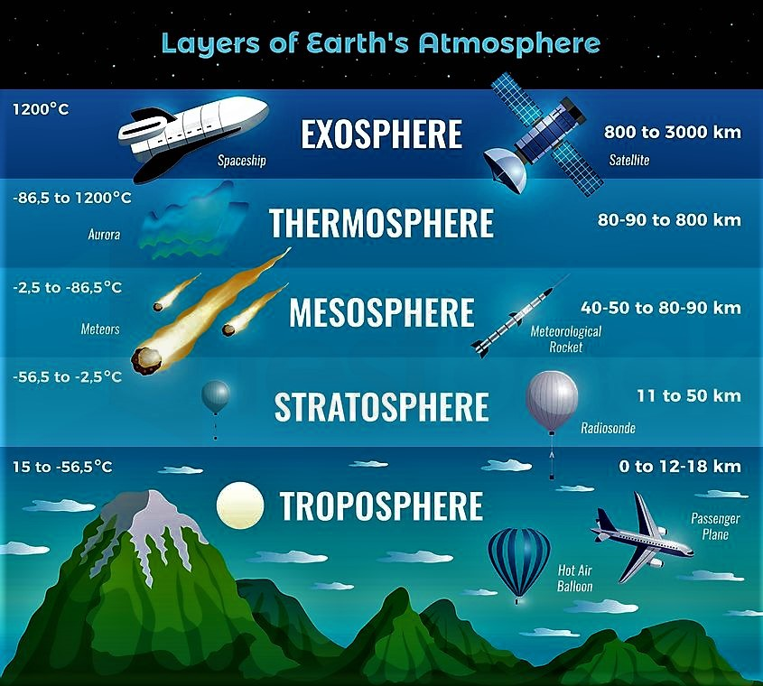

Troposphere:
The layer of the atmosphere closest to the Earth is the troposphere. This layer is where weather occurs. It begins at the surface of the earth and extends out to about 4- 12 miles. The temperature of the troposphere decreases with height. This layer is known as the lower atmosphere.

Stratosphere:
The second layer up from the ground is the stratosphere. This layer extends from about 10-30 miles, and unlike the troposphere, it increases in temperature with elevation. It starts out from about -60°F at the bottom to about 32°F, at the top). This is because ozone molecules form here and absorb the warm ultraviolet radiation from the sun.
Above the troposphere is the stratosphere, which extends to about 30-35 miles above the earth's surface. Temperature rises within the stratosphere but still remains well below freezing. Jet streams occur here, which are fast moving currents of air between the 2 layers.
Mesosphere:
The third and middle layer is the mesosphere. This layer extends from 30-50 miles in altitude, and unlike the stratosphere below, it absorbs very little solar radiation. This layer is incredibly cold, going from freezing at the bottom to about -130°F at the top
From about 35 to 50 miles above the surface of the earth lies the mesosphere, where the air is especially thin and molecules are great distances apart. Temperatures in the mesosphere reach a low of -184°F (-120°C). It is the coldest layer of the atmosphere. Radio waves are reflected to Earth and meteors burn up in this layer. The stratosphere and the mesosphere are the middle atmosphere.
Thermosphere:
The thermosphere rises several hundred miles above the earth's surface, from 50 miles up to about 400 miles. Temperature increases with height and can rise to as high as 3,600°F (2000°C). Nonetheless, the air would feel cold because the hot molecules are so far apart. This layer is known as the upper atmosphere. The next layer up, the thermosphere, is the largest layer, extending from 50-300 miles. Satellites orbit Earth here, and this layer actually increases in temperature with increasing altitude
The ionosphere is a sub-layer found at the top of the mesosphere and the bottom of the thermosphere and gets it because it is ion-rich. This region is a special place in the sky because this is where displays of light in the sky called auroras occur.
Exosphere:
Extending from the top of the thermosphere to 6200 miles (10,000 km) above the earth is the exosphere. This layer has very few atmospheric molecules, which can escape into space. When meteoroids enter Earth's atmosphere, they enter through the exosphere, which is extremely hot. Because of the heat, most meteoroids burn up.
The final layer is the called the exosphere because it is on the outside like an exoskeleton. This layer begins at about 300 miles from the ground but, as mentioned before, slowly fades into space, so it's hard to tell exactly where it ends.
Between each layer of the atmosphere is a boundary. Above the troposphere is the tropopause; above the stratosphere is the stratopause; above the mesosphere is the mesopause; and above the thermosphere is the thermopause. At these "pauses," maximum changes between the "spheres" occur.

Atmospheric Layers
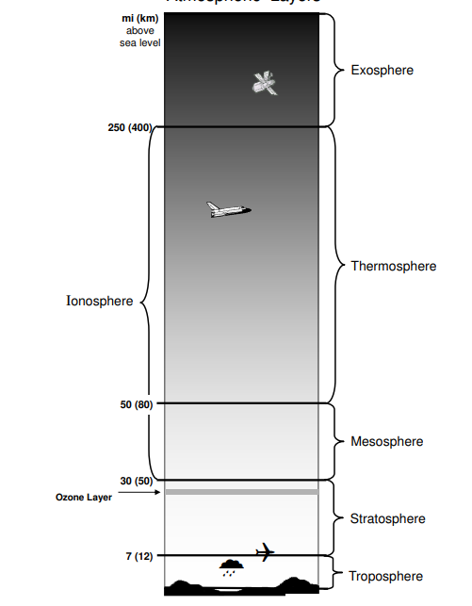

LAYERS OF THE ATMOSPHERE
The Earth’s atmosphere covers the planet, keeps us warm, provides oxygen to breathe, and is where all weather occurs. Earth’s atmosphere has five major layers.
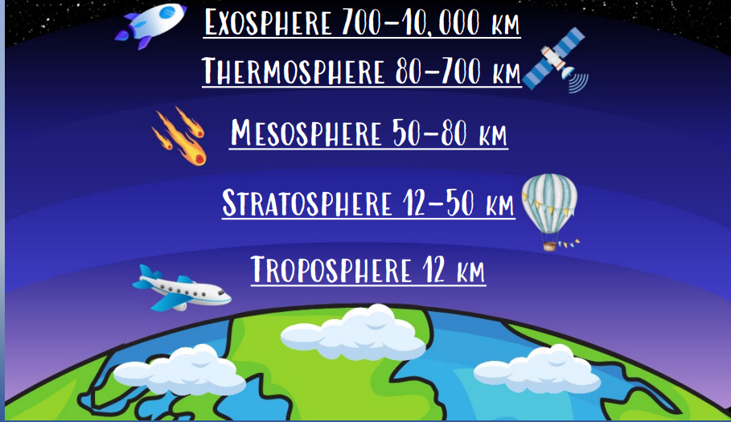
The Earth's Atmosphere
The atmosphere surrounds Earth and protects us by blocking out dangerous rays from the sun. The atmosphere is a mixture of gases that becomes thinner until it gradually reaches space.
It is composed of Nitrogen (78%), Oxygen (21%), and other gases (1%). Oxygen is essential to life because it allows us to breathe. In addition, some of the oxygen has changed over time forming ozone. The ozone layer filters out the sun's harmful ultraviolet radiation.
Recently, there have been many studies on how humans caused a hole to develop in the ozone layer. Humans are also affecting Earth's atmosphere through the greenhouse effect. Due to increases in gases, such as carbon dioxide, that trap heat being radiated from the Earth, scientists believe that the atmosphere may have problems balancing the incoming solar radiation and the reradiated heat from Earth's surface creating the greenhouse effect.
The atmosphere is divided into five layers depending on how temperature changes with height. Most of the weather occurs in the first layer.
Layers of the Earth's Atmosphere The atmosphere is divided into five layers. It is thickest near the surface and thins out with height until it eventually merges with space.
• The troposphere is the first layer above the surface and contains half of the Earth's atmosphere. Weather occurs in this layer.
• Many jet aircraft fly in the stratosphere because it is very stable. Also, the ozone layer absorbs harmful rays from the Sun.
• Meteors burn up in the mesosphere.
• The thermosphere is a layer with auroras. It is also where the space shuttle orbits.
• The atmosphere merges into space in the extremely thin exosphere. This is the upper limit of our atmosphere.
Regions of the Ionosphere
The ionosphere can be further broken down into the D, E and F regions. The breakdown is based on
what wavelength of solar radiation is absorbed in that region most frequently or on what level of
radiation is needed to photodissociate the molecules found in these individual regions.
The D region is the lowest in altitude, though it absorbs the most energetic radiation, hard x-rays.
The D region doesn't have a definite starting and stopping point, but includes the ionization that
occurs below about 90km (or ionization that occurs below the E region).
The E region peaks at about 105km. It absorbs soft x-rays.
The F region starts around 105km and has a maximum around 600km. It is the highest of all of the
regions. Extreme ultra-violet radiation (EUV) is absorbed there.
On a more practical note, the D and E regions (the lower parts of the ionosphere), reflect standard
AM radio waves back to Earth. Radio waves with shorter lengths are reflected by the higher F
region. Visible light, radar, television and FM wavelengths are all too short to be reflected by the
ionosphere. So these types of global communication are made possible by satellite transmissions.

Structure of Atmosphere
Our atmosphere is composed of many components. But the structure of the atmosphere is a combination of various layers. The structure of the atmosphere is represented in a pictorial form below:
There are five layers in the structure of the atmosphere depending upon temperature. These layers are:
- Troposphere
- Stratosphere
- Mesosphere
- Thermosphere
- Exosphere
Troposphere
1- It is considered as the lowest layer of Earth’s atmosphere.
2- The troposphere starts at the surface of the earth and goes up to a height of 8 kms (poles) to 18 kms (equator). The main reason of higher height at the equator is due to presence of hot convectioncurrents that push the gases upward.
3- All kinds of weather changes occurs within this layer.
4- This layer has water vapor and mature particles.
5- Temperature decreases with increasing height of atmosphere at the rate of 1 degree Celsius for every 165 m of height. This is called Normal lapse rate.
6- Tropopause, the transitional zone, separates Troposphere and Stratosphere.

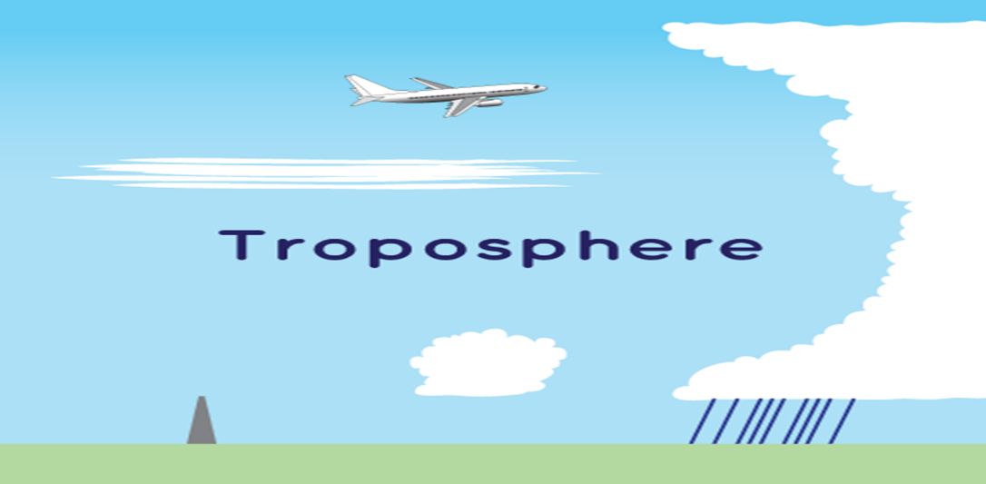

Mesosphere
1- The Mesosphere is found above the stratosphere.
2- It is the coldest of the atmospheric layers.
3- The mesosphere starts at 50 km above the surface of Earth and goes up to 80 km.
4- The temperature drops with altitude in this layer.
5- By 80 km it reaches -100 degrees Celsius.
6- Meteors burn up in this layer.
7- The upper limit is called Mesopause which separates Mesosphere and Thermosphere.

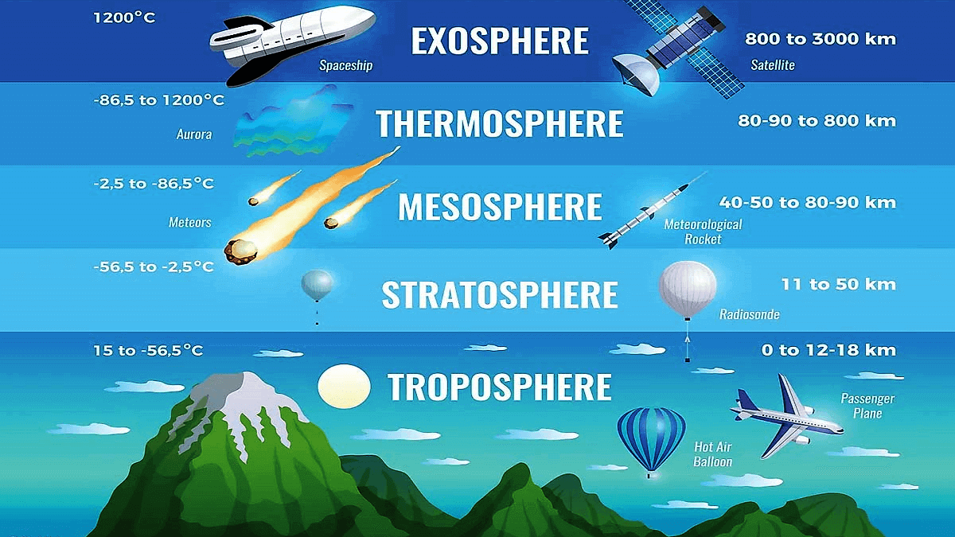
Thermosphere
1- This layer is found above Mesopause from 80 to 400 km.
2- Radio waves that are transmitted from the earth are reflected by this layer.
3- The temperature starts increasing again with increasing height in this layer.
4- Aurora and satellites occur in this layer
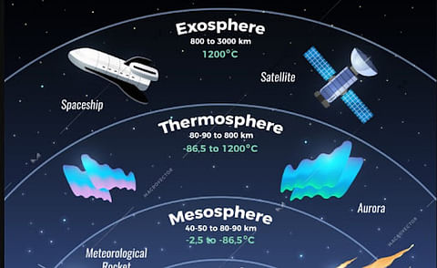
Ionosphere
1- The lower Thermosphere is called the Ionosphere.
2- The ionosphere consists of electrically charged particles known as ions.
3 -This layer is defined as the layer of the atmosphere of Earth that is ionized by cosmic and solar
radiation.
4- It is positioned between 80 and 400 km above the Mesopause.
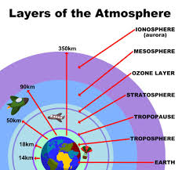
Exosphere
1- It is the outermost layer of the atmosphere.
2- The zone where molecules and atoms escape into space is mentioned as the exosphere.
3- It extends from the top of the thermosphere up to 10,000 km.

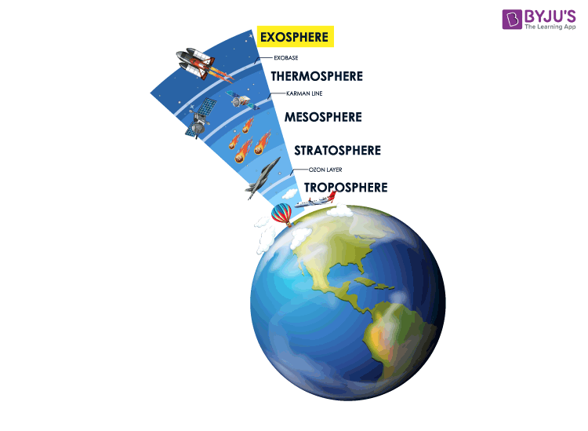

What are 3 facts about the atmosphere?
The atmosphere layer closest to the earth is referred to as the troposphere. Beyond the troposphere are the stratosphere, the ozone layer, the mesosphere, and the thermosphere. The atmosphere is made up of 78% nitrogen, 21% oxygen, and smaller amounts of argon, carbon dioxide, helium, and neon.
Which is the coldest layer of the atmosphere?
The top of the mesosphere is the coldest area of the Earth’s atmosphere because temperature may locally decrease to as low as 100 K (-173°C).
What is the hottest layer of the atmosphere?
The thermosphere is often considered the “hot layer” because it contains the warmest temperatures in the atmosphere. Temperature increases with height until the estimated top of the thermosphere at 500 km. Temperatures can reach as high as 2000 K or 1727 ºC in this layer.
What is 80% of the atmosphere?
About 80% of the total mass of the atmosphere is contained in the troposphere. It is also the layer where the majority of our weather occurs. Maximum air temperature also occurs near the Earth’s surface in this layer.
Why is the atmosphere so important?
The atmosphere is important for many reasons! One reason is that the earth’s atmosphere acts as an insulating layer that protects the earth’s surface from the intense light and heat of the sun. The atmosphere is also important because it contains oxygen, which we and other living organisms breathe.
Atmospheric Temperature and Pressure
As Altitude Increases, Air Pressure Decreases The atmosphere is held around the Earth by gravity. Gravity pulls gas molecules in the atmosphere toward the Earth's surface, causing air pressure. Air pressure is the measure of the force with which air molecules push on a surface. Air pressure is strongest at the Earth's surface because more air is above you. As you move farther away from the Earth's surface, fewer gas molecules are above you. As altitude (distance from sea level) increases, air pressure decreases. Think of air pressure as a stack of books. The books at the bottom have all the weight and pressure of the books on top. Air pressure works in a similar way. People wonder why we are not crushed by air pressure. The reason is that the air pressure is equal in all directions, so air pushes equally on all sides and the forces are balanced.
As the air pressure decreases, the density of the atmosphere also decreases. The air particles are not packed together as tightly as the altitude increases, since there is less gravity acting on the gas particles. The air at sea level and at 6km has the same 21% oxygen, but there are just fewer molecules taken in with each breath. The traditional instrument for measuring air pressure was a barometer, which used a glass tube filled with mercury to register the increasing and decreasing level in air pressure. However, we now know that mercury is a very dangerous substance and is not available for use in this capacity any longer. Modern measurements are done with a high tech pressure sensor. These instruments use silicon chips and are airtight sealed, stainless steel containers with the pressure sensitive sensor inside.
Air temperature also changes as altitude increases. The temperature differences result mainly from the way solar energy is absorbed as it moves through the atmosphere. Some parts of the atmosphere are warmer because they contain a high percentage of gases that absorb solar energy. Other parts of the atmosphere contain less of these gases and are cooler. The uppermost atmospheric layer is called the thermosphere. Here, temperature again increases with altitude because concentrations ofnitrogen and oxygen are high. Nitrogen and oxygen absorb solar radiation and release thermal energy, which causes temperatures in the thermosphere to be 1000 °C or higher.
When most people think of an area that has high temperatures, they think of a place that is very hot. Although the thermosphere has very high temperatures, it does not feel hot. Temperature is different from heat. Temperature is a measure of the average energy of particles in motion. The high temperature of the thermosphere means that particles in that layer are moving very fast. Heat, however, is the transfer of thermal energy between objects of different temperatures. Particles must touch one another to transfer thermal energy. The space between particles in the thermosphere is so great that particles do not transfer much energy. In other words, the density of the thermosphere is so low that particles do not often collide and transfer energy.

