Chapter four
Air Temperature
Daily Temperature Variations
Daytime Warming:
Air Temperature The temperature of the atmosphere which represents the average kinetic energy of the molecular motion in a small region and is defined in terms of a standard or calibrated thermometer in thermal equilibrium with the air.

Daytime Warming. The atmosphere does not absorb much solar radiation. The sun heats the ground which in turn heats the air above the ground. As the sun rises in the morning, sunlight warms the ground, and the ground warms the air in contact with it by conduction. However, air is such a poor heat conductor that this process only takes place within a few centimeters from the ground. As the sun rises higher in the sky, the air in contact with the ground becomes even warmer, and, on a windless day, a substantial temperature difference usually exists just above the ground.
The atmosphere does not absorb much solar radiation.
The sun heats the ground which in turn heats the air above the ground.
Notice the difference in temperature between heights of 1.5m and 0 m

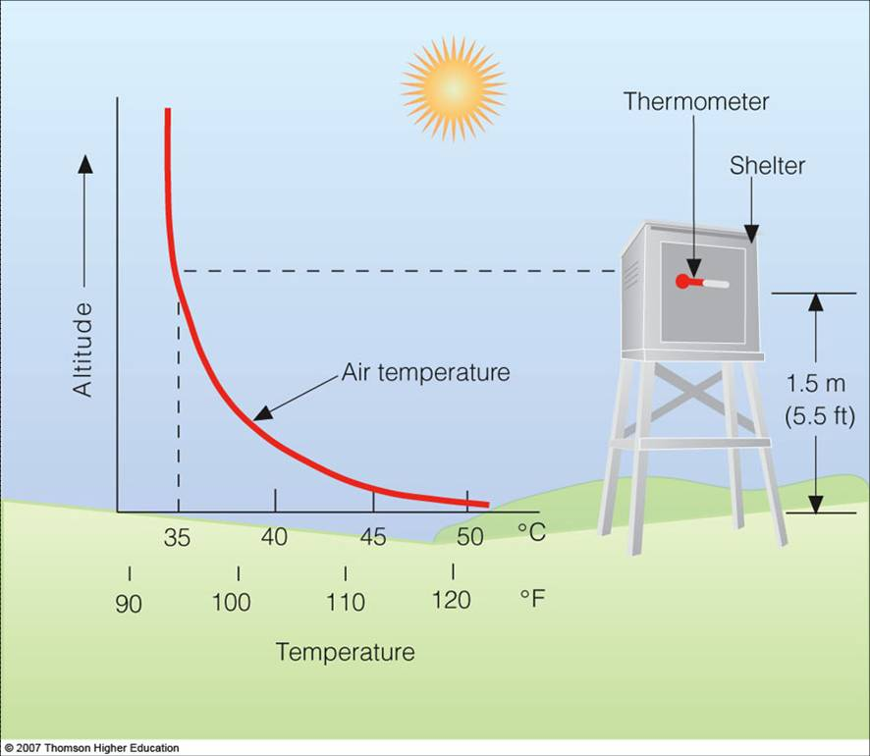

Daytime Warming
- Sunlight warms the ground, and the ground warms the air in
contact with it by conduction.
- Air is a poor heat conduction.
- Near surface, convection can also
help to redistribute the heat. In
calm weather, the thermal
convection effect is small
and do not effectively mix
the air near the surface.
- Thus, there is a substantial
temperature difference above the
ground on windless day.
Daytime Warming
On windy days, turbulence eddies are able to mix hot, surface air with cooler air above. This form of mechanical stirring, called forced convection, helps the thermals to transfer heat away from the surface more efficiently Temperature gradient is smaller in windy day than calm day.
Daily Temperature Variations
Each sunny day is like a tiny season as the air
goes through a daily cycle of warming and cooling.
- Air warms during morning hours, as the sun
rises higher in the sky.
- It is around noon when the earth’s surface receives the most intense solar rays.
- However, noontime is not the warmest part of
the day. Why?

Daily Temperature Variations
- Around noon, the sun’s rays are most intense.
- However, even though incoming solar radiation decreases in intensity after noon, it still exceeds outgoing heat energy from the surface for a time.
- This situation leads to energy surplus for 2-4
hours after noon.
- It leads to a lag between the time of maximum
solar heating and the time of maximum air
temperature.

Daily Temperature Variations
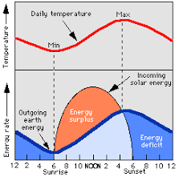

Daily Temperature Variations
The exact time of the maximum temperature varies.
- T_{max} is about 3-5pm during summer cloud-free days.
- If there is afternoon cloudiness or haze, T_{max} usually occurs an hour or two later.
- T_{max} also depends on surface type and cover
1. Absorption characteristics (Strong absorbers enhance surface heating)
2. Vegetation/moisture (Available energy partially used to
evaporate water)
- T_{max} also depends on wind. Strong mixing by wind will mix heated
air near ground to higher altitudes.
- Daily Temperature Variations

Nighttime Cooling
- At night, both ground and air above cool by radiating infrared energy, a process called radiational cooling.
- Ground, a better radiator than air, is able to cool more quickly.
- After sunset, surface is cooler
than the air above it

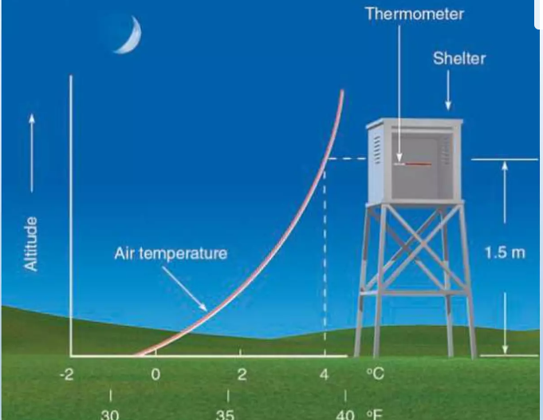

Measuring Air Temperature
- Thermometers were developed to measure air temperature.
- Liquid-in-glass thermometers are often used for measuring surface air temperature because they are easy to read and inexpensive to construct.
- Thermometers have a glass bulb attached to a sealed tube about 25 cm long. When the temperature rises (decreases), the liquid in the bulb expands (contracts). Hence, the length of the liquid in the tube represents the air temperature.

Maximum Thermometer
Maximum thermometer looks like any other liquid-in-glass thermometer with one exception:
*It has a small constriction within the bore just above the bulb.
* As the air temperature increases, the mercury expands and freely moves past the constriction up the tube, until the maximum temperature occurs.
* However, as the air temperature begins to drop, the small
constriction prevents the mercury from flowing back into the bulbs.
* Thus, the end of the stationary mercury column indicates the maximum temperature for the day.
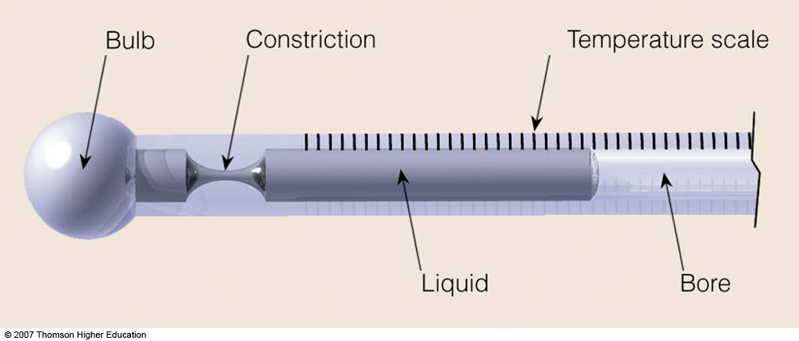
Maximum Thermometer

Minimum Thermometer
* A minimum thermometer measures the lowest temperature during a
given period.

* It is similar to other liquid-in-glass thermometers except that it contains a small barbell-shaped index marker in the bore.

*As the air temperature drops, the contracting liquid moves back into the bulb and brings the index marker down the bore with it.

* When the temperature stops decreasing, the liquid and the index marker stop moving down the bore.

* When the temperature increases, the alcohol expands and moves
freely up the tube past the stationary index marker.

* Because the index marker does not move as the air warms, the minimum temperature is read by observing the upper end of the marker.

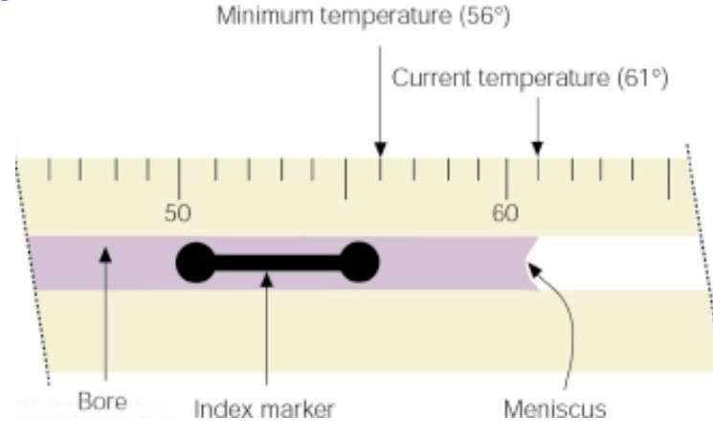

Other Thermometers
*Electrical thermometer: Since the resistance of the material chosen for these thermometers changes as the temperature changes, the resistance can be calibrated to represent air temperature.
*Infrared sensors (Radiometers): By measuring both the intensity of radiant energy and wavelength of maximum emission of a particular gas (either H2O or CO2), radiometers in orbiting satellites are able to estimate the air temperature at selected levels in the atmosphere.

Bimetallic thermometer:
- It consists of two different metal (brass and iron) welded together to form a single strip. As the temperature changes, the brass expands more than the iron, causing the strip to bend.
- The small amount of bending is amplified through a system of levers to a pointer on a calibrated scale.
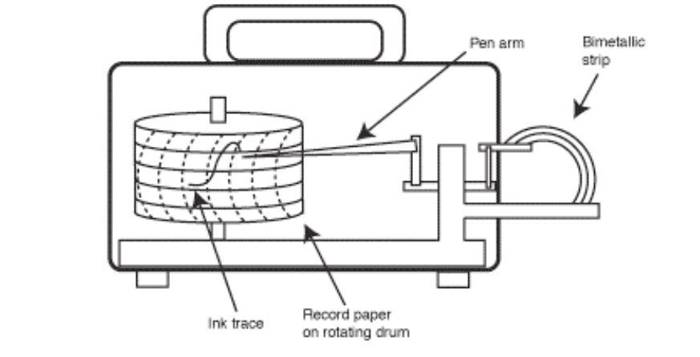

Why is Air Temperature Important?
Air temperature affects the growth and reproduction of plants and animals, with warmer temperatures promoting biological growth. Air temperature also affects nearly all other weather parameters. For instance, air temperature affects:

- the rate of evaporation
- relative humidity
- wind speed and direction
- precipitation patterns and types, such as whether it will rain, snow, or sleet.
How is Air Temperature measured?
Temperature is usually expressed in degrees Fahrenheit or Celsius. 0 degrees Celcius is equal to 32 degrees Fahrenheit. Room temperature is typically considered to be 20-25 degrees Celcius (68-77 degrees Fahrenheit).

A more scientific way to describe temperature is in the standard international unit Kelvin. 0 degrees Kelvin is called absolute zero. It is the coldest temperature possible, and is the point at which all molecular motion stops. It is approximately equal to -273 degrees Celcius and -460 degrees Fahrenheit.

