Department of Physics
College of Education Salahaddin University-Erbil Subject: Astrophysics Course Book: Higher diploma
Lecturer's name: Aven Magded Hamadamen

Academic Year:
2023/2024 Second Semester

Course Book

 | 1. Course name | Astrophysics
 | 2. Lecturer in charge | Aven Magded Hamadamen
 | 3. Department/ College | Physics/ Education
 | 4. Contact | e-mail: aven.hamadamen@su.edu.krd  Tel: 07504861176
 | 5. Time (in hours) per week | Theory: 2 hours  Sunday:(8:30-10:30)
 | 6. Office hours
 | 7. Course code
 | 8. Teacher's academic profile | 2009 BSc. in Department of Physics College of Education Salahaddin University -Erbil 2015 MSc. In Astrophysics  2023 PHD In Astrophysics  Department of Physics College of Education Salahaddin University -Erbil
 | 9. Keywords | Astronomy, Astrology, Astronomic unit , Solar system, Kepler’s Law
(1) Provide the students with the basic and fundamentals of astronomy through the study of the solar system, and
(2) Study the fundamentals of astrophysics as they apply to stars and planets.
(3) To teach a basic understanding of general astronomy and electromagnetic waves theory and their underlying interconnection,
(4) To emphasize the quantum-mechanical nature of light,
(5) To familiarize students with some technological advances in the fields of modern astronomy.
(6) To develop analytical skills (beyond university physics) by providing challenging problem solving practice.

- Course objective:
The course will cover principle information about
- To know the physical properties of stars, plants, galaxies, and comets along with other celestial objects in the sky.
- To be familiar with astronomical units which are the most often used to express interplanetary distances.
- To use the classical calculators and personal computer to measure and calculate the physical properties of astronomical objects.
- Training and using refractor and reflector telescopes (optical telescopes).

- Student's obligation
When I ask the student for preparing in class, and in the exam, preparing and writing a report and discusses in class, this stimulate the students to become more active and able to learn more things about Astrophysics.
- Forms of teaching
Different forms of teaching will be used to reach the objectives of the course: power point presentations for the head titles and definitions and summary of conclusions, classification of Environmental health and any other illustrations, besides worksheet will be designed to let the chance for practicing on several aspects of the course in the classroom, furthermore students will be asked to prepare research papers on selective topics and summaries articles contents published in English into either Kurdish language, those articles need to be from printed media or internet articles. There will be classroom discussions and the lecture will give enough background to translate, solve, analyze, and evaluate problems sets, and different issues discussed throughout the course.
To get the best of the course, it is suggested that you attend classes as much as possible, read the required lectures, teacher’s notes regularly as all of them are foundations for the course. Lecture’s notes are for supporting and not for submitting the reading material including the handouts. try as much as possible to participate in classroom discussions, preparing the assignments given on the course.

- Assessment scheme

The student must provide the following quizzes and exams during the course:

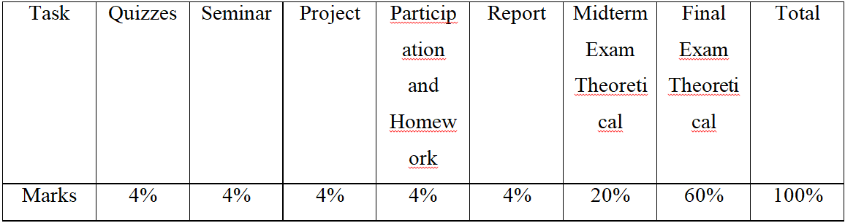

15. Student learning outcome:
After students have completed this course they will be able to:
1- Define functions of the planet characteristics, in particular, as applied to exercise; describe what impact exercise has on solar system.
2- Describe the general structure of H-R diagrams.
3- Describe and differentiate the physical meaning of the most astronomical concepts.

4- List the different types of celestial objects.
5- Understand and use the correct mechanical terms in describing Keplers law of planetary motion.

6- Using the both reflector and refractor optical telescopes.

7- Identify and locate the position of stars in the sky.

8- Using calculators and PC to deal with astronomical formulae and equations
9- The benefits to promote astronomy to all students and young people (both Amateurs and professionals).

16. Course Reading List and References‌:
Required book:

- Aaronson, M. et al. 1982, Astrophys. J. 258, 64.
- Aaronson, M. et al. 1986, Astrophys. J. 302, 536.
- Abdurashitov, J. N. et al. 1996, Phys. Rev. Lett. 77, 4708.
- Abell, G. O. 1958, Astrophys. J. Suppl. 3, 211.
- Baade, W. 1944, Astrophys. J. 100, 137.
- Baade, W. 1954, Trans. I. A. U. 8, 397.
- Baade, W. and Zwicky, F. 1934, Phys. Rev. 45, 138.
- Chadwick, J. 1932, Proc. Roy. Soc. A 136, 692.
- Chandrasekhar, S. 1931, Astrophys. J. 74, 81.
- Chandrasekhar, S. 1935, Mon. Not. Roy. Astron. Soc. 95, 207.
- Downs, G. S. 1981, Astrophys. J. 249, 687.
- Dreher, J. W. and Feigelson, E. D. 1984, Nature 308, 43.
- Dressler, A. 1980, Astrophys. J. 236, 351.
- Dreyer, J. L. E. 1888, Mem. Roy. Astron. Soc. 49, 1.
The core materials of the course consists of the above book, articles from media and internet, and lecture’s notes, make sure you read all the materials and prepare well before going for the examinations.
Students are encouraged to search for any other materials that may help improve their English language ability in reading, writing, listening and speaking plant communities' texts.

17. The Topics:
Chapter One:  2 Weeks | - Historical of Astronomy  - Astronomy, Astrophysics and Astrology
Chapter Two:  1 Week | The Cosmic Distance Scale
Chapter Three:  2 Weeks | Electromagnetic waves
Chapter Four:  2 Weeks | Kepler's Laws
Chapter Five:  2 Weeks | The solar system
Chapter Six:  2 Weeks | Star and Galaxy
18. Practical Topics (If there is any) |  | Not Exist
20. Extra notes:
Due to a number of unforeseen reasons that may lead to the shifting of the academic year program, it may be subjected to modifications. Also extra curriculum hours may be needed to cover all the topics mentioned above. The students shall be notified of the changes if and when they may occur.
21. Peer review

