Department:
Earth Sciences and petroleum

Final Exam
P. Stratigraphy

Q1/ Define the lithostratigraphic unite with sketch
Q2-Order the event in the figure below.

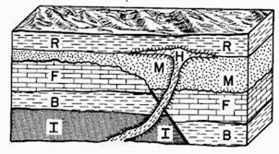

Q3- Mention the type of well log.

Q4- Represent the following stratigraphic information by drawing stratigraphic column to a scale 1cm:10m from top to bottom. (5mark)
1 - (15m) thick; calcareous shale. with Ammonites.
2 - (28m) thick, cross-bedded sandstone contains few gastropoda shells in the upper part.
3 - (5m) thick. Coal.
4 - (12m) thick. Massive limestones contain conglomerate in their lower part.

Q5-Explain briefly the problems of lithostratigraphic correlation.

Q6- Name and determine the kind of each biozone.

Q7 -Mention type of unconformity
Q8- Define onlap and off lap with sketch

