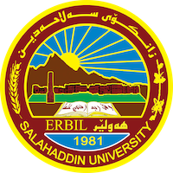
Academic Curriculum Vitae
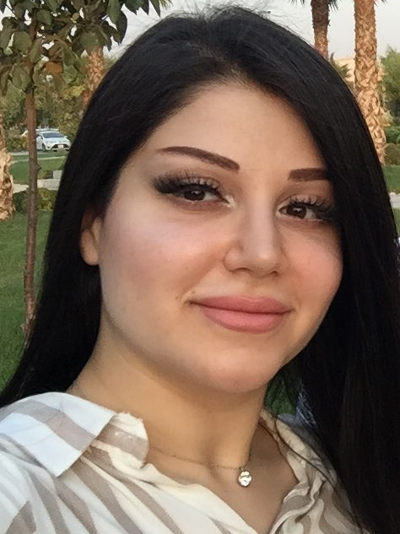
Personal Information:
Full Name: Avin Ali Mahmood
Academic Title: Assist. Lecturer
Email: Avin.Mahmood@su.edu.krd
Mobile: 07507952690

Education:
- Nilufer High school 2008-2009
- BSc degree 2012-2013 in Geology Dept. Science college. Salahaddin Uni.
- MSc degree 2014-2017 in Geology Dept. Science college. Salahaddin Uni.
- Phd student 2019- current in Geology Dept. Science college. Salahaddin Uni.

Employment:
- 2012-2013 in Geology Dept. Science college. Salahaddin Uni.

Qualifications
- Asst. Lecturer
- Excel, Autocad, surfer
- Ielts academy= 6

Teaching experience:
- Assist. Geologist in practical Geochemistry. Geophysics, structure, Environmental Geo., stratigraphy, sedimentary, Mineral, Crystallography.

Research and publications
- Assessment of clay deposits quality from east of Erbil, Kurdistan Region, Iraq for some Ceramic Industries (2021) published research
- Assessment of clay briquettes from East of Erbil City North Iraq for utilization in various building applications (2022) published research
- Evaluation of limestone from Cretaceous to Tertiary age in Kurdistan Region of Iraq for heavy duty road pavement (2022) published research

Conferences and courses attended
- Give details of any conferences you have attended, and those at which you have presented delivered poster presentations.

Funding and academic awards
- Certification from Dean of Science College/ Salahaddin Uni. In Quality Assurance

Professional memberships
- List any membership you hold of any professional body or learned society relevant to your research or other life activities.

Professional Social Network Accounts:

avin ali mahmood Surdashy‬ - Google Scholar‬
Aveen Ali Mahmood Surdashy (researchgate.net)

It is also recommended to create an academic cover letter for your CV, for further information about the cover letter, please visit below link:
https://career-advice.jobs.ac.uk/cv-and-cover-letter-advice/academic-cover-letter/

