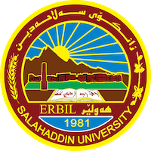

**Academic Curriculum Vitae**

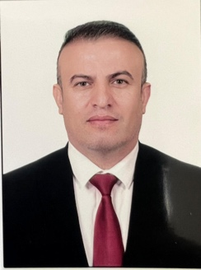

**Personal Information:**

Full Name: AWARA BAKHTIAR RASOUL

Academic Title: Lecturer

Email: [awara.rasool@su.edu.krd](mailto:hussein.mustafa@su.edu.krd)

Mobile: +9647502001212

**Education:**

**2010-July 2011 :**

**University of Derby MSc Marketing and Advertising (passed with Merit)**

• Marketing Communications  
• Marketing Metrics  
• Creative Advertising Solutions  
• Brand Excellence  
• Advertising Campaign Management  
• Managing the Dynamic Organisation  
• Developing Skills for Business Leadership

**2009-July 2010 :**

**University of Derby**  **BA (Hones) Business studies (Upper Second Class Honours (2:1)**

• Electronic commerce  
• Global business environment  
• Organisational dynamics  
• Retail marketing and logistics  
• Services marketing management • Strategic management  
• Independent study

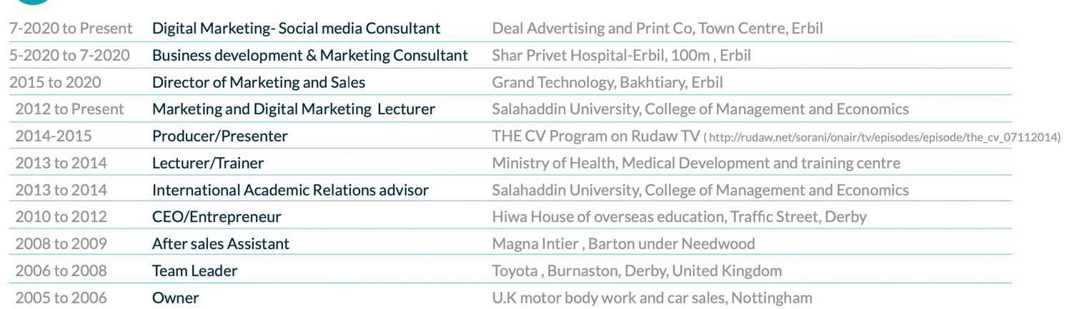**Employment:**

**Qualifications**

* Able to speak, write fluently three different languages (English, Persian and Kurdish).
* I hold a full UK driving license with no endorsements
* I am well versed in Microsoft Office.
* An Iraqi refuge spoke no English, today gains masters’ degree. Was a headline of BBC interview with me in 2011.
* Through my line of work at university I am constantly involved in advising and consulting the privet and public sector, concerning management and market issues.  
  Presenter and creator of the (THE CV) program which was aired on Rudaw TV.
* I own the copy right for many more TV shows such as (Business Doctors, The Mystery Custom- er, XanaXwi and Kari Gorni).
* Head of the department of Scientifics publications of the Salahadden University.
* Trainer and mentor in Thesis Gate centre in areas of personal and entrepreneurship develop- ment
* Active member of Market Research team in Thesis Gates research centre https://thesis- gate.com/research-center

**Teaching experience:**

* Teaching the subject of Marketing Managment 2012- 2015
* Teaching the subject of General English for University Students and English for Specific Purposes/ ESP 2015 - 2019.
* Teaching the subject of Academic Skills 2019- 2022.
* Teaching the subject Environmental management 2023 - 2024

**Research and publications**

[- The Effects of Sales Promotion on Customer Buying Behavior An Analytical study on Carrefour supermarket’s customers in Erbi](https://zancojournals.su.edu.krd/index.php?journal=JAHS&page=article&op=view&path%5B%5D=2164)l

دور متطلبات نظم المعلومات الاستراتيجية في فاعلية المنظمة دراسة تحليلية لآراء مديري عينة من مصارف القطاع الخاص في مدينة اربيل

**Conferences and courses attended.**

* 2nd Student Research Project & Idea Grant Conference Salahaddin University-Erbil, 2022 9th March
* 4th Student Research Project Conference, Salahaddin University-Erbil, May 2022
* 3rd International Conference on Accounting, Business, Economics and Politics, June 29th-30th, 2021..
* 2nd International Conference on Accounting, Business, Economics, and Politics ISBN: 978-9922-9036-3-7. Tishik International University, 2019..

**Professional memberships**

* Member of QA & Technical Auditing at Salahaddin University-Erbil 2022 until now
* Member of Quality Assurance within the tourism department at Salahaddin University-Erbil 2021-2022.
* Member of Examination committee at the College of Administration and Economics, 2021-2022.
* Member of the conference preparation for the second Student Research Project & Idea Grant Conference Salahaddin University-Erbil, 2022 9th March
* Member of the 4th Student Research Project conference preparation, Salahaddin University-Erbil, May 2022.
* Member of the conference’s preparation of the 5th Student Research Project& Idea Grant, Salahaddin University-Erbil, 2022-2023.