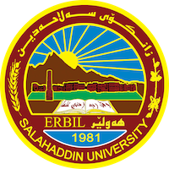
Academic Curriculum Vitae

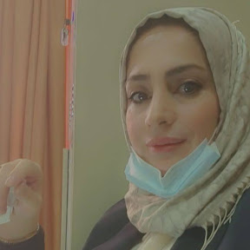
Personal Information:

Full Name: Awat Ibrahim Khudhur
Academic Title: lecturer
Email: awat.khudur@su.edu.krd
Mobile: 0750 4613344

Education:
- Ph.D.: archaeology 22-12-2022
- Masters: archaeology 2014
- Undergraduate: Archaeology

Employment:
- University of Salahaddin/ College of Arts/ Archaeology Department

Qualifications :
- IT qualifications:
- MS Word
- Database
- Excel
- Power Point

- Communication Instrument

- Mother tongue language is Kurdish
Language | Reading | Writing | Speaking
Arabic | Very good | Very good | Very good
English | Good | good | Good

Teaching experience:
- Paleography & Islamic manuscript / Undergraduate
- Islamic illustrate/ Undergraduate

Research and publications
- بەکارهێنانی زەخرەفەی نووسین لەسەر بینا لەناو شاری هەولێر بەپشت بەستن بە وەرگرتنی چەند نموونەیەک
- قيود الختام او حرود المتن دراسة تطبيقية بالاستناد على نماذج مختارة من المخطوطات الاسلامية من القرن(10-13هـ/ 16-19م في المكتبة المركزية بأربيل):

Conferences and courses attended

Funding and academic awards

Professional memberships

Professional Social Network Accounts:

- Research Gate: https://www.researchgate.net/profile/Awat-Khudhur
- Google Schooler: https://www.researchgate.net/profile/Awat-Khudhur
- Facebook: https://www.researchgate.net/profile/Awat-Khudhur

