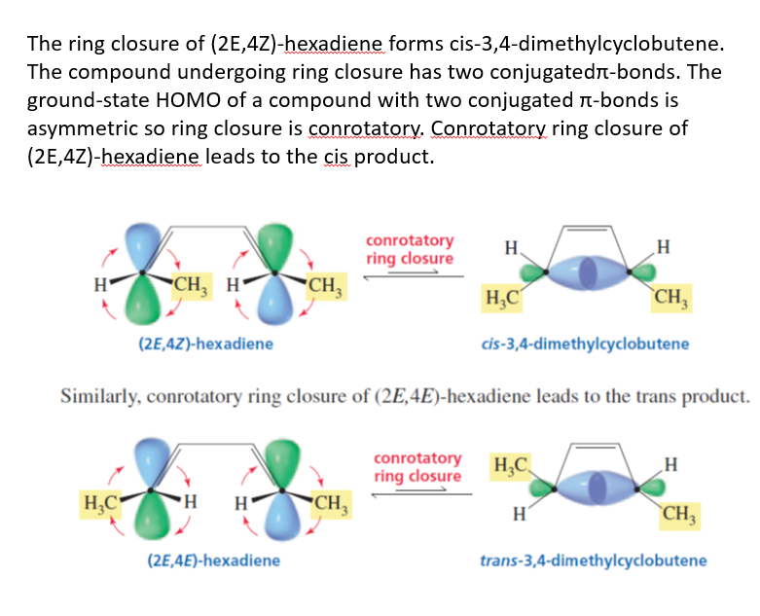

If the reaction is carried out under photochemical conditions, however, the excited state HOMO of a compound with two conjugated bonds is symmetric. (Recall that the ground-state HOMO and the excited-state HOMO have opposite symmetries.)

So (2E,4Z)-hexadiene will undergo disrotatory ring closure, resulting in the trans product, whereas (2E,4E)-hexadiene will undergo disrotatory ring closure and form the cis product.

We have seen that the ground-state HOMO of a compound with two conjugated double bonds is asymmetric, whereas the ground-state HOMO of a compound with three conjugated double bonds is symmetric. If we examine molecular orbital diagrams for compounds with four, five, six, and more conjugated double bonds, we can conclude that the ground-state HOMO of a compound with an even number of conjugated double bonds is asymmetric, whereas the ground-state HOMO of a compound with an odd number of conjugated double bonds is symmetric.

