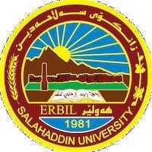
Academic Curriculum Vitae

Personal Information:
- Full Name: Awaz Sulaiman Ismail
- Academic Title: Lecturer
- Email: awaz.ismail@su.edu.krd
- Mobile: 9647507382255
Education:
- Bachelor Degree - Salahaddin University Erbil - College of Law –1990
- Master of Arts - University of Baghdad - College of Law – 1994
- Master of Arts - Salahaddin University – Erbil - College of Law – 1996
- Doctor of Philosophy - University of Baghdad - College of Law – 2000

Employment:
- Assistant lecturer - Salahaddin University – Erbil 1996-08-17
- Lecturer - Salahaddin University – Erbil - 2001-05-17
Teaching experience:
- Demonstrator - College of Law - Salahuddin University 1991-1992
- Assistant Lecturer - College of Law - Salah Al-Din University 1998-2003
- Lecturer at the College of Law - University of Duhok - 1998-2003
- Lecturer at the Faculty of Law - Koya University - 2003-2009
- Lecturer at the College of Administration and Economics 2009 – 2023.
Research and publications
- The law applicable to contracts between absentees in contracts (Scientific Journal of Cihan University - Sulaymaniyah, pp.: 150-161, Volume (6) - Issue (2), December 2022)
https://journal.sulicihan.edu.krd/index.php/sjcus/article/view/177/161

