زانكؤى سةلاحةدين - هةوليَر
Salahaddin University – Erbil

Using Spss To Analysis T-Test
Research Project
Submitted to the department of ( Mathematic ) in partial fulfillment of
the requirements for the degree of BSc. in ( Mathematic )

By:
Asma Khalis Azeez
Email: edma00617@student.su.edu.krd

Supervised by:
L.Awaz SH. Mohamad

2022 - 2023

Certification of the Supervisors

I certify that this work was prepared under my supervision at the Department of Mathematics / College of Education / Salahaddin University-Erbil in partial fulfillment of the requirements for the degree of Bachelor of philosophy of Science in Mathematics.

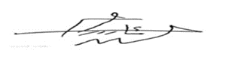
Signature:
Supervisor: L.Awaz SH.Mohammed
Scientific grade: Assist. Professor
Date: 5 / 4 / 2022

In view of the available recommendations, I forward this work for debate by the examining committee.

Signature:
Name: Dr. Rashad Rasheed Haje
Scientific grade: Assist. Professor
Chairman of the Mathematics Department
Date: 5 / 4 / 2022

Acknowledgements

- To Superviser L.Awaz SH.Mohammed
- To all teachers in Department of Mathematics College of Education at Salahaddin University-Erbil

Abstract

A t test is a type of statistical test that is used to compare the means of two groups. It is one of the most widely used statistical hypothesis tests A t-statistic is necessary because the population standard deviation, defined as the measure of variability in a population, is not known for a small sample. T-statistics, on the other hand, allow for the use of the sample standard deviation, or which measures a specific sample's variation, and is more applicable to smalle sized samples. In This research a T-test and type of T-test is analyzed by using the SPSS statistical program an example which was taken from the book .

Table Of Contents:

Contents
Certification of the Supervisors I
Acknowledgements II
Abstract III
Table Of Contents: IV
Introduction: 1
Chapter One 2
T-Test Assumption: 3
1:Introduction:-…………………………………………………………………………………………………………………………………4
1-3: - Type Of T-Test:- 5
1-1:One Sample T-Test:- 6
1-2: Two Sample T-Test:- 7
1-3:Paired Sample T-Test:- 8
Chapter Two 9
Introduction:- 10
2-1:Example Of One Sample T-Test:- 11
2-2: Example Of Two Sample T-Test:- 12
2-3: Example Of Paired Sample T-Test:- 13
References: 14
پوختە :- 15

Introduction

A t test is a type of statistical test that is used to compare the means of two groups. T-tests are commonly used in statistics and econometrics to establish that the values of two outcomes or variables are different from one another. There are two types of statistical inference: parametric and nonparametric methods. Parametric methods refer to a statistical technique in which one defines the probability distribution of probability variables and makes inferences about the parameters of the distribution. In cases in which the probability distribution cannot be defined, nonparametric methods are employed. T tests are a type of parametric method; they can be used when the samples satisfy the conditions of normality, equal variance, and independence. t-tests are calculations used to test a hypothesis, but they are most useful when we need to determine if there is a statistically significant difference between two independent sample groups. In other words, a t-test asks whether a difference between the means of two groups is unlikely to have occurred because of random chance. Usually, t-tests are most appropriate when dealing with problems with a limited sample size (n < 30).

Chapter One

1-1: T-Test Assumption
• The first assumption made regarding t-tests concerns the scale of measurement. The assumption for a t-test is that the scale of measurement applied to the data collected follows a continuous or ordinal scale, such as the scores for an IQ test.
• The second assumption made is that of a simple random sample, that the data is collected from a representative, randomly selected portion of the total population.
• The third assumption is the data, when plotted, results in a normal distribution, bell-shaped distribution curve. When a normal distribution is assumed, one can specify a level of probability (alpha level, level of significance, p) as a criterion for acceptance. In most cases, a 5% value can be assumed.

• The fourth assumption is a reasonably large sample size is used. A larger sample size means the distribution of results should approach a normal bell-shaped curve.
• The final assumption is homogeneity of variance. Homogeneous, or equal, variance exists when the standard deviations of samples are approximately equal.

1-2: Type of T- test:-
    - : One sample T- test[3]:-

One sample t-test is a statistical procedure used to examine the mean difference between the sample and the known value of the population mean. In one sample t-test, we know the population mean. We draw a random sample from the population and then compare the sample mean with the population mean and make a statistical decision as to whether or not the sample mean is different from the population mean. We can use this analysis, for example, when we take a sample from the city and we know the mean of the country (population mean). If we want to know whether the city mean differs from the country mean, we will use the one sample t-test.
Procedure:
Set up the hypothesis:
- Null hypothesis: assumes that there are no significance differences between the population mean and the sample mean.
- Alternative hypothesis: assumes that there is a significant difference between the population mean and the sample mean

- Calculate the standard deviation for the sample by using this formula:
$s=\sqrt{\frac{\sum{{\left(x-\overline{x}\right)}^{2}}}{n-1}}$
Where:-
S = Standard deviation
X =sample mean
n = number of observations in sample
2.Calculate the value of the one sample t-test, by using this formula:
$$t=\frac{\overline{x}-M}{\frac{S}{\sqrt{n}}}$$

Where:
T=one sample t-test
M=population mean
3. Hypothesis testing: In hypothesis testing, statistical decisions are made to decide whether or not the population mean and the sample mean are different. In hypothesis testing, we will compare the calculated value with the table value. If the calculated value is greater than the table value, then we will reject the null hypothesis, and accept the alternative hypothesis.
- Assumptions:
1. Dependent variables should be normally distributed.
2. Samples drawn from the population should be random.
3. Cases of the samples should be independent.
4. We should know the population mean.

    - :Two samples Test-T.
The two-sample t-test (also known as the independent samples t-test) is a method used to test whether the unknown population means of two groups are equal or not.
You can use the test when your data values are independent, are randomly sampled from two normal populations and the two independent groups have equal variances.
- Procedure:-
- Determine the hypotheses.

The hypotheses for a difference in two population means are similar to those for a difference in two population proportions. The null hypothesis, H₀, is again a statement of “no effect” or “no difference.”
- H₀: μ₁ – μ₂ = 0, which is the same as H₀: μ₁ = μ₂
The alternative hypothesis, H₁, can be any one of the following.
- H₁: μ₁ – μ₂ < 0, which is the same as H_{a}: μ₁ < μ₂
- H₁: μ₁ – μ₂ > 0, which is the same as H_{a}: μ₁ > μ₂
- H₁: μ₁ – μ₂ ≠ 0, which is the same as H_{a}: μ₁ ≠ μ₂
- Assess the evidence.

The t-test statistic has a familiar form.
$$T=\frac{\left({\overline{x}}_{1}-{\overline{x}}_{2}\right)-(M_{1}-M_{2})}{\sqrt{\frac{s_{1}^{2}}{n_{1}}}+\frac{s_{2}^{2}}{n_{2}}}$$

- State a conclusion.
To state a conclusion, we follow what we have done with other hypothesis tests. We compare our P-value to a stated level of significance.
- If the P-value ≤ α, we reject the null hypothesis in favor of the alternative hypothesis.
- If the P-value > α, we fail to reject the null hypothesis. We do not have enough evidence to support the alternative hypothesis.

3-1-2: Paired sample T-Test:
The paired t-test is a method used to test whether the mean difference between pairs of measurements is zero or not.
You can use the test when your data values are paired measurements. For example, you might have before-and-after measurements for a group of people. Also, the distribution of differences between the paired measurements should be normally distributed.
The paired t-test is also known as the dependent samples t-test, the paired-difference t-test, the matched pairs t-test and the repeated-samples t-test.

- Formula of paired sample T test

Chapter Two
Example Of T-Test Assumption

2-1:Introduction:-
This chapter tackles the practical application of the T- test . For calculation the type of T-test By giving solved examples taken from book [1][2]

2-2: One Sample T-Test:
Example// Comparing the Average Achievement of students in mathematics among a sample of students in a school with an average.
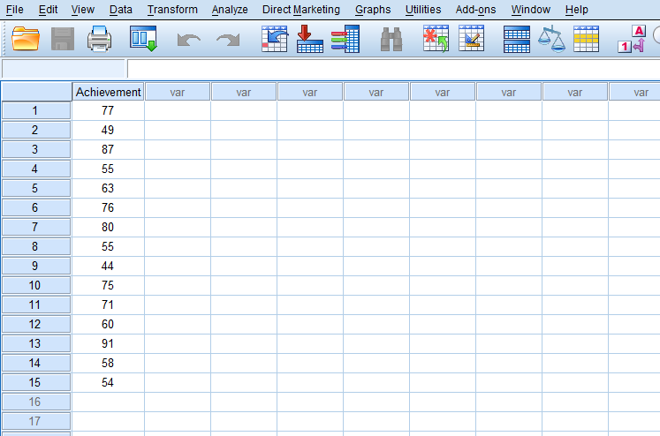
Figher -1-
Data of mathematic student

 | One-Sample Test
 |  | Test Value = 0
 |  | t | df | Sig. (2-tailed) | Mean Difference | 95% Confidence Interval of the Difference
 |  |  |  |  |  | Lower | Upper
Student achievement of mathematics |  | 17.989 | 14 | .000 | 66.333 | 58.42 | 74.24
Table(2-1)
One sample Test

2-3: Two sample T-test [4]:-
The head of the English department is interested in the difference in writing scores between freshman English students who are taught by different teachers. The incoming freshmen are randomly assigned to one of two English teachers and are given a standardized writing test after the first semester. We take a sample of eight students from one class and nine from the other. Is there a difference in achievement on the writing test between the two classes? Here’s the data from the two cla

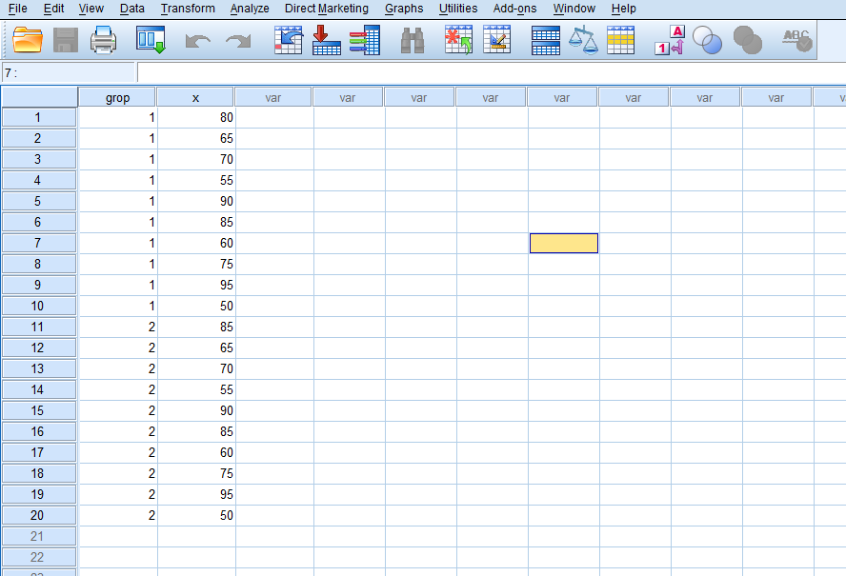
Solution:
$H_{0}$:$M_{1}=M_{2}$
$H_{0}$:$M_{1}≠M_{2}$

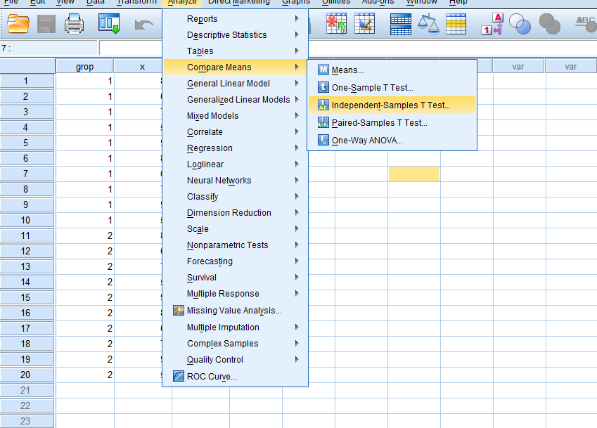

Group Statistics
 | Type of material | N | Mean | Std. Deviation | Std. Error Mean
Degree Achievement | male | 10 | 72.50 | 15.138 | 4.787
 | 2 | 10 | 75.50 | 13.834 | 4.375

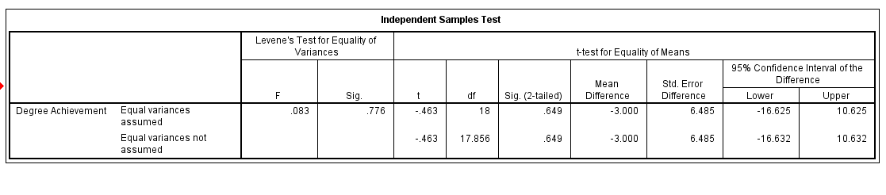

2-4: paired sample T – test [5]:-
Example:
Study of how 15 volunteers performed on a set of tasks under two conditions:
Using a 15-inch computer monitor compared to using a 42-inch monitor.

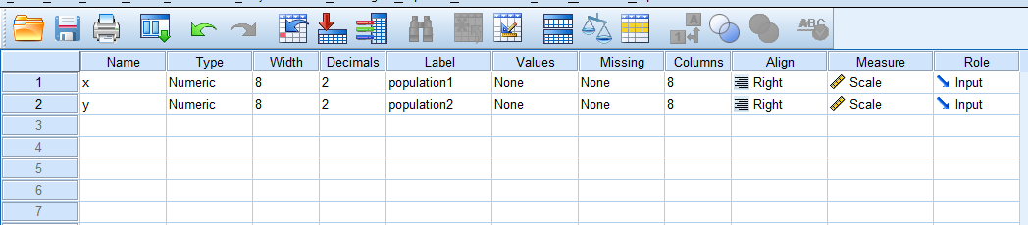

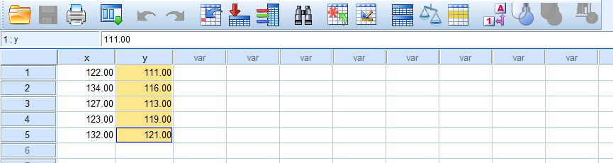

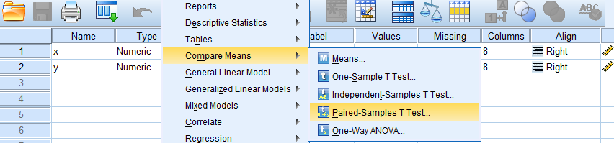

Paired Samples Statistics
 |  | Mean | N | Std. Deviation | Std. Error Mean
Pair 1 | population1 | 127.6000 | 5 | 5.31977 | 2.37908
 | population2 | 116.0000 | 5 | 4.12311 | 1.84391

Paired Samples Correlations
 |  | N | Correlation | Sig.
Pair 1 | population1 & population2 | 5 | .433 | .466

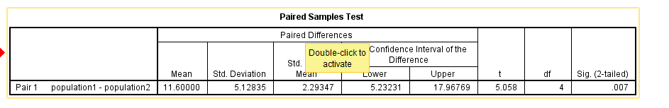

References
[1]Ross A, Willson, V.L. "paired samples T-test." Basic and advanced statistical tests, (2017).: (pp.17-19)Brill sense.
[2]Gerald, B. "A brief review of independent, dependent and one sample t-test." international Journal of Applied mathematics and Theoretical physics,, (2018).: 4(2),50-54.
[3]Rietveld, T.,and Van Hout,R. "The paired t test and beyond:Recommendations for testing thr central tendencies of two paired samples in research on speech,language and hearing pathology." journal of communication disorders,, (2017).: ,69,44-57.
[4]R.Johnson and G.Bhattacharyya. "statistics:Principles and method;." 3rd editio;John Wiley and sons,, Inc;(1996).
[5]l.R.Savage and K.W.Deutsch. "A Statistical Model of the Gross Analysis of Transaction Flows Econometrical 28." (1960),: no.3 551-572.

پوختە :-
تی تێست جۆرێکە لە تاقیکردنەوەی ئامار کە بەکاردێت بۆ بەراوردکردنی ئامرازەکانی دوو گرووپ. یەکێکە لە زۆرترین تاقیکردنەوەی گریمانەی ئامار کە بە شێوەیەکی بەربڵاو بەکاردێت ئامارێکی تی پێویستە چونکە لادانی ستانداردی دانیشتوان، کە بە پێوانەی جیاوازی لە دانیشتواندا پێناسە دەکرێت، بە نموونەیەکی بچووک نازانرێت. ئاماری تی، لە لایەکی ترەوە، ڕێگە بە بەکارهێنانی نمونەی لادانی پێوانەیی، یان s دەدات، کە جیاوازی نمونەیەکی دیاریکراو پێوانە دەکات، و زیاتر کارپێکراوە بۆ نموونە بچووکترەکان.
ئەم توێژینەوەیە لە دوو بەشی پێکهاتووە، لە بەشی یەکەمەوە تاقیکردنەوەی تی وجۆرەکانی تاقیکردنەوەی تی ڕوونکراوەتەوە، ئامانجی بەکارهێنانی تێست و لە بەشی دووەمدا نمونەی چارەسەرێک ڕوونکراوەتەوە کە لە کتێبەکە وەرگیراوە

زانكؤى سةلاحةدين - هةوليَر
Salahaddin University – Erbil
بةكارهيَناني بةرنامةى spss)) بؤ شيكاركردنى تا قيكردنةوةي تي

ثرِؤذةى دةرضوون
ثيَشكةش بة بةشى (ماتماتيك) كراوة ، وةك بةشيَك لة ثيَداويستييةكانى بةدةستهيَنانى
برِوانامةى بةكالؤريؤس لة زانستى (ماتماتيك) .

ئامادة كراوة لةلايةن :
أسماْ خالص عزيز
بةسةرثةرشتى:
م. ئاواز شهاب محمد

2023 2022-

