

زانكؤى سةلاحةدين - هةوليَر

Salahaddin University – Erbil

**Create geometric shapes using MATLAB**

ResearchProject

Submitted to the department of ( Mathematic ) in partial fulfillment of

the requirements for the degree of BSc. in ( Mathematic )

**By:**

Nergz Ibrahim

Email: Edma04017@student.su.edu.krd

Supervised by:

L.Awaz SH. Mohamad

**2021 - 2022**

Certification of the Supervisors

I certify that this work was prepared under my supervision at the Department of Mathematics / College of Education / Salahaddin University-Erbil in partial fulfillment of the requirements for the degree of Bachelor of philosophy of Science in Mathematics.

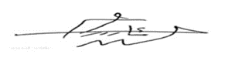

Signature:

Supervisor: L.Awaz SH.Mohammed

Scientific grade: Assist. Professor

Date: 10 / 4 / 2022

In view of the available recommendations, I forward this work for debate by the examining committee.

Signature:

Name:**Dr. Rashad Rasheed Haje**

Scientific grade: Assist. Professor

Chairman of the Mathematics Department

Date: 10 / 4 / 2022

# Acknowledgements

* To Superviser L.Awaz SH.Mohammed
* To all teachers in Department of Mathematics College of Education at Salahaddin University-Erbil
* To my family, my father , my mother and my sisters and my frinds “narmin ,glena ,sumaya”

# 

# Abstract

**Geometric shapes** are the figures which demonstrate the shape of the objects we see in our everyday life. In geometry, shapes are the forms of objects which have boundary lines, angles and surfaces. There are different types of [2d shapes](https://byjus.com/maths/2d-shapes/) and [3d shapes](https://byjus.com/maths/3d-shapes/). In this research we creat the geometric shapes using the MATLAB program.

MATLAB®  is a programming platform designed specifically for engineers and scientists to analyze and design systems and products that transform our world. The heart of MATLAB is the MATLAB language, a matrix-based language allowing the most natural expression of computational mathematics.

# Table Of Contents:

Contents

Certification of the Supervisors I

Acknowledgements II

Abstract III

Table Of Contents: IV

List Of Table V

List of figher V

Introduction: 1

Chapter One 2

1-1: introdaction [3]:- 2

1-2: **Types and Properties of Geometric Shapes**:- 3

1-3: MATLAB's Power of Computational Mathematics [2][4]:- 3

1-4: Features of MATLAB [4]:- 4

1-5: Desktop Basics MATLAB:- 5

1-6: Current Directory (current folder):-………………………………………………………………………………………………

Chapter Two 6

PRACTICAL ASPECT 6

2-1:Introduction:- 6

2-2: Calculate Pearson’s coefficient of linear correlation: 6

2-3: Calculation method Spearman’s coefficient of rank correlation: 8

2-4: Calculate Kendall’s τ [4] : 11

References: 13

پوختە :- 14

# List Of Table

|  |  |  |
| --- | --- | --- |
| **NO.** | **TITIL** | **PAGE** |
| **1-2** |  |  |
| **2-2** |  |  |
| **3-2** |  |  |
| **4-2** |  |  |

# List of figher

|  |  |  |
| --- | --- | --- |
| **NO.** | **TITIL** | **PAGE** |
| **1** |  | **2** |
| **2** |  | **6** |
| **3** |  | **7** |
| **4** |  | **9** |
| **5** |  | **10** |
| **6** |  | **11** |
| **7** |  | **12** |

# Chapter One

# **1-1:** Introduction:-

Geometrical shapes are the figures which represent the forms of different objects. Some figures are two-dimensional, whereas some are three-dimensional shapes. The two-dimensional figures lie on only the x-axis and y-axis, but 3d shapes lie on the x, y and z axes. The z-axis shows the height of the object. As we have already discussed in the introduction, there are different shapes defined in geometry.

To draw or design any of these figures start with a line or a line segment or a curve. Depending upon the number and arrangement of these lines, we get different types of shapes and figures like a triangle, a figure where three line segments are connected, a pentagon (five-line segments) and so on. But every figure is not a complete figure.

# **1-2:** Types and Properties of Geometric Shapes:-

Go through the different types of shapes in geometry along with definitions here.

* Triangle

Triangle is a polygon, which is made of three sides and consists of three edges and three vertices. Also, the sum of its internal angles equals to 180o.

* Circle

Locus of all points at a fixed distance from a reference central point is called a Circle.

* Square

Square is a quadrilateral where all the four sides and angles are equal and the angles at all the vertices are equal to 90° each.

* Rectangle

A quadrilateral has two pairs of opposite sides equal in length and interior angles are at the right angles.

* Parallelogram

A parallelogram is a quadrilateral with two pairs of parallel sides and opposite angles are equal in measure.

* Polygons

These are made up of line segments and no curves. They are enclosed structures based on different lengths of sides and different angles.

1-3:MATLAB programe:-

MATLAB is a programming language developed by MathWorks. It started out as a matrix programming language where linear algebra programming was simple. It can be run both under interactive sessions and as a batch job.

MATLAB (MATrix LABoratory) is a fourth-generation high-level programming language and interactive environment for numerical computation, visualization and programming. It allows matrix manipulations; plotting of functions and data; implementation of algorithms; creation of user interfaces; interfacing with programs written in other languages, including C, C++, Java, and FORTRAN; analyze data; develop algorithms; and create models and applications. It has numerous built-in commands and math functions that help you in mathematical calculations, generating plots, and performing numerical methods.

1-4: MATLAB's Power of Computational Mathematics [2][4]:-

MATLAB is used in every facet of computational mathematics. Following are some commonly used mathematical calculations where it is used most commonly:

- Dealing with Matrices and Arrays

- 2-D and 3-D Plotting and graphics

- Linear Algebra 26

- Algebraic Equations

- Non-linear Functions

- Statistics

- Data Analysis

- Calculus and Differential Equations

- Numerical Calculations

- Integration

- Transforms

- Curve Fitting

- Various other special functions

# 1-5: Features of MATLAB [4] :-

: Following are the basic features of MATLAB:-

• High-level language for numerical computation, visualization, and application development.

• Interactive environment for iterative exploration, design, and problem solving.

• Mathematical functions for linear algebra, statistics, Fourier analysis, filtering, optimization, numerical integration, and solving ordinary differential equations.

• Built-in graphics for visualizing data and tools for creating custom plots.

• Development tools for improving code quality and maintainability and maximizing performance.

• Tools for building applications with custom graphical interfaces.

• Functions for integrating MATLAB based algorithms with external applications and languages such as C, Java, .NET, and Microsoft Excel.

# 1-6: Desktop Basics MATLAB:

MATLAB development IDE can be launched from the icon created on the desktop. The main working window in MATLAB is called the desktop. When MATLAB is started, the desktop appears in its default layout

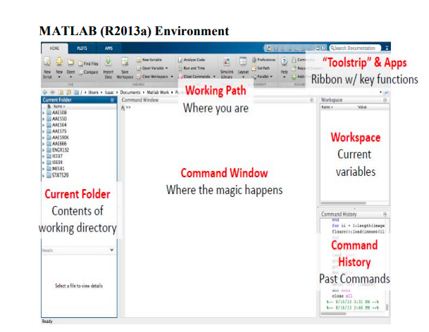

The desktop has the following panels:

• **Current Folder** — Access your files.

• **Command Window** — Enter commands at the command line, indicated by the prompt (>>).

• **Workspace** — Explore data that you create or import from files.

As you work in MATLAB, you issue commands that create variables and call functions.

For example, create a variable named x by typing this statement at the command line: >> x = 3 MATLAB adds variable x to the workspace and displays the result in the Command Window.

x = 3

* Toolbar

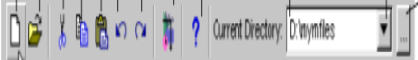

This toolbar consist more commands like:-

 Used to create a new file of type m-file .

 Used to open file saved of type m.file

 Used in cutting or cutting selecting

 Used in copying selecting steps.

 The previously broken or cloned steps are used to paste.

 Used to undo one step

 Is a help containing important information's.

**1-7:Current Directory(current folder): $-$**

The MATLAB files are saved in this file**.**



Geometrical shapes are the figures which represent the forms of different objects. Some figures are two-dimensional, whereas some are three-dimensional shapes. The two-dimensional figures lie on only the x-axis and y-axis, but 3d shapes lie on the x, y and z axes. The z-axis shows the height of the object. As we have already discussed in the introduction, there are different shapes defined in geometry.

To draw or design any of these figures start with a line or a line segment or a curve. Depending upon the number and arrangement of these lines, we get different types of shapes and figures like a triangle, a figure where three line segments are connected, a pentagon (five-line segments) and so on. But every figure is not a complete figure.

# Chapter Two

# PRACTICAL ASPECT

# **2-1:Introduction**:-

This chapter tackles the practical application of the create geometric shapes . by using MATLAB Program .

**2-2: Lin graph:-**

Line( ) : use this command to create line in matlab

Example: a=[2 3 5 6 7 8 9],b=[5 6 7 8 9 6 7],graph line (a,b) .

# : 2-3:plot:

# a)-plot(y): Create a 2-D line plot of Y. MATLAB plots each matrix column as a separate line.

# Example: Define Y as the 4-by-4 matrix returned by the  magic  , plot y .

# ans: see figure

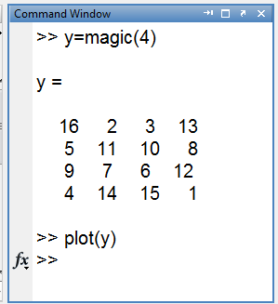

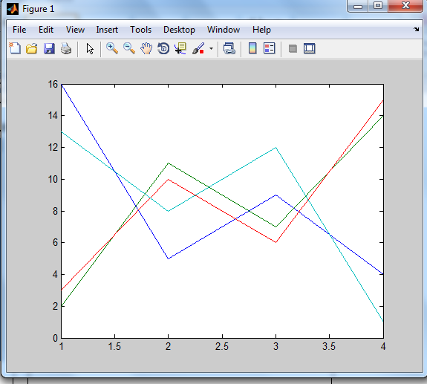

Figher(2)

2-D line graph

**b)- plot(x,y):creates a 2-D line plot of the data in Y versus the corresponding values in X.**

* - If X and Y are both vectors, then they must have equal length.the plot function plots Y versus X.
* - If X and Y are both matrices, then they must have equal size. The plot function plots columns of Y versus columns of X.
* - If one of X or Y is a vector and the other is a matrix, then the matrix must have dimensions such that one of its dimensions equals the vector length. If the number of matrix rows equals the vector length, then the plot function plots each matrix column versus the vector. If the number of matrix columns equals the vector length, then the function plots each matrix row versus the vector. If the matrix is square, then the function plots each column versus the vector.

Example: Create x as a vector of linearly spaced values between 0 and https://ch.mathworks.com/help/examples/graphics/win64/CreateLinePlotExample_01.png. Use an increment of https://ch.mathworks.com/help/examples/graphics/win64/CreateLinePlotExample_02.png between the values. Create y as sine values of x. Create a line plot of the (x,y).ans:

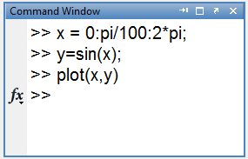

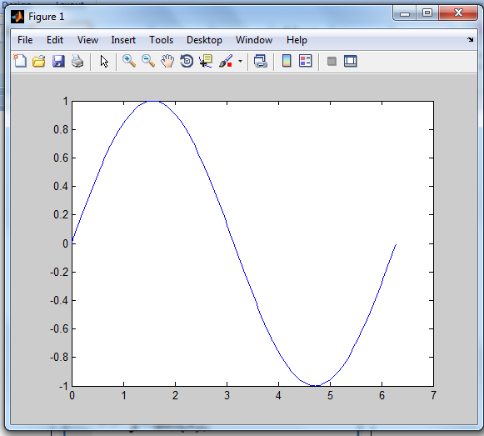

Figer(3)

2-D line plot of the data in Y versus the corresponding values in X.

**2-4:Adding Title:**

Title( ): The title command use to put a title on the graph.

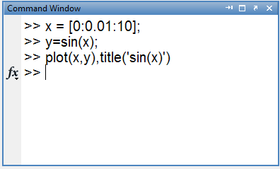

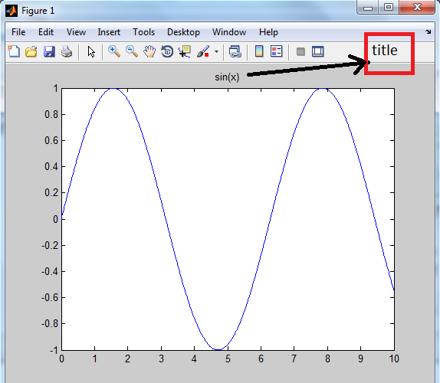

Figher(4)

Adding title

# 2-5: creat geomatrc shape:-

1-2-5: **1-2-5:Rectangle**

Use this command to create rectangle:-

**('position',[x,y,w,h],'curvature',[x,y],'linewidth',2,'linestyle',..,'facecolor','r')**

**'position',[x,y,w,h]:-** the x and y elements determine the location and the w and h elements determine the size.

**'curvature',[x,y]:-** to adds curvature to the sides of the rectangle Which is between 0 and 1

**linewidth':-** Identify the line width for rectangle which is number .

**linestyle:-** select the style of rectangle which is ) -. , -- , - , .-)

**facecolor :**- Determine the triangle color.

Example: Draw a rectangle that has a lower left corner at the point (1,2). Make the width of the rectangle 5 units and the height 6 units. change color red

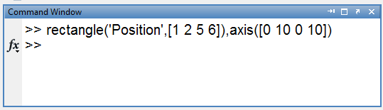

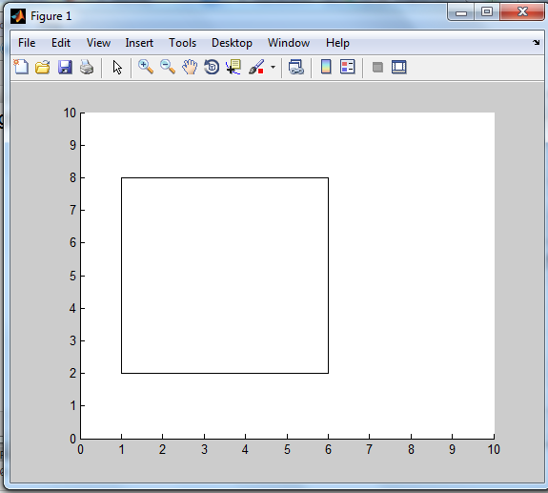

Figer(5)

Drawing the rectangle

Figher(5)

The calculate data to find Spearman correlations

# References:

[1]Mukaka MM. Statistics corner: a guide to appropriate use of correlation coefficient in medical research. Malawi Med J. 2012;.

[2] Ozer DJ. Correlation and the coefficient of determination.

Psychol Bull.

[3] perry Hinton,D.,Hinton,P. R.,MCMurray,I.,&Brownlow,C.(2004).SPSS using SPSS.Routledge.

[4] Dhttps://en.m.wikipedia.org/wiki/Pearson_correlation_coefficient.

[5]Blunch, N., 2012.Introduction to structural equation modeling using IBM SPSS statistics and AMOS.Sage **.**

# پوختە :-

**هاوکۆلکەی هاوپەیوەندی پێوانەيکی ئامارییە بە هێزی پەیوەندی نێوان خزم دوو گۆرانی تر لە و توێژینەوە دادە خوێنین جۆری پەیوەندی بۆ زانینی پەیوەندی نێوان هەندەک نەخۆشی کاریگەریان لە سەر یەک و دیاریکردنی بە هێزی پەیوەندیەکە لە رێگەی کۆکردنەوەی داتا لە نە خۆشخانەی ژین-ی نێودەولەتی و هەندەک نممونە لە کتێبدا.**



زانكؤى سةلاحةدين - هةوليَر

Salahaddin University – Erbil

**بةكارهيَناني بةرنامةى MATLAB بؤ دروست كردنى شيَوة ئةندازةيةكان**

ثرِؤذةى دةرضوون

ثيَشكةش بة بةشى (ماتماتيك) كراوة ، وةك بةشيَك لة ثيَداويستييةكانى بةدةستهيَنانى

برِوانامةى بةكالؤريؤس لة زانستى (ماتماتيك) .

ئامادة كراوة لةلايةن :

نيركز

بةسةرثةرشتى:

م. ئاواز شهاب محمد

2022 2021-