زانكؤى سةلاحةدين - هةوليَر
Salahaddin University – Erbil

Method of point estimation

By:
Kastro Ismael khithur
Email: kastroismael059@gmail.com

Supervised by:
L.Awaz SH. Mohamad

2022 - 2023

Abstract

In statistics, estimation refers to the process by which one makes inferences about a population, based on information obtained from a sample.
Statisticians use sample statistics to estimate population parameters. For example, sample means are used to estimate population means; sample proportions, to estimate population proportions.
An estimate of a population parameter , in this research we use point estimation to estimate population parameters.

Table of Contents
Abstract ii
Introduction: 2
Chapter one 3
Define point estimation 3
Point Estimators 3
1-Moments Method:- 4
2- Maximum Likelihood Estimation Method(m.l.e.). 5
3-Minimum Variance Method (Least Variance Method) (m.v.u.e.):- 6
4- Bayesian Estimation Method(BEM) :- 6
Non Informative prior probability 7
3-2: Properties of point estimation: 8
1-Un biasedness . . . 8
Chapter two 8
1-Moments Method 8
2-Maximum Likelihood Estimation Method(m.l.e.). 9
3-Minimum Variance Method (Least Variance Method) (m.v.u.e.):- 10
4- Bayesian Estimation Method(BEM) :- 12
Non Informative prior probability 12
2-Informative prior probability 12
Reference 14

Chapter one:-

1-1: Introduction:
It is often of interest to learn about the characteristics of a large group of elements such as individuals, households, buildings, products, parts, customers, and so on. All the elements of interest in a particular study form the population. Because of time, cost, and other considerations, data often cannot be collected from every element of the population. In such cases, a subset of the population, called a sample, is used to provide the data. Data from the sample are then used to develop estimates of the characteristics of the larger population. The process of using a sample to make inferences about a population is called statistical inference. Characteristics such as the population mean, the population variance, and the population proportion are called parameters of the population. Characteristics of the sample such as the sample mean, the sample variance, and the sample proportion are called sample statistics. There are two types of estimates: point and interval. A point estimate is a value of a sample statistic that is used as a single estimate of a population parameter. No statements are made about the quality or precision of a point estimate. Statisticians prefer interval estimates because interval estimates are accompanied by a statement concerning the degree of confidence that the interval contains the population parameter being estimated. Interval estimates of population parameters are called confidence intervals.

1-2: point estimation:-

In statistics, point estimation involves the use of sample data to calculate a single value (known as a point estimate since it identifies a point in some parameter space) which is to serve as a "best guess" or "best estimate" of an unknown population parameter (for example, the population mean). More formally, it is the application of a point estimator to the data to obtain a point estimate.
Point estimation can be contrasted with interval estimation: such interval estimates are typically either confidence intervals, in the case of frequentist inference, or credible intervals, in the case of Bayesian inference. More generally, a point estimator can be contrasted with a set estimator. Examples are given by confidence sets or credible sets. A point estimator can also be contrasted with a distribution estimator. Examples are given by confidence distributions, randomized estimators, and Bayesian posteriors.
1-3: Properties of point estimates:-
1-1-3: Biasness:-
“Bias” is defined as the difference between the expected value of the estimator and the true value of the population parameter being estimated. It can also be described that the closer the expected value of a parameter is to the measured parameter, the lesser the bias. When the estimated number and the true value is equal, the estimator is considered unbiased. This is called an unbiased estimator. The estimator will become a best unbiased estimator if it has minimum variance. However, A biased estimator with a small variance may be more useful than an unbiased estimator with a large variance.^{[1]} Most importantly, we prefer point estimators that has the smallest mean square errors.
If we let T = h(X₁,X₂, . . . , X_{n}) be an estimator based on a random sample X₁,X₂, . . . , X_{n}, the estimator T is called an unbiased estimator for the parameter θ if E[T] = θ, irrespective of the value of θ.^{[1]} For example, from the same random sample we have E( x̄ ) = µ(mean) and E(s²) = σ² (variance), then x̄ and s² would be unbiased estimators for µ and σ². The difference E[T ] − θ is called the bias of T ; if this difference is nonzero, then T is called biased.
1-1-3: Consistency
Consistency is about whether the point estimate stays close to the value when the parameter increases its size. The larger the sample size, the more accurate the estimate is. If a point estimator is consistent, its expected value and variance should be close to the true value of the parameter. An unbiased estimator is consistent if the limit of the variance of estimator T equals zero.

3-1-3: Efficiency:-
Let T₁ and T₂ be two unbiased estimators for the same parameter θ. The estimator T₂ would be called more efficient than estimator T₁ if Var(T₂) < Var(T₁), irrespective of the value of θ.^{[1]} We can also say that the most efficient estimators are the ones with the least variability of outcomes. Therefore, if the estimator has smallest variance among sample to sample, it is both most efficient and unbiased. We extend the notion of efficiency by saying that estimator T₂ is more efficient than estimator T₁ (for the same parameter of interest), if the MSE(mean square error) of T₂ is smaller than the MSE of T₁.^{[1]}
Generally, we must consider the distribution of the population when determining the efficiency of estimators. For example, in a normal distribution, the mean is considered more efficient than the median, but the same does not apply in asymmetrical, or skewed, distributions.
4-1-3:Sufficiency:-
In statistics, the job of a statistician is to interpret the data that they have collected and to draw statistically valid conclusion about the population under investigation. But in many cases the raw data, which are too numerous and too costly to store, are not suitable for this purpose. Therefore, the statistician would like to condense the data by computing some statistics and to base his analysis on these statistics so that there is no loss of relevant information in doing so, that is the statistician would like to choose those statistics which exhaust all information about the parameter, which is contained in the sample. We define sufficient statistics as follows: Let X =( X₁, X₂, ... ,X_{n}) be a random sample. A statistic T(X) is said to be sufficient for θ(or for the family of distribution) if the conditional distribution of X given T is free from θ.
1-4: Types of point estimation:-

1-Moments Method:-
In this method we equate population moments and sample moments about the origin. This means that we solve:
$M_{j}^{'}=m_{j}^{'}$ $, j=1,2,3,…,k$
Where $k$ is the number of parameters to be estimated ,and
$M_{j}^{'}$=$E\left(X^{j}\right)→population moment about the origin$
$m_{j}^{'}$=$\frac{1}{n}\sum_{i=1}^{n}{x_{i}^{j}}$→sample 𝑚𝑜𝑚𝑒𝑛𝑡 𝑎𝑏𝑜𝑢𝑡 𝑡ℎ𝑒 𝑜𝑟𝑖𝑔𝑖𝑛

2- Maximum Likelihood Estimation Method(m.l.e.).
$$the\text{ likelihood function is the joint distribution function }j.p.d.f$$
$of n observations,$
$$L\left(θ\right)=f\left(x_{1},x_{2},x_{3},…,x_{n};θ\right)=\prod_{i=1}^{n}{f(x_{i}} ;θ)$$

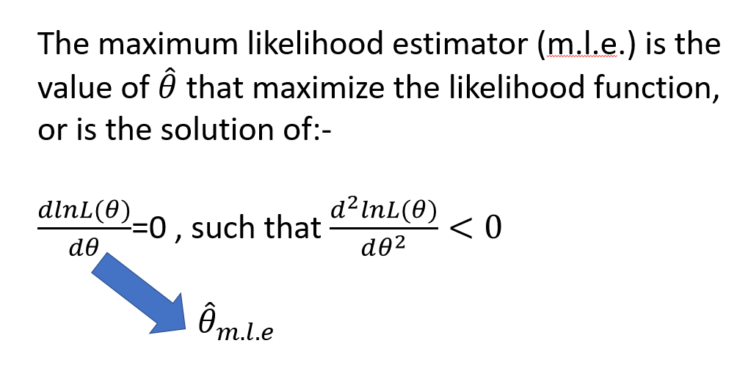

3-Minimum Variance Method (Least Variance Method) (m.v.u.e.):-
In this method the unbiased estimate $\hat{θ}$, which has the minimum (or least)variance should satisfy the following relation
$\frac{dlnL(θ)}{dθ}$=$\frac{\hat{θ}-θ}{v(\hat{θ})}$

4- Bayesian Estimation Method(BEM) :-
Philosophy observed data x is fixed , and the unknown parameter $θ$ is random (certainty about $θ$ depends on both empirical information x and prior knowledge about $θ$ )
In Bayesian Estimation method the parameters treats as random variable with prior probability p($θ$) .or we have prior information about the parameter $θ$.
Let A and B be two event , then the conditional probability of A given B is :-
P(A/B)=$\frac{P(A∩)}{P(B)}$ = $\frac{P (B /A )P(A)}{P(B)}$
Let A=$θ$ and B=X, Then in arss with p.d.f. f(x;$θ$) and prior probability p($θ$) :
$p(θ/x$) = $\frac{p\left(x/θ\right)p(θ)}{p(x)}$
P(x) does not contain $θ$, we can write it as:
$p(θ/x$) $∝$ p(x/$θ$) p($θ$)
$∝$ L($θ$) p($θ$)
Where:
$p(θ/x$) is called posterior probability and Bayes estimator denote $\hat{θ}$_{Bayes} is the mean of posterior probability E($θ$/X)
L($θ$) : Is likehood function
P($θ$) : is prior probability .
- We have two types of prior probability
- Non Informative prior probability .
- Informative prior probability .

Non Informative prior probability

Is proportional to the square root of fisher information :
P($θ$)$∝[F.I.]^{\frac{1}{2}}$ , F.I=-E[$\frac{d^{2}lnf(x;θ)}{dθ^{2}}$
- Informative prior probability
ID | Probability distriution | Informative prior probability
1- | Bern($θ$) | Beta($α_{0},β_{0}$)
2- | Bino(n,$θ$) | Beta($α_{0},β_{0}$)
3- | Geo($θ$) | Beta($α_{0},β_{0}$)
4- | Poisson($θ$) | Gamma($α_{0},β_{0}$)
5- | Expo($\frac{1}{θ}$) | Gamma($α_{0},β_{0}$)
6- | Expo($θ)$ | Inverse Gama($α_{0},β_{0}$)
7- | Normal($θ,σ^{2}$)($θ known)$ | Inverse Gama($α_{0}/2,β_{0}/2$)
8- | Normal($θ,σ^{2}$)($σ^{2}known)$ | Normal($θ_{0},{σ^{2}}_{0}$)

Chapter two

In this chapter we take the practical side in all methods of point estimation by take example in book.

1-Moments Method
Example//let $x_{1},x_{2},x_{3},…,x_{n}$be a r.s.s.n use moment method to an estimate for parameters of the following distribution:-
1-Ber($θ$)
Sol//
$f\left(x;θ\right)=θ^{x}(1-θ)^{1-x}$ $EX=θ ,V(x)=θ\left(1-θ\right)$
Because this distribution has only one parameter then
$$M_{1}^{'}=m_{1}^{'}$$
Where:-
$M_{1}^{'}$=$E\left(X^{j}\right)$= $E\left(X^{1}\right)$= $θ$

$m_{j}^{'}$= 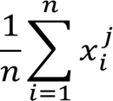 where $j=1$
$m_{1}^{'}$= $\frac{1}{n}\sum_{i=1}^{n}{x_{i}^{1 }}$=$\overline{x}$
$\hat{θ}$=$\overline{x}$ moment estimate for $θ.$

2-Maximum Likelihood Estimation Method(m.l.e.).

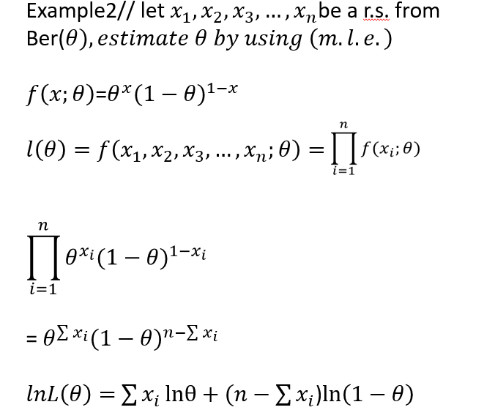

3-Minimum Variance Method (Least Variance Method) (m.v.u.e.):-
Example1// In a r.s.s.n from
1- Ber($θ)$
Find m.v.u.e. for $θ$
Solution//
$f\left(x;θ\right)$=$θ^{x}(1-θ)^{1-x}$
$l\left(θ\right)=f\left(x_{1},x_{2},x_{3},…,x_{n};θ\right)=\prod_{i=1}^{n}{f(x_{i};θ)}$
= $\prod_{i=1}^{n}{θ^{x_{i}}(1-θ)^{1-x_{i}}}$

= $θ^{\sum{x_{i}}}(1-θ)^{n-\sum{x_{i}}}$
$lnL\left(θ\right)=$ $\sum{x_{i}}lnθ+(n-$ $\sum{x_{i}}$)$\ln\left(1-θ\right)$
$\frac{dlnL\left(θ\right)}{dθ}$ = $\frac{\sum{x_{i}}}{θ} - \frac{n- \sum{x_{i}}}{\left(1-θ\right)}$
$\frac{\left(1-θ\right)\sum{x_{i}-θ(n-\sum{x_{i}})}}{θ(1-θ)}$ =$\frac{\sum{x_{i}-θ}\sum{x_{i}}-nθ+θ\sum{x_{i}}}{θ(1-θ)}$
$$\frac{\sum{x_{i}-θn}}{θ(1-θ)}\left.\right]÷\frac{n}{n}$$

$$\frac{\frac{\sum{x_{i}}}{n}-\frac{θn}{n}}{\frac{θ(1-θ)}{n}}$$

$\frac{dlnL\left(θ\right)}{dθ}$ =$\frac{\overline{x}-θ}{\frac{θ(1-θ)}{n}}$
V($\overline{x}$)=$\frac{v(x)}{n}$= $\frac{θ(1-θ)}{n}$
$\frac{dlnL(θ)}{dθ}$=$\frac{\hat{θ}-θ}{v(\hat{θ})}$
$\hat{θ}$= $\overline{x}$ is (m.v.u.e.)

4- Bayesian Estimation Method(BEM) :-

Non Informative prior probability

Example//
Estimate Bayes estimator for parameter of
1-Exp($θ$)

2-Informative prior probability
Example//estimate the parameter of
1-Geo($θ$)
Using Bayesian information prior probability

Reference
[1] Li, HongShuang, ZhenZhou Lü, and XiuKai Yuan. "Nataf transformation based point estimate method." Chinese Science Bulletin 53.17 (2008): 2586-2592.
[2] Li, K. S. "Point-estimate method for calculating statistical moments." Journal of Engineering Mechanics 118.7 (1992): 1506-1511.
[3] Deren, Wang, and Zhao Fengguang. "The theory of Smale's point estimation and its applications." Journal of Computational and Applied Mathematics 60.1-2 (1995): 253-269.
[4] -Introduction to Mathematical Statistics. By R.V. Hogg and A. T. Craig. Pp. ix, 245. 47s. 1959. (The Macmillan Company, New York)
[5]https://books.google.iq/books?hl=ar&lr=&id=4f24CgAAQBAJ&oi=fnd&pg=PR18&dq=introduction+to+point+estimation&ots=K8T0dTSXl5&sig=hg1W75TKxM5yONqzugnRPMyQM1o&redir_esc=y#v=onepage&q=introduction%20to%20point%20estimation&f=false

