Chapter one
1-1: methods of Estimation .
The following are familiar methods of estimation: -
1)- moments method.
2)-maximum likelihood method.
3)-Least(or minimum) variance method.
4)-Bayesian method.
------------------------------------------------------------------------------
1)- Moments Method:-
In this method we equate population moments and sample moments about the origin. This means that we solve:
$M_{j}^{'}=m_{j}^{'}$ $, j=1,2,3,…,k$
Where $k$ is the number of parameters to be estimated ,and
$M_{j}^{'}$=$E\left(X^{j}\right)→population moment about the origin$
$m_{j}^{'}$=$\frac{1}{n}\sum_{i=1}^{n}{x_{i}^{j}}$→sample 𝑚𝑜𝑚𝑒𝑛𝑡 𝑎𝑏𝑜𝑢𝑡 𝑡ℎ𝑒 𝑜𝑟𝑖𝑔𝑖𝑛

Example//let $x_{1},x_{2},x_{3},…,x_{n}$be a r.s.s.n use moment method to an estimate for parameters of the following distribution:-
1-Ber($θ$)
2-unif($θ$)
3-Geomtric($θ$)
4-poisson(𝜃)

Sol//
1-Bernoulli:-
$f\left(x;θ\right)=θ^{x}(1-θ)^{1-x}$ $EX=θ ,V(x)=θ\left(1-θ\right)$
Because this distribution has only one parameter then
$$M_{1}^{'}=m_{1}^{'}$$
Where:-
$M_{1}^{'}$=$E\left(X^{j}\right)$= $E\left(X^{1}\right)$= $θ$

$m_{j}^{'}$= 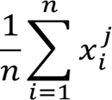 where $j=1$
$m_{1}^{'}$= $\frac{1}{n}\sum_{i=1}^{n}{x_{i}^{1 }}$=$\overline{x}$
$\hat{θ}$=$\overline{x}$ moment estimate for $θ.$

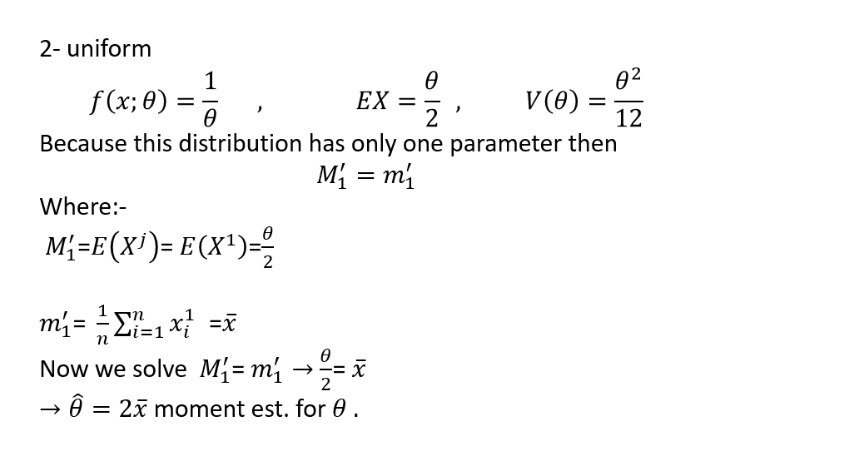

3-Geomtric
$f\left(x;θ\right)=θ^{}(1-θ)^{x}$ $EX=\frac{1-θ}{θ} ,V(x)=\frac{1-θ}{θ^{2}}$
where $j=1$
$M_{1}^{'}=m_{1}^{'}$
$M_{1}^{'}$=$E\left(X^{j}\right)$= $E\left(X^{1}\right)$= $\frac{1-θ}{θ}$
$m_{1}^{'}$=$\frac{1}{n}\sum_{i=1}^{n}{x_{i}^{1 }}$=$\overline{x}$
$→$ $\frac{1-θ}{θ}$= $\overline{x}$
$\overline{x}θ=1-θ$
$\overline{x}θ$+ $θ$=1
$θ\left(\overline{x}+1\right)=1$
$→ \hat{θ}=\frac{1}{\left(\overline{x}+1\right)}$
4-poisson(𝜃)
$f\left(x;θ\right)=\frac{e^{-θ}θ^{x}}{x!}$ , $EX=θ ,V(x)=θ$
Because this distribution has only one parameter then
$$M_{1}^{'}=m_{1}^{'}$$
$M_{1}^{'}$=$E\left(X^{j}\right)$= $E\left(X^{1}\right)$= $θ$
$m_{j}^{'}$=$\frac{1}{n}\sum_{i=1}^{n}{x_{i}^{j}}$ where $j=1$
$m_{1}^{'}$=$\frac{1}{n}\sum_{i=1}^{n}{x_{i}^{1}}$=$\overline{x}$
$\hat{θ}$=$\overline{x}$ moment estimate for $θ$
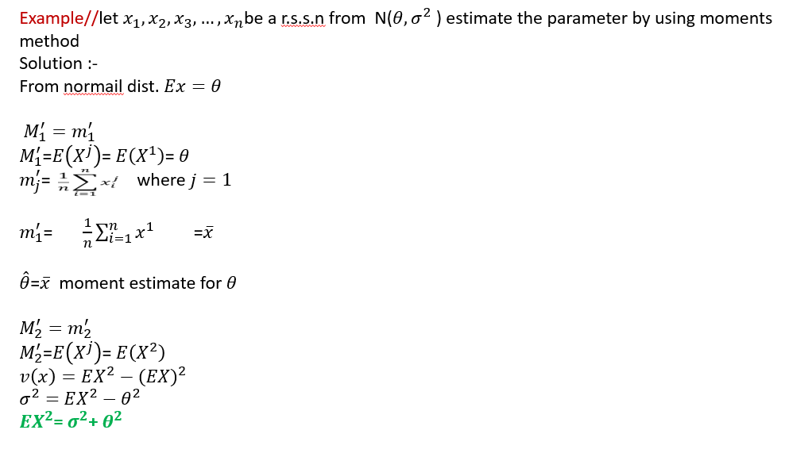
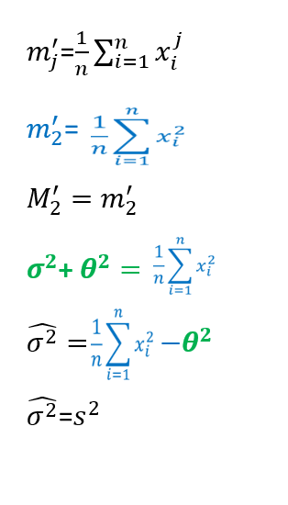

2-Maximum Likelihood Estimation Method(m.l.e.).
$$the\text{ likelihood function is the joint distribution function }j.p.d.f$$
$of n observations,$
$$L\left(θ\right)=f\left(x_{1},x_{2},x_{3},…,x_{n};θ\right)=\prod_{i=1}^{n}{f(x_{i}} ;θ)$$

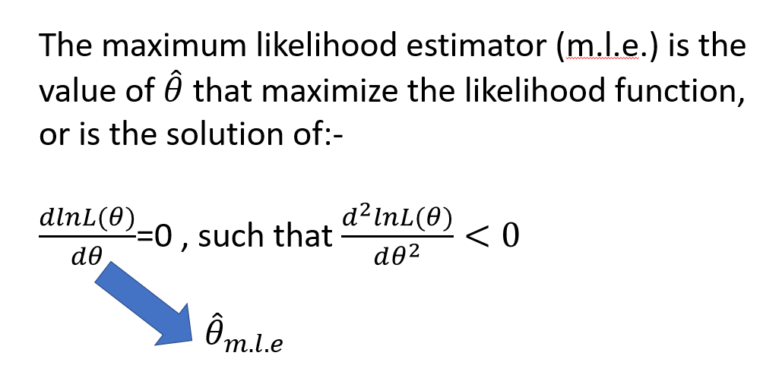

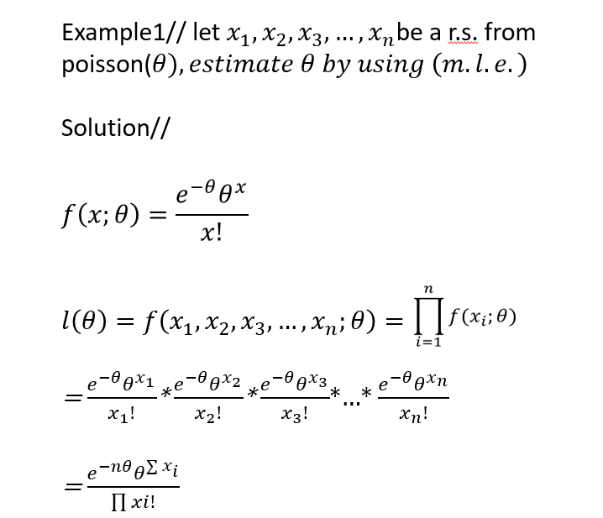

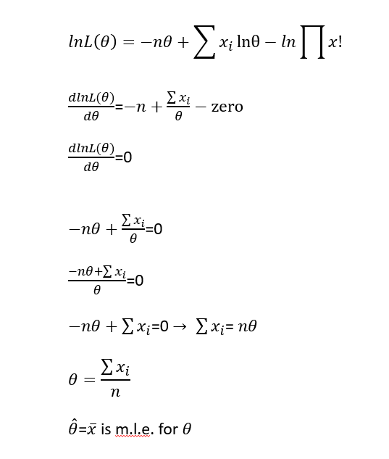

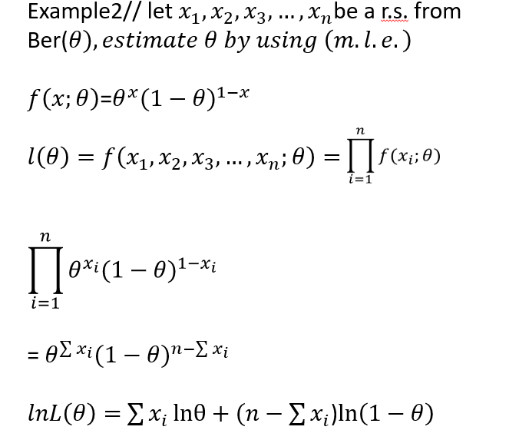

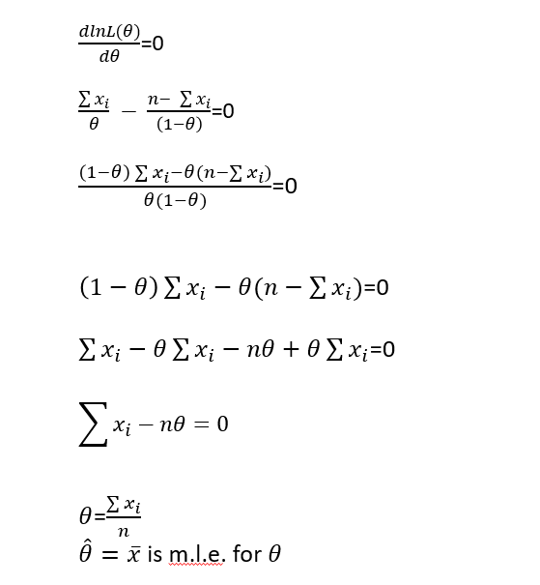

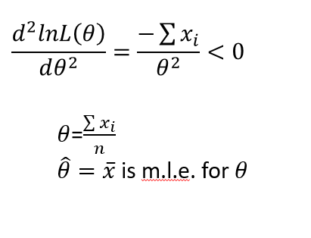
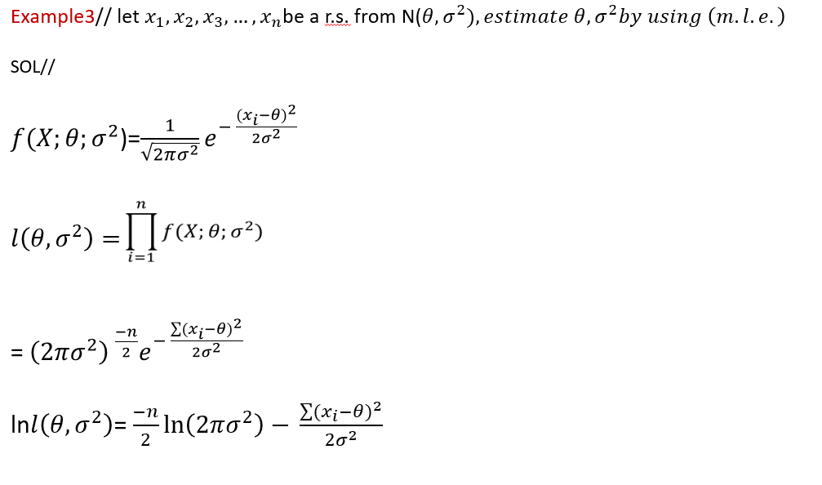

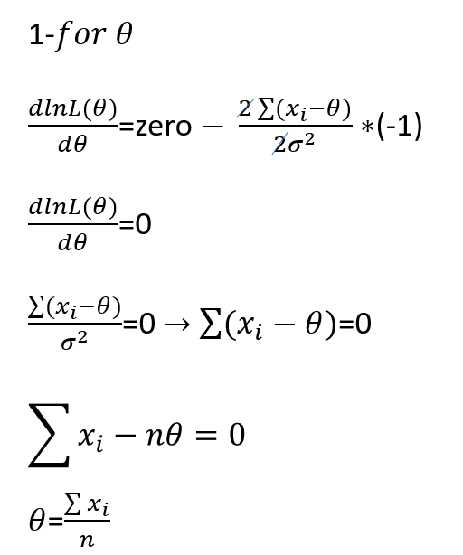

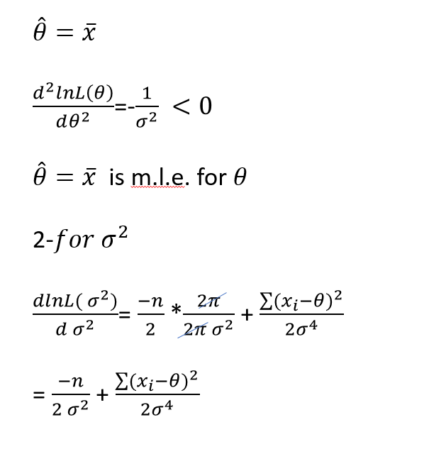

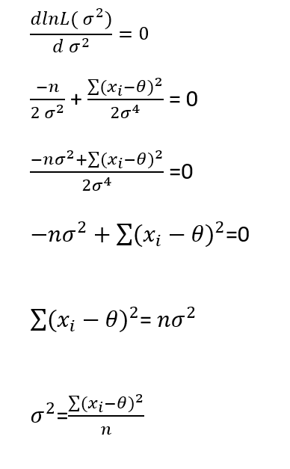
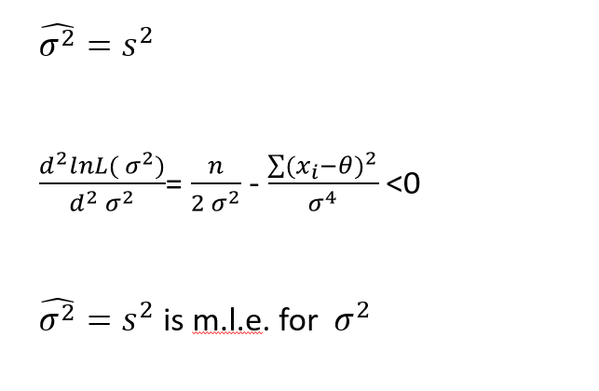
3-Minimum Variance Method (Least Variance Method) (m.v.u.e.):-
In this method the unbiased estimate $\hat{θ}$, which has the minimum (or least)variance should satisfy the following relation
$\frac{dlnL(θ)}{dθ}$=$\frac{\hat{θ}-θ}{v(\hat{θ})}$

Example1// In a r.s.s.n from
1- Ber($θ)$
2-poi($θ)$ ,Find m.v.u.e. for $θ$
Solution//
$f\left(x;θ\right)$=$θ^{x}(1-θ)^{1-x}$
$l\left(θ\right)=f\left(x_{1},x_{2},x_{3},…,x_{n};θ\right)=\prod_{i=1}^{n}{f(x_{i};θ)}$
= $\prod_{i=1}^{n}{θ^{x_{i}}(1-θ)^{1-x_{i}}}$

= $θ^{\sum{x_{i}}}(1-θ)^{n-\sum{x_{i}}}$
$lnL\left(θ\right)=$ $\sum{x_{i}}lnθ+(n-$ $\sum{x_{i}}$)$\ln\left(1-θ\right)$
$\frac{dlnL\left(θ\right)}{dθ}$ = $\frac{\sum{x_{i}}}{θ} - \frac{n- \sum{x_{i}}}{\left(1-θ\right)}$
$\frac{\left(1-θ\right)\sum{x_{i}-θ(n-\sum{x_{i}})}}{θ(1-θ)}$ =$\frac{\sum{x_{i}-θ}\sum{x_{i}}-nθ+θ\sum{x_{i}}}{θ(1-θ)}$
$$\frac{\sum{x_{i}-θn}}{θ(1-θ)}\left.\right]÷\frac{n}{n}$$

$$\frac{\frac{\sum{x_{i}}}{n}-\frac{θn}{n}}{\frac{θ(1-θ)}{n}}$$
$\frac{dlnL\left(θ\right)}{dθ}$ =$\frac{\overline{x}-θ}{\frac{θ(1-θ)}{n}}$
V($\overline{x}$)=$\frac{v(x)}{n}$= $\frac{θ(1-θ)}{n}$
$\frac{dlnL(θ)}{dθ}$=$\frac{\hat{θ}-θ}{v(\hat{θ})}$
$\hat{θ}$= $\overline{x}$ is (m.v.u.e.)

$2-$pois $\left(θ\right)$
$$f\left(x;θ\right)=\frac{e^{-θ}θ^{x}}{x!}$$
$$l\left(θ\right)=f\left(x_{1},x_{2},x_{3},…,x_{n};θ\right)=$$
= $\frac{e^{-θ}θ^{x_{1}}}{x_{1}!}$* $\frac{e^{-θ}θ^{x_{2}}}{x_{2}!}$* $\frac{e^{-θ}θ^{x_{3}}}{x_{3}!}$*…* $\frac{e^{-θ}θ^{x_{n}}}{x_{n}!}$
= $\frac{e^{-nθ}θ^{\sum{x_{i}}}}{\prod{x_{i}!}}$
$$lnL\left(θ\right)=-nθ+\sum{x_{i}}lnθ-ln\prod{xi!}$$
$\frac{dlnL(θ)}{dθ}$=$-n+\frac{\sum{x_{i}}}{θ}-zero$
$$-n+\frac{\sum{x_{i}}}{θ}$$
$\frac{-nθ+\sum{x_{i}}}{θ}$ $\left.\right]÷\frac{n}{n}$
$\frac{\frac{\sum{x_{i}}}{n}-θ}{\frac{θ}{n}}$ = $\frac{\overline{x}-θ}{v(\overline{x})}$
$\hat{θ}$= $\overline{x}$ is m.v.u.e.

4- Bayesian Estimation Method(BEM) :-
Philosophy observed data x is fixed , and the unknown parameter $θ$ is random (certainty about $θ$ depends on both empirical information x and prior knowledge about $θ$ )
In Bayesian Estimation method the parameters treats as random variable with prior probability p($θ$) .or we have prior information about the parameter $θ$.
Let A and B be two event , then the conditional probability of A given B is :-
P(A/B)=$\frac{P(A∩)}{P(B)}$ = $\frac{P (B /A )P(A)}{P(B)}$
Let A=$θ$ and B=X, Then in arss with p.d.f. f(x;$θ$) and prior probability p($θ$) :
$p(θ/x$) = $\frac{p\left(x/θ\right)p(θ)}{p(x)}$
P(x) does not contain $θ$, we can write it as:
$p(θ/x$) $∝$ p(x/$θ$) p($θ$)
$∝$ L($θ$) p($θ$)
Where:
$p(θ/x$) is called posterior probability and Bayes estimator denote $\hat{θ}$_{Bayes} is the mean of posterior probability E($θ$/X)
L($θ$) : Is likehood function
P($θ$) : is prior probability .
We have two types of prior probability
- Non Informative prior probability .
- Informative prior probability .

- Non Informative prior probability

Is proportional to the square root of fisher information :
P($θ$)$∝[F.I.]^{\frac{1}{2}}$ , F.I=-E[$\frac{d^{2}lnf(x;θ)}{dθ^{2}}$
Example//
Estimate Bayes estimator for parameter of
- Exp($θ$) 2- ber($θ$)

- Informative prior probability .
The form of prior probability for parameters of some dist. As follows:
ID | Probability distriution | Informative prior probability
1- | Bern($θ$) | Beta($α_{0},β_{0}$)
2- | Bino(n,$θ$) | Beta($α_{0},β_{0}$)
3- | Geo($θ$) | Beta($α_{0},β_{0}$)
4- | Poisson($θ$) | Gamma($α_{0},β_{0}$)
5- | Expo($\frac{1}{θ}$) | Gamma($α_{0},β_{0}$)
6- | Expo($θ)$ | Inverse Gama($α_{0},β_{0}$)
7- | Normal($θ,σ^{2}$)($θ known)$ | Inverse Gama($α_{0}/2,β_{0}/2$)
8- | Normal($θ,σ^{2}$)($σ^{2}known)$ | Normal($θ_{0},{σ^{2}}_{0}$)

Example//estimate the parameter of
- Geo($θ$) 2- poisson($θ$)
Using Bayesian information prior probability

1-2:The Exponential family of probability dist. Fun.
Let x has a p.d.f. f(x;$θ$) then the family of f(x;$θ$) is be longs to exponential class of dist. If it can be written in the following :-
f(x;$θ$)=exp[ln f(x;$θ$)]
= exp[q($θ$) + p($θ$) k($θ$) + s(x)]
Example//let $x_{1},x_{2},…,x_{n}$ be arssn from Ber($θ$) show that if the dist. Of x can be written in exponential form ?( belongs to the expon. Family )
Answer//

1-3:Rao-Black well Theorem
Let x has a p.d.f. f(x;$θ$) and u be unbiased estimated to$∅(θ)$ and T be sufficient estimator ,then :
- E[E(u/T)]= =E(u) , Where w=E(u/T)
- V(u)$≥$ v[E(U/T)]
Answer//

