Statistical Hypothesis: – a conjecture about a population parameter. This conjecture may or may not be true.
Hypothesis testing:- or significance testing is a method for testing a claim or hypothesis about a parameter in a population, using data measured in a sample. In this method, we test some hypothesis by determining the
likelihood that a sample statistic could have been selected, if the hypothesis
regarding the population parameter were true.

There are two types of statistical hypotheses:
We have to decide between two hypotheses regarding one or more parameter, the two hypotheses are :-
Null Hypothesis (H0) – a statistical hypothesis that states that there is no difference between a parameter and a specific value, or that there is no difference between two parameters.
Alternative Hypothesis (H1) – a statistical hypothesis that states the existence of a difference between a parameter and a specific value, or states that there is a difference between two
FOUR STEPS TO HYPOTHESIS TESTING
Step 1: State the hypotheses.
Step 2: Set the criteria for a decision.
Step 3: Compute the test statistic.
Step 4: Make a decision.
Note: H₀ will ALWAYS have an equal sign (and possibly a less
than or greater than symbol, depending on the alternative
hypothesis). The alternative hypothesis has a range of values
that are alternatives to the one in .

- The null and alternative hypotheses are stated together. The
following are typical hypothesis for means, where k is a specified
number.

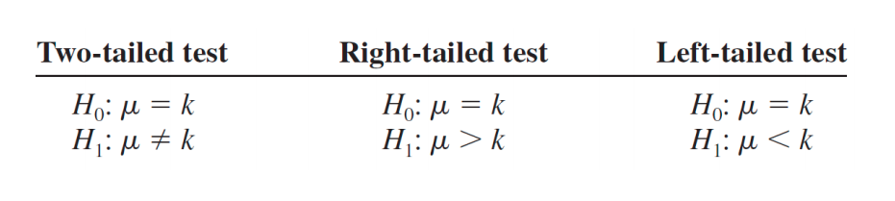
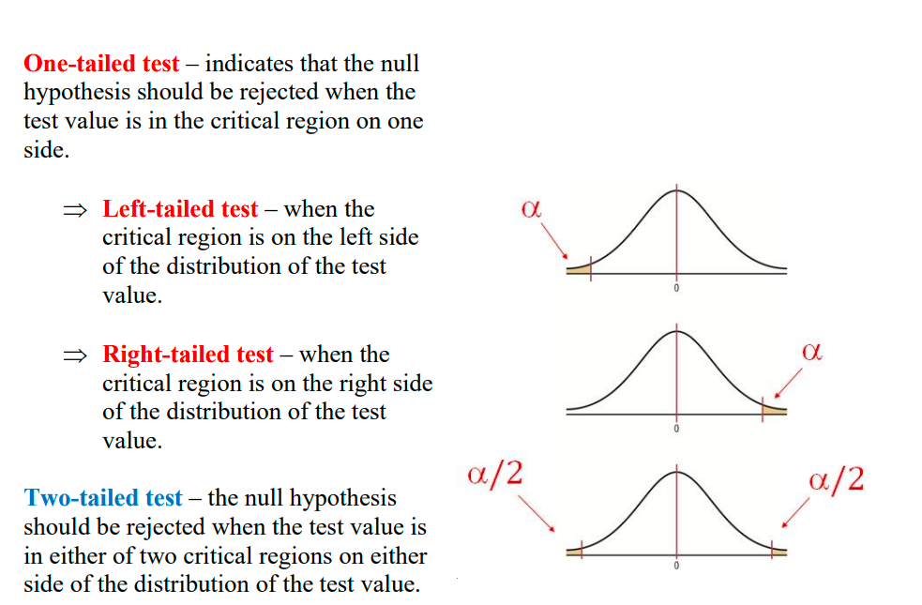

Examples: State the H₀ and H1 for each case. A researcher thinks that if pregnant mothers use vitamins, the birth weight of the babies will increase. The average birth weight of the population is 8.6 pounds.
H₀: $M$= 8.6 H₁: M > 8.6

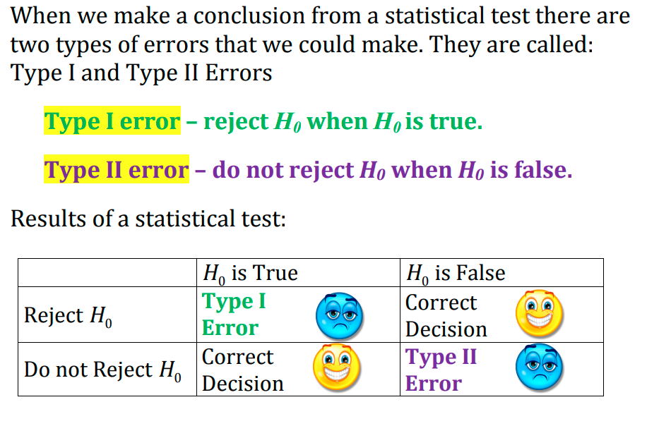

Testing a hypothesis about the mean of a population:
- We have the following steps:
1.Data: determine variable, sample size (n), sample mean($\overline{x}$ ) , population standard deviation or sample standard deviation (s) if is unknown
2. Assumptions :We have two cases:
- Case1: Population is normally or approximately normally distributed with known or unknown variance (sample size n may be small or large),
-Case 2: Population is not normal with known or unknown variance (n is large i.e. n≥30)

3.Hypothesis:
we have three cases
- Case I :
H₀: μ=μ₀
H₁: μ$≠$ μ₀
- e.g. we want to test that the population mean is
different than 50
- Case II :
H₀: μ = μ₀
H₁: μ > μ₀
- e.g. we want to test that the population mean is greater
than 50
- Case III :
H₀: μ = μ₀
H₁: μ< μ₀
- e.g. we want to test that the population mean is less
than 50
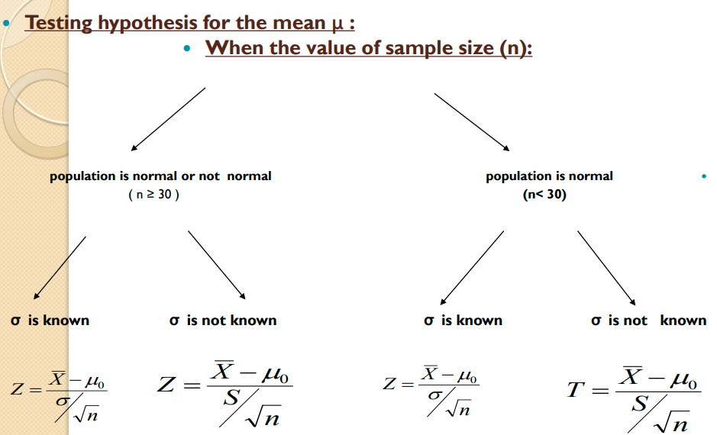

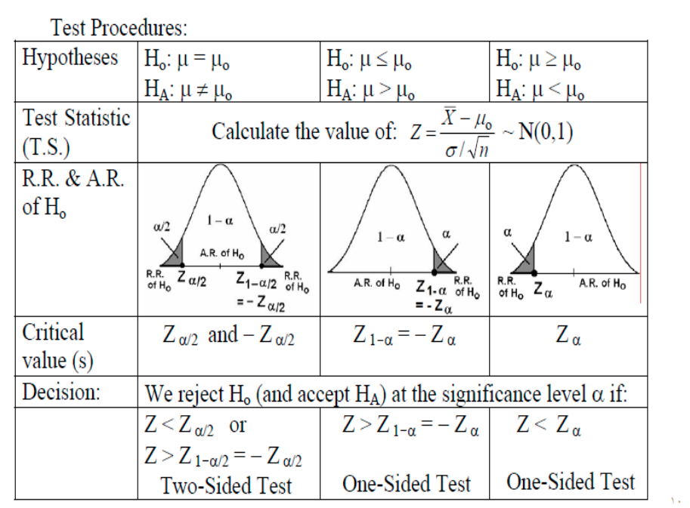

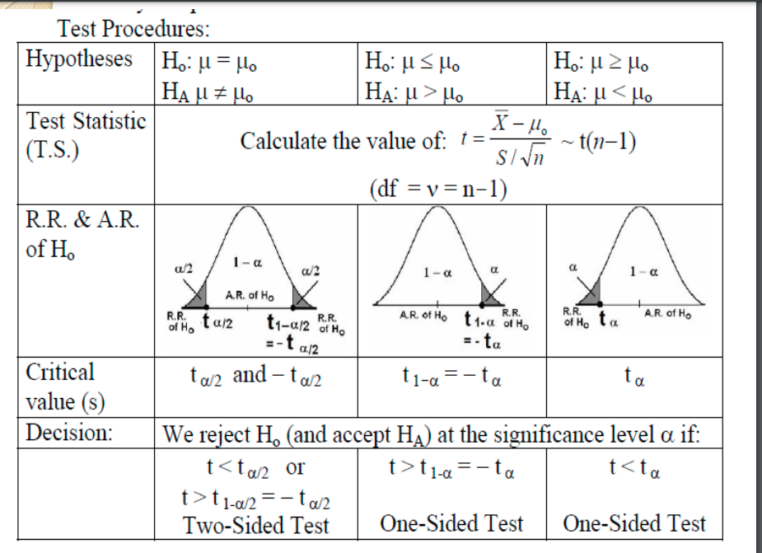
Example//
Among 157 African-American men ,the mean systolic blood pressure was 146 mm Hg with a standard deviation of 27. We wish to know if on the basis of these data, we may conclude that the mean systolic blood pressure for a population of African-American is greater than 140. Use α=0.01.
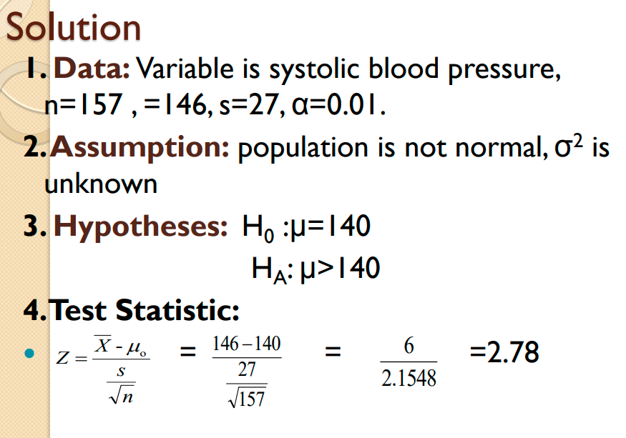

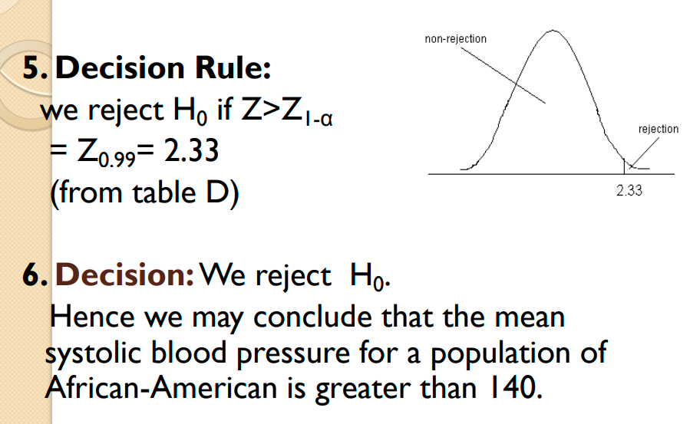

Example// Researchers are interested in the mean age of a certain population. A random sample of 10 individuals drawn from the population of interest has a mean of 27. Assuming that the population is approximately normally distributed with variance 20,can we conclude that the mean is different from 30 years ? (α=0.05) .
-Data: variable is age, n=10,m =27 ,σ2=20,α=0.05
2-Assumptions: the population is approximately
normally distributed with variance 20
3-Hypotheses:
 H₀ : μ=30
 H₁: μ $≠$30

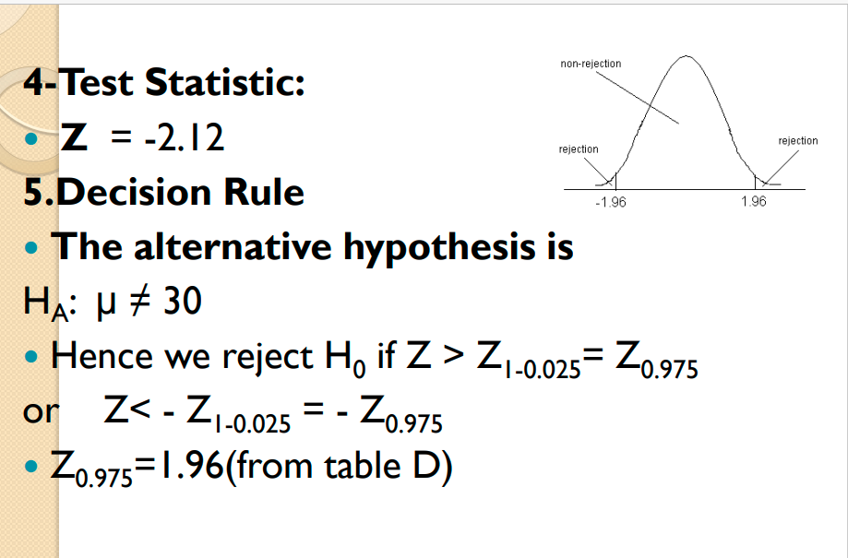
6.Decision:
 We reject H0
,since -2.12 is in the
rejection region .
 We can conclude that μ is not equal to 30

