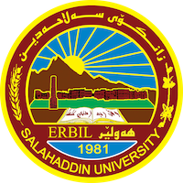
Academic Curriculum Vitae
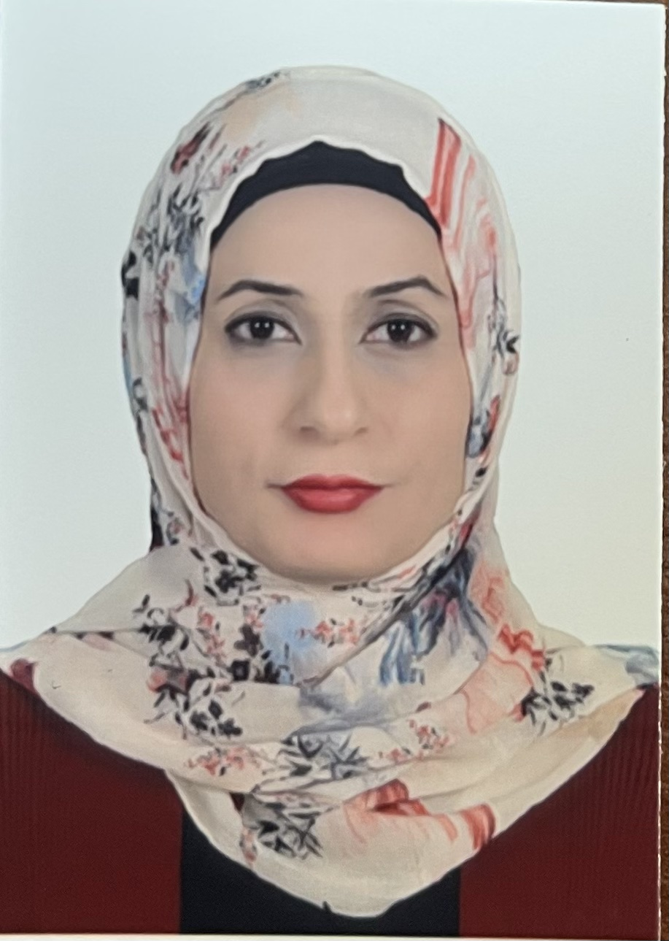
Personal Information:
Full Name:Awaz Shamsadin Salih
Academic Title: Assistant Lecturer
Email: (university email) awaz.salih@su.edu.krd
Mobile:07504886811

Education:
- Master Degree

Employment:
- Salahadin University – College Of Law

Qualifications
- Experience in using computer programs

Teaching experience:
- Experience in giving lectures on corporate law and commercial law
Research and publications
- No.

Conferences and courses attended
- Participated in several local conferences, including human rights in the Kurdistan region
Funding and academic awards
- No.

Professional memberships
- Member of the Jurists Syndicate
Professional Social Network Accounts:
- awaz shamsadin salih‬ - Google Scholar‬‬‬
- https://www.researchgate.net/profile/Awaz-Salih

