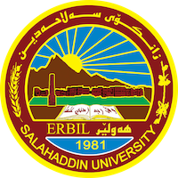
Academic Curriculum Vitae

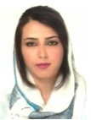
Personal Information:
Full Name: Awen Seyed Abdollah Karim
Academic Title: Assistant Lecturer
Email: (awen.karim@su.edu.krd)
Mobile:07508102685

Education:
-B.Sc. in Mathematics. Mathematics Department- College of Science- Urmia University-Urmia, Iran in 2008.
- M.Sc. in Numerical Analysis. Mathematics Department - College of Science- Urmia University- Urmia, Iran in 2012.

Employment:
- As an assistant lecturer, I have been teaching in the Department of Mathematics, College of Basic Education, Salaheddin University, Erbil, since 2013 until now.

- Qualifications
- Teaching methods course 2013
Teaching experience:
Lessons taught:
-IT/ First stage
- Calculus/ First stage
- Advanced Calculus/ Second Stage
- Vector Analysis / Second Stage
-Matlab / Second stage
-Entrepreneurship education / second stage
- Numerical Analysis/ Third stage

Conferences and courses attended
-Training course in Teaching methods, Salahaddin University-Erbil, 2013.
- Training course in “Teacher Education and Society: Potentials and Innovations in the Kurdistan Region of Iraq” between 13 -07-2020 and 23 -07-2020.
-Training course about Diversity and Entrepreneurship in Education, FA University in Nuremberg and Erlangen, Germany from 15-07-2017 to 29-7-2017.
-Attending the First International Conference between Salahaddin Univ. and FAU in Germany.
-Attending the First International Conference between Salahaddin Univ. and FAU in Germany.

Professional Social Network Accounts:

awen saydabdollah karim‬ - Google Scholar‬

https://www.linkedin.com/in/awen-karim-83a624122/

https://www.researchgate.net/profile/Awen-Karim

Awen Karim (0009-0001-9297-7091) (orcid.org)

