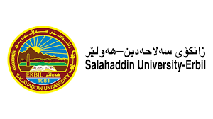

The investigation of Thermal Expansion in Silicon and Copper Materials

Research Project
Submitted to the department of Physics in partial fulfillment of the requirements for the degree of BSc. in Physics

BY:
GAYLAN AHMED KHIDHIR

Supervised By:
DR. AYOUB SABIR KARIM
APRIL– 2023

