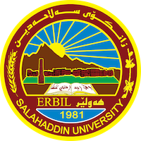
Academic Curriculum Vitae
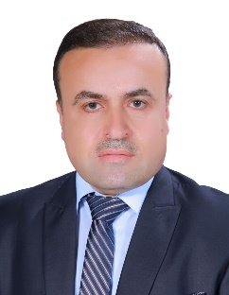
Personal Information:
Full Name: Ayoub Adam Rasoul
Academic Title: Assistant professor
Email: ayoub.rasoul@su.edu.krd
Mobile: 07504667151

Education:
- Salahaddin university- Bachelor's degree in Islamic Studies- 1999- 2000
- Koya University- Master's degree in Interpretation and science of the Qur’an
- Iraqi Sunni Affairs- Alimam Aladham University college- PHD in Interpretation

- Assistant Lecturer - University of Souran- 2009-09-01
- Lecturer- Salahaddin university- 2017-11-27
- Assistant professor- Salahaddin university- 2021-11-28

Employment:
- Course of the Department of Law in the Faculty of Law at Soran University 2009
- Teaching representative at the College of Education - Shaqlawa 2017-2019
- Chairman of the Examinations Committee at the College of Education - Shaqlawa 2021-2022
- Member of the Scientific Committee in the Department of Arabic Language at the College of Education - Shaqlawa 2022-2023
- Chairman of the Quality Assurance Committee of the Arabic Language Department at the College of Education - Shaqlawa 2022-2023

Qualifications
- Teaching Methods Course / Continuing Education Center / Salahaddin University 2010
Teaching experience:
Subjects you studied:
- Personal Status Law Course, Soaran University, Faculty of Law, second stage, 2009-2013
- General Arabic subject, at Suaran University, Faculty of Law, second cycle, 2010-2012
- Exchange course, Salah Al-Din University, College of Education, first stage, 2012-2013
- Morphology, Salahaddin University, College of Education - Shaqlawa, first stage, 2012-2013
- Rhetoric Sciences - Rhetoric and Al-Badi', at Salah Al-Din University, College of Education - Shaqlawa, second stage, 2014-2018
- Rhetoric Sciences - Semantics, Salah Al-Din University, College of Education - Shaqlawa, third stage, 2017-2022
- Subject of the science of interpretation, at Salah al-Din University, College of Education - Shaqlawa, fourth stage, 2017-2018
- Subject of observation and application, at Salah al-Din University, College of Education - Shaqlawa, fourth stage, 2019-2022
Research and publications
- The gnomic interpretation by Abi Bakr Alrazi (666 H 1268 ad) combining ,documenting and comparison studying/ Qalaai Zanist journal/ / Summer 2018
- Sayings Weakened by Ibn Attia Al-Andalusi in his Interpretation of Contrasting with the Place of Revelation - Presentation, Analysis and Study - Surahs and Meccan Verses as a Model / Journal of Literature Al-Rafidain - University of Mosul/ 11-01-2019
- Gharib’s interpretation of the Qur’an according to Ibn al-Sakit (d.: 244 AH) through his book (Islah al-Mantiq), a collection and study - Majalat Tuwer / 01-09-2020
- Reasons for revelation in Tahdheeb al-Lugha by Abu Mansoor al-Azhari (370 AH), compilation, graduation and study / Journal of the University of Garin / 02-06-2021
Conferences and courses attended
- Give details of any conferences you have attended, and those at which you have presented delivered poster presentations.

Funding and academic awards
- List any bursaries, scholarships, travel grants or other sources of funding that you were awarded for research projects or to attend meetings or conferences.
Professional memberships
- Kurdistan Teachers Union
- Member of the teaching staff at Salahaddin University
- Kord zear Organization for Training and Development
Professional Social Network Accounts:

- https://www.researchgate.net/
- https://www.linkedin.com/in/%D8%A3%D9%8A%D9%88%D8%A8-%D8%A7%D9%84%D8%A8%D8%B1%D8%B2%D9%86%D8%AC%D9%8A-065354161/

It is also recommended to create an academic cover letter for your CV, for further information about the cover letter, please visit below link:
https://career-advice.jobs.ac.uk/cv-and-cover-letter-advice/academic-cover-letter/

