Academic Curriculum Vitae
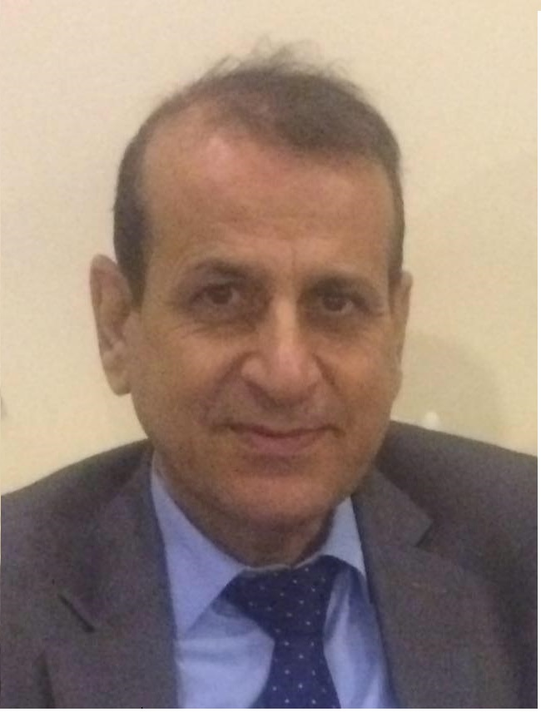
Personal Information:
Full Name: Azad Arshad Abdul-Wahab
Academic Title: Assistant Lecture
Email: (university email) azad.abdulwahab@su.edu.krd
Mobile:0096407504470077

Education:
- 1999 M.Sc. in Urban & Regional Planning -Baghdad University
- 1989 B.Sc. Surveying Engineering -College of Engineering Baghdad Uneversity
Employment:
- (1991-1994) KRA (Kurdistan Relief Association NGO organization for habitat emergency
- (1994-1996) Surveying Engineer -Engineering Division- Slahaddin-Erbil University Presidency
- 1994 -Till now Lecture in Geomatics Department -College of Engineering -Salahaddin -Erbil University

Qualifications
- Teaching qualifications
- IT Office programs, AutoCAD ,Civil 3D ,GIS qualifications
- Language qualifications such as , IELTS equivalent from salahaddin University Language Center
- Field Surveying, GPS application
- English Language Course- salahaddin University Language Center
Teaching experience:
- undergraduate
- Land Law
- Cadastral Surveying
- Basic Surveying Instruments
- Construction Surveying
- Quantity Surveying

Research and publications
1- Evaluation of Road Networks Based on Traffic Accidents in Erbil City
IOP Conference Series: Earth and Environmental Science,
To cite this article: Azad Arshad Abdulwahab 2021 IOP Conf. Ser.: Earth Environ. Sci. 754 012021
2- Optimization of the urban green area in Erbil territory for sustainable development - Periodicals of Engineering and Natural Sciences Original Research
Vol. 11, No. 3, May 2023, pp.203-216-
3- Development of Land Value Algorithm for Establishing an Effective Cadastral System in Erbil City
Heritage and Sustainable Development, Vol. 5, No. 2, August 2023, pp.199-212

Conferences and courses attended
- Prospects of Sustainability of Planning and Cites -The center of Urban & Regional Planning for Postgraduate Studies -Dec-16-17 -2020

Funding and academic awards

Professional memberships
- Kurdistan Engineering Union, ID No. 02153

Professional Social Network Accounts:

https://www.researchgate.net/publication/356713199_Evaluation_of_Road_Networks_Based_on_Traffic_Accidents_in_Erbil_City

ORCID : https://orcid.org/0009-0002-1019-3371

