Meat Analysis - 1
Carcass Fabrication

Carcass fabrication is the process of cutting carcasses into standard wholesale (primal) and retail cuts. The objective of carcass fabrication can be classified into:

- Importance cutting for the butcher
1. Modern cutting increases 30% of profit when comparing with traditionally cutting.
- The Varity of price between meat pieces increases the purchasing capability.

- Importance cutting for the consumer
- Ability of selection meat pieces for consumer.
- Safeguard the rights of consumers from cheating.
Type of cut meat
Cut meat can be divided into ‘noble’ and ‘less noble’ meat.
- The ‘noble’ cuts are those most highly regarded by chefs and gourmets because they have:
- High contents of muscle
- Small amounts of fat, which is on the outside of the meat and so, can be easily removed if unwanted
- Low contents of connective tissue or gristle and none in the form of large, thick pieces
- Small amounts of bone, which can be easily removed.
Meat with these properties is:
- Simple to cook, e.g. by grilling or roasting
- Tender when lightly cooked
- Simple to serve
- Highly priced
- The less noble cuts have the reverse characteristics from those listed above and are more likely to be used for manufacturing. They come mainly from the forequarter, where there are:
- Many and complex moving parts
- A complex bone structure
- Many and smaller muscles

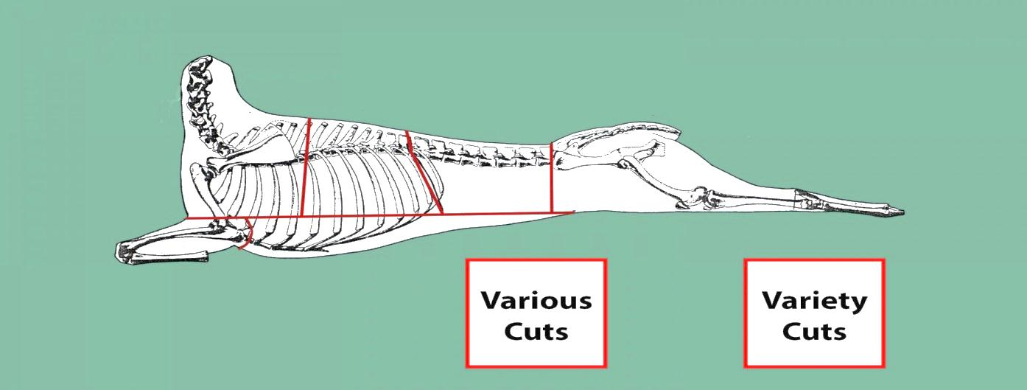

Carcass Fabrication of Lamb
Shoulder
Foreshank
Breast
Neck
Leg
Loin
Ribs

High-Priced Cuts: 1. Loin 2. Rib 3. Leg 4. Shoulder
Low-Priced Cuts: 5. Neck 6. Breast 6. Fore-shank

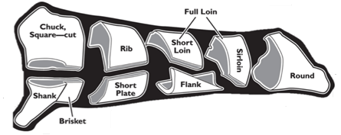
Carcass Fabrication of Beef

DATA SHEET

Name of cut | Intact cut/ tissue | Weight (g) | Percentage of wholesale cut (%)
Leg | Wholesale cut
 | Muscle
 | Fat
 | Bone
Loin | Wholesale cut
 | Muscle
 | Fat
 | Bone
Rib | Wholesale cut
 | Muscle
 | Fat
 | Bone
Shoulder | Wholesale cut
 | Muscle
 | Fat
 | Bone
Neck | Wholesale cut
 | Muscle
 | Fat
 | Bone
Breast | Wholesale cut
 | Muscle
 | Fat
 | Bone
Fore shank | Wholesale cut
 | Muscle
 | Fat
 | Bone
Flank | Wholesale cut
 | Muscle
 | Fat
 | Bone
 | Wholesale cut

