Exp.1: Evaluation of petroleum and its products by distillation

Simple distillation:
Distillation, a method of separation, is the most commonly used method of purification for liquid samples. As part of the distillation process, you will obtain the boiling point range of both components of your mixture. The better your separation, the more accurate your boiling points will be.
Both boiling point and refractive index are physical properties that are used to characterize organic liquids and give some indication of their purity. You will use the boiling points and to assess how well the mixture was separated using each method of distillation.

Boiling point principles:
The boiling points of organic compounds can give important clues to other physical properties. A liquid boils when its vapour pressure is equal to the atmospheric pressure. Vapour pressure is determined by the kinetic energy of molecules. Kinetic energy is related to temperature and the mass and velocity of the molecules. When the temperature reaches the boiling point, the average kinetic energy of the liquid particles is sufficient to overcome the forces of attraction that hold molecules in the liquid state. Then these molecules break away from the liquid forming the gas state.
Molecules which strongly interact or bond with each other through a variety of intermolecular forces cannot move easily or rapidly and therefore, do not achieve the kinetic energy necessary to escape the liquid state. Therefore, molecules with strong intermolecular forces will have higher boiling points. This is a consequence of the increased kinetic energy needed to break the intermolecular bonds so that individual molecules may escape the liquid as gases. The boiling point can be a rough measure of the amount of energy necessary to separate a liquid molecule from its nearest neighbors.
Simple fractional distillation:
Fractional distillation is a method to separate mixtures of liquids with boiling points that are close to each other. It uses the same principles as simple distillation, but it involves the separation of different liquids rather than the isolation of impurities or the most volatile component.
When a solution is distilled in fractions, it passes through a series of redistillations that increase the purity of the final products. The distillation column (condenser) used in a simple distillation is packed with a nonreactive material in order to increase the surface area. This is referred to as a fractionating column. As the liquid is heated, vapor will begin to rise. The vapors condense as they come in contact with the cooler surfaces in the fractionating column. Continued heating of the liquid causes more vapors to rise. The condensed vapors in the column re-vaporize and move up the column. As this process is repeated many times, the component which vaporizes the easiest (lowest boiling point) reaches the top of the column first and is collected in the collection vial. The other components will be collected in order of ascending boiling points.
This process is also useful in separating mixtures with many different liquids. Crude oil, for example, is separated in towers that are 150 feet high. One hundred different components are separated from 200,000 barrels of crude oil per day.
Apparatus:
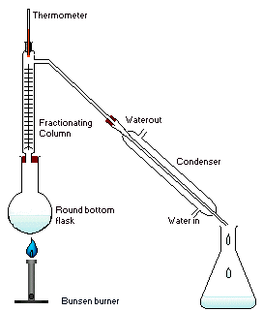
Fractional distillation in a laboratory makes use of common laboratory glassware, as well as some single-purpose items like a fractionating column and "pigs" and "cows" used to cut fractions.
- Heat source, such as a hot plate with a bath.
- Distilling flask, typically a round-bottom flask.
- Receiving flask, often also a round-bottom flask.
- Fractionating column.
- Distillation head.
- Thermometer and adapter if needed.
- Condenser.
- Vacuum adapter (not used in upper right image).
- Boiling chips, also known as anti-bumping granules.
The cut types of petrol can be illustrated as follows
Cut Boiling range
Upper 25- 95
Part (light gasoline)
Naphtha 95 -150
Kerosene 150 – 230
Oil gas 230 – 340
Fractional vacuum distillation:
Is similar to the normal or simple fractional distillation except in this type the fractional column used is big in diameter in order to stabilize the speed of the vapor at vacuum pressure; this pressure generated by using steam rejecters; i.e. the low volatile parts can be distillated without increasing the temperature to the range which leads to the thermal cracking reactions if the process taking part at normal atmospheric pressure, and temperature must not exceed 400Cº.

Super fractionation: this type of distillation has fractional column of higher number of fractional plates to produce pure compounds, this type used for separation of isopentan in high pure percent 90% (aviation gasoline) as well as can be separate isohexane and isoheptane.
The aim of the experiment:
The crude oil can be evaluated by distillation; if the distillation volume percent is high at low temperature i.e this sample is very good economically while, is all distillate components distillate at high temperature 160Cº, i.e. this sample contains heavy compounds or asphalt so it is not good economically and cannot be used as fuel.

Boiling range %volume
60 – 70 6
70 – 80 19
80 – 90 22
90 – 100 25
100 – 130 30
Procedure:
- Set up your fractional distillation apparatus as described above in the figure
- Make sure that all of the joints of your distillation apparatus are tightly sealed.
- Prepare a sample of 50 ml of crude oil and place it in the round bottom flask.
- After preparing all the apparatus, begin to apply heat gradually using oil or sand bath.
- Note the temperature when the first drop of the distillate begin to fall, that’s mean the initial boiling point of the first component.
- Collect the distillate volume form the initial boiling point to 50Cº.
- Continue the distillation and collect the volume for each 50Cº until 400Cº.
- Calculate the volume percents according to this equation
- Vol.%= (volume / 50) * 100

Discussion:
- Make a graph of your Temperature vs. Volume percent data and evaluate the quality of your distillation.

Exp.2: Normal paraffin separation
Petrol nowadays occupy a great part between the different energy sources in the world, that’s because it contain several products in addition of large amounts of natural gas since it exist under earth and under pressure, also it’s availability and simplicity of extraction from earth.
In addition of it characterized by high thermal efficiency in compare with solid fuel, also it’s transportation is easy, for these reasons the production of petrol is developed from the last century.
Petrol contains mainly hydrocarbons in addition of small amounts of inorganic compounds which consist of sulfur, oxygen, nitrogen and other metals, mostly petrol composition specify it’s physical and chemical properties also the quality of it’s products, All hydrocarbon classes are present in the crude mixture, except alkenes and alkynes. This may indicate that crude oils originated under a reducing atmosphere. The following is a brief description of the different hydrocarbon classes found in all crude oils.

Paraffinic hydrocarbons:
It’s formula is (C_{n}H_{2n}+2) and it is a saturated compounds exist in petrol beginning from methane is the principal constituent of natural gas. Methane, ethane, propane, and butane are gaseous hydrocarbons at ambient temperatures and atmospheric pressure. They are usually found associated with crude oils in a dissolved state. to the compounds of carbon atoms (C₄₄) or more, in normal temperature it will be gases (C₁- C₄) or liquids (C₅- C₁₅) or solids starting from hexadecane (C₁₆- C₄₄), . Normal alkanes (n-alkanes, n-paraffins) are straight-chain hydrocarbons having no branches. Branched alkanes are saturated hydrocarbons with an alkyl substituent or a side branch from the main chain. Abranched alkane with the same number of carbons and hydrogens as an n-alkane is called an isomer. For example, butane (C₄H₁₀) has two isomers, n-butane and 2-methyl propane (isobutane). As the molecular weight of the hydrocarbon increases, the number of isomers also increases. Pentane (C₅H₁₂) has three isomers; hexane (C₆H₁₄) has five.
Naphthenes (cycloparaffins) hydrocarbons:
Saturated cyclic hydrocarbons, normally known as naphthenes, are also part of the hydrocarbon constituents of crude oils. Their ratio, however, depends on the crude type. The lower members of naphthenes are cyclopentane, cyclohexane, and their mono-substituted compounds. They are normally present in the light and the heavy naphtha fractions. Cyclohexanes, substituted cyclopentanes, and substituted cyclohexanes like (methylcyclopentane, cyclopentane, methylcyclohexane) are important precursors for aromatic hydrocarbons.
If a naphtha fraction contains these compounds, the first two can be converted to benzene, and the last compound can dehydrogenate to toluene during processing. Dimethylcyclohexanes are also important precursors for xylenes.
Heavier petroleum fractions such as kerosine and gas oil may contain two or more cyclohexane rings fused through two vicinal carbons.

Aromtic hydrocarbons:
Lower members of aromatic compounds are present in small amounts in crude oils and light petroleum fractions. The simplest mononuclear aromatic compound is benzene (C₆H₆). Toluene (C₇H₈) and xylene (C₈H₁₀) are also mononuclear aromatic compounds found in variable amounts in crude oils. Benzene, toluene, and xylenes (BTX) are important petrochemical intermediates as well as valuable gasoline components.
Separating BTX aromatics from crude oil distillates is not feasible because they are present in low concentrations. Enriching a naphtha fraction with these aromatics is possible through a catalytic reforming process.
Binuclear aromatic hydrocarbons are found in heavier fractions than naphtha. Trinuclear and polynuclear aromatic hydrocarbons, in combination with heterocyclic compounds, are major constituents of heavy crudes and crude residues. Asphaltenes are a complex mixture of aromatic and heterocyclic compounds. The nature and structure of some of these compounds have been investigated. The following are representative examples of some aromatic compounds found in crude oils:
(Benzene, Toluene, Xylene, Naphthalene, 1,2-benzopyrene, Tetralin), Only a few aromatic-cycloparaffin compounds have been isolated and identified. Tetralin is an example of this class.
In this experiment an industrial method for n-paraffin separation from the other cycloparaffins, using urea with methanol as activation compound in addition to existence of a solvent like (cyclohexane, isopropanol), with agitating where the n-paraffins enters in the vacancies which is made by urea molecules as a result for the linkage between it’s molecules by a hydrogen bonds, so there is no way for passage of isomers where it stay in the reaction media.
Crude oil contains (naphthenic, n-paraffins which no. of carbon atoms greater than 6, iso-paraffins) so the high percent of n-paraffins in crude oil increase it’s importance.
the urea adduct (additional product) can form (hydrogen bonding) as result fromchannels related with n-paraffins (i.e inter to these channels) which can be then separated through their solubility in hot water to form two phases by using organic solvent to separate n-paraffins to the organic phase.
Iso-paraffins can be separated by using thio urea because of the formation channels is bigger as compared with urea because the outer shell of the sulfur is greater than oxygen which iso-paraffins can enter the channels separated as similar to urea adduct.
Procedure:
  - in a conical flask mixture 10g of urea with 1.5 ml methanol and 10ml of solvent with 10g of from petroleum.
  - Agitate the mixture for one hour in 25Cº.
  - Filtrate the mixture on a Buchner funnel then wash the precipitate using the solvent, where the precipitate contains the n-paraffins.
  - Heat 150ml of distilled water at 60Cº then add the separated urea with n-paraffins and let it until urea dissolves and n-paraffins separated.
  - Transfer them to a separation funnel and shake them well until the n-paraffins are separated from the aqueous solution of urea.
  - Weight the extracted results and determine the percentage.

Exp.3: Separation of aromatic and non aromatic compounds from the high boiling point oils using liquid - solid chromatography

Benzene, toluene, xylenes (BTX), and ethylbenzene are the aromatic hydrocarbons with a widespread use as petrochemicals. They are important precursors for many commercial chemicals and polymers such as phenol, trinitrotoluene (TNT), nylons, and plastics. Aromatic compounds are characterized by having a stable ring structure due to the overlap of the π-orbitals (resonance).
Accordingly, they do not easily add to reagents such as halogens and acids as do alkenes. Aromatic hydrocarbons are susceptible, however, to electrophilic substitution reactions in presence of a catalyst.
Aromatic hydrocarbons are generally nonpolar. They are not soluble in water, but they dissolve in organic solvents such as hexane, diethyl ether, and carbon tetrachloride.
Extraction of aromatics industrially
Benzene, toluene, xylenes (BTX), and ethylbenzene are obtained mainly from the catalytic reforming of heavy naphtha. The product reformate is rich in C₆, C₇, and C₈ aromatics, which could be extracted by a suitable solvent such as sulfolane or ethylene glycol.
These solvents are characterized by a high affinity for aromatics, good thermal stability, and rapid phase separation. The Tetra extraction process by Union Carbide (American company) uses tetra ethylene glycol as a solvent. The feed (reformate), which contains a mixture of aromatics, paraffinic , and naphthenic, after heat exchange with hot raffinate, is counter currently contacted with an aqueous tetra ethylene glycol solution in the extraction column. The hot, rich solvent containing BTX aromatics is cooled and introduced into the top of a stripper column. The aromatics extract is then purified by extractive distillation and recovered from the solvent by steam stripping.

Chromatography:
It is a separation process which depends on differential distribution of the components of the mixture between a mobile bulk phase and an essential thin film stationary phase, the stationary phase may be either in the form of packed column (column chromatography) through which a mobile phase is allowed to flow, or in the form of a thin layer adhering to a suitable form of packing material (thin-layer chromatography) over which the mobile phase is allowed to ascend by capillary action.

Liquid-solid column chromatography:
Separations on a preparative scale employing this technique are generally accomplished by loading the substance on to a cylindrical column of the solid stationary phase, and developing the chromatogram by allowing the liquid mobile phase contained in a suitable reservoir to flow through the column under gravity or under pressure applied to the top of the solvent reservoir.
In this experiment there is a separation for oils which contains a mixture of hydrocarbons which boils between (230-538 Cº), using Liquid-solid column chromatography, where the aromatic part flows with the polar solvent like Ether and in addition to the aromatic compound, it contains compounds having sulphur, oxygen, and nitrogen atoms, while the non-aromatic parts slips with the non-polar solvents like petroleum ether or pentane, and this part contains a mixture of paraffinic and naphthenec hydrocarbons.
The end point for the separation of aromatic compounds can be specified by using oil drop test or refractive index test for separated compounds.
Procedure:
- Prepare a glass column and put in its end a little amount of glass wool then fill it by silica gel (100-200 mesh) which activated, in the oven at 160Cº for 8 hours then cover it by the glass wool and fix the column by stand.
- Add to the column 30ml of petroleum ether at (40-60 Cº) for the saturation of the stationary phase with solvent, then weight 5g of oil and dilute it by 25ml of petroleum ether, add the solution to column.
- Collect the displaced liquid from the end of column in weighted dry beaker then evaporate the solvent and weight the rest (A).
- To specify the separation end point between the aromatic and non aromatic compounds, put a drop from the displaced liquid on a filter paper and note the spot after evaporation of solvent, this indicate that the separation of the non aromatic compounds in ended and it is the beginning of aromatic separation, or by the refractive index test where it is 1.474 for non aromatics, (1.5-1.6) for aromatics.
- Removal of the rest oil (aromatics) from the column with 100ml of di-ethyl ether which collected in a weighted dry beaker, then solvent evaporated in a water bath and the rest is weighted (B).
- Calculation:

Percent of aromatics & non aromatics = (gross weight (A+B) / sample weight)* 100
Percent of non-aromatics in extract= (weight of A / sample weight)*100
Percent of aromatics in sample = (weight of B / sample weight)*100

Exp.4: Determination of molecular weight of petroleum using viscosity method

Viscosity is a measure of the resistance of a fluid to deform under either shear stress or extensional stress. It is commonly perceived as "thickness", or resistance to flow. Viscosity describes a fluid's internal resistance to flow and may be thought of as a measure of fluid friction.
Viscosity is divided in to two types:
1- Dynamic (absolute) viscosity (µ):
It is the tangential force on unit area of either of two parallel planes at unit distance apart when the space between the planes is filled with the fluid and one of the planes moves relatively to the other with unit velocity in it’s own plane.
The cgs (centimeter-gram-second) physical unit for dynamic viscosity is the poise (P), It is more commonly expressed, particularly in ASTM standards, as centipoise (cP). The centipoise is commonly used because water has a viscosity of 1.0020 cP (at 20 °C).
1 P = 1 g·cm⁻¹ ·s⁻¹= dyne s/cm² = 1/10 Pa s

2- Kinematic Viscosity (ν)
It is the ratio of absolute or dynamic viscosity to density - a quantity in which no force is involved. Kinematic viscosity obtained by dividing the absolute viscosity of a fluid with its mass density as: ν = μ / ρ
Where ν = kinematic viscosity μ = absolute or dynamic viscosity ρ = density
Kinematic viscosity has SI units (m².s⁻¹). The cgs physical unit for kinematic viscosity is the stokes (abbreviated S or St), It is sometimes expressed in terms of centistokes (cS or cSt). In U.S. usage, stoke is sometimes used as the singular form.
1 stokes = 100 centistokes = 1 cm² ·s⁻¹ = 0.0001 m² ·s⁻¹
1 centistokes = 1 mm² /s

Viscometer:
A viscometer (also called viscosimeter) is an instrument used to measure the viscosity of a fluid. For liquids with viscosities which vary with flow conditions, an instrument called a rheometer is used. Viscometers only measure under one flow condition, viscometer types are:
1- U-tube viscometers:
These are also known as Ostwald viscometers or glass capillary viscometers. They basically consist of a glass tube in the shape of a U held vertically in a controlled temperature bath.
2- Falling Sphere Viscometers:
In these the fluid is stationary in a vertical glass tube. A sphere of known size and density is allowed to descend through the liquid. If correctly selected, it reaches terminal velocity, which can be measured by the time it takes to pass two marks on the tube.
3- Vibrating viscometers:
Vibrating viscometers are rugged industrial systems used to measure viscosity in the process condition. The active part of the sensor is a vibrating rod. The vibration amplitude varies according to the viscosity of the fluid in which the rod is immersed.
4- Rotation viscometers:
Rotational viscometers uses the idea that the torque required to turn an object in a fluid, can indicate the viscosity of that fluid. The common Brookfield-type viscometer determines the required torque for rotating a disk or bob in a fluid at known speed.
5- Stormer viscometer:
The Stormer viscometer is a rotation instrument used to determine the viscosity of paints, commonly used in paint industries. It consists of a paddle-type rotor that is spun by an internal motor, submerged into a cylinder of viscous substance.

In this experiment the kinematic viscosity of oil is determined using U-tube viscometer at 100 and 210 Fº (37.78 and 98.89 Cº) a function H of the 100 Fº viscosity is established by reference to a tabulation of H function versus 100 Fº viscosity, the H value and the 210 Fº viscosity are then used to estimate the mean relative molecular mass from a correlation chart.

Procedure
- Prepare a U-tube viscometer and fix it in a temperature controlled water bath.
- Take a sample of oil and put it inside the viscometer and adjust the bath thermometer to 100 Fº.
- Measure the time taken by the oil to move between the two marks of viscometer.
- Apply the following equation to calculate the kinematic viscosity:
ν = kt where k = viscometer constant t = time measured.
- Repeat the above steps for temperature of 210 Fº.
- Look in table 1 for 100 Fº viscosity and read the value of H correspond to the measured viscosity.
- Read the viscosity-mean relative molecular mass chart for H and 210 Fº viscosity, to find the accurate molecular mass value.

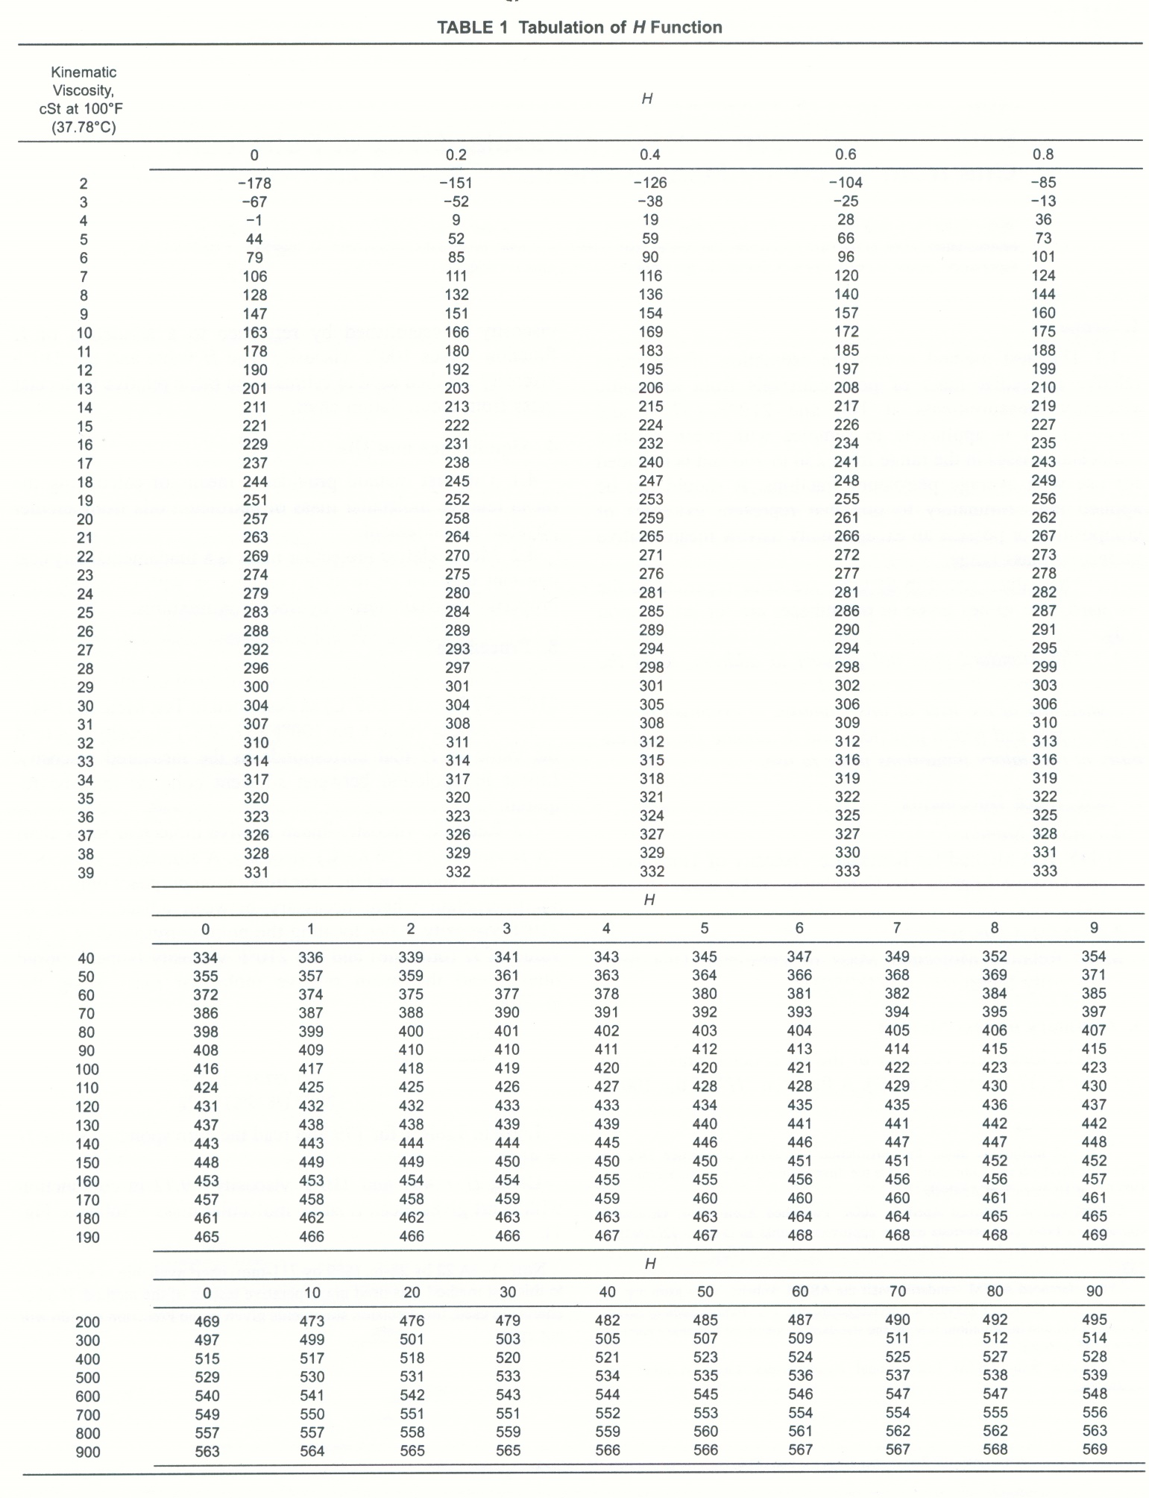

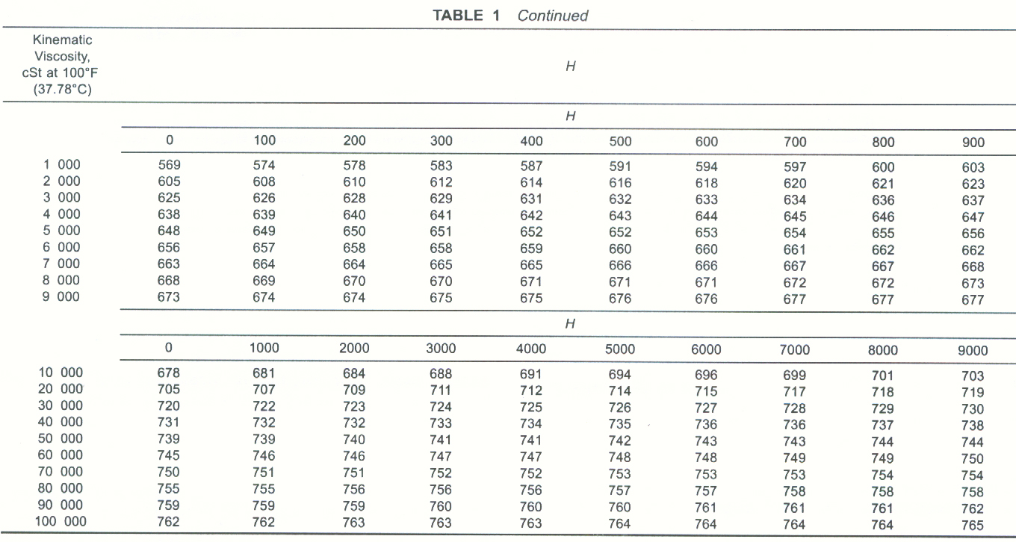

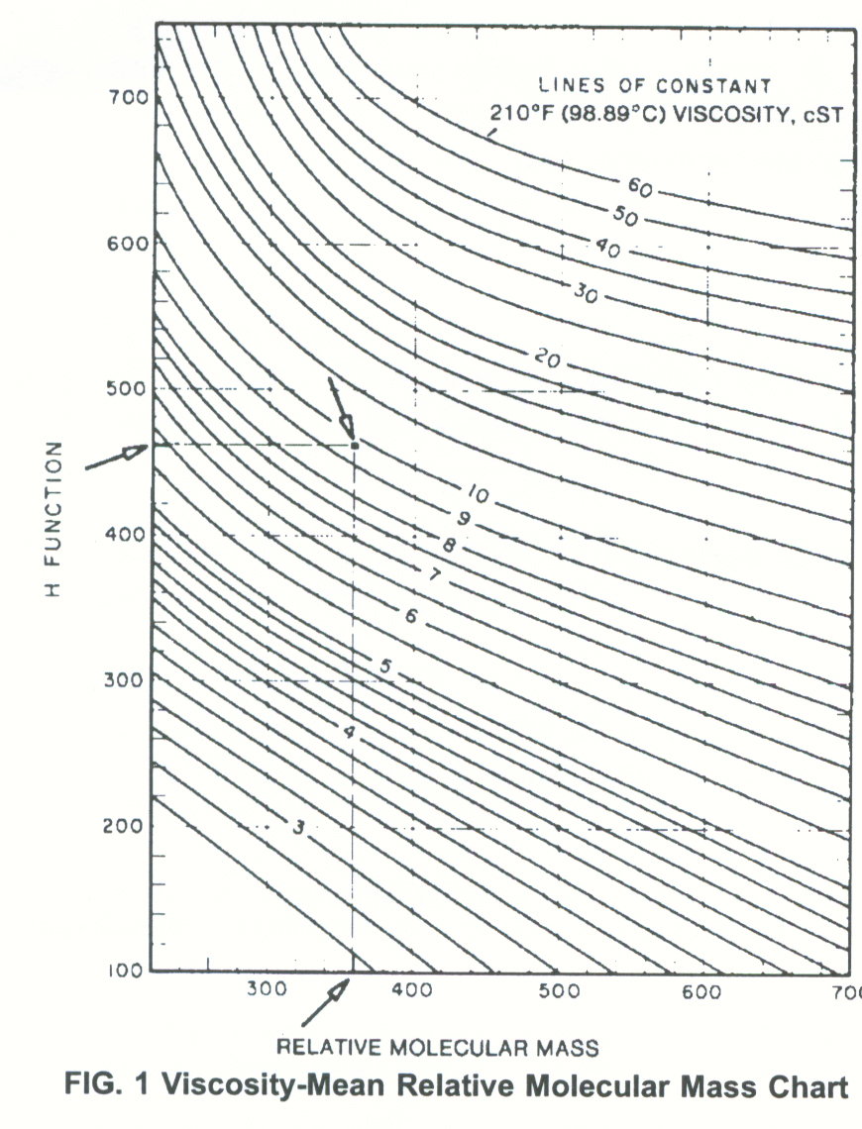

Exp.5: Analysis of compound group of petroleum using
(n-d-M) method

This test method covers the calculation of the carbon distribution and ring content of olefin-free petroleum oils from measurements of refractive index, density and molecular weight (n - d - M).
The Refractive Index (n) - of a medium is a measure for how much the speed of light is reduced inside the medium. The speed of light in a medium can be expressed as v = c / n
Where v = speed of light in the medium
c = speed of light in air or vacuum - approximately 3x10⁸ meters per second
n = refractive index

Density (d): is mass (m) per unit volume (V) — the ratio of the amount of matter in an object compared to its volume. A small, heavy object, such as a rock or a lump of lead, is denser than a larger object of the same mass, such as a piece of cork or foam. In the common case of a homogeneous substance, density is expressed as:
ρ = m/v
Where, in SI Units: ρ (rho) is the density of the substance, measured in kg·m ^{–3}
m is the mass of the substance, measured in kg
V is the volume of the substance, measured in m ³

Molecular weight calculation: it may be calculated in different methods like estimation it by viscosity measurement or by using freezing point depression, which it is described as phenomenon that the freezing point of a liquid (a solvent) is depressed when another compound is added, meaning that a solution has a lower freezing point than a pure solvent. This happens whenever a solute is added to a pure solvent, such as water. The phenomenon may be observed in sea water, which due to its salt content remains liquid at temperatures below 0°C, which it is the freezing point of pure water.

as illustrated in the following scheme

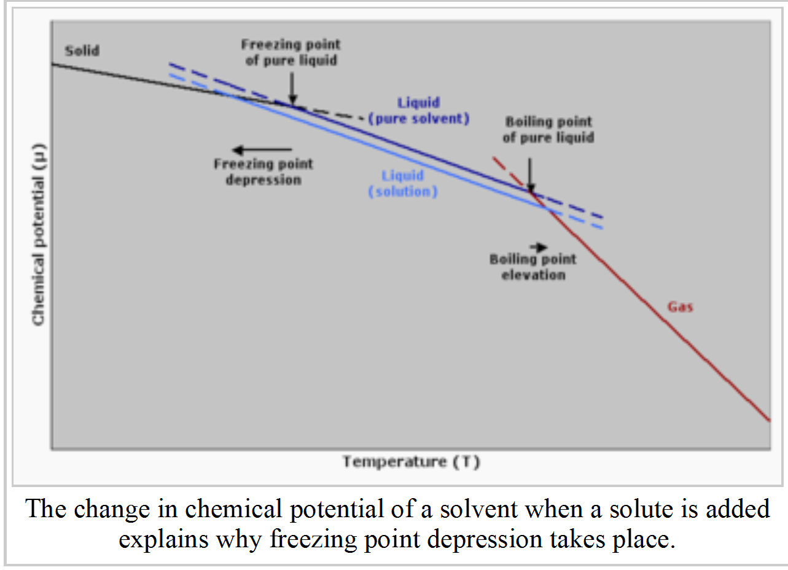

The composition of complex petroleum fractions is often expressed in terms of the proportions of aromatic rings (RA), naphthene rings (RN), and paraffin chains (CP) that would comprise a hypothetical mean molecule. Alternatively, the composition may be expressed in terms of a carbon distribution, that is, the percentage of the total number of carbon atoms that are present in aromatic ring structures (% CA), naphthene ring structures (% CN), and paraffin chains (% CP).
Significance of experiment:
The carbon distribution and ring content serves to express the gross composition of the heavier fractions of petroleum, these data can be used to as an adjunct to the bulk properties in monitoring the manufacture of lubricating oil base stock by distillation, and in comparing the composition of stocks from different crude sources.
Illustration for calculation purposes:
% C_{A} Percentage of Aromatic Carbon
% C_{N} Percentage of Naphthenic Carbon
% C_{P} Percentage of paraffinic Carbon
R_{A} Average Number of aromatic rings per Molecule
R_{N} Average Number of naphthene rings per Molecule
R_{T} Average Number of rings per Molecule
The mass % Sulfur must be determined in order to calculate values for R_{T} and R_{N}. The n-d-M and Sulfur content are determined by the following:
Refractive Index at 20°C (n)
Density at 20°C (d)
Average Molecular Weight (M)
Sulfur Content (mass %)

Procedure:
- Determine the refractive index and density of the oil sample at 20 Cº.
- Determine the molecular weight experimentally using freezing point depression or estimate it from the viscosity measurement at 100 and 210 Fº.
- Calculate the carbon distribution (% C_{A}, % C_{N}, % C_{P}) or the ring analysis R_{A}, R_{N} using these data as described in the calculation section.

Calculation:
- Calculate the factors ν and w from the observed density (d) and the observed refractive index (n) using the following equations:
v = 2.51(n_{D}²⁰ – 1.475) – (d₄²⁰ – 0.851)
w = (d₄²⁰ – 0.851) – 1.11(n_{D}²⁰ – 1.475).
- Calculate the percentage of aromatic carbons (%C_{A}) from v and the molecular weight (M) using one of the following equations:
If v is positive: %C_{A}= 430 v + 3660/M
If v is negative: %C_{A}= 670 v + 3660/M
- Calculate the percentage of carbon in total (aromatic and naphthenic) ring structures (%C_{R}) from w and the molecular weight.
If w is positive %C_{R} = 820 w – 3S + 10000/M
If w is negative %C_{R} = 1440 w -3S + 10600/M
Where S = mass % sulphur. (m of S=0.001)
- Calculate the percentage of naphthenic carbon (%C_{N}) and the percentage of paraffinic carbon (%C_{P}) as follows:
%C_{N} = %C_{R} - %C_{A}
%C_{P} = 100 - %C_{R}
- Calculate the average number of aromatic rings per molecule (R_{A}) from v and the molecular weight.
If v is positive R_{A} = 0.44 + 0.055 M v
If v is negative R_{A} = 0.44 + 0.080 M v
- Calculate the average total number of rings per molecule (R_{T}) from w and the molecular weight.
If w is positive R_{T} = 1.33 + 0.146 M (w – 0.005 S)
If w is negative R_{T} = 1.33 + 0.180 M (w – 0.005 S)
- calculate the average number of naphthene rings per molecule (R_{N}) by difference
R_{N} = R_{T} – R_{A}

