Exp.6: Determination of water content of petroleum and petroleum products

This method determines the water content of crude petroleum, greases, cutback bitumen, asphalt, and of petroleum products whose final boiling points are not less than 300 Cº by distillation using Dean and Stark apparatus.

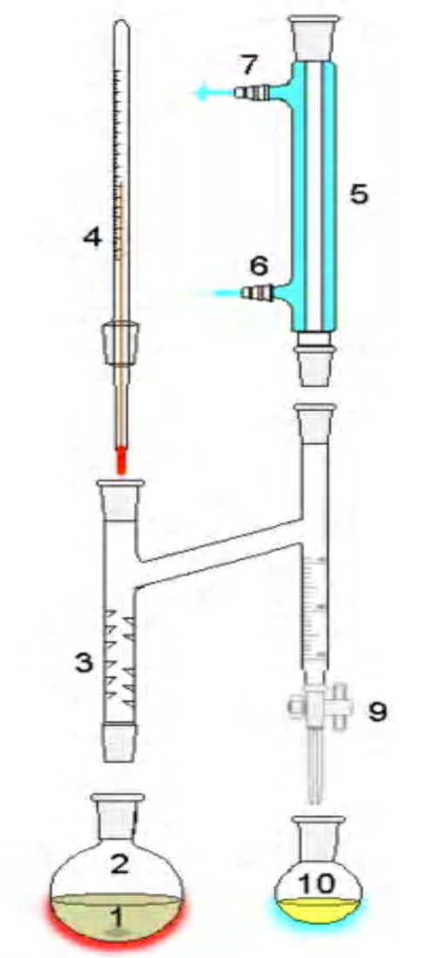
The Dean-Stark apparatus or Dean-Stark receiver or distilling trap is a piece of laboratory glassware used in synthetic chemistry to collect water (or occasionally other liquid) from a distillation flask. It is used in combination with a reflux condenser and a batch flak for continuous removal of the water.

1: Stirrer bar/anti-bumping granules
2: Still pot
3: Fractionating column
4: Thermometer/Boiling point temperature
5: Condenser
6: Cooling water in
7: Cooling water out
8: Burrette
9: Tap
10: Collection vessel

The Dean-Stark apparatus in the laboratory typically consists of vertical cylindrical piece of glass (the trap, above (9) in figure), often with a volumetric graduation on its full length and a precision tap on the bottom very much like a burette. The top of the cylinder is a fit with the bottom of the reflux condenser (5). Protruding from the top the cylinder has a side-arm sloping toward the distillation flask (2). At the end the side-arm makes a sharp turn so that the end of the side arm (3) is vertical as well. This end connects with the reactor.

The material to be tested is heated under reflux with a water-immiscible solvent, which is co-distilled with the water in the sample, condensed solvent and water are continuously separated in a trap, the water settling in the graduated section of the trap and the solvent returning to the still.

Significance of experiment:
Knowledge of the water content of petroleum products is important in the refining, purchase, sale, and transfer of products.
The amount of water as determined by this test method may be used to correct the volume involved in the custody transfer of petroleum products and bituminous materials, also it is specified in the contracts.

Solvent carrier liquid
A solvent – carrier liquid appropriate to the material being tested shall be used, different types of solvent – carrier liquid are used in this test like:
- Aromatic solvent like xylene, toluene and mixture of xylene and toluene
- Petroleum distillates, available from most chemical companies under the name of Stoddard solvent or ligroine.
- Volatile spirits solvent, like petroleum spirit, iso-octane

Procedure:
- Measure 100 ml of the sample into the distillation flask and add 100 ml of solvent – carrier liquid.
- When testing solid or semi-solid materials, weight 100g of the sample or 50g if it is a lubricating grease, and place it in the distillation vessel together with 100ml of solvent – carrier liquid.
- Assemble the apparatus as described in the above figure.
- Heat the flask and regulate the heating so that the condensate falls from at a rate of (2-5) drops per second.
- Continue heating the sample until the volume of water in the receiver remains constant for 5 minutes.
- When the volume of water remains constant remove the heat source and allow cooling to room temperature, record the total volume of water.
- calculate the percent of water by:
Volumetric percent of water = (vol. of condensed water) / (total vol. of sample) * 100

Exp.7: Determination of specific gravity of petroleum and petroleum
Products using pyknometer method

This method covers the determination of the specific gravity or density crude petroleum and petroleum products using pyknometer, it is used when great accuracy is required, or when as for solids or viscous liquids the hydrometer is not suitable.

Specific gravity: it is the ratio of the mass of a given volume of liquid at 60 ºF to the mass of an equal volume of pure water at the same temperature.

Pycnometer or Pyknometer
A device used for measuring fluid density, also known as a specific gravity bottle. Uses an appropriate working fluid such as water or mercury to find a volume for use in laboratory principle.
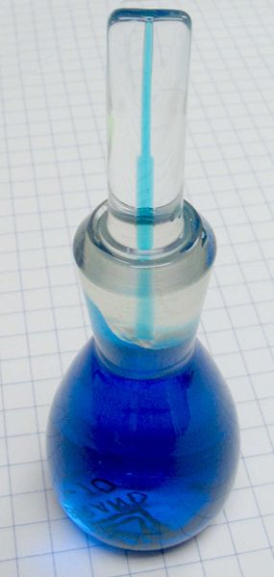
It consist of flask with a close-fitting ground glass stopper with a fine hole through it, so that a given volume can be accurately obtained. This enables the density of a fluid to be measured accurately, by reference to an appropriate working fluid such as water or mercury, using an analytical balance.
If the flask is weighed empty, full of water, and full of
a liquid whose specific gravity is desired, the specific
gravity of the liquid can easily be calculated.
The particle density of a powder, to which the usual
method of weighing cannot be applied, can also be
determined with a pycnometer. The powder is added to
the pycnometer, which is then weighed, giving the weight of
the powder sample. The pycnometer is then filled with a liquid of known density, in which the powder is completely insoluble. The weight of the displaced liquid can then be determined, and hence the specific gravity of the powder.

Procedure
  - Weight the clean and dry pycnometer.
  - Fill the pyknometer with the sample, bring the pyknometer and it's content to the test temperature (T₁) by immersing the pyknometer up to it's neck in the constant temperature bath for (20) minute in order to stabilize the temperature, assist filling and permit air bubbles to rise to the surface.
  - When the temperature is constant, firmly insert the capillary stopper, which has also been brought to the test temperature taking care to avoid trapping air bubbles below the stopper.
  - Remove the pyknometer from the bath and cool it to the room temperature.
  - Clean the pyknometer from outside and weigh it.
  - Calculate the specific gravity using the following equation.
Specific gravity T₁/60 ºF = (W₂- W₁)/W + C
Where:
W₁= weight of empty pyknometer.
W₂= weight of pyknometer with sample.
W= water equivalent of pyknometer at 60 ºF.
C= air buoyancy correction, obtained from table I.
  - calculate the API gravity using the following equation:
API _{gravity} = (141.5/sp.gr 60/60 ºF) – 131.5

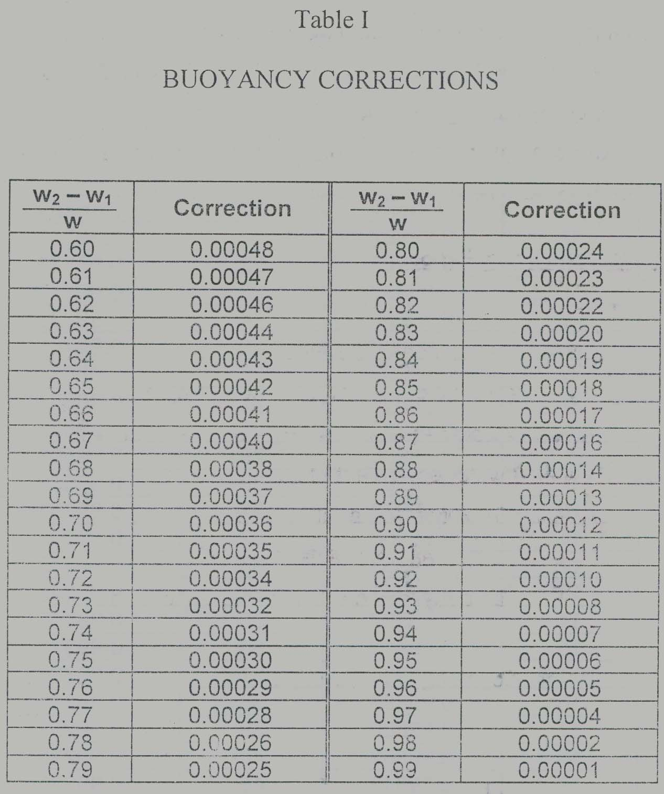

Exp.8: Determination Aniline point and Diesel index

Petroleum and petroleum products are mixed with several organic solvents like benzene and toluene in normal temperature but in some solvents like aniline, mixing done in a specified temperature and it depend on the aniline percent.

Aniline point
The minimum temperature for a complete mixing of aniline and materials such as gasoline; it is also called the point temperature," which is the lowest temperature (°F or °C) at which equal volumes of aniline (C₆H₅NH₂) and the oil form a single phase.
The aniline point (AP) correlates roughly with the type of aromatic hydrocarbons in an oil sample. A product of high aniline point will be low in aromatics and naphthenic and, therefore, high in paraffinic, a low AP is indicative of higher aromatics, Diesel oil with AP below 120°F [49°C] is probably risky oil-base mud.
The aniline point may be used to calculate the diesel index and heat of combustion for aviation fuels.

Diesel index
A measure of the ignition quality of diesel calculated from a formula involving its gravity and its aniline point.

Procedure
- Prepare the apparatus as in the figure
- Take 5ml of sample (crud oil, kerosene, gasoil) and 5ml of aniline in the test tube.
- Heat the mixture by water bath with stirring until complete miscibility is obtained.
- Remove the apparatus and let the solution to cool.
- Record the temperature when the mixture is separated in two layers, which is the aniline point.
- Determine the diesel index for the sample using the relation:

Diesel index = (aniline point * API) / 100

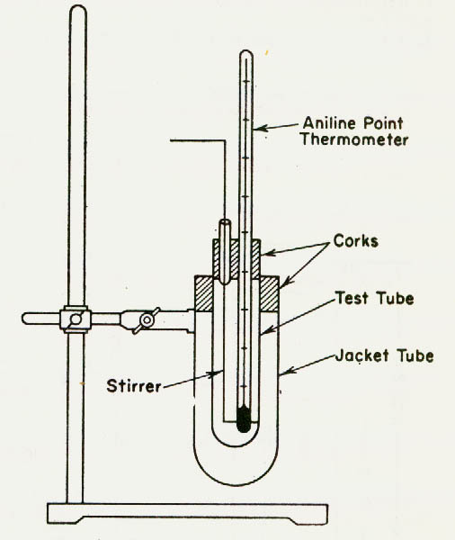

or 100 (RON).
In this experiment the device
used is a very advanced octane analyzer portable device depends on the infrared technology to analyze different types of gasoline and diesel as in the following procedure:

Procedure:
1) Switch power to ON. The display will show the version number followed by a 15-second countdown, after which "Clear Chamber and Press Measure" will appear.
2) Make sure there is no sample holder in

Exp.9: Flash Point by Cleveland Open Cup

The flash point of a flammable liquid is the lowest temperature at which it can form an ignitable mixture in air, or the lowest temperature at which application of an ignition source causes the vapors of a specimen of the sample to ignite under specified conditions of test.
The fire point is defined as the temperature at which the vapour continues to burn for at least 5 seconds after being ignited.

Measuring flash points
There are two basic types of flash point measurement: open cup and closed cup. In open cup devices the sample is contained in an open cup which is heated, and at intervals a flame is brought over the surface. The measured flash point will actually vary with the height of the flame above the liquid surface.
Closed cup testers, are sealed with a lid through which the ignition source can be introduced periodically. The vapour above the liquid is assumed to be in reasonable equilibrium with the liquid. Closed cup testers give lower values for the flash point (typically 5-10 °C) and are a better approximation to the temperature at which the vapour pressure reaches the lower flammable limit (LFL).

This experiment is a flash point and fire point test method is a dynamic method and depends on definite rates of temperature increases to control the precision of the test method. Its primary use is for viscous materials having flash point of 79°C (175°F) and above. It is also used to determine fire point, which is a temperature above the flash point, at which the test specimen will support combustion for a minimum of 5 s.

Significance and Use
- The flash point is one measure of the tendency of the test specimen to form a flammable mixture with air under controlled laboratory conditions.
- Flash point is used in shipping and safety regulations to define flammable and combustible materials.
- Flash point can indicate the possible presence of highly volatile and flammable materials in a relatively nonvolatile or nonflammable material.

Procedure:
- Fill the test cup with the sample so that the top of the meniscus of the test specimen is exactly at the filling mark, and place the test cup on the center of the heater.
- Light the test flame and adjust it to a diameter of 3.2 to 4.8 mm (1⁄8 to 3⁄16 in.) or to the size of the comparison bead.
- Apply heat initially at such a rate that the temperature as indicated by the temperature measuring device increases 14 to 17°C/min. When the test specimen temperature is approximately 56°C (100°F) below the expected flash point, decrease the heat so that the rate of temperature rise during the last 28°C before the flash point is 5 to 6°C/min.
- Apply the test flame when the temperature of the test specimen is approximately 28°C below the expected flash point and each time thereafter at a temperature reading that is a multiple of 2°C. Pass the test flame across the center of the test cup at right angles to the diameter, which passes through the temperature measuring device.
- Record, as the observed flash point, the reading on the temperature measuring device at the time the test flame causes a distinct flash in the interior of the test cup.

Exp.10: Pour point test of petroleum products

The pour point of a liquid is the lowest temperature at which it will pour or flow under prescribed conditions. It is a rough indication of the lowest temperature at which oil is readily pumpable. Also, the pour point can be defined as the minimum temperature of a liquid, particularly a lubricant, after which, on decreasing the temperature, the liquid ceases to flow.

Measuring the pour point of petroleum products
The specimen is cooled inside a cooling bath to allow the formation of paraffin wax crystals. At about 9 ºC above the expected pour point, and for every subsequent 3 ºC, the test jar is removed and tilted to check for surface movement. When the specimen does not flow when tilted, the jar is held horizontally for 5 secs. If it does not flow, 3 ºC is added to the corresponding temperature and the result is the pour point temperature.

Significance and Use
The pour point of a petroleum specimen is an index of the lowest temperature of its utility for certain applications.

Procedure:
- Pour the specimen into the test jar to the level mark.
- Close the test jar with the cork carrying the high-pour thermometer.
- See that the disk, gasket, and the inside of the jacket are clean and dry. Place the disk in the bottom of the jacket. Place the gasket around the test jar, 25 mm from the bottom. Insert the test jar in the jacket. Never place a jar directly into the cooling medium.
- Pour points are expressed in integers that are positive or negative multiples of 3°C. Begin to examine the appearance of the specimen when the temperature of the specimen is 9°C above the expected pour point (estimated as a multiple of 3°C).
- Continue in this manner until a point is reached at which the specimen shows no movement when the test jar is held in a horizontal position for 5 s. Record the observed reading of the test thermometer.
- Add 3°C to the temperature recorded in previous step and report the result as the Pour Point.

Exp.11: Octane number measurement
The Octane Number, is a measure of the antiknock quality of petrol - the ability of a petrol to resist knocking upon combustion in an engine. Knocking is a description of the sound that an engine makes when it runs on a too low octane fuel, and it causes a drop in fuel efficiency.
Or it is the Measure of the ignition quality of gasoline or petrol. Higher this number, the less susceptible is the gas to 'knocking' when burnt in a standard internal combustion engine. Octane number denotes the percentage (by volume) of iso-octane in a combustible mixture (containing iso- octane and normal-heptane) whose 'anti-knocking' characteristics match those of the gasoline being tested.

In 1927, Graham Edgar suggested a test method to quantify the knocking behavior of a fuel. Edgar proposed the use of two fuels: n- heptane and 2,2,4-trimethyl pentane (iso-octane); fuels with a low and a high antiknocking value respectively.
Any commercial fuel that was available on the market at that time could be compared in knocking behavior to blends of these two compounds. The introduction of reference fuels lead to the design of various test engines and test conditions. Nowadays, the most commonly used test methods are the Research Octane Number (RON), and the Motor Octane Number (MON). The Research Octane Number settings represent typical mild driving, without consistent heavy loads on the engine. While The conditions of the Motor Octane Number method represent severe, sustained high speed, high load driving. For most hydrocarbon fuels, including those with either lead or oxygenates, the Motor Octane Number will be lower than the Research Octane Number.

*Research Octane Number (RON)
RON is determined in a single cylinder variable compression ratio engine that operates at 600 RPM with a 125o F inlet air temperature at standard barometric pressure. The procedures and hardware for the RON test were originally developed in 1931. The hardware was revised in 1948 with procedural changes made until the late 1960s.
*Motor Octane Number (MON)
MON is determined in a single cylinder engine similar to the RON engine with a few changes that make operating conditions more severe and therefore the octane numbers are lower. The MON engine runs at 900 RPM with a 300o F mixture temperature.
In most countries (including all of Europe and Australia) the "headline" octane rating, shown on the pump, is the RON, but in the United States, Canada and some other countries the headline number is the average of the RON and the MON, sometimes called the Anti-Knock Index (AKI), Road Octane Number (RdON), Pump Octane Number (PON), or (R+M)/2. Because of the 8 to 10 point difference noted above, the octane shown in the United States is 4 to 5 points lower than the same fuel elsewhere: 87 octane fuel, the "regular" gasoline in the US and Canada, is 91-92 in Europe. However most European pumps deliver 95 (RON) as "regular", equivalent to 90-91 US (R+M)/2, and some even deliver 98 (RON) the sample chamber. Cover the chamber with the light shield.
3) Press the MEASURE key to standardize the instrument. "Put in sample" will appear on the display. This indicates the instrument has been standardized: it is now ready to measure octane.
4) Remove the light shield from the sample chamber.
5) Place the sample holder containing gasoline in the sample chamber, being careful to align the alignment stripe on the jar with the left alignment stripe on the instrument.
6) Carefully replace the light shield over the jar. This shield must always be used when measuring a gasoline sample or a standard; otherwise, the results will be incorrect.
7) Press MEASURE. “Remove & Replace” will be displayed.
8) Remove the jar and rotate it to align the stripe on the jar with the right alignment stripe on the instrument.
9) Carefully replace the light shield over the jar.
10) Press MEASURE. “Remove & Press M” will be displayed.
11) Remove the jar and cover empty chamber with light shield. Press MEASURE. The results will appear in the display while they are printed.

Exp.12: Carbon Residue and Ash Content Determination
Carbon Residue:
Carbon residue is a measure of the amount of material left after evaporation and pyrolysis of crude oil and provides some indication of the relative coke-forming propensity. The residue formed is not composed entirely of carbon but is a coke, the composition of which can be changed by further pyrolysis. which is designated by CR. Therefore, heavier fractions with more aromatic contents have higher carbon residues while volatile and light fractions such as naphthas and gasolines have no carbon residues. CR is particularly an important characteristic of crude oils and petroleum residues. Higher CR values indicate low-quality fuel and less hydrogen content.

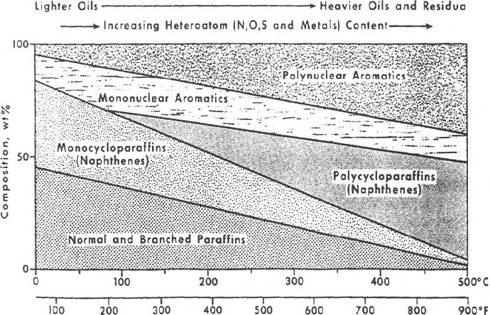

While ash results from non-combustible extraneous solids such as dirt and rust present in a crude oil. Normally there is a close correlation between a crude oil's ash content and its sediment content. In use of crude oil as a fuel, it is important to know its ash content, as this can be related directly to particulate emissions.
Oils that have ash forming compounds have erroneously high carbon residues by both Carbon Residue methods. For such oils ash should be removed before the measurement.
In most cases carbon residues are reported in wt% by Conradson method, which is designated by %CCR.
Carbon residue can be correlated to a number of other properties. It increases with an increase in carbon-to-hydrogen ratio (CH), sulfur content, nitrogen content, asphaltenes content, or viscosity of the oil. The most precise relation is between CR and hydrogen content in which as hydrogen content increases the carbon residues decreases. The hydrogen content is expressed in terms of H/C atomic ratio and the following relation may be used to estimate CCR from H/C
%CCR = 148.7 - 86.96 H/C
if H/C _> 1.71 (%CCR < 0), set %CCR = 0.0 and if H/C < 0.5 (%CCR > 100), set %CCR = 100. H/C.
The carbon residue is nearly a direct function of high boiling asphaltic materials. One of the main characteristic of residuum is its asphaltene content. Asphaltenes are insoluble in low molecular weight nalkanes including n-pentane. Knowledge of n-pentane insolubles in residual oils is quite important in determining yields and products qualities for deasphalting, thermal visbreaking, and hydrodesulfurization processing. The relation between the normal pentane insoluble and carbon residue is as follows
%NCs = 0.74195 (%CCR) + 0.01272 (%CCR) 2
Where %NC5 is the wt% of n-pentane insoluble and %CCR is the wt % of Conradson carbon residue.
Once %NCs is known, the asphaltene content (asphaltene wt%) of a residue can be determined from the following empirical relation:
%Asphaltene = a(%NCs)
Where a is 0.385 for atmospheric residue and 0.455 for vacuum residues.
A weighed quantity of sample is placed in a crucible and subjected to destructive distillation. The residue undergoes cracking and coking reactions during a fixed period of severe heating. At the end of the specified heating period, the test crucible containing the carbonaceous residue is cooled in a desiccators and weighed. The residue remaining is calculated as a percentage of the original sample, and reported as Conradson carbon residue.
Procedure:
1-Weigh to the nearest 5 mg a 10-g sample of the oil to be tested, free of moisture and other suspended matter, into a tared porcelain or silica crucible containing two glass beads about 2.5 mm in diameter. Place this crucible in the exact center of the larger iron crucible. Apply covers to the iron crucible,and allow free exit to the vapors as formed.
2- On a suitable stand or ring, place the bare Nichrome wire triangle and on it the insulator. Next center the sheet-iron crucible in the insulator with its bottom resting on top of the triangle, in a hood in order to distribute the heat uniformly during the process.
3-Apply heat with a high, strong flame from the gas burner, so that the pre-ignition period will be 10 6 1.5 min. When smoke appears above the chimney, immediately move or tilt the burner so that the gas flame plays on the sides of the crucible for the purpose of igniting the vapors. Then remove the heat temporarily, When the vapors cease to burn and no further blue smoke can be observed, readjust the burner and hold the heat as at the beginning so as to make the bottom and lower part of the sheet-iron crucible a cherry red. The time periods shall be observed with whatever burner and gas is used.
4- Remove the burner and allow the apparatus to cool until no smoke appears, and then remove the cover of the crucible (about 15 min). Remove the porcelain or silica crucible with heated tongs, place in the desiccators, cool, and weigh. Calculate the percentage of carbon residue on the original sample.

