**Lecture -2-**

**Classification of Honey bees:-**

Honey Bees belong to the animal kingdom, Phylum Arthropoda, Order Hymenoptera; class Insecta, Super family Apoidea, family Apidae, genus *Apis*. The genus *Apis* is divided into several species and sub-species/ races but the 5 main species are: *Apis dorsata* (Giant Wild Honeybee), *Apis laboriosa* (Rock Honeybee), *Apis florea* (Dwarf Honeybee), *Apis cerana* (Indian Honeybee) and *Apis mellifera* (International Honeybee).

**Different Species of Honey Bees:**

There are about 22 thousand species of bees in the world that live to feed on flowers, and only nine species are recorded as honey-collecting bees and there are five well known species of true honey bees (belonging to genus *Apis*) in the world:

**1***-Apis dorsata* F. (Giant bee)

**2***-Apis laboriosa* F. (Rock bee)

**3***-Apis florea* F. (Little bee)

**4***-Apis cerana* F. (Indian bee)

**5***-Apis mellifera* L. (European bee)

**Characteristics of five well known species of honey bees:**

|  |  |  |  |  |  |
| --- | --- | --- | --- | --- | --- |
| Characteristics | *Apis dorsata* | *Apis laboriosa* | *Apis florea* | *Apis cerana* | *Apis mellifera* |
| Size | Largest honeybee | Largest honeybee | Small size | Medium size | Medium size |
| Nest builds | Single large open comb on high branches of trees | Single large  open comb  on rock | Single small combs in  bushes and hedges | Several parallel combs in cavities of tree, trunks and mud walls | Several parallel combs in cavities of tree, trunks and mud walls |
| Swarming | Strong tendency | Strong tendency | Strong  tendency | Strong tendency | Only in African sub species |
| Temperament or Mood | More  ferocious | More ferocious | Mild Ferocious | Mild  ferocious | Gentle except African sub species |
| Breeding | wild bees cannot domesticate | wild bees cannot domesticate | wild bees cannot domesticate | Hive bees can domesticate | Hive bees easily domesticate |
| Average honey yield per colony/year | Large quantity | Large quantity | Little quantity | Medium quantity | Enough amount  20- 45 kg |

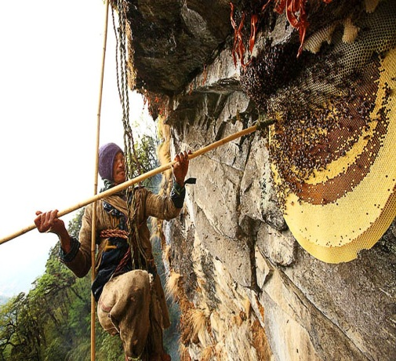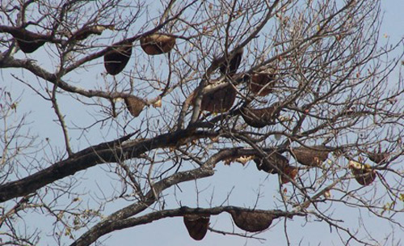 *Apis laboriosa Apis dorsata*

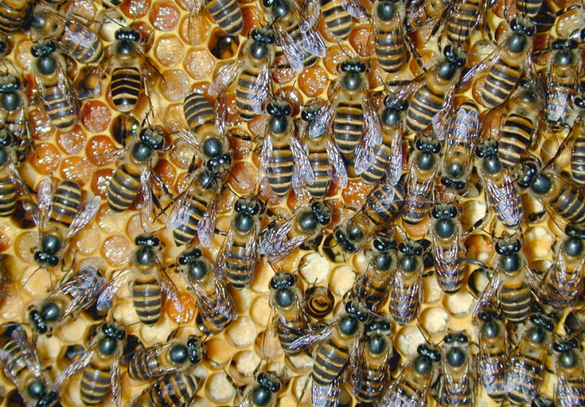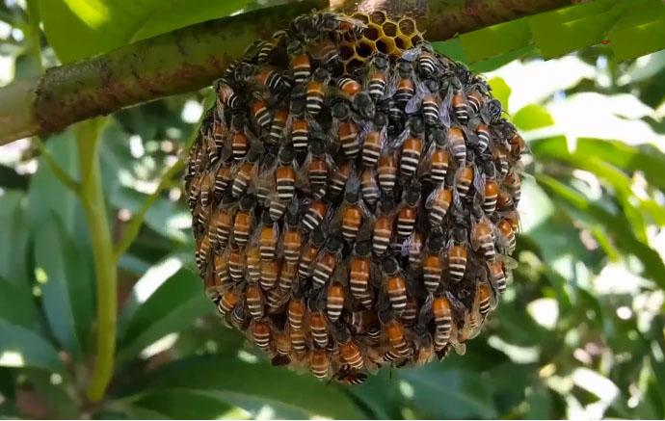

*Apis florea Apis cerana*

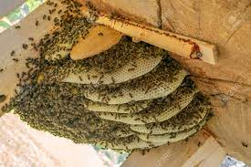

*Apis mellifera*

**Races of Honeybees**:

Before identifying the races of honeybees, the basics and main characterizes are used to recognizing between different races should be identified. They are basic genetic features; the most important of which are:

**1. Colour:** Each race is characterized by a special colour that distinguishes it from other races. The colour of the abdomen segments varies between yellow and black.

**2.** **The Length of the Tongue:** The races differ from each other in the length of their tongues. For example, the length of the Carniolanworker tongue is 6.35 mm. But in Medaworker is 5.3 mm.

**3.** **Size:** This can be noticed by the naked eye. For example, the races spreading in North Africa are characterized by their small sizes, while those spreading in North Europe by their large sizes.

**4. Hairs:** The lengths of the hairs that cover the Bees body it changes in the different races and according to that the colour and density.

**5.** **Veins of Wings:** This is the most distinguishing feature by which the different races and species of bees can be distinguished.

**6.** **The Shape and Size of Wax Glands:**  It changes from one race to another.

**7. The Number of Hooks:** These are hooks on the forward edge of the hind wing. They differ in number according to the races.

**Species and Subspecies/Races of Honey Bees:**

It is important to know difference between a species and subspecies. Species are reproductively isolated from each other and these cannot interbreed. But Subspecies are geographically isolated and can interbreed.

Among the two domestic bee species, each has many subspecies in different parts of the world e.g. *Apis cerana* has four subspecie

1- *Apis cerana cerana*

2- *Apis cerana indica*

3- *Apis cerana himalaya*

4- *Apis cerana japonica*

**International Races of Honeybees in the World According to the Geographical Location:**

Generally, the races of the international honeybee (Apis mellifera) can be divided into three groups

**1. Eastern races**

**2. European races**

**3. African races**

The races can be dividing in to three types according to colours:

**1. Yellow bees group**: It is available in the Mediterranean basin including Egyptian, Syrian, Turkish and Italian bee.

**2. Dark bees group:** They are found in South Eastern Europe and Caspian Sea area including Carniolan bees and Caucasian bees.

**3. Black bees group**: They are found in North Western Europe and in North Africa including Netherland, German, England, Swedish, French and North Africa bees.

**1- Eastern races:**

1. ***Apis mellifera meda***(North of Iraq, North of Iran)

**1.** Yellow colour and the Drones colours are darker.

**2.** Aggressive, tend to swarm and to collect propolis.

**3.** Tolerates cold winter.

**There are two types of this race**:

**1.** Sheepish with somehow light yellow colour. Being quiet and tend to rob.

**2.** Wild (goatish) with dark colour and aggressive low production.

1. ***Apis mellifera yementica***(*jementica*)
2. ***Apis mellifera syriaca***(in Syria, Israel and Lebanon)

**2- European races:**

1. ***Apis mellifera mellifera***( German bee) They are characterized by:
2. Having a dark to black colour with the existence of small yellow spots

on the second and third abdominal terga.

**2.** Aggressive having tendency to swarm and robbing.

**3.** Little production.

**4.** Having a short tongue 5.7-6.4mm.

**5.** Sensitive to brood diseases especially the European foul brood,

chalk brood diseases and wax moths.

1. ***Apis mellifera carnica***(Carniolan bee; in Southern Austria)

characterized by:

**1.** A grey colour and being the quietest bee race. Tolerate to severe cold.

**2.** Collecting larger amounts of honey due to their long tongue 6.4 - 6.8mm.

**3.** Queen active in laying eggs and having a black colour.

**4.** Not robbing and not tending to collect propolis.

**5.** Low tending to swarm and having low resistance to paralysis and Nozima disease.

Carniolan bees come second in terms of spread and importance after Italian bees as it spreads now all over the world.

1. ***Apis mellifera ligustica***(Italian bee) They are characterized by

**1**.Quiet and having the ability to toleration severe cold.

**2**. Having a golden yellow colour and the existence of yellow strips on the first two abdomen segments or the first four segments.

**3**. Distinguished in collecting honey as the length of their tongue is 6.3-6.6mm.

**4**. Having a queen that is active in laying eggs.

**5**. Able to defend its colony against robbing. But having the defect of tending to robbing and less tendency to swarm.

**6.** Not tending to gather propolis. Having resistant to the European foul brood disease and wax moth.

1. ***Apis mellifera******caucasica***(Caucasican bee) They are characterized by

**1.** Attractivegrey colour.

**2**. Quiet and tolerate cold temperatures.

**3.** Good collector of honey and the length of the tongue is **7.2**mm.

**4.** The queen is very active in laying eggs.

**5.** Having low tendency to swarm, but having tendency to rob and collect more propolis and sensitive to be infected by Nosema disease.

1. ***Apis mellifera anatolica***They come from Turkey an characterized by

**1.** A large size worker that has a dark orange or yellow colour.

**2.** Quiet and producing large amounts of honey and tolerate to severe cold.

**3.** The queen active in lays eggs.

**4.** Having low tendency to swarm and collecting propolis.

1. *Apis mellifera adami*
2. *Apis mellifera Cypria*
3. *Apis mellifera armenica*

**3- African races:**

1. ***Apis mellifera lamarckii***(Egyptian bee) characteristics by

**1.** They have a grey black colour and the fluffs that cover the body are wide with the availability of yellow and white strips on the abdomen segments.

**2.** Aggressive and tend to swarm.

**3.** Good at collecting honey.

**4.** The queen is active in laying eggs has a reddish bronze colour and the end of its abdomen is pointed.

1. ***Apis mellifera capensis***(Cape bee) Cape Town city in South Africa characteristics by

**1.** Having a dark colour and small size.

**2.** Quiet having a long tongue.

**3.** The worker has Spermathica that is free of sperms.

**4.** In case the queen is lost, one of the workers lay unfertilized eggs that grow and develop into females from which the colony can breed a new queen.

**5.** The worker that lays eggs has the ability to produce queen substance which leads to the inactivation (inhibition) of the growth of ovaries of other workers.

1. ***Apis mellifera adansonii***(African bee; also known as killer bee) include the states of Senegal, Mali, Niger and Tanzania: They are characterized by

**1.** A very small size.

**2.** A semi-yellow colour, and have few hairs.

**3.** Highaggressive they are called killer bees and were imported to Brazil and adapted to the hot conditions there.

1. ***Apis mellifera intermissa***( Morocco and Lybia)

**The *Apis* races have the following general characteristics:**

**1.** All races are social insects. The total number of members in the whole nest ranges between 25000 to 80000 members.

**2.** The colony has one queen. The queens are rearing (breeding) for the purpose of change or swarming.

**3.** All species control the temperature of the brood nest.

**4.** Honey is stored over the area where the broods are kept.

**5.** The internal anatomy and the physiological aspects are identical.

**6.** The way of gathering nectar and changing it to honey is the same. The same applies to pollen storing.

**7.** Mating takes place outside the hive.

**8.** All species have the same dancing language but it is not completely of the same form.

**9.** The system of pheromone is the same but there are some minor differences.

**10.** Some diseases infect all these species and transfer among them just like varroa mite.

The international honeybee (*Apis mellifera*)is the best of these species in producing honey under all circumstances. It is also the best pollination of crops due to its ability to adapt in the agricultural environment.

**Standard Characteristics that should be Available in the Productive Race of Honeybees:**

**1**. The queen should be active and starts laying eggs early.

**2**. The workers should have high ability to collect nectar and pollen.

**3.** Workers do not tend to lay eggs (laying workers).

**4.** Workers do not tend to gather larger amounts of propolis.

**5.** The bees should be quiet in nature.

**6.** Workers regularity in building wax combs and cells.

**7.** Defend the hive to protect it from enemies.

**8.** Tolerate very difficult environmental conditions.

**9.** Resist diseases and do not tend to swarm.