**Lecture -3-**

**Apiary Site Selection:**

We live in our house located in a village or town. Similarly, bee lives in beehive which is located in an apiary. Thus, an apiary is a place where beehives are placed and managed to allow maximum food gathering by bees. It is also termed as “bee yard”. The nectar flow in an area at a particular time is dependent on the plant species of the locality and weather conditions. Hence, the selection of site is very important to ensure regular flow of nectar by bee colony. While as a beekeeper you can do few efforts to enhance the nectar flow. A good management of bee colony may be one of the important efforts. It is recommended to maintain strong colonies at the time of maximum nectar flow to maximize honey production.

**Apiary** – The location and total number of hives at one place or is the place where the bee colonies are kept.

**Locating an Apiary:**

You must carefully select the area where you can locate your hives. The selected site should be close to your house for easy and regular supervision. There are several factors you should consider while selecting a site to place beehives. Few are as follows:

* Apiary should be located in areas of sufficient sources of nectar and pollen yielding plants. Bees usually forage within a 2-3 km radius of their hives, so make sure there are food sources within that radius.
* The site should be dry without dampness. High relative humidity will affect bee flight and ripening of nectar.
* Easy access to an apiary site throughout the year, with a hard path down to the apiary.
* Apiary should be established away from roads and other busy places.
* A flat site is easier to place hives.
* Apiary should not be located in animal grazing areas because beehives may be toppled.
* The site should receive sun rays in morning and evenings and shade during hottest part of the day.
* The site should be sheltered from wind, so that foragers don’t struggle to land at the hive entrance and the roof stays on. A hedge provides good cover against the wind.
* Clean fresh running water should be available in the apiary or nearby apiaries.
* Dense foliage cover can make hives too wet and cold; however some shade in the afternoon helps the bees to work less to cool the hive or even dying from heat exhaustion or collapsing honey combs. Hence, avoid placing hives under dense foliage.
* Enclose the apiary with a barrier of some sort, such as a hedge or fence to force the bees to fly in above head height.
* Avoid establishment of apiaries in poor drainage areas and heavy pesticide use areas.
* Keep the area around the hives clear of tall weeds or grass. Cut grass and weeds – don’t use spray of any kind.
* The distance between two hives should be at least 3 meters.
* An apiary should not have more than 25-40 hives. If too many hives are placed into an apiary the bee colonies compete with each other.
* Facing the hive entrance to the East is the best way to get the most work out of bees as they usually fly from morning until early afternoon. If the bees see the sun early, they will start work earlier.

****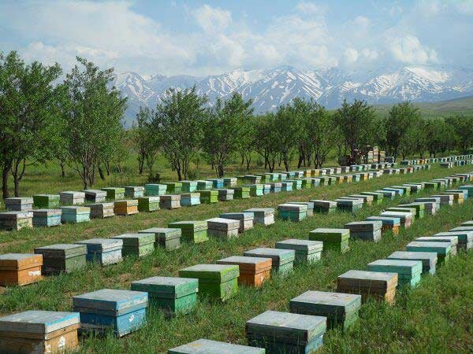

Apiary site selection

**Apiary Management:**

**1-Management of Colonies: The general apiary management practices you should follow in an apiary**.

1. **Colony Inspection:** Inspect the beehives at least once in a week during the honey-flow seasons preferably during the morning hours to observe the presence of healthy queen, brood development, storage of honey and pollen, presence of queen cells, bee strength, growth of drones and presence of bee enemies like wax moth, mites and diseases.
2. **Cleaning in Beehive:** Clean hive in the following sequence: roof, super chamber, brood chambers and bottom board. Use thin knife to scrape and destroy eggs of wax moth laid in slits or cracks of beehive.
3. **Feeding Bees with Sugar Syrup:** Provide sugar syrup (1 part sugar and 1 part water) to feed bees during dearth period. Feed all the colonies in the apiary at the same time to avoid robbing particularly in dearth period.
4. **Addition of Artificial Comb Foundation Sheets:**

Using comb foundation sheets has a number of advantages-

* Comb foundation sheet saves the bee’s time and energy in building new combs.
* It helps in production of straight regular combs which are easy to handle and fits well in honey extractor.
* Combs are stronger and will not be damaged during migration.
* Drone production in a hive can be minimized as the foundation sheets does not have the larger cells needed for drone rearing. When the bees want to rear drones, they adapt the foundation and make larger cells.
* Providing artificial comb foundation sheet in empty frame during honey flow period reduces strain on honeybees for construction of combs.

1. **Bee Swarming and its Management:**

* Control of Swarming.
* Collecting Swarms.

1. **Uniting Bee Colonies:**
2. **Avoid Spraying of Pesticides when Crop is in Blooming:**

Many pesticides are extremely toxic to honey bees and other beneficial insects. Honey bees are attracted to blooming flowers of all plant species. If at all possible do not spray blooms directly with pesticides for pest management. If the pesticide needs to be sprayed, apply it in the evening hours.

1. **Extraction of Honey:**

The combs, which are completely sealed or two-third capped may be taken out for extraction of honey and returned to supers after honey extraction.

**2- Seasonal Management:**

1. **Honey Flow Season Management (Spring Management):**

* Provide more space for honey storage by giving artificial comb foundation sheets.
* Place queen excluder sheets in between brood and super chamber to confine the queen to brood chamber to prevent egg laying in super chamber as it is meant for honey production.
* Prevent swarming.
* Prior to honey flow, use sugar syrup to stimulate the queen to start laying in the spring.
* Divide strong colonies into 2-3 new colonies, if colony multiplication is required.
* Artificial queen grafting technique may be followed to produce new queens for new colonies. By following this technique, queens can be produced throughout the year. In normal case queen cells are constructed only in honey flow season.

1. **Summer Management:**

* To reduce the effect of high temp in summer the colonies are kept under shade of trees or shade provided with sheds.
* Place gunny bags on all sides of beehive except entrance and sprinkle water twice a day.
* Increase ventilation by introducing a splinter between brood and super chamber.
* Provide sugar syrup and pollen supplement.
* A source of fresh water within a short distance of an apiary is essential. Water is required to blend with the food and to lower the temperature of the hives during hot weather.

1. **Winter Management:**

* Strong colonies perform well in winter as more bees produce heat.
* All cracks crevices and holes should be closed.
* The direction of hives should be in such a way to avoid winds entering.
* Artificial diet should be given to maintain strong and disease free colonies.
* Provide new queen to the hives.
* Winter packing in cooler areas.

1. **Rainy Season/Monsoon Management:**

* A regular examination of the colony immediately after rains.
* Clean the hive to reduce undue water contents inside the hive.
* While raining when bees are confined to the hive, feed them with sugar syrup.