**Lecture -7-**

**Honey Bee Language:-**

**Dances of Honey Bees:**

The Father Spitzner in 1788 who for the first time described bee dances as method of communication among inmates of the hive about volume of honey flow and place of source of nectar. These observations remained unnoticed till Frisch (1920) published his observations. Karl von Frisch got noble prize in 1973 (under physiology and medicine, who shared it with two other animal behaviourists) on the basis of his work published in 1946.

**Types of dances:** In honey bees there is a well-developed recruitment system to increase foraging efficiency. Some of the foraging force (5-35%) acts as scout bees/searcher bees. These bees may travel many kilometers. Average foraging radius of a colony is only few hundred metres in agricultural areas and about 2km in forested areas. Scouts communicate distance, direction and quality of flowers through different types of dances which in turn results in recruitment of other workers to forage on the best available sources. The forager bees perform two types of dances.

**1- Round Dance**

This type of dance is performed if food source is nearby (within100 metres in case of *A. mellifera* and 10 metres in *A. cerana*). The performing bee takes quick short steps and runs around in narrow circles on the comb; once to right and then left and then repeating for several seconds. The dance excites the bees and they touch the performer with their antennae and then leave the hive in search of source of food. In this dance there is no indication of direction of food and the foragers search within 100 metres in all direction using floral odour clinging to hairy body of scout bee as cue as well as from the sips of nectar which they receive from the dancing bee.

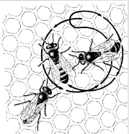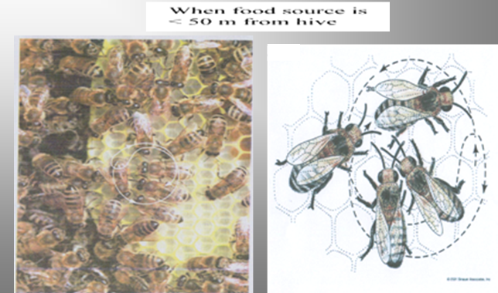

**2-Wag-Tail Dance (Waggle Dance)**

This dance is performed when the distance of food source is more than 100 metres from the hive. In this dance the bee starts dancing on the comb making a half circle to one side and then takes a sharp turn and runs in a straight line to starting point. Thereafter takes another half circle on the opposite direction to complete one full circle. Again the bee runs in a straight line to the starting point. In the straight run the dancing bee makes wiggling motion with her body that is why this dance is known as wag-tail dance. Location of food is

indicated by direction of straight run in relation to line of gravity. If the food is in line with the sun, bee wag-tails upwards and if away from the sun, it performs downwards If the food source is to the left of the sun the bees dance at an angle counterclockwise to the line of gravity whereas, if it is to the right of the sun the bees dance to the right of the line of gravity.



**Direction indication in wag-tail dance when food is in the direction of sun.**



**Dance when food is away from direction of sun.**



**If food is to the left of the sun, bee dances at an angle counterclockwise to the line of gravity.**

 If food is to the right of the sun, bee dances to the right of the line of gravity.

**The distance is indicated by the number of straight runs per 15 seconds as given below:**

|  |  |
| --- | --- |
| Distance of food from hive  (metres) | Number of straight runs/15 sec. |
| 100 | 9-10 |
| 600 | 7 |
| 1000 | 4 |
| 6000 | 2 |

**ROBBING AND ABSCONDING:**

**Absconding:** Is an entire colony of bees that abandons the hive because of disease, wax moth, excessive heat or water, lack of resources, or other reasons.

**Robbing:**  Is stealing of food store by bees from other colonies.

**What causes robbing?**

1- Exposure of colonies for long duration during examination

2- Exposed sugar syrup or its spillage near apiary

3- Careless feeding of weak colonies

4- Robbing is more during lean period when there is little nectar in the field.

**How can we identify robber bees?**

1- Robber bees become smooth, shiny and dark coloured due to repeated attack of guard bees.

2- Robbing bees generally do not alight at the hive entrance boldly and face the guard bees with fear. They try to sneak in the hive through cracks and crevices.

**Prevention of robbing:** For an attentive beekeeper robbing is not a problem. Following precautions are needed:

1- Never leave combs of honey exposed and examine the colonies quickly during dearth period.

2- During feeding avoid spillage of sugar syrup near apiary.

3- Take special care of weak colonies while feeding, since these are prone to robbing. Try to make weak colonies strong by uniting weaker ones. Feed such colonies in the evening.

4- Do not keep honey combs exposed after honey extraction. These combs are given back to the colonies only in the evening when foraging activity has stopped.

**Control of robbing:** If inspite of taking precautions the robbing is prevalent, manage colonies in the following manner:

1- Reduce the entrance of the colony and close all other cracks and crevices

2- Place wet grass in front of entrance of colony being robbed

3- Sprinkling of repellents like carbolic acid or kerosene at hive entrance will also discourage robbing

4- The colonies being robbed badly may be shifted to new site in the apiary after reducing entrance and throwing green grass at the hive entrance.

**Absconding:** It is desertion in which the whole colony leaves the hive. *Apis cerana* is more prone to absconding than *Apis mellifera*.

**Causes:**

1- Shortage of food reserves

2- Attack of bee enemies

3- Too much disturbance and handling.

**Prevention:**

1- Keep colonies strong and ensure that each colony has at least 5kg of food stores

2- Avoid broodlessness in the colonies. If a colony is broodless, provide 1-2 frames of young healthy brood.

3- Check the colonies for diseases and attack of bee enemies. Manage colonies accordingly.