**Lecture-4-**

**II. Wax Foundation Fixing Tools.**

Wax foundation sheets are made of pure bee wax embossed with the bases hexagonal cells for bees to build their comb on. For fixing foundation the following tolls are needed:-

1. Frame.

2- Wire.

3- Spur Embedder or Electric wire Embedder.

4- Embedding (fixing) Board.

5- Waxmelter.

6- Wire Crimper.

7- Frames Cleaner.

**1-Frames.**There is two types of frame, wooden and plastic frame rectangle in shape. Each wooden frame consists of top bar, two side bars and grooved bottom bar.

**2-Wire.** Is made of stainless steel resistant to rust before fixing the foundation need to prepare your frame by wiring it. Adding wire to the frame helps to:-

* Give the wax foundation strong and support.
* Prevent the honey comb from sagging in the middle of the frame.

**3- Embedders**.

A-Spur Embedder: It is made of metal gear with wooden handle and used for embedding the frame wire into wax foundation by rolling the wheel up the wire.

B-Electric Embedder: This device is used with the 12 volt transformer heat horizontal the frame wire and embeds with foundation.

4-**Embedding (fixing) board**: It is a sheet of wood its size equal to inside frame size. It used for fixing the wax foundation in the frame when we use the spur embedder.

**5**-**Waxmelter**: It used for melting wax then use to fixing wax founding on the frame and use for making wax cups for queen rearing in Doolittle method.

6-**Wire crimper**: It is crimping tool with plastic handle and two wheels. Placed on the completed wire, grip tight then pull along the wire and tighten in one movement makes wiring frames curly to strong and support wax foundation.

7-**Frames cleaner**: stainless steel tool with swan neck use for clean the grooves of frames from wax, dirt and propolis.

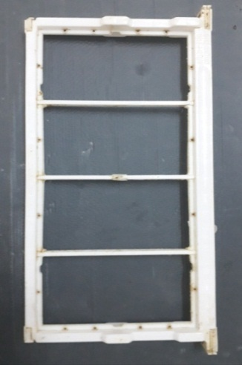

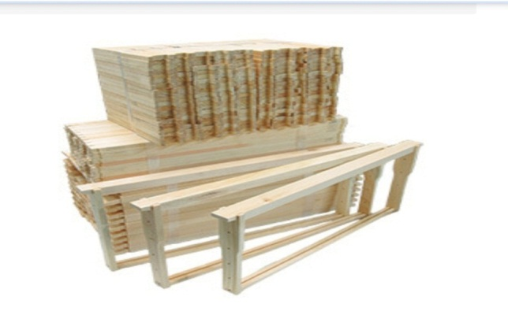

Top bar

Wooden frame

Plastic frame

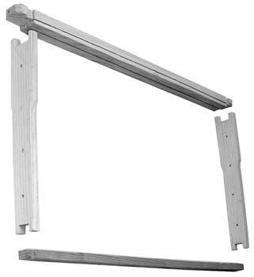

Side bar

Grooved bottom bar

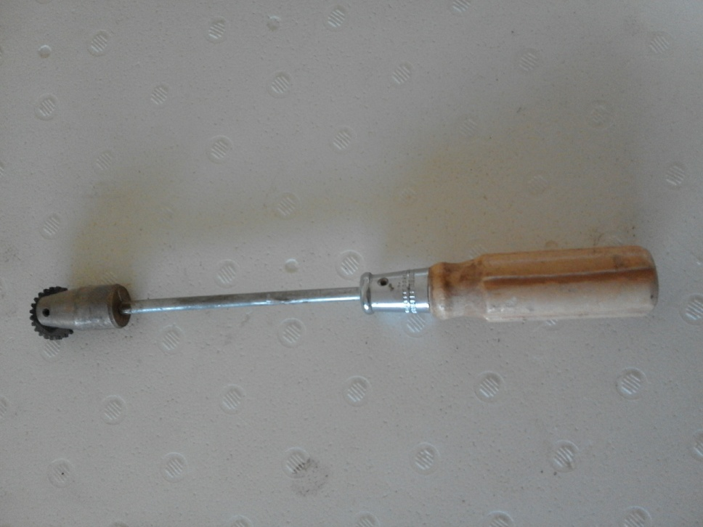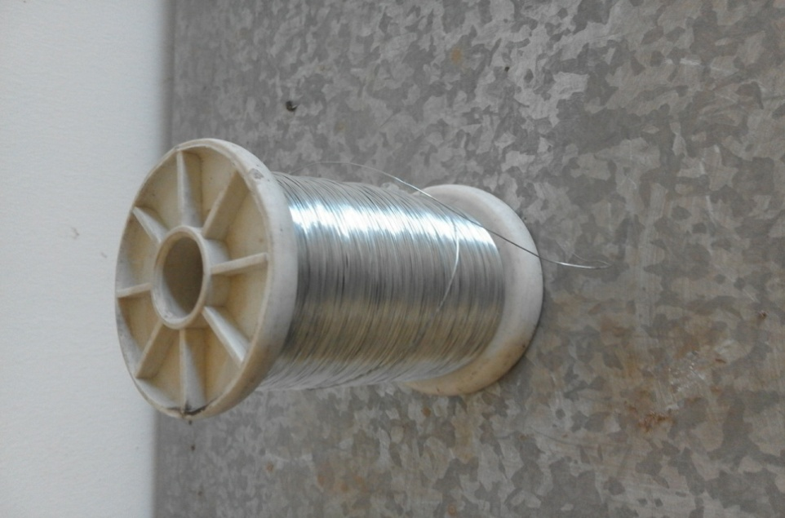

**Wire**

**Embedder**

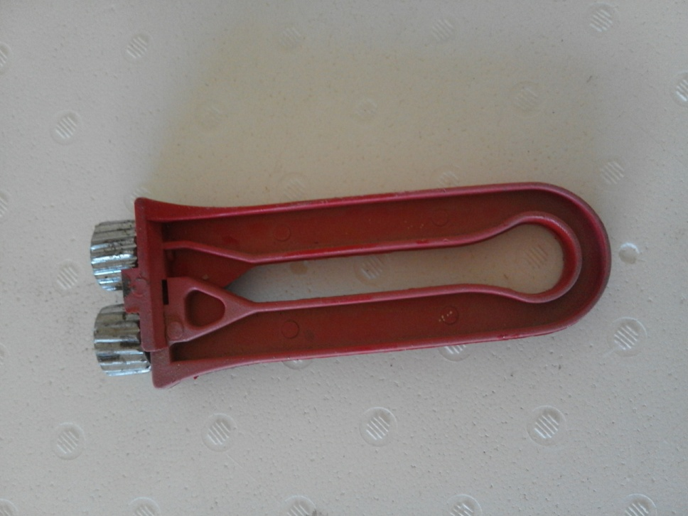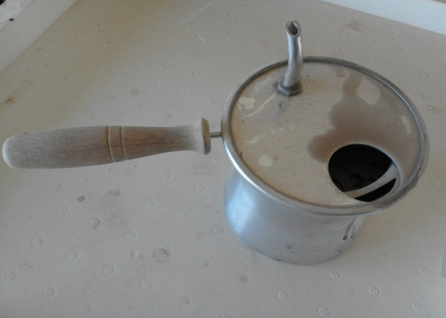

**Waxmelter**

**Wire crimper**

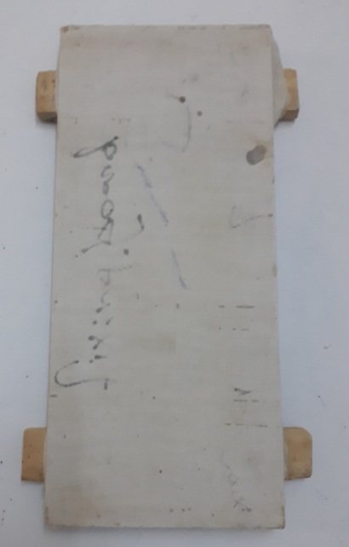

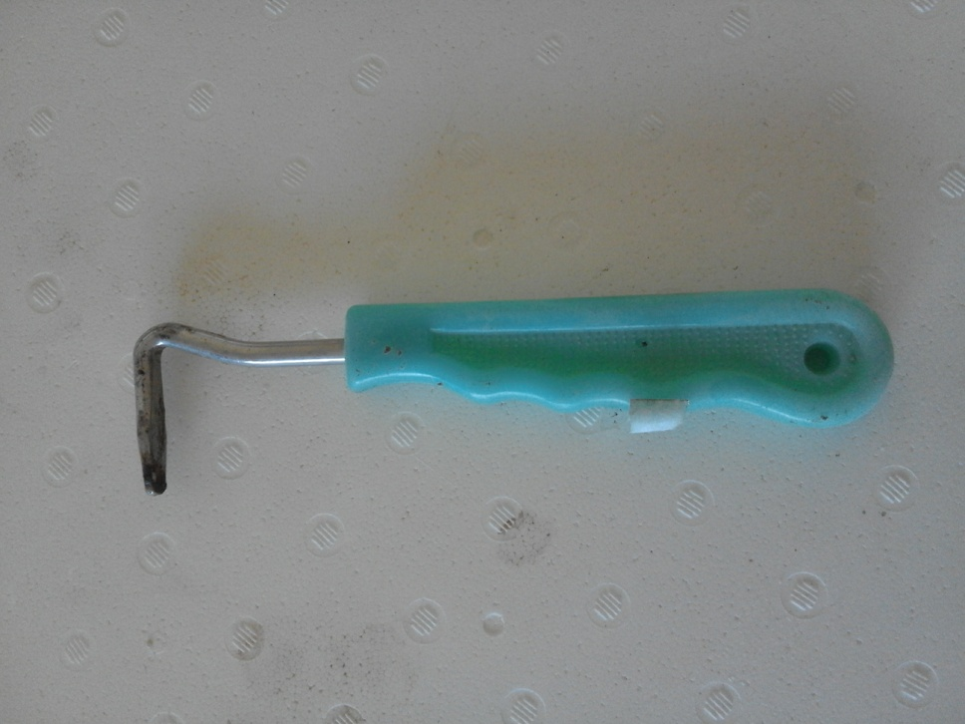

**Frames cleaner**

**Embedding board**

**III. Beekeeper Protection Tools.**

1-**Bee veil**: Don’t ever visit your hive without wearing a veil. There are different in design and materials. It is a head veil made of mosquito netting and used to protect the head (face) from the bee sting.

2- **Gloves**: They are needed for beginner beekeeper to protect the hands from bee sting. But the experienced beekeeper can handle the bees without gloves.

3-**Bee suit**: the clothes that beekeepers wear is called bee suit. There are two types full suit and half suit. It should be made of white thick cloth. It is useful while working in an apiary to prevent the bee sting.

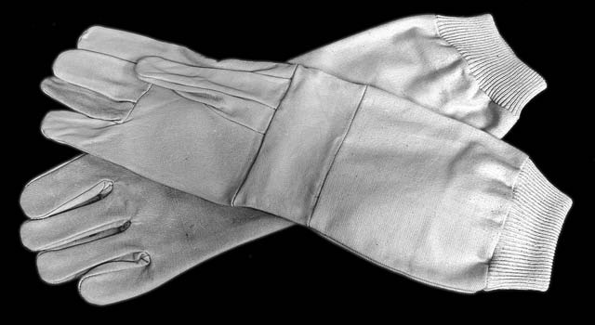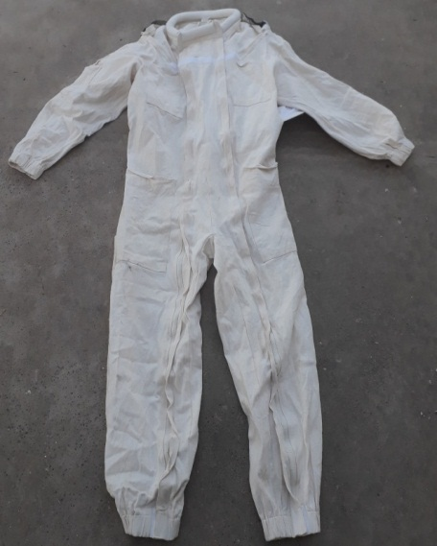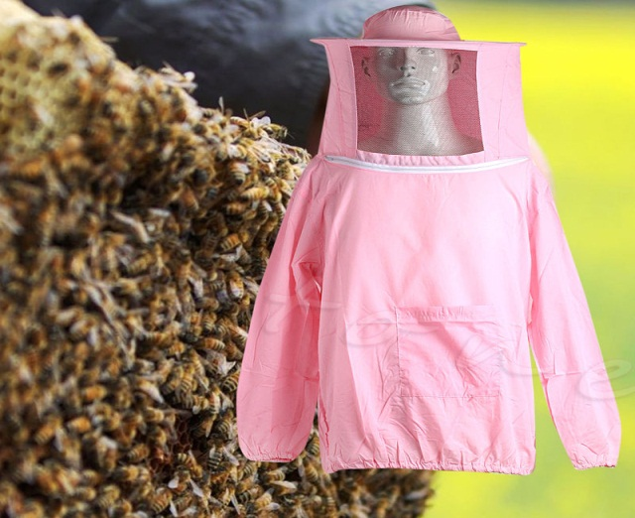

Full suit

Half suit

Gloves