**Lecture-5-**

**IV. Opening and Inspection Hive Tools**:-

1-**Bee smoker**: The smoker will become your best friend and one of the essential tools of beekeeping. Smoke calms the bees and you can to safely inspect your hive because the smoke changing the odor inside the hive and protects beekeepers from bee stings.

2-**Hive tool**: The hive tool is essential equipment to the beekeeper. There are different in size and shape flat steel bar with a sharp head and bend at one end, multipurpose used. It can be used to:

* Separate between inner cover and brood chamber.
* Take out the frames and clean it.
* Clean inside the hive from dirt and remove random comb.
* Used instead of uncapping knife during honey extractor.

3-**Bee brush**: A hairbrush or soft broom with handle wooden. The [bee brush](https://beebuilt.com/collections/tools-and-equipment/products/bee-brush) can be used to

* Gently move the bees from the frame and comb during inspecting hive and extracting honey.
* Move the bees during transfer the bees from local hive to the modern hive.
* Move the bees from beekeeper clothes.

4- **Frame Grip**: Frame grips are used to remove a frame from brood or honey chamber. It is a great tool that allows beekeeper to securely grip a frame with one hand and other hand free for inspection. This tool works by clamping down and locking onto the frame.

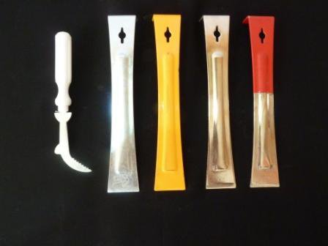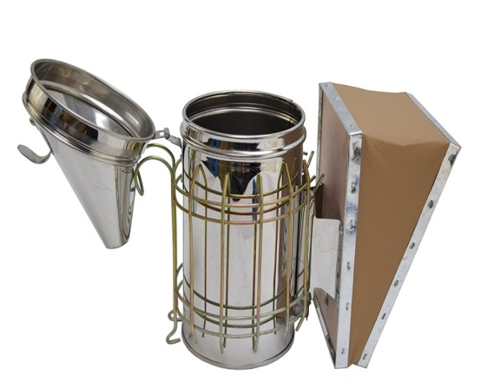

Hive tools

Bee smoker

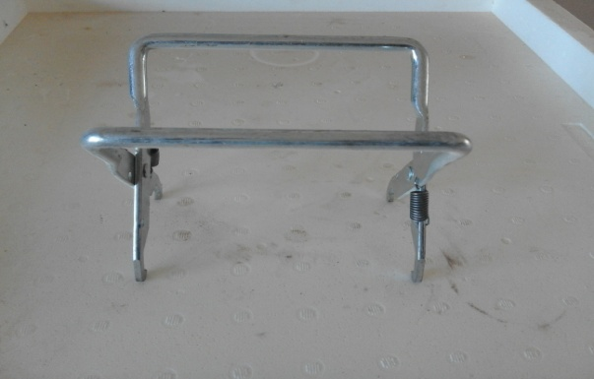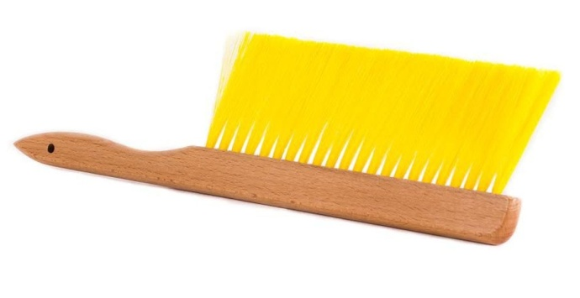

Frame Grip

Bee brush

**V. Honey Bee Extraction Tools**:-

1**- Queen excluder:** As it is mentioned before.

2**- Bee escape:** It has different shaped structure with one way that insert into the center hole of an inner cover. Then the inner cover with the escape inserted is placed between the brood and honey Chamber before 24 hours for removing frame with sealed honey to extraction it. This tool allows the bees to leave the honey chamber to the brood chamber, but they can`t return back.

3**-Bee brush**: as it is mentioned before.

4**-Uncapping knifes**: There are different types of it, handle or electrical heating. Used to slice (scraping off) the wax capping of the sealed honey before extracting.

5**-uncapping fork**: It can be used instead of uncapping knife.

6**-Honey extractor**: It is a hand or motor operated centrifugal machine with revolving chamber into which the frames fit with different shape and size. When it worked honey flows out of the frames by the centrifugal force with breaking the comb and there is a faucet bottom the extractor for taking honey.

7-**Ripener**: It is a container that consists of stainless steel and is of a cylindrical shape with a pipe at the bottom. On the top of it there is one or more strainer with variable holes to block all the impurities in the honey and it is left for one day or more. After this process a pure honey can be left.

8-**Packing containers**: They are containers with different size and attractive shapes used for packing honey for the purpose of trading. These can be glass or plastic that can contain 100,250,500 gram…. etc. It is preferable to attach label on them showing the name of beekeeper, where was produced and the date of production.

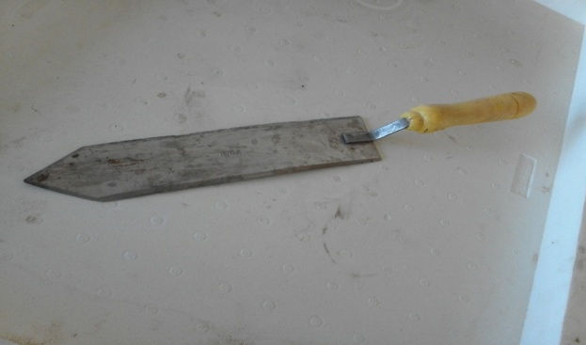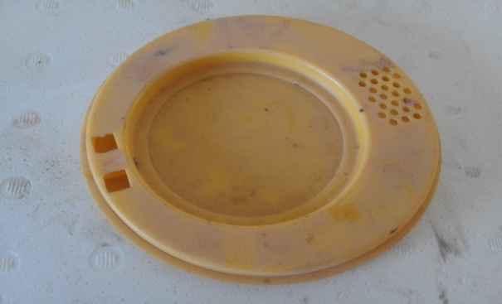

Uncapping knife

Bee escape

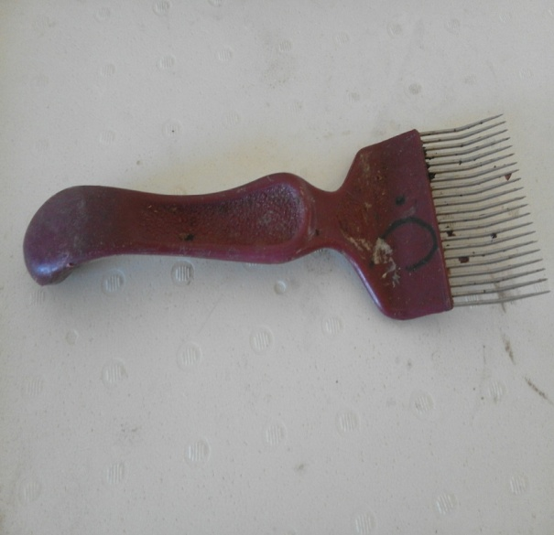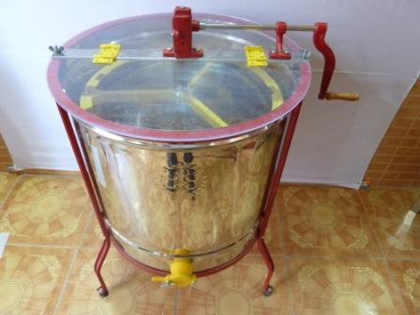

**Uncapping fork**

**Honey extractor**

**VI. Other tools**:

1**- Queen trap:** it placed in the entrance the hive, used for prevent swarming.

2**- Pollen trap**: -it placed in the entrance the hive or above the bottom board, it used during active season (spring time) to collect so much pollen from worker`s pollen basket during their passing through the trap then the collect pollen use for feeding colonies when it is very few in the field or for selling.

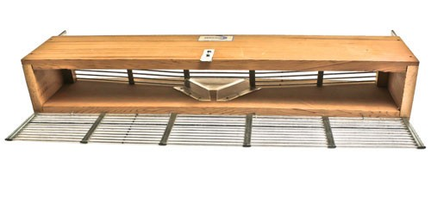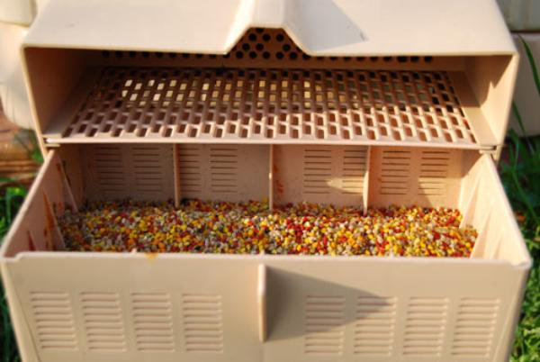

Pollen trap

Queen trap