**Lecture-6-**

**VII: Feeders:** There are two types of feeder:

**A-Slow feeders**: in this type feeding offer to the bees slowly and with different amount according to the type of feeders such as:

**1-Slow jar feeder**: it is glass jar with tight cover or lid and just drill few small holes in the cover, then fill with sugar syrup and placed inverse on the hole of inner cover or directly placed on the frames, then surround with an empty honey chamber, then the hive covered with outer cover.

**2- Slow jar feeder with regulator:**

It is similar to above mentioned but the lid just drill 9 small holes and provided with indicator, then placed inverse on the wooden base and placed on the top of frames, then surrounded as before.

In this type beekeeper can control the number of holes in which sugar syrup throw according to the colony needed.

**3-Boardman (entrance) feeder:**

* It manufacture from wood and plastic with iron, used slow jar feeder as above and placed in the entrance of the hive. They make it easy to see how much feed is left and are easy to refill without bees annoyance.
* But this type is generally not a recommended practice because do not perform well in cold weather the liquid may be freeze or the bees may not be able to get to it.
* Many beekeepers feel that they induce robbing because the food is right at the entrance where it is hard to defend.

**B-Quick feeders**: In this case feeding offer to the bees exposed head such as:-

**1-Miller feeder:** This type is approximate size of a half-depth honey box and placed on the top of the hive. It contains 2 pans or open-top trays that can be filled with sugar syrup. Crawl spaces are provided so that the bees can enter the feeder and reach the syrup.

* The disadvantages of these feeders tend to be some distance from the bee cluster and are not as efficient as jar feeder.
* Some bees may be store propolis at the entrance of feeders so that the bees cannot reach the stored syrup.

**2-Dummy feeder:** This feeder looks like a typical deep frame without a top. The feeder is made of either wood or plastic and it actually replaces one of the frames in the hive, frequently in the brood chamber such a feeder will hold about a gallon of sugar syrup. The feeder should be equipped with a floater have a wire screen attached to the sides to prevent bees from drowning while they are collecting the syrup.

**This device has major advantages:-**

a- Have good amount of syrup (1 gallon).

b- It can be left in the hive easily.

c -Feeder is filled by simply pouring syrup into the top of the feeder without annoyance bees.

d-They are completely inside the hive where they are less likely to induce robbing. However, they can create problems. Most are designed so bees can crawl out easily but bees drown anyway. Also, if you let the feeders go empty the bees will build comb inside.

**3-Rimfeeder**: It is similar to inner cover and we can use inner cover instead of it and used for offer candy to the bees, it placed above brood chamber and covered with outer cover.

**4-Empty drawn comb**: Is filled by pouring syrup into both sides of it and placed beside brood nest in brood chamber.

**5-Small open container (open air feeders)**: such as dishes it fills with syrup and provide with small floating inside it to avoiding bees drowning. This feeder is undesirable because it will be source of infection diseases and pests.

They attract all types of wildlife beside bees including **wasps**, **birds**, **ants** and **insects** whatever is around.

**Artificial feeding of honey bees:** The bees usually feeding during dearth periods when natural source for honey is reduce and reduce of plant flowers in field.

**Generally artificial feeding carries out in these cases:**

1- During early spring to encourage the queen start laying more eggs.

2-The decrease of natural sources of nectar and pollen.

3- During dividing strong colonies to return their activity.

4- Package bees, swarming bees, mating nucleolus.

5- During wintering colonies.

**The signs for the food reducing in the colony:**

1. By inspection (especially modern hive).

2-The queen stops egg laying.

3-The workers drop the larvae and pupa out the hive in front of the entrance.

4-The workers kill the drones and drop them out the hive.

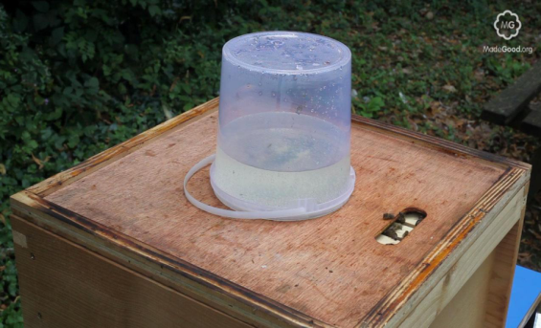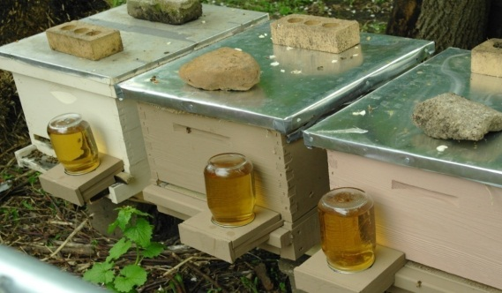

Boardman (entrance) feeder

**Slow jar feeder**

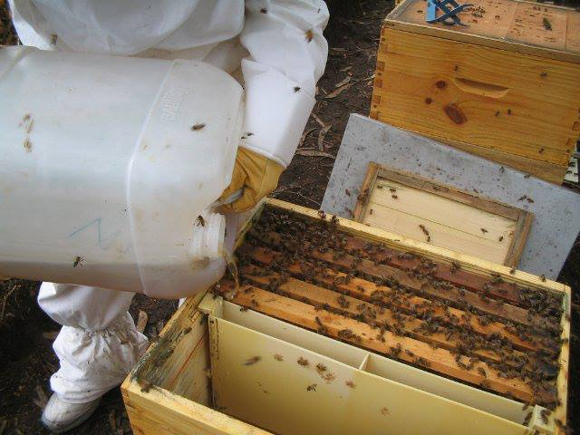

Dummy feeder