**Lecture-8-**

**Queen Rearing and Production:**

**The aim or purpose for queen rearing**:-

1-To replacement the old aged, weak, illness, deformity queen.

2-Introduction to new colony produced by dividing strong colony.

3-Used for emergency state such as queen died suddenly.

4-For commercial purpose.

5-For changing bad races with good races.

**The factors required to be availability when queen breeding:**-

1- Strong colony with crowded workers.

2- Orphan colony (queenless colony).

3- Availability of fertilized eggs or young larvae less than 2days age.

4- Availability of sufficient quantity food and suitable weather.

5- Ample drones to mate with the newly emerged virgin queens.

**Methods of Queen Rearing:-**

**I. The natural methods**:-

A-By workers only without beekeeper intervention (Production of queen cells under non-controlled conditions) such as:-

**1- The swarm queen.**

Swarming is a natural phenomenon and is the bee colony’s method of reproduction and ensures the survival of their species. When a colony preparing to swarm, bees build large number of queen cells about6-12 but some strains build 20 or more. They are built on the sides or along the bottom of the comb in successive batches and are found in various stages of development, this generally occurs in spring up to midsummer depending on weather and the strength of the hive and the swarming tendency of the bees. Some beekeepers use swarm cells to requeen colonies or introduce to new colonies when dividing, this practice is not recommended in modern beekeeping.

**2- Supersedure queen.**

When the queen becomes too old or infertile or has a physical mishap or diseased, the bees decide to raise a new queen to replace her with a young one more efficient. They build only one to three queen cells in the center of the comb in which the original queen lays eggs; these are usually raised on the face of the comb. If a few cells are found on the face of a comb, and there are eggs present, these are supersedure cells and indicate a dud queen. When the new queen emerges, the two queens exist together and do not fight with each other the old queen will disappear from the hive within a few weeks.

**3- Emergency queen.**

When a queen dies suddenly or killed accidentally through colony inspection, the bees discover her absence and begin quickly to raise a new queen from a few worker cells contain eggs or larvae by enlarging and extending the worker cells and feeding royal jelly to the selected larvae. Emergency queen cells are distinguishes from the queen cells of supersedure or swarming by being raised in enlarged worker cells on the comb face and are often smaller in size than queen cells raised from queen cups. Emergency cells may not have the best quality as bees sometimes select older larvae than 3 days old resulting in undersized queens with small ovaries, in that case are unsatisfactory as production queen. Sometimes emergency queen cells are mistaken for swarming cells and if destroyed by beekeeper, the bees will be queen less and laying workers will develop in the hive.

**Methods used for benefit from natural queen cells:-**

1- Caging the sealed queen cells by half round cage and let it in their colony till the virgin queen emerging then entered to colony needed it.

2-Dividing colony containing sealed queen cells to several nucleus each one contain some queen cells till queen virgin emerging then benefit from them.

3- Adding the comb containing some sealed queen cells without bees to the colony needed it.

4- Cut small part of combs containing one sealed queen cell and then affixing it on the comb in colony needed it.

**b- Natural methods queen rearing by Beekeeper:**-

**Production of queen cells under controlled conditions selection of breeder queen.**

The process of rearing queens begins with the selection of a mother queen of high quality, a selection of the desired stock (race) to breed from is very important.

**1**-**The Miller Method**:

This is the simplest of all procedures and is one of the best for amateur beekeepers.

-The prepared frame is placed in the breeder colony.

-In about a week the comb will be drawn out and the queen will have

laid in the comb.

-The frame is removed from the hive and the bees gentlybrushed off.

-The frame is laid down on a board and the egg-containing margins of the comb trimmed away with a warm sharp knife leaving the youngest larvae on the margins.

-The comb is now ready to be put into a queenlesscell-building colony.

-Cells will be built along the cut edges of the comb.

**2- Case method.**

**3- Hopkins method**.

**4- The Alley method.**

**5- Townsend method.**

**6- Brooks method.**



**Miller Method**

**Time for rearing**

In general, the best time of the year for producing good quality of queens is when nectar and pollen are abundant and there are enough drones available to ensure successful mating. In the Middle East region, this is the period between mid-spring and mid-summer.

**Some of the** **traits of importance in selecting bees are:-**

* Gentleness or kindness.

• High honey production.

• Early spring build up in population.

• Not or low level of swarming tendency.

• Disease and varroa mite resistance.

• Good comb builders.

• Ripens honey rapidly.

• Not or low propolis producers.

•Not or low followers (bees do not follow the beekeeper when leaving the apiary).

• Economical brood rearing when nectar flow is low or stopped.

BUT, it is impossible in queen rearing to get all these characteristics at the same time, however, 3 or 4 items on this list will be achieved.

**II-Commercial methods**:-

**A-Doolitele methods** and calledas wax cups or grafting method.

**Tools needed for this method are**:

1-Waxmelter.

2-Frame with 2-3 movable wooden slices fixed on it.

3-Wooden pen for making wax cups (queen cells).

4-Grafting needle: for transfer larva from comb to wax cup.

5- Royal jelly.

6- Dropper.

7- Magnifying glass.

**Requirements for successful queen rearing:**

• Choose a good queen to graft larva from.

• Graft larvae of not more than one and a half day old.

• During grafting keep the larvae out of a colony for no longer than 30 minutes.

• If there is no honey flow, place a feeder of syrup in the cell-building hive. Large cells will be produced by well-fed colony.

• Choose a strong hive with ample young bees and food (pollen and

honey) as a cell-building colony.

**Be careful not to damage the larva, a damaged larva will not be accepted by the bees**.

When the grafting is done, fix the stick into the modified frame and transfer the frame immediately to a strong, queen less hive to minimize any drying out. The cell building is prepared a day beforehand by removing the queen and unsealed brood, so that the colony is queen less and brood less. Place the frame between combs of sealed brood with pollen and honey. Up to 20 cells are given to the cell-building colony. The bees being queen less will attempt to raise queens in these artificial cells by adding wax to the cells and feed the larvae royal jelly.

**B- Jenter method:**

With these systems the queen is made to lay in purpose made artificial cells and these cell are then transferred to the cell building colony once they at the correct age.

**Types of queen bees during selling:-**

1-Untested queen: are guaranteed as having been mated and laying when caged for sale .Almost all queen bees are of this type.

2- Tested queen: have been kept until their progeny have hatched in order to confirm.

3- Selected tested queen: have been selected from colonies displaying various characteristics such as purity of mating, high honey production, gentleness and quietness on the comb.

4- Artificially inseminated with semen from chosen drone.

5-Isolated mated queen**.**

**Methods for queen introduction into the colony**:-

**A- Indirect methods**: such as

1- Benton cage or 3 hole cage or post cage. It may be used for queen transporting with or without some workers.

2- Plastic cage (queen puzzle cage). Used also for queen transporting 3- Pipe cover (half - round) queen cage.

4- Press-in cage.

5- Queen plastic holder.

6- Queen emerging cage.

7-complete cage with 2 meshes faces its capacity 1 frame. This type used for introduction the rarity queen .because the success ratio is 100%.

**B-** **Direct introduction methods**:-

1- Heavily (thickly) smoking.

2- Flour dusting.

3- Honey painting of queen abdomen.

4- Thymine liquid drop.

5- Scent method.

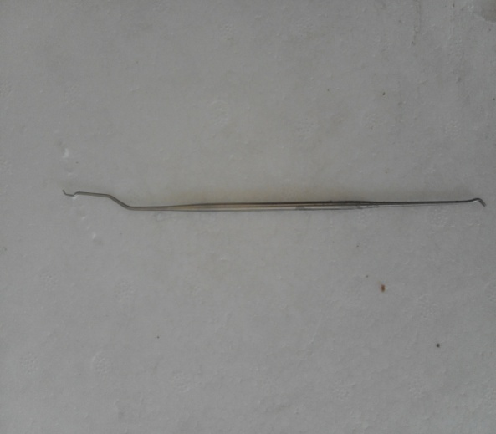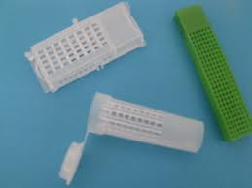

**Queen plastic holder Grafting needle**

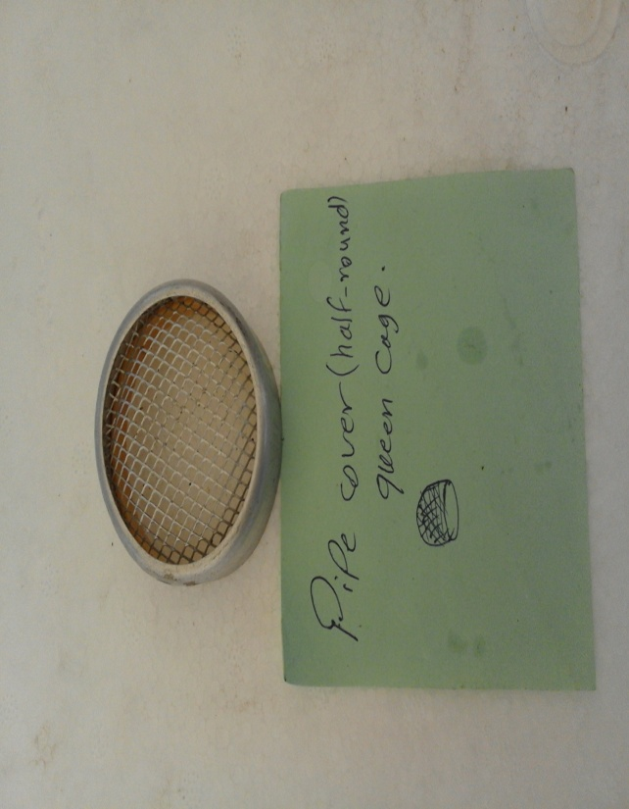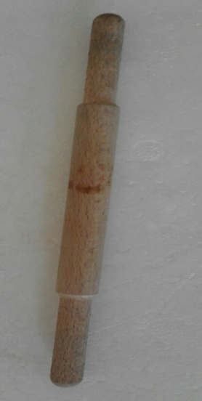

**Wooden pen Pipe cover (half - round) queen cage**

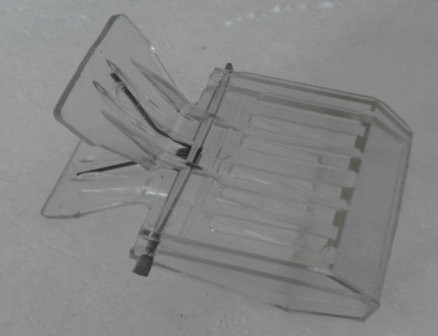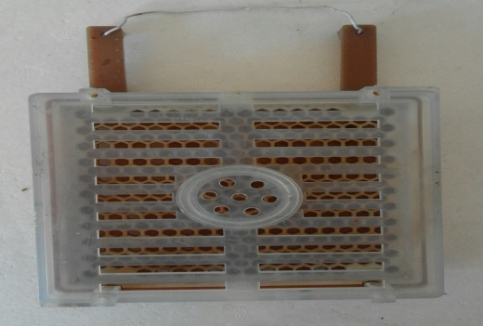

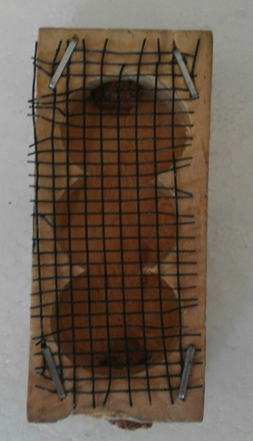 **Queen emerging cage Jenter method**

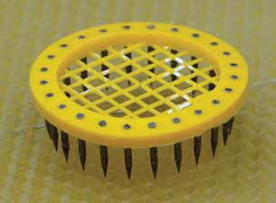

**Benton cage Press-in cage**



**Plastic cage**