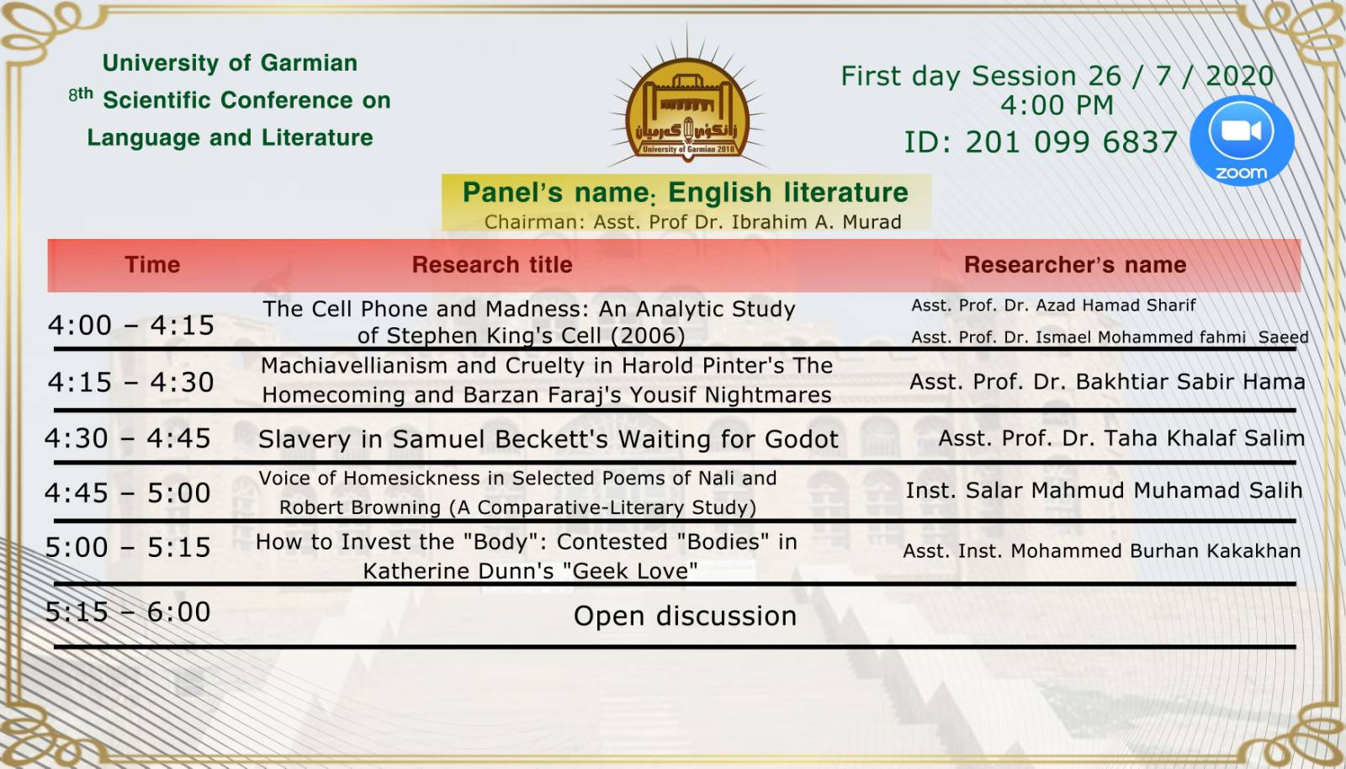

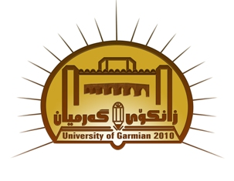
حكومةتى هةريَمى كوردستان حكومة اقليم كوردستان
ئةنجوومةنى وةزيران رئاسة مجلس الوزراء
وةزارةتى خويَندنى بالآ وزارة التعليم العالي والبحث العلمي
وتويَذينةوةى زانستى رئاسة جامعة طرميان
سةرؤكايةتى زانكؤى طةرميان المؤتمر العلمي الثامن
هةشتةمين كؤنفرانسي زانستيى Iraqi Kurdistan Region
Council of Minister
Ministry of Higher Education & Scientific Research
Presidency of Garmian University
8th Scientific conference on Language and Literature
...............................................................................................................................................................................................

Participation Certificate

Dears: Asst. Prof. Dr. Azad Hamad Sharif & Asst. Prof. Dr. Ismael Mohammed Fahmi Saeed

On behalf of the presidency of Garmian University, we appreciate your active participation by a research in the 8th Scientific conference on Language and Literature held in our university on-line in July 26th and 27th, 2020 Under the slogan of
(Language and Literature between Actuality and Contemporary Requirements).
Best of wishes.

Prof. Dr. Ibrahim Abdul-Rahman Mahmood
Head of the Higher Committee

29 / 8/ 2020

