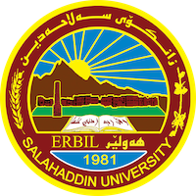
Academic Curriculum Vitae

Personal Information 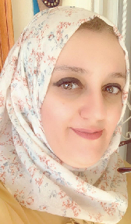
Full Name: Azheen Sardar Mohammad
Academic Title: Assistant Lecture
Email: (Azheen.Mohammad@su.edu.krd )
Mobile: 00964 7504612604

Education:
- B.Sc. in Mathematics. Mathematics Department- College of Basic Education- Salahaddin
University- Erbil in 2005.
- M.Sc. in Method of teaching Mathematics. Mathematics Department- College of Basic Education – Salahaddin University- Erbil in 2015.

Employment:
- Teaching assistant at the College of Basic Education / Salahuddin University, Erbil, on
23/11/2005.
- I started a master degree in 2013-2015 at Salahaddin University / College of Basic Education /
Department of Mathematics.
- I have been teaching in the Department of Mathematics, College of Basic Education,
Salahaddin University, Erbil, since 2016 until now.

Qualifications
- Teaching qualifications
- IT qualifications LIKE / MICRO SOFT OFFICE like word, power point and excel.
- Language qualifications such as IELTS AND CERTIFIC from Language center at Salahidden University.
- Any professional qualification
- Method of teaching especially in mathematics.
- Academic skills subject.
- Measurement and evaluation.
- Teaching methods course 2010
- - English language course 2013

Teaching experience:
-Working as Teacher in University of Salahaddin Erbil– College of basic
Education – Mathematics Department since 2016.
Lessons taught:
- Management and Education / fourth stage
- Academic skills / First stage
- Measurement and Evaluation / third stage (first semester)
_observation/ third stage (Second semester)

LANGUAGES:

Good in English, very good in Arabic, and Kurdish (Mother Language).
Professional Social Network Accounts:

- https://academics.su.edu.krd/azheen.mohammad/azensardar@gmail.com
- https://www.researchgate.net/profile/Azheen-Mohammad
- https://scholar.google.com/citations?user=_LTsMskAAAAJ&hl=ar
- https://orcid.org/my-orcid?orcid=0009-0008-3407-8574

