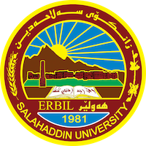
Academic Curriculum Vitae
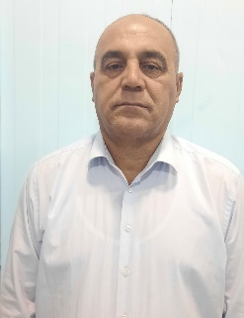
Personal Information:
Full Name: Badrkhan Abdullah Hamzah Salih
Academic Title: Assistant Lecturer
Email: badrkhan.hamzah@su.edu.krd
Mobile: 07504475333

Education:
- Bachelor Degree of Law in College of Law-salahaddin University Erbil -Iraq2010
- Master degree of Law in college Law and political science -Beirut Arabi University –Lebanon 2015

Employment:
- 2003 – 2012 Assistant Researcher , University of Salahaddin,College of Arts. Erbil
- 2012-2015 Postgraduate student( Master) college of Law and political science-Law dep. Beirut Arabi Uni.
- 2015-2023 Assistant lecturer in philosophy Department, college of Arts .salahaddin Uni

Qualifications
-Teaching methods, Salahaddin University-Continuing Education, Erbil, Kurdistan, juh-jul2015

Teaching experience:
Faculty Member and Lecturer, the Salahaddin University, College of Arts, philosophy Dep. Erbil.
2015 – 2017 Lecturer, , college of Arts, Lebanon France University/Erbil, Kurdistan.

Research and publications
Formal conditions in imposition of disciplinary penalties in the Disciplinary
Code state and public sector employees NO (14) for the year (1991) amended
Conferences and courses attended
Affiliation and Nationalization problems , College of Arts ,Salahaddin Uni. 1-2 march2023

Funding and academic awards

Professional memberships

Professional Social Network Accounts:
- Facebook https://www.facebook.com/khattab.azeez?mibextid=LQQJ4d
- Linkden linkedin.com/in/sulaiman-sulaiman-35bb6215b

More Activities
It is also recommended to create an academic cover letter for your CV, for further information about the cover letter, please visit below link:
https://career-advice.jobs.ac.uk/cv-and-cover-letter-advice/academic-cover-letter/

