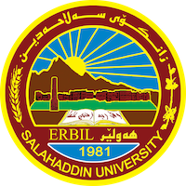
Academic Curriculum Vitae
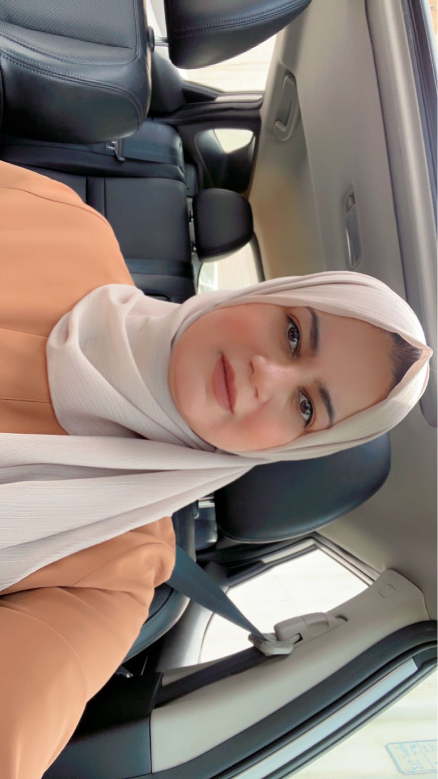
Personal Information:
Full Name: Bahar Muhammed Ahmad
Academic Title: Assist. Lecturer
Email: bahar.ahmad@su.edu.krd
Mobile:07829468732

Education:
B.Sc. in Dams and Water Resources Engineering in 2010.

M.Sc.,in Dam and water resource department ,engineering college ,,salahaddin university –hawler, erbil Kurdistan region ,Iraq,2016.

Employment:
-2011-2012 lab engineer, drawing lab , computer lab at department of dam and water resource salahaddin university .
-2013-2013 Lab supervision, Fluid Mechanics Lab, Dept. of dam and water resource at salahaddin university higher education.
-2013-2015 M.Sc. Student, Dept. of dam and water resource at.
- 2016-2023 Assistant Lecture, Dept. of dam and water resource at salahaddin university higher education.
Qualifications
- Assistant Lecture, Dept. water resource engineering, salahaddin university
- Flow 3D –HEC-RAS –SPSS Nonlinear Regression – Pipe Flow Expert-
- Language qualifications such as IELTS and Language center in Salahaddin University
- English language courses in Cambridge center
- Computer programing courses in IT department in College of Education Salahaddin University

Teaching experience:
- Hydrology, Dept. water resource engineering, salahaddin university
- Engineering drawing Dept. water resource engineering, salahaddin university
- Fluid mechanics laboratory Dept. water resource engineering, salahaddin university
- Engineering Auto cad Dept. water resource engineering, salahaddin university
- Soil mechanics laboratory Dept. water resource engineering, salahaddin university

- Research and publications
- State all researches, publication you made.

Conferences and courses attended
- Give details of any conferences you have attended, and those at which you have presented delivered poster presentations.

Professional memberships
-Kurdstan engineering syndicate (KES)
Professional Social Network Accounts:
1. https://www.researchgate.net/profile/Bahar-Ahmed-2
2. https://scholar.google.com/citations?user=IuNaL1wAAAAJ&hl=en
3.ORCID: https://orcid.org/0009-0008-3911-3973
4. https://academics.su.edu.krd/bahar.ahmad

