Principles of plant production

Second year students
Fall semester
Soil and water department
2022 - 2023

Agriculture
Agriculture is a science of farming, the term agriculture is derived from the Latin words ager or agri meaning soils and cultura , means cultivation. Agriculture is the art, science and business of crop production. It encompasses all aspects of crop production, livestock farming, fishery and forestry.
Agriculture is the backbone of any country's economy. It is the main source of people's livelihood in most of the world particularly the developing and under-developing countries. Under-developing countries are suffering with food insecurity due to poor productivity of agricultural land. Soil degradation, lack of improved agricultural technologies, lack of irrigation water etc. are some of the important factors responsible for poor yields.
Agronomy
Is the science and technology of culturing utilizing and improving field crops (grasses, fiber, and forage crops …etc. It concerned with the scientific use of plant, soil, water, atmosphere and farm resources for the production of crops as an economic activity.
The term was derived from two Greek words, agro (field) and nomos (to manage).
The central theme of agronomy is soil - crop relationship. For crops without soil cannot be considered and soil without crop is barren. In the present context, agronomy can be seen as art, science and business.
Crop production began when domestication of plants became essential to supplement natural supplies; Agronomy encompasses(include) work in the areas of :
- Plant genetics
- Plant physiology
- Meteorology
- Soil science
- The combination of sciences like biology, chemistry, economics, ecology and earth science.
The plant production consists.
1. Field crops: which commonly refers to field crops, e.g. wheat, rice, corn, sorghum, soybean, cotton, as well as pasture, sugar, and forage crops.
2. Horticulture : is concerned with fruits, vegetables, flowers, and ornamental plants.
3. Silviculture, or forestry : with forest trees; and agro forestry, with mixtures of trees with other crops
Agronomists often specialize in areas such as crop rotation, irrigation and drainage, plant breeding, plant physiology, soil classification, soil fertility, weed control, insect and pest control.
Field Crops Identification (definition)
Crops that are grown on a huge open land, their growth habit are determinate, as they flower and mature at one time therefore, they harvest at one time with an exception on this rule ,cotton and tobacco leaves which can pick more than one time ,and it tolerate Transportation, handling and longer storability than other crops.
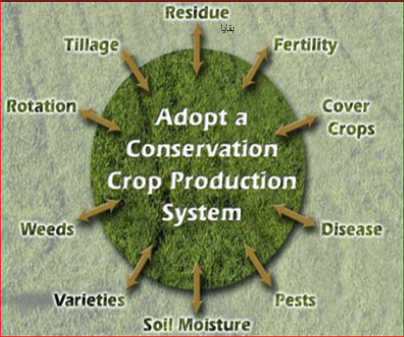
Geographical origin of field crops
Field crops are believed to have been derived from wild species .They were adapted to the needs of man long before the dawn of recorded history .Vavilov determined the center of origin of a crop by finding the origin where the greatest diversity of type occurred in the crop .
There is also DeCandole who works with the original of the field crops is conducted that 199 cultivated plants originated in the old world and 45 in America.
Center of origin according to vavilov:
- Centers of china – sugarcane, sesame, millets
- India–rice,sorghum,cotton,chickpea.sugarcane
- Middle of Asia –wheat, rye, peas, lentil, flax, safflower
- Nearest- barley, oat, alfalfa, fababean, sesame, rape, wheat spp.
- Mediterranean-cereals, legumes, oat, clover.
- Ethiopia - barley, sorghum fababean, millet, coffee , castor bean .
- South Mexico and middle A Mercia –maize, cotton
- Latin America (southern America) –maize, cotton, tobacco.

According to DeCandole
Center of china –rice, soybean, oat.
India –soft wheat, Asian cotton.
Africa and southern Europe –sorghum, peas, barley, rye, oat, hard wheat, flax.
America –maize, cotton, peanut, tobacco.
Iraqi Kurdistan Region as Region of Some Crops
In Kurdistan region the American archaeologists, found archaeological remains of barley at jarmo site near jumjumal about 6800 B.C and found carbonized kernels of wheat in the same site at the mid of nineteenth century about 6000-7000 years old. Chickpea is another crop was domesticated in the Fertile Crescent some 7000 years ago .
Ways of classification of crops
Classification is done to generalize similar crop plants as a class to attending best understanding of them. Field crops are classified in the following:
Classification of crops
- Range of cultivation
- Garden crops: They are grown on a small scale in gardens. eg, onion, brinjal, ete.
- Pantation crops: They are grown on a large scale in estates and perennial in nature eg. tea coffee, cacao, rubber
- Field crops They are grown as a vast scale under field condition. They are mostly seasonal such as rice, wheat, cotton etc.

2-Place of origin:
- Native crops: They are grown within the geographical limits of their origin, eg. rice, barely, wheat, rapeseed, mustard, castor, sugar beet and cotton, grown in
Kurdistan
- Exotic or introduced crops: they are introduced from other countries, such as tobacco, potato, jute, maize. apple etc.
3- Plant Life Cycles
Annuals
Complete their life cycle (from seedling to setting seed) within a single growing season.
However, the growing season may be from fall to summer, not just spring to fall.
These plants come back from seeds only.
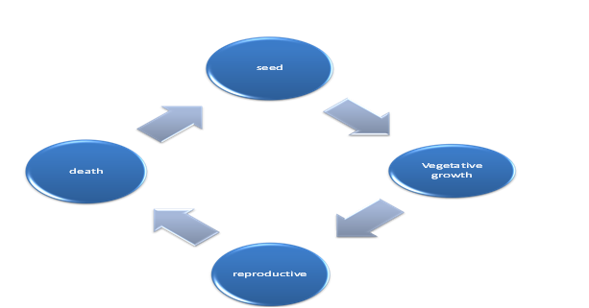

(Biennials)
Biennials – Bi = two, ennial = years
Intermediate life cycle between annuals, perennials
Live for two years with distinct growth patterns for each year
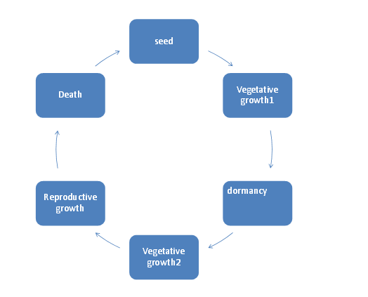
Year 1
– Grow vegetative Leaves, stems, roots, germinate from seed during the growing season and often produce an over-wintering storage root or bulb the first summer. Quite often they maintain a rosette growth habit the first season, meaning that all the leaves are basal.
Year 2
Grow reproductively (sexually) they flower and develop seeds the second summer, followed by death. Sugar beet, carrots
Perennial
Perennial – a plant that lives for more than two years, is herbaceous, and regrows each year from
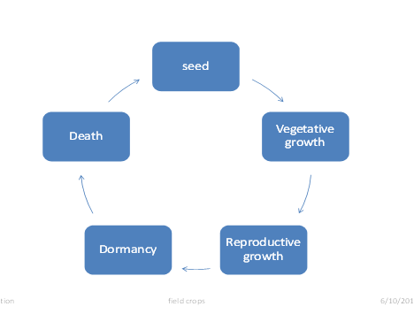
A perennating structure Live through several growing seasons, and can survive a period of dormancy between growing seasons. These plants regenerate from root systems or protected buds, in addition to seeds, Develop over-wintering woody tissue only at the base of shoots or have underground storage structures from which new stems are produced.
4 - Crop classification according to ontogeny (their growing season):
The growing season depends on climatic conditions (temperature, atmospheric humidity and photoperiod) .
a. Cool Season Crops (Winter Habit):
They are sown in the autumn, germinate and grow vegetative, and then become dormant during winter, they resume growing in the spring time and mature in late spring or early summer. Winter varieties do not flower until springtime because they require verbalization. These crops comprise wheat, barley, fababean, lentils, chickpea, and clover.

b. Warm Season Crops (Summer Habit):
These are grown in tropical lowlands year-round and in temperature climates during the frost-free season. In early springtime and mature later that same summer, these are typically requiring more irrigation. These crops are planted in early spring time and mature later that same summer, these are typically requiring more irrigation.’ These crops comprise rice, tobacco, sesame, maize.
5 -Botanical classification
Eg. Broad bean
Kingdom – Plantae
Division – Spermatophyte
Sub-division – Angiosperm
Class – Dicotolydon
Order – Fabales
Family – Fabaceae (leguminosae)
Genus – Vicia
Species - faba
Botanical classification
Eg. Wheat
Kingdom – Plantae
Division – Spermatophyte
Sub-division – Angiosperm
Class – Monocotyledon
Order – Poanales
Family –Poaceace
Genus – Tritium
Species - aesitivum Soft wheat
Kingdom – Plantae
Division – Spermatophyte
Sub-division – Angiosperm
Order – Poanales
Family –Poaceace
Genus – Tritium
Species - durum
Tritium durum ( Hard wheat)
6-Agronomic classification
1-Cereal or grain crops:
Cereals are grasses grown for their edible seeds, the term cereal being applied either to the grain or to the plant itself. they include wheat, barley, rice, maize, grain, sorghum, oats rye and pearl millet.
2. Legume for seed:
Such as broad bean, chickpea, lentils, field beans, peas, cowpeas, soybeans, mug beans.
3. Forage crops:
Fresh or preserved, utilized as feed for animals, include grasses, legumes, crucifers, and other crops cultivated and used for hay, pasture, fodder, silage.
4. Root crops:
They are grown for their enlarged roots; include sugerbeet, carrot sweet potatoes. turnips.
5. Fiber crops:
Fiber crops include cotton, flax, ramie, kenaf and hemp.
6. Tuber crops:
Such as potato, a tuber is not root; it’s a short, thickened, underground stem.
7. Sugar crops:
The sugar beet and sugar cane are grown for their sweet juice from which sucrose is extracted and crystallized. Sorghum as well as sugarcane is grown for syrup production.
8. Drug crops:
The drug crops include tobacco, mint
9. Oil crops:
Include soybeans, peanut, sunflower, safflower, sesame, Castro bean, rape, flax and cotton seed and corn.
10. Rubber crops.

7 - Special purposes classification:
1. Cover crops:
These crops are seeded to provide a cover for the soil, such a crop turned under while still green would be a green – manure crop , such as clovers, alfalfa, vetches, soybean, cowpea and rye .

2.Catch crops: (emergency crops):
Are substitute crops planted too late for regular crops or after the regular crop has failed short –season crops such as millet.

3. Soiling crops:
Crops cut and fed green, such as vetch, field peas and maize,

4. Silage crops:
Are those preserved in a succulent condition by partial fermentation in a tight receptacle, such as corn, sorghum, forage grasses and legumes.

5. Companion crops:
Sometimes called nurse crops, is the planting of different crops in proximity for any of a number of different reasons, including pest control, pollination, maximizing use of space, and to increase crop productivity, grain crops and flax are often used for these purpose.

6. Trap crops:
Planted to attract certain insect or parasites, trap crops are plowed under or destroyed once they have served their purpose.

7. Green- manure crops:
Those crops are grown to be plowed under or to be disked into the soil to increase its productivity .as a rule , legumes are more desirable than non-legumes for this purpose ,as a rule ,legumes are more desirable than non-legumes for this purpose , as they often add nitrogen to the soil .
There are many other classifications such as:
8- Taxonomical classification.
9- Commercial classification.
10- cultural requirement of crops.
11- According to irrigation types.
12- According to methods of harvest.

