Industrial Crops

Overview of industrial crops
Crops are commonly categorized as food, feed, or industrial, based on their use. Wheat, rice, sugarcane, sugar beet, peanut, beans, and peas, are called food crops because of their primary use for human consumption. Similarly, crops like maize, sorghum, oats, barley, hay, and silage, which are grown mainly for animal consumption, are labeled as feed crops. Finally, are a group of crops that although grown commercially for products of economic value, have limited value for food or feed. Examples of industrial crops are cotton, flax, and tobacco. This definition, however, is very narrow and does not reflect the current and potential utilization of different crops correctly. For example, while maize is considered a feed crop, it is the human staple food in Central America. Maize is also an essential feedstock for several industrial products, including bio plastic and biofuel.
Similarly, the classification of Sorghum as a feed crop is ironic, considering the millions in Africa who depend on it for survival. Tobacco, a crop growing in the past only for the manufacturing of cigarettes, holds the promise of becoming a factory of made-to-order drugs. Also, the utilization of Sugarcane has expanded from being mainly from sugar to Buffalo and a host of co-products. The industry is defined as the production of goods and services. Therefore, the term 'industrial crops' has been used in this semester to describe goods that can be produced from plants.
Industrial Crop Definitions
The industrial crop is a crop grown to produce goods for manufacturing; for example, flax is grown for fiber for clothing, rather than food for consumption.
The industrial crop is a crop grown to use the seeds, leaves, stems or roots for industrial purpose — for example, Sunflower seeds for oil extraction, tobacco, sugar cane, and sugar beet.
Industrial crops are plants which are classified primarily because of their industrial uses, but they may also have secondary domestic applications. These crops require industrial processing before consumers can utilize them.
Type of Industrial Crops
Most of the field crops are industrial crops; there are a few crops which it doesn't account as industrial crops.
In general, industrial crops are those which they have a large amount of raw material and used in industrial, if compared with the other field crops.
Oil Crops:
A crop is grown for the extraction of the oil in its seed, for example, Sunflower oil for cooking, sesame, soybean, safflower, rapeseed, ...etc.
Fiber Crops:
A crop is grown for their fibers, which are come from the seed hairs (cotton plant), stem or baste fibers (flax, jute), leaf fibers (sisal plant), and husk fibers (coconut husk).
Sugar Crops:
Sugar beet: A form of the common beet (Beta vulgaris) it is a plant whose root contains a high concentration of sucrose and it is grown commercially for sugar production.
Sugar cane: A tall tropical southeast Asian grass (Saccharum officinarum) having a thick, solid, tough stem that is a chief commercial source of sugar.
Aromatic Crops:
A crop which has an aroma, fragrant, or sweet-smelling. Aromatic herbs such as Tobacco and Tembec.
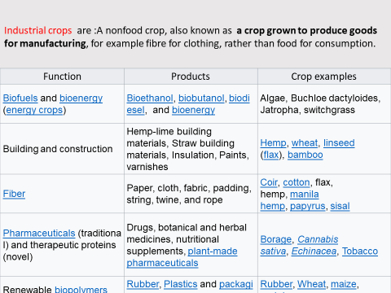

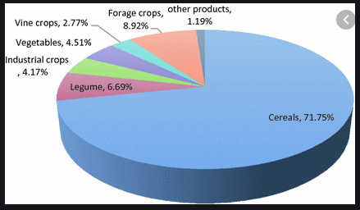
Fig 1. Shows distribution of different crops by pie chart.

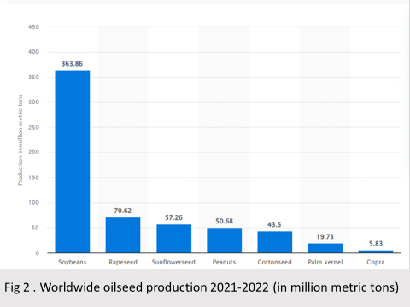
The history of industrial crops
The history of industrial crops can be traced back to primitive humans’ earliest encounters with fire. The subsequent knowledge that fire could also be created artificially by friction led to its utilization for such purposes as keeping the body warm, cooking food, warding off predators and making spears, bowls and digging sticks. In due course, this primitive discovery became the basis of the establishment of the first industry in the form of energy.
The value of wood as a natural resource for the fire was known from the very beginning as humans watched fire caused by lightning kept alive by forest wood until extinguished by the rain. Increasing the efficiency of energy produced from wood by converting it into charcoal through pyrolysis was among the early pioneering industrial inventions. It was used in the smelting of a variety of metals such as aluminum, copper, and iron until replaced by coke. Charcoal production remains alive to this day and continues to be an important cooking fuel in many of the world's rural areas.
With time, humans learned that not only was the cellulosic biomass of the plant a reservoir of energy, but the seeds were also. Seeds of certain plant species were found to contain liquid that could be extracted easily and when burned, producing light. The ancient Egyptians burned Castor oil to light lamps. In some parts of the world, lamps using plant oil are still used on religious occasions.
The 18th-century revolution in agriculture and industry laid the foundation for the accelerated use of plant feed stocks for multiple industrial purposes. Cotton was the leading industrial crop during this period, and Britain led the league of industrialized nations. Industrial crops like jute also gained prominence because of their utility in the protective wrapping of cotton and other products during shipment.
Feedstock’s. for the synthetic industry were, for the most part, supplied by plants until approximately 100 years ago. Plants were the source of inks, paints, dyes, adhesives, glues and other industrial chemicals. Cotton, wool, and some minor crops provided yarn for weaving clothes. The source of the first plastic introduced in the 1880s was cotton, and in the 1920s, plastics used in manufacturing car radios were derived from wood pulp. The first synthetic fiber, rayon, was derived from cotton.
While the plants were gaining importance as the raw material source for other industries, they were losing ground to coal as the source of energy. The discovery of technology to convert coal into kerosene on an industrial scale in the mid-19th century led to a gradual replacement of plant oil by kerosene oil because it was cheaper and more readily available. The next wave of energy source came in the form of petroleum. but the lack of technology to drill wells to pump it out of the earth and refine it to usable products was a stumbling block to its industrial utilization. By the beginning of the 20th century, these hurdles had been overcome. These chemicals replaced those produced from plant-based feedstock comprised of starch, vegetable oil, and cellulose during the early industrial period.
Lately, the advantage in the concentration of petroleum deposits in a few countries has turned into a definitive hindrance to the reliable supply of this vital commodity. Several of these countries are beset by political and economic problems that threaten their stability, and petroleum pipelines are often sabotaged as a political statement.

