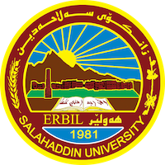
Academic Curriculum Vitae

Personal Information:
Full Name: Bahar zayr muhamad
Academic Title: Lecture
Email: Bahar.muhamad@su.edu.krd
Mobile:07504513161

Education:
MA, PhD
Employment:
2003/10/3
Qualifications
- Teaching in Salaheddin University since 2009
- IT
- Language, IELTS level, 5
- Writer

Teaching experience:
- Theorical linguistics
- Diversity education
- Pragmatics
- Morphology
Research and publications

-Rhetorical Argumentation in formal News.
-Logic Argumentation in formal News.
- A decors strategi in Nali and salm letters.
Conferences and courses attended
- I was a member of runner course with my colic about diversity education in 2017.
Funding and academic awards
-3 academic awards from
-2 award from minister of high education.
Professional memberships
- List any membership you hold of any professional body or learned society relevant to your research or other life activities.

Professional Social Network Accounts:

-google scholar
-LinkedIn
-Research gat
-Facebook

It is also recommended to create an academic cover letter for your CV, for further information about the cover letter, please visit below link:
https://career-advice.jobs.ac.uk/cv-and-cover-letter-advice/academic-cover-letter/

