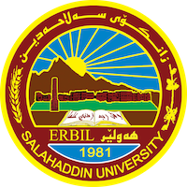
Academic Curriculum Vitae

Personal Information:
Full Name: Bahzad Muhsin Raouf
Academic Title: assistant lecturer
Email: (bahzad.raoof@su.edu.krd)
Mobile:07512065874

Education:
- Bch 2003 Salahaddin University / College of art / Kurdish department
- M.A. 2010 Salahaddin University / College of language / Kurdish department

Employment:
- University of Raparin/ 2010

Qualifications
- NONE
Teaching experience:
- Experience of teaching from 2010 till now
Research and publications
- State all researches, publication you made.

Conferences and courses attended
- Give details of any conferences you have attended, and those at which you have presented delivered poster presentations.

Funding and academic awards
- List any bursaries, scholarships, travel grants or other sources of funding that you were awarded for research projects or to attend meetings or conferences.

Professional memberships
- List any membership you hold of any professional body or learned society relevant to your research or other life activities.

Professional Social Network Accounts:

- List your profile links of ReserchGate, LinkedIn, etc.

It is also recommended to create an academic cover letter for your CV, for further information about the cover letter, please visit below link:
https://career-advice.jobs.ac.uk/cv-and-cover-letter-advice/academic-cover-letter/

