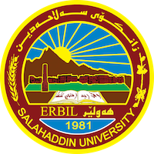
Academic Curriculum Vitae
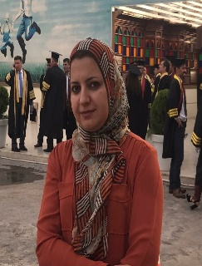
Personal Information:
Full Name: Ban Sabah Yahia
Academic Title: Assistant Professor
Email: (ban.yahia@su.edu.krd)
Mobile: 07504684168

Education:
-Bachelor's degree in Pediatrics\ University of Baghdad 1999
-Master's degree in Kindergarten / University of Baghdad, Kindergarten Department 2000
-PhD in Educational Psychology University of Baghdad \ Department of Educational and Psychological Sciences 2007

Employment:
- First appointment, University of Baghdad, Kindergarten Department, 2001
Qualifications
- Certificate in Modern Teaching Methods \University of Baghdad 2000
Computer course certificate for scientific competencies 2000
Word, Excel and Access learning course at Al-Mansour Vocational Institute / Baghdad 1999
- Fluent in Arabic speaking, reading and writing very well
Fluent in Turkish speaking, reading and writing very well
Fluent in English speaking, reading and writing well
- Training course for early childhood learners 21-25 February 2016 UNICEF/CDC Training kindergarten teachers on how to use active learning in the educational process
- The role of friendly schools / Erbil May 2006 UNICEF / Saad Abdul Rahman Hall Member A workshop on how to activate the role of friendly schools in / Erbil
-Workshop / curriculum development for the kindergarten department 27- 29 November /2013 Basic education university of salahadeen Erbil Associate Member Salahaddin University
-Workshop / Germany 15-16/9/2015 University of Leipzig - Germany Participation with a working paper Current issue of early childhood education and teacher education in Kurdistan Region
Teaching experience:
- Bachelor (general psychology, educational psychology, educational techniques, art education in kindergartens, scientific and mathematical concepts in kindergartens, child behavior modification)
- Masters (Advanced Studies in Developmental Psychology, Kindergarten Child Problems)
Kindergarten teachers development course / Erbil Preparation and Training Authority 2013
Research and publications
1. المناخ المدرسي وعلاقته بالتكيف الاجتماعي لدى تلاميذ الصف الاول الابتدائي في محافظة اربيل المركز.مجلة العلوم التربوية و النفسية العدد(51) 2016
2.الحاجات التدريبية لدى معلمات رياض الاطفال من وجهة نظرهن . no.13,Vol.1(July2017)كوَظارى كةرميان .
3.التوجه للانجاز وعلاقته بمستويات الانجاز و الطمأنينة الانفعالية لدى طلبة الصف الحادي عشر الاعدادي في محافظة اربيل. منشور في مجلة جامعة تكريت.2017
4. الثقة بالنفس لدى تلاميذ المرحلة الاساسية وعلاقتها بجودة حياة الاب و لام.منشور في مجلة جامعة رابةرين ،السنة الخامسة،العدد(15) (2018).
5. توكيد الذات وعلاقته بالذكاء لدى تلاميذ الصف الاول الاساسي في المدارس الحكومية و الاهلية .منشور في مجلة جامعة السليمانية للدراسات الانسانية Bالعدد(57) (2018).
6. الصفات الاكاديمية و المهنية للاساتذة قسم رياض الاطفال من وجهة نظر طالباتهن، منشور في مجلة زانكو، العدد(2) (2019)
Conferences and courses attended
- Give details of any conferences you have attended, and those at which you have presented delivered poster presentations.

Funding and academic awards
- List any bursaries, scholarships, travel grants or other sources of funding that you were awarded for research projects or to attend meetings or conferences.

Professional memberships
- List any membership you hold of any professional body or learned society relevant to your research or other life activities.

Professional Social Network Accounts:

https://orcid.org/my-orcid?orcid=0009-0007-3654-7154
https://scholar.google.com/citations?hl=en&user=03yVhmkAAAAJ

