Accommodating for Students Different Learning Styles in EFL Classes

Research Project
Submitted to the department of English in partial fulfillment of the requirements for the degree of B.A in English language and linguistics

By:
Essa H. Saed
Shayda M. Suleiman

Supervised by:
Dr. Bandar A. Muhammed

2022 – 2023

Certification
I certify that this study was prepared by students (Essa Humar and Shayda Muhammed) under my supervision at College of Education/ Salahaddin University- Erbil in partial fulfilment of the requirements for the degree of Bachelor in English Language. The title of their graduation project is (Accommodating for students’ different learning styles in EFL classes)

Signature
Dr. Bander Muhammed

Acknowledgments
We would like to express our gratitude to our supervisor Dr.Bander Muhammad who guided us throughout this project. We would further more like to say the biggest piece of the cake goes to our family and friends for supporting us in every part of our life, and giving and offering us deep insight into this study.

Table of contents

Abstract
Students have different interests or preferences in terms of the activities they do in class and how to do them. Teachers on the other hand have different teaching styles. However, it is the job of the teacher to use the techniques and styles that most, if not all, the students can engage to.
The aim of this graduation project is to suggestion some recommendations for teachers to accommodate for students different learning styles. Another aim is to find the insights of teachers on how to deal with students’ preferences.
The research paper is divided into three sections. Section one is introduction in which the problems and aims of the study are explained along with methodology. Section two is literature review in which we talk about the relation between learning and teaching and also we provide two classifications for learning styles (VARK and KOLB). Section three is about data collection and analysis and the data collected through the questionnaires are analyzed.
THE main findings of the study is that teachers need to use different modalities in class and have different activities so as to help most of the students to take something out of the lecture.

Introduction
Section one
  - Statement of the problem:
Student have different learning styles. this complicates the process a problem for the teaching and learning process. Having different learning styles create problems for the students as a whole and for the teachers.
  - aims of the study:
The paper aims at suggesting some teaching tips and techniques for dealing with the different learning styles of the student. The aim is to provide some options that teachers can deal with students’ different learning styles in and outside the class.
  - The significance of the study:
This research is important for teachers to understand the different styles of learning so as to give different activities and assignments to the students. It is also important for the students to know what activity suits them. Furthermore, it is significant for syllabus designers to consider readers’ different styles when they design the textbook.
  - Methodology:
Based on the theoretical background, a questionnaire is designed for the learners to know which learning style they have. In other words, to know the percentage of the learning styles among the students of Salahaddin university – Erbil / College of education / English depart5ment / fourth year students.
Another questionnaire is designed for the teachers to know which teaching style or strategy is the most effective to accommodate for the students different learning styles.
Section two
Theoretical background
2.1 learning and teaching process
Language learning and teaching can have a strong relation together as they are the two sides of the same coin. They are in a complementary relation and need to take one another in to consideration if a successful process is to be achieved.
Learning can be considered as change that is permanent in nature because change is brought into students by a teacher through techniques like developing specific skills, changing some attitudes, or understanding specific scientific law operating behind a learning environment (Sequeira, 2012). However, in order to be an active learner in higher education, each student expects to be treated as an adult learner who has some right over the learning ambience in the form of asking questions and clearing of doubts (Michael, and Modell, 2003). That is, students expect to have ownership over the learning session (Mitra, 2008; Pond & Rehan, 1997). Moreover, students also want their instructor to be cooperative and humorous who would teach clearly and usually use relevant examples so that the course material being taught becomes easy to understand, which I think is increasingly being required in classrooms today (Becker et al., 1990).
The research was initiated with the desire to complete the professional development milestone. The area of interest was a key factor for both the researcher’s current academic practice. As university lecturers, we have been in a continuous dialogue to see how we can ensure continuous improvement at our everyday lesson and thus realized an immense study that needs to be done in inclusive practice. With our current involvement in the higher education settings, we often use the term ‘inclusive education’ that sounds synonymous with education for children with disabilities, however, we have tried to look at the learning barriers in our higher education setting and found many mature students feel that they have barriers to learning. Multiple higher education research explored that the inclusion and equity in teaching and learning resulting in policy makers and scholars have been discussing the importance of widening participation in tertiary education (e.g., Bradley & Miller, 2010). Therefore, we always felt that promoting inclusive teaching and learning through different pedagogical approaches may not be enough. It is essential to ensure inclusive education in designing curricula and assessment by ensuring that our teaching and learning process enhance our teaching effectiveness and can also be used as a medium to eliminate barriers to education to include all students. The research mainly addressed to analyze the factors responsible for creating a process to ensure effectiveness in teaching and learning. This study aims to analyze the teaching and learning process to ensure effectiveness

2.2 The different learning styles:
There are different classification for the students preferences. VARK and KOLB are the most famous ones:
2.2.1 Vark
Learning styles are a popular concept in psychology and education and are intended to identify how people learn best. The VARK model of learning styles suggests that there are four main types of learners: visual, auditory, reading/writing, and kinesthetic.
he idea that students learn best when teaching methods and school activities match their learning styles, strengths, and preferences grew in popularity in the 1970s and 1980s. However, most evidence suggests that personal learning preferences have little to no actual influence on learning outcomes.
While the existing reaserch has found that matching teaching methods to learning styles has no influence on educational outcomes, the concept of learning styles remains extremely popular (Harmer, 2007).
Perceptual preferences Each of us reacts to a range of sensory input. In the world of NLP (neuro-linguistic programming) these are described as Visual (relating to what we see), Auditory (relating to what we hear), Kinaesthetic (relating to movement), Olfactory (relating to our sense of smell) and Gustatory (relating to our sense of taste). Most people, while using all these systems to experience the world, nevertheless have one ‘preferred primary system’ (Revell and Norman 1997: 31), or, suggests Marjorie Rosenberg, ‘in stressful situations, we tend to use a primary and (sometimes) a secondary system in which we perceive, process and store information’ (Rosenberg 2013a: Part A) (Harmer, 2014 , p.99)
There are many different ways of categorizing learning style , but Neil Fleming's VARK model is one of the most popular. Fleming introduced an inventory in 1987 that was designed to help students and others learn more about their individual learning preferences.

According to the VARK model, learners are identified by whether they have a preference for:
• Visual learning (pictures, movies, diagrams)
• Auditory learning (music, discussion, lectures)
• Reading and writing (making lists, reading textbooks, taking notes)
• Kinesthetic learning (movement, experiments, hands-on activities)
(Harmer, 2014)

What Type of Learner Are You?
In order to identify which type of learner people are, Fleming developed a self- report that posed a series of situations. Respondents select the answers that best match their preferred approach to learning.

Example
Imagine that you are learning how to perform a new physical skill such as riding a bike or dancing a certain style of dance. In which way would you learn this skill the best?
1. Look at pictures of people performing the skill. (Visual)
2. Listen to an expert explain how to do the task. (Auditory)
3. Read about how to perform the task in a book. (Reading/Writing)
4. Watch someone else perform the skill and then trying it yourself. (Kinesthetic)

2.2.2 Kolb
Kolb's four learning styles are Diverging (feeling and watching), Assimilating (watching and thinking), Converging (doing and thinking), and Accommodating (doing and feeling). In Kolb's theory, people have a tendency to have one of these four distinct styles which impacts the way
Why is Kolb's theory important?
Kolb's Experiential Learning Theory combines a four-stage learning cycle with four learning styles. It provides a powerful foundation for learning and development by describing the ideal processes where knowledge is created

Kolb described the four stages in the cycle of experiential learning as:
• Concrete Experience – (CE)
• Reflective Observation – (RO)
• Abstract Conceptualization – (AC)
• Active Experimentation – (AE)
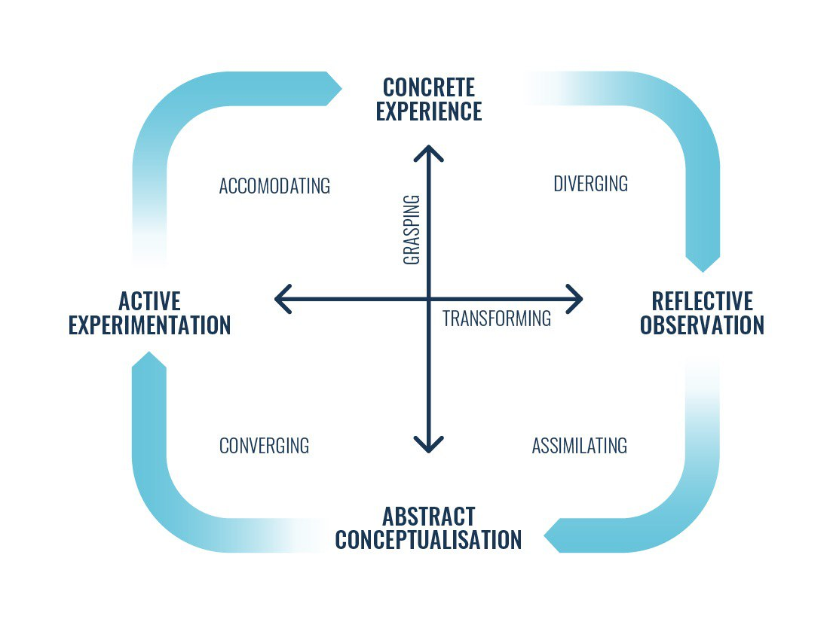
Kolb's experiential learning theory works on two levels: a four-stage cycle of learning and four separate learning styles. Much of Kolb’s theory is concerned with the learner’s internal cognitive processes.
Kolb states that learning involves the acquisition of abstract concepts that can be applied flexibly in a range of situations. In Kolb’s theory, the impetus for the development of new concepts is provided by new experiences.

Section three
Data collection and analysis
3.1 introduction:
In this section, the methodology of the research paper is explained to understand how we concluded the findings and results. First, the data is selected based on the gap of literature review. Then the data collection procedures and the data analysis method are elaborated. At the end of the section some findings and results are shown.
3.2 Data collection procedures:
Based on the review of literature, we found it important to ask the insights of students of teachers about the topic of learning styles. Hence, a questionnaire was designed for students to find their preferences and how to deal with their learning styles. Another questionnaiare is designed for teachers to propose the best practices for dealing withindividual differences or learning style of the students. The participants are students and teachers of English department at college of education of Slahaddin university – Erbil (2023). The total number of participants were 54.

3.3 Data analysis procedures:
The data collected from the questionnaire are analyzing through the use of excel in office 2010 to find the percentages for the responses of the partici[pants. The data are quantative and qualitative. Hence, a mixed approach of data collection and analysis is used.

3.4 Findings and results:
Based on the insights and views provided by teachers, Learning styles and preferences take on a variety of forms—and not all people fit neatly into one category. But generally speaking, these are the most common types of learners:

1. Visual learners
How to recognize visual learners in your class: Someone with a preference for visual learning is partial to seeing and observing things, including pictures, diagrams, written directions and more. This is also referred to as the “spatial” learning style. Students who learn through sight understand information better when it’s presented in a visual way. These are your doodling students, your list makers and your students who take notes.
The whiteboard or smartboard is your best friend when teaching these types of learners. Give students opportunities to draw pictures and diagrams on the board, or ask students to doodle examples based on the topic they’re learning. Teachers catering to visual learners should regularly make handouts and use presentations. Visual learners may also need more time to process material, as they observe the visual cues before them. So be sure to give students a little time and space to absorb the information.

2. Auditory learners
How to recognize auditory learners in your class: Auditory learners tend to learn better when the subject matter is reinforced by sound. These students would much rather listen to a lecture than read written notes, and they often use their own voices to reinforce new concepts and ideas. These types of learners prefer reading out loud to themselves. They aren’t afraid to speak up in class and are great at verbally explaining things. Additionally, they may be slower at reading and may often repeat things a teacher tells them.
How to cater to auditory learners: Since these students generally find it hard to stay quiet for long periods of time, get your auditory learners involved in the lecture by asking them to repeat new concepts back to you. Ask questions and let them answer. Invoke group discussions so your auditory and verbal processors can properly take in and understand the information they’re being presented with. Watching videos and using music or audiotapes are also helpful ways of learning for this group.

3. Kinesthetic learners
How to recognize kinesthetic learners in your class: Kinesthetic learners, sometimes called tactile learners, learn through experiencing or doing things. They like to get involved by acting out events or using their hands to touch and handle in order to understand concepts. These types of learners might struggle to sit still and often excel at sports or like to dance. They may need to take more frequent breaks when studying.
How to cater to kinesthetic learners: The best way teachers can help these students learn is by getting them moving. Instruct students to act out a certain scene from a book or a lesson you’re teaching. Also try encouraging these students by incorporating movement into lessons: pacing to help memorize, learning games that involve moving around the classroom or having students write on the whiteboard as part of an activity.
Once kinesthetic learners can physically sense what they’re studying, abstract ideas and difficult concepts become easier to understand.

4. Reading/writing learners
According to the VARK Modalities theory developed by Fleming and Mills in 1992, reading/writing learners prefer to learn through written words. While there is some overlap with visual learning, these types of learners are drawn to expression through writing, reading articles or books, writing in diaries, looking up words in the dictionary and searching the internet for just about everything.
Of the four learning styles, this is probably the easiest to cater to since much of the traditional educational system tends to center on writing essays, doing research and reading books. Be mindful about allowing plenty of time for these students to absorb information through the written word, and give them opportunities to get their ideas out on paper as well.
Understanding these different learning styles doesn’t end in the classroom. By equipping students with tools in their early years, teachers are empowering them for their futures. Pinpointing how a child learns best can dramatically affect their ability to connect with the topics you’re teaching, as well as how they participate with the rest of the class.

Conclusions

References
(Doctoral dissertation). Available from SIKS Dissertation. (Series No. 2007-1)
(ED. ED451140).
24(4) 219-244.
37
April 2010]. Center for Learning and Teaching, Cornell University, USA.
Armstrong, A. M. (2004). Instructional Design in the Real World: A View from the Trenches. United States:
Armstrong, A. M. (2004). Instructional Design in the Real World: A View from the Trenches. United States:
Brown, H. D. (2000). Principles of language teaching and learning, (4th Ed.). White Plains, NY: Longman.
Brown, H. D. (2000). Principles of language teaching and learning, (4th Ed.). White Plains, NY: Longman.
Byrnes, S. (2010). Assimilative Domain Proficiency and Performance in Chemistry Coursework (Doctoral
Byrnes, S. (2010). Assimilative Domain Proficiency and Performance in Chemistry Coursework (Doctoral
Cassidy, S. (2004). Learning styles: an overview of theories, models, and measures. Educational Psychology,
Cassidy, S. (2004). Learning styles: an overview of theories, models, and measures. Educational Psychology, 24(4) 219-244.
Celce, M. M. (2001). Teaching English as a second or foreign language, (3rd Ed.). Dewey Publishing Services:
Celce, M. M. (2001). Teaching English as a second or foreign language, (3rd Ed.). Dewey Publishing Services: NY.
Cuaresma, J. (2008). Learning Style Preferences and Academic Performance of PHEM Majors at the University
Cuaresma, J. (2008). Learning Style Preferences and Academic Performance of PHEM Majors at the University of the Cordilleras. Unpublished Undergraduate Thesis. University of the Cordilleras, Baguio City.
dissertation). Available from ProQuest Dissertation and Theses databases. (UMI No.3397866).
dissertation). Available from ProQuest Dissertation and Theses databases. (UMI No.3397866).
Drago, W. A., & Wagner, R. J. (2004). VARK Preferred Learning Styles and Online Education. Management
Drago, W. A., & Wagner, R. J. (2004). VARK Preferred Learning Styles and Online Education. Management Research News, 27(7), 1-13.
Dreeben, O. (2010). Patient Education in Rehabilitation. Sudbury, Mass: Jones and Bartlett Publishers.
Dreeben, O. (2010). Patient Education in Rehabilitation. Sudbury, Mass: Jones and Bartlett Publishers.
Fleming, N. (2011). Teaching and Learning Styles: VARK Strategies. Christchurch: N.D. Fleming . p. 128
Fleming, N. (2011). Teaching and Learning Styles: VARK Strategies. Christchurch: N.D. Fleming . p. 128
Harmer, Jeremy . 2007. How to teach English . Longman : England
Harmer, Jeremy . 2014 The practice of English language teaching . Pearson :England
implications. :Educational methodologies. Journal of Dental Education, 68 (8), 859-866.
Incorporated.
Information Science Publishing.
ISSN 2422-8435 An International Peer-reviewed Journal
Journal of Literature, Languages and Linguistics www.iiste.org
Kaplan, E.J. (1995) Teaching and learning styles: Which came first? Journal of Instructional Psychology. V.U.
Kaplan, E.J. (1995) Teaching and learning styles: Which came first? Journal of Instructional Psychology. V.U. Publishing Co. P. 28-34.
Larkin, T. & Budny, D. (2005). Learning styles in the classroom: approaches to enhance student motivation and
Larkin, T. & Budny, D. (2005). Learning styles in the classroom: approaches to enhance student motivation and learning. Paper presented at ITHET 6th Annual International Conference.
learning. Paper presented at ITHET 6th Annual International Conference.
Mackay, A. (2007). Motivation, ability, and confidence building in people. Jordan Hill, Oxford: Linacre.
Mackay, A. (2007). Motivation, ability, and confidence building in people. Jordan Hill, Oxford: Linacre.
MacKeracher, D. (2004). Making Sense of Adult Learning, (2nd Ed.). Canada: University of Toronto Press
MacKeracher, D. (2004). Making Sense of Adult Learning, (2nd Ed.). Canada: University of Toronto Press Incorporated.
Mayzler, A., & McGann, A. (2010). Tutor in a book: better grades as easy as 1-2-3. Avon, MA: Adams Media.
Mayzler, A., & McGann, A. (2010). Tutor in a book: better grades as easy as 1-2-3. Avon, MA: Adams Media.
Miller, P. (2001). Learning Styles: the Multimedia of the Mind. Research Report. Retrieved from ERIC database.
Miller, P. (2001). Learning Styles: the Multimedia of the Mind. Research Report. Retrieved from ERIC database. (ED. ED451140).
Miller, P. (2001). Learning styles: the multimedia of the mind: ED 451340. Unpublished.
Miller, P. (2001). Learning styles: the multimedia of the mind: ED 451340. Unpublished.
Murphy, R. J., Gray, S. A., Straja, S. R., & Bogert, M. C. (2004). Student learning preferences and teaching
Murphy, R. J., Gray, S. A., Straja, S. R., & Bogert, M. C. (2004). Student learning preferences and teaching implications. :Educational methodologies. Journal of Dental Education, 68 (8), 859-866.
NY.
of the Cordilleras. Unpublished Undergraduate Thesis. University of the Cordilleras, Baguio City.
Personality and Individual Differences, 37(8), 1551-1564
Piping, S. (2005). Penerapan teori multiple intelligence dalam pembelajaran. Jurnal Pendidikan Penabur, 4 (5).
Piping, S. (2005). Penerapan teori multiple intelligence dalam pembelajaran. Jurnal Pendidikan Penabur, 4 (5).
Publishing Co. P. 28-34.
Research News, 27(7), 1-13.
Stash, N. (2007). Incorporating Cognitive/learning Styles in a General Purpose Adaptive Hypermedia system
Stash, N. (2007). Incorporating Cognitive/learning Styles in a General Purpose Adaptive Hypermedia system (Doctoral dissertation). Available from SIKS Dissertation. (Series No. 2007-1)
Virleen, M. C. (2010). Found on VARK: A guide to learning styles. http://www.vark-learn.com/ [accessed 12
Virleen, M. C. (2010). Found on VARK: A guide to learning styles. http://www.vark-learn.com/ [accessed 12 April 2010]. Center for Learning and Teaching, Cornell University, USA.
Vol.38, 2017
Wolfman, S. A., & Bates, R. A. (2005). Kinesthetic learning in the classroom. CCSC. P. 203-206.
Wolfman, S. A., & Bates, R. A. (2005). Kinesthetic learning in the classroom. CCSC. P. 203-206.
Zhang, L. F. (2004). Do university students’ thinking styles matter in their preferred teaching approaches?
Zhang, L. F. (2004). Do university students’ thinking styles matter in their preferred teaching approaches? Personality and Individual Differences, 37(8), 1551-1564

Appendix (1) Questionnaire
Dear students,
We are fourth years students and working on our research graduation paper entitled (Accommodating for students’ different learning styles in EFL class). We would like to obtain your insights about the topic. Your sincerity will make the study more scientific.
Which learning style do you prefer ?
- Visual learning (pictures, movies, diagrams)
- Auditory learning (music, discussion, lectures)
- Reading and writing (making lists, reading textbooks, taking notes)
- Kinesthetic learning (movement, experiments, hands-on activities

Which learning style is the most difficult for you ?
- • Visual learning (pictures, movies, diagrams)
- • Auditory learning (music, discussion, lectures)
- • Reading and writing (making lists, reading textbooks, taking notes)
- • Kinesthetic learning (movement, experiments, hands-on activities)

Essa H. Saeed & Shayda M. Suleman
Fourth year students
English Department / College of Education
Salahaddin University – Erbil
Essahusain28@gmail.com
07512342092

Appendix (2) Questionnaire
Dear teachers,
We are fourth years students and working on our research graduation paper entitled (Accommodating for students’ different learning styles in EFL class). We would like to obtain your insights about the topic. Your sincerity will make the study more scientific.
Which learning style do you use very often in class?
- Visual learning (pictures, movies, diagrams)
- Auditory learning (music, discussion, lectures)
- Reading and writing (making lists, reading textbooks, taking notes)
- Kinesthetic learning (movement, experiments, hands-on activities)

Q: what can you do to reduce the gap between the students who have different learning styles when you do class activities?
………………………………………………………………………………………………………………………………………………………………………………………………………………………………………………………………………………………………………………………………………………………………

Essa H. Saeed & Shayda M. Suleman
Fourth year students
English Department / College of Education
Salahaddin University – Erbil
Essahusain28@gmail.com
07512342092

