زانکۆی سەلاحەدین – هەولێر
Salahaddin University-Erbil

Uses of Tenses in Kurdish and English: a Comparative Study

Research project
Submitted to the department of English in partial fulfillment of the requirements for the degree of B.A in English Language

By:
Asia Kamal Omer
Helin Dara Sadq

Supervised by:
Dr. Bandar A. Muhammed

Erbil - Kurdistan

May 2023

Certification
This is to certify that (Asia Kamal and Helin Dara) have worked under my supervision on their graduation paper entitled (Uses of Tenses in Kurdish and English: a Comparative Study) as partial fulfillment for the degree of bachelor in English language at Salahaddin University – Erbil / College of Education / English department.

Dr. Bandar A. Muhammed
The supervisor

Acknowledgement

(In the name of Allah, most Gracious and most Merciful)
Thanks to Allah, for his infinite grace and for having made everything possible by giving me strength and courage to do this work, gave me the desire, and facilitated the ways for me to carry on my study.
My deepest gratitude goes to my supervisor Dr. Bandar A. Muhammed for his constant encouragement and guidance.
My special thanks belong to my family, which supported me in all possible ways during my whole studies and gave me the possibility of a university education.

TABLE OF CONTENTS

ABSTRACT Error! Bookmark not defined.
CERTIFICATION ……………………………………………………………2
Acknowledgement………………………………………………….3
TABLE OF CONTENTS 4
SECTION ONE: INTRODUCTION 6
1.2: Aims: 6
1.3: Significance: 6
1.4: Methodology: 6
SECTION TWO: Theoritical Background 7
2.1 Tense,Time and Aspect 7
2.2 Tense in English 8
2.2.1 The Present Tenses: 8
2.2.2 The Past Tenses: 9
2.3 Kurdush Tenses: 10
SECTION THREE: Data collection and Analysis Error! Bookmark not defined.
3.1 Introdaction: Error! Bookmark not defined.
3.2 Data collection: Error! Bookmark not defined.
3.3 Data analysis: Error! Bookmark not defined.
3.4 Findings and Results: Error! Bookmark not defined.
SECTION FOUR: RESULTS AND CONCLUSIONS 18
conclusions
REFERENCE : 19

Abstract

Tense is the display of time through language. Each language represents time differently. It has a sign cant challenge for translators. The aim of this graduation project is to compare and contrast the tense system of Kurdish and English.
The research consists of three sections. The first section is introduction in which the problems, aims and methodology are explained. The second section is theoretical background where the Kurdish and English tense systems are elaborated. The third section is about data collection and analysis where the data are explained. The main findings are that Kurdish present continuous is equivalent to english present simple, continuous, perfect continuous and future tense but only time expression or co text can show the different between them.

Section One
Introduction
Languages have different tense systems. In this section, the problems that need to be solved are tackled and the aims are shed light on. The methodology of the research is explained in brief.

1.1 problem
Tense is a reference to time trough language. Languages are different. Hence tense is language specific. Number of tenses is different from one language into another. As such, comparing tenses between two languages is challenging.
1.2 Aims
The aim is to identify the function /uses of each tense in Kurdish and English. We compare the tense to find equivalent ones that can serve the same function.
1.3 Significance
it is significance for Kurdish and English language learners to know the tenses. It is also important for translator this paper is crucial for teacher to know the uses of the tenses.So as to use them appropriately and to avoid misunderstanding translate to reproduce the target text as close as possible to the original text.
1.4 Methodology
The data collect is through contrastive analysis to find the similarities and differences between Kurdish and English tense systems. To validate the findings, we get some samples from [Treasure Island].

Section two
Theoretical background
In this section, the theoretical background of the research is explained to have background information about tense and tense system in Kurdish and English.
2.1 Tense, time and aspect:
When talking about tense system in any language, there has to be a line between what a tense is compared to time and aspect. These three concepts comprise the tense system, at least the core of it.
Aspect (n.) (Asp) A category used in the GRAMMATICAL description of VERBS (along with TENSE and MOOD) referring primarily to the way the grammar marks the duration or type of temporal activity denoted by the verb.
Tense (adi /n.) (1) (tns, TNS) a CATEGORY used in the GRAMMATICAL description of VERBS (along with ASPECT and MOOD), referring primarily to the way the grammar marks the time at which the action denoted by the verb took place. Tense FORMS (i.e. variations in the MORPHOLOGICAL form of the verb) can be used to signal MEANINGS other than temporal ones. In English, for example, the past-tense form (e.g. I knew) may signal a tentative meaning, and not past time, in, some contexts (e.g. I wish I knew - that is, 'know now'). Nor is there a simple one-to-one relationship between tense forms and time (P.459).
Aspect /'aspekt/ n. A grammatical category which relates to the internal temporal structure of a situation. Aspect is most commonly reflected in the form of the verb, and in many languages the expression of aspect is intimately bound up with the expression of tense, from which, however, aspect must be distinguished. for example, the forms I did it, I was doing it and I used to do it are all past tense, but they express different aspects. Among the aspectual categories often expressed in languages are perfective, imperfective, perfect, progressive, habitual, durative, punctual and iterative. Adj. aspectual. See Cowrie (1976) and Dahl (1985) for discussion ( 1993C , R.L.Trask ,P.21).
Tense /tens/ n. 1 The grammatical category which correlates most directly with distinctions of time English exhibits a minimal tense system with a two-way contrast between past and non-past forms. ( 1993C , R.L.Trask , P.276).

2.2 Tense in English
Tense is a grammatical device by which we understand the connection between the form of the verb and our concept of past, present, and future times. In English, there are present and past tenses and several means of expressing future time. Taking into account that tense is often considered in relation to the perfective and progressive aspects; the manners in which the verbal action is experienced or regarded(See (Quirk and Greenbaum, 1973:40); (Alexander, 1988:159- 60)). Therefore, there are at least twelve major tenses in English identified in the English linguistic research, as in the following:

    - The Present Tenses
The present tenses in English are divided into simple, continuous, perfect, and perfect continuous. The present simple is represented by the form (I do), e.g., 'I work in a bank.' The present continuous is represented by the form (I am doing), e.g., 'Please, don't disturb me. I'm working'. The resent perfect simple is represented by the form (I have done), e.g., 'I've lost my key.' The present perfect continuous is represented by the form (I have been doing), e.g., 'I'm tired. I've been working all day.'(See (Murphy, 1994:1-32)).

*Present simple is used to talk about things in general.we use it to say that something happens all the time or repeatedly or that something is true in general: The earth goes round the sun.
*Present continuous we use continuous for things happening or around the time of speaking .The action is not complete.
Let's go out. It isn't raining now.
*Present perfect simple When we talk about a period of time that continues from the past unit now, we use the present perfect {have been/ have travelled etc.}
e.g. we’ve never had a car.
Present perfect continuous is use for an activity that has recently a topped or just stopped.
e.g.: Paul is very tired. He’s been working very hard. {morphy,1994, p 18}

    - The Past Tenses
The past tenses in English include the following tenses: The past simple which is represented by the form (I did), e.g., 'The parcel arrived last week.' The past continuous takes the form (I was doing), e.g., 'I was feeling ill.' The past perfect simple is represented as (I had done), e.g., 'I had read his books before I met him.' The past perfect continuous is represented as (I had been doing),
e.g., 'It had been raining, and the streets were still wet.'
(Gramley and Patzold, 1992:148); (Leech and Svartvik, 1994:68, 70, 75)

Past continuous is about the action or situation had already started before this time but had not finished:
e.g. {This time last year l was living in brazil.

2.3 Kurdish Tense
Tense is how a language communicates the timing of events. Did it happen yesterday? Is it happening now? Will it happen at some point in the future? These questions can only be answered by understanding the tenses of a language. Sorani Kurdish has one combined present/future tense and four past tenses. Here is a breakdown of each of the five tenses:
Present / Future – The “here and now” can be used to communicate a future action as well. This is much like English, which sometimes uses a present tense conjugation to indicate a future action. For example, you can say, “I am going to the store later, want to come?” which means virtually the same as, “I will go to the store later, want to come?” Sorani combines this all into one tense called “ڕانه‌بردوو” or “non-past”.
Simple Past – A past action that has been completed. As the name suggests, it is simple and uncomplicated. It simply happened. An example would be “I left” or “I ate food”.
Continuous Past – For communicating an action that was ongoing in the past. “I was eating dinner when she arrived”. This shows that an action was in process, it occurred over a certain time, but has stopped.
Present Perfect – Generally equivalent to the present perfect in English. In Sorani it is referred to as ڕابردووی ته‌واو (completed past). This describes an action that happened in the past, but continues into the present. “The food has burned” happened in the past, but the ramifications are felt in the present.
Far Past / Past Perfect – Describes an action that happened in the past, and was clearly completed. Even additional past actions might have happened after this completed action. “The food had burned, but we ate it nonetheless”.

Take a look below to see the verb ڕۆیشتن )to go ) conjugated in the various tenses
Tense / Form | English | (Sorani) سۆرانی
Infinitive (un-conjugated) | To go | ڕۆیشتن
Present / Future | I am going / will go | ئه‌ڕۆم
Simple Past | I went | ڕۆشتم
Continuous Past | I was going | ئه‌ڕۆشتم
Past / Present Perfect | I have left / gone | ڕۆشتووم
Far Past / Past Perfect | I had left / gone | ڕۆشتبووم

The construction of tense in Sorani Kurdish is very complex and can’t be covered easily here.

In Kurdish, the simple present (e.g. I go), the present continuous (e.g. I’m going) and the future (e.g. I will go) tense are all expressed in the same manner.
Normally, the future sense is gained from context or by time expressions.

I leave now. | )ﻣﻦ( ئێستا دەرۆم.
I’ll leave tomorrow. | )ﻣﻦ( سبەینێ دەڕۆم .

Are you leaving? (Standard Hawleri) | تۆ دەڕۆیت؟
Are you leaving? (Sulemani) | تۆ ئەڕۆیت؟

Today, I’m going to bazaar. | ئەمڕۆ )ﻣﻦ( ئەمرۆ دەرۆم بۆ ﺑﺎﺯﺍﺭﹺ.
Are you going to wash your hands, now? | ئێستا, )تۆ( ﺩەﺳﺘﺖ ﺩەﺷۆیت؟
We’ll come back. | )ﺋێمە( دەگەرێینەوە.

Four different kinds of Past Tense exist in the Kurdish Language.

Simple Past (e.g. ‘I came.’, ’I ate dinner.’, ‘I studied Kurdish.’ etc.)
Past Continuous/Habitual (e.g. ‘I was eating dinner.’, ‘I was studying.’ etc.)
In Kurdish, certain verbs indicating someone’s likeness or hope are commonly expressed with the Past Continuous tense, rather than the Simple Past tense.
Present Perfect (e.g. I have come.)
For general purposes, the Present Perfect tense of Kurdish is equivalent to the English Present Perfect.
When an event started in the past and is still active:
We have been seated here ئێمە لێرە ﺩﺍ ﻧﻴﺸﺘﻮﻭﻳﻦ
When we talk about something that happened in the past, but we don't specify precisely when it happened (perhaps we don't know, or it is not important to say when it happened):
eaten?) you (Have ﻧﺎﻧﺖ ﺧﻮﺍﺭﺩﻭﻭە؟
come.) has (He ئەو هاتووە؟
Past Perfect (e.g. I had come.)
The Past Perfect tense of Kurdish is equivalent to the English Past Perfect and mostly used for subjective expressions.
When I have left mom came من ڕۆیشتبووم کاتێک دایکم هات

Table 1.2 Amin’s classification of Kurdish aspectual system (2004:71)

Tense | Aspect | Rules | Examples
Past | Simple Continuous Perfect Conditional | past stem + personal pronouns  da + past stem + personal pronouns  past stem + bu: + personal pronouns personal pronouns + âya | خواردمان ( We ate).  دەمان خوارد ( We were eating ).  خواردبوو مان( We had eaten ). بمان خواردایە  ( If we ate ).
Present | Simple Perfect | da + future stem + personal pronouns Past stem + u: + personal pronouns +  -a with intransitive verbs | دەخۆین ( We eat ) خواردوو مانە ( We have eaten )

Table 1.3 Ahmad’s classification of Kurdish aspectual system (2004:270)

Aspect | Meaning | Examples
Perfective | - In the past, it is marked by / t, d, i, a, u /  - In the non-past, it is restricted to subordinate classes  with subjunctive marker bi- | هات (came), bird (took),  نوسی: (wrote)  هێنا ( brought),  چوو: (went)
Imperfective | It is marked by the combination of the imperfective marker da- with  both past and non-past stems. | دەخۆم (I eat). دەرۆین (We go).
Progressive | It is not restricted to one tense, although it is clearer in present tense than others. | دەمان خوارد  (We were eating).  دەتان نوسی:  (You were writing).

Section Three
Data collection and Analysis:
3.1 introduction:
The aim of study is to compare and contrast tense system in English and central Kurdish. To provide practical side for the study, the uses of the tenses are compared. In this section, the data collection process and data analysis procedures are shed light on.
3.2 Data collection:
The data of our research is English and Kurdish sentences. A questionnaire is designed to find how English tenses are translated into Kurdish. The focus is on contrasting the tense of the English sentences with their translation counterparts.
The questionnaire contained some sentences and teachers of English department / College of education/ Salahaddin University – Erbil. 21 teachers participated although 27 questionnaires were distributed. Furthermore, some students responded to the questionnaire too. Hence, the data are the teachers and the tool is the questionnaire.

3.3 Data Analysis:
Contrastive analysis is used to find the differences and similarities between English and Kurdish tense systems. The focus is on the uses of the tenses to find which ones have similar uses and can be equivalent to each other. The tenses are written in a list with each one next to the ones that have similar uses in the other language. The procedure has practical implications in English language.

3.4: Findings and results:
Based on the responses of the participants to our questions in which they were asked to translate some sentences into English, the following responses were received:
She reads a book in library. ئەو كتاب دەخوێنێتەوە لە كتێبخانە
I am listening to music. گوێ لە مۆسیقا دەگرم
It has rained a lot lately. بارانێكی زۆر باریوە بەم دواییە
She has been singing a song. ئەو گۆرانی دەڵێ
We watched the news. سەیری هەواڵەكانم كرد
I was learning German last year. پار ساڵ زمانی ئەڵمانیم دەخوێند
They will study math. ئەوان بیركاری دەخوێنن

They will be studying. دەرس دەخوێنن

Based on the contrastive analysis of the tense system of Kurdish and English and the translation of the sentences by the teachers and translators, we arrived at the following findings and results:
Present simple in English has the use as present tense in Kurdish which is to talk about routines. However, the structure of Kurdish present progressive (دەخوێنم) can have three English counterparts: I study (present simple), (I am studying (present continuous), and I will study or will be studying (future tense). As such, the uses might confuse some people but using a time expression to decide which tense is meant or through the dependence on the context we know which one is meant.
Present perfect in English (it has rained) which is about something started in the past but still has impact on now is equivalent to Kurdish present perfect (باران باریوە). The (we) which is linked to the verb in Kurdish is a symbol for perfective tense.
(de) as in (دەمخوێند = I was studying) is a symbol for continuous or progressive case in Kurdish. Hence, I was studying can be equivalent to (دەمخوێند). However, (خوێندم) is past simple in Kurdish and its counterpart is (I studied) in English.
(بوو) in (کردبووم) is a symbol for far past in Kurdish which is equivalent to past perfect in English. Hence, (I had done or I had seen him) can be translated as (کردبووم or بینی بووم). Present perfect continuous in English is translated into present progressive in Kurdish. (they have been studying) has the same use as
(دەرس دەخوێنن).

Conclusions
Throughout the graduation paper, we arrived at the following conclusions:
Time is a universal concept and tense is representation of time through language. Hence, tense is language specific (each language has its own tense system). In Kurdish, time expressions and context decide whether a structure refers to present simple, present continuous, present perfect continuous or future but in English each tense has its own structure. Although some structures can be used for more than a tense.
In Kurdish, there are many classification for the tense system. Some scholars divide it into three or six or twelve tenses. English on the other hand has a fixed system with each tense having its own structure.

References
Alexander, L.G. (1988). Longman English Grammar. Harlow: Longman.
Aziz, Yowell Y. (1989). A Contrastive Grammar of English and Arabic. Mosul: University of Mosul Press.
_ (1998). Topics in Translation with Special Reference to English and Arabic. Benghazi: University of Garyounis.
Broughton, G., C. Brumfit, R. Flavell, P. Hill, and A. Pincas. (1980). Teaching English as a Foreign Language. London: Rout ledge.
Fitzgerald, F.S. (1926). The Great Gatsby. Middlesex: Penguin Books. Leech, Geoffrey, and Jan. Svartvik. (1994). A Communicative Grammar of English.
Murphy, R. (1987). English Grammar in Use. Cambridge: Cambridge
University Press.
Pickthall, Mohammed Marmaduke. (trans.). (2006). The Meaning of the Holy Qur'an. New Delhi: UBS Publishers' Distributors Pvt. Ltd.
Quirk, R., and Sidney, G. (1973). A University Grammar of English. London: Longman.
Quirk, Randolph, Sidney Greenbaum, Geoffrey Leech, and Jan Svartvik. (1985). A Comprehensive Grammar of the English Language. London: Longman.
Wright, W. (1981). A Grammar of the Arabic Language. Vol. 1, 2
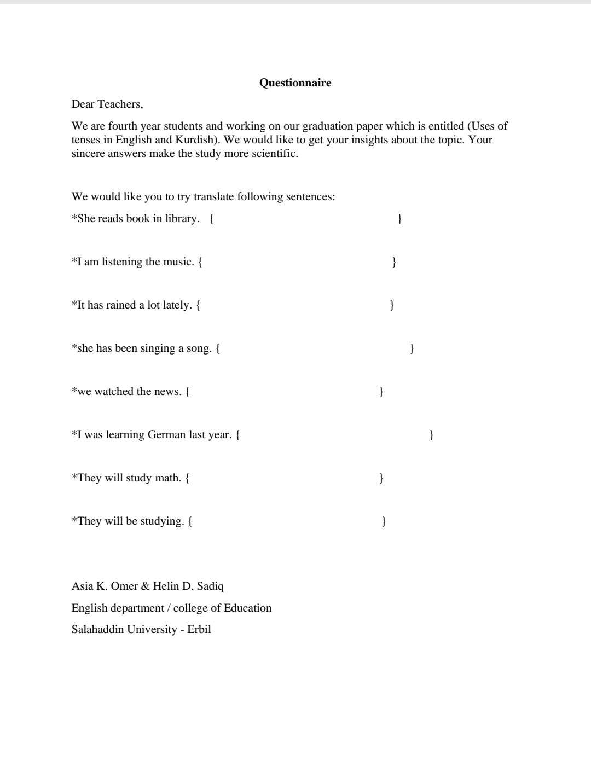
appendix

