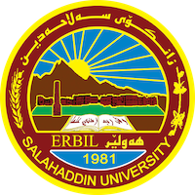
Academic Curriculum Vitae

Personal Information: 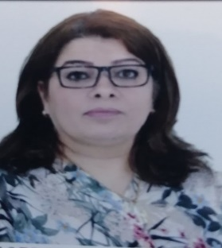
Full Name: parween Abdullah khudhur
Academic Title: Lecture
Email: barween.khudhur@su.edu.krd
Mobile:07504567020 or 07508961931

Education:
MA, PhD
Employment:
1992
Qualifications
- Teaching in Salaheddin University since 2010
- IT
- Language, IELTS level, 5
- Writer

Teaching experience:
- literary prose
- history of literature

-journalism
- childrens liteature
Research and publications
-
1- Latif Helmet's duality of rebellion and revolution in his collection of poems.
2- The Image of Hell in Dante’s (Comedian) by Mahabad Qardaghi).
3-Paradox poetry of Sherko Bekas poetries and Latif Halmat as a model.
4 - Prose poem in Kurdish literature as an example, it is included in the text of the poet
dlshad Abdullah, “Anthem of Snow Writing or Burning Colors.
5- I love somewhat to live” by Sabah Ranjdar.
-6 Feeling of aging in the poetry of Hemn Mokryany
7- Form Poetry Posterin Contem Porary Kurdish Poetry.

Conferences and courses attended
Participated in the international conference of Garmian University in 3-4 -3-2024.
Funding and academic awards
- لة2007 لةئامادةيى مةشق وراهيَنان سةر بة وةزارةتى ثةروةردة لة ( خوولى فير بوونى زمانى كوردى ) كةبؤ هةرسىَ ثارضةى كوردستان كرا بؤوة .
لة 2007 لةهةمان شؤيَن لةخوولى شياندنى مامؤستان وانةم وتيتةوة .2-
لة 2010 لةسةنتةرى شاو وشكا لةخوولى ( فيربوونى زمانى كوردى ) وانةم وتيتةوة 3-
.2017 لەخولی فێربوونی زمانی كوردی لەرێكخراوی جسر ی ایتالی وانەم وتیتەوە 4-

Professional memberships
- List any membership you hold of any professional body or learned society relevant to your research or other life activities.

Professional Social Network Accounts:

-google scholar
-LinkedIn
-Research gat
-Facebook

