Experiments in atomic Physics Lab.

Department of Physics
University of Salahaddin

Prepared By:
Laboratory staff

Experiment No.(1)
Magnetic momentum in the magnetic field
Related
Torque, magnetic flux, uniform magnetic field, Helmholtz coil.
Principle and task
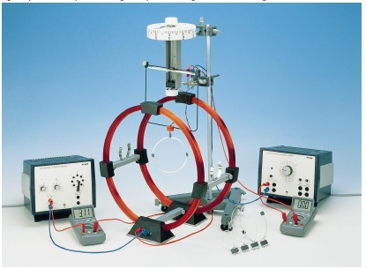
A conductor loop carrying a current in a uniform magnetic field experiences a torque. This is determined as a function of the radius, of the number of turns and the current in the conductor loop and of the strength of the external field.
Apparatus:
- Conductors, circular, set
- Torsion dynamometer, 0.01 N
- Coil holder.
- Power supply, universal
- Power supply var. 15 VAC/12 VDC/5 A
Theory:
The zero-point of the torsion balance should be checked frequently, since rapid rotary movements can displace the connecting leads. Very small torques occurs when measuring torque as a function of the Helmholtz coil current and of the angle. It is therefore recommended to use only the coil with 2 turns and to increase the coil current briefly (approx. to 6). The angles should be set at 15ᵒ intervals, by alternate use of the notches in the coil carrier. Current I, a magnetic moment m is defined.
$$m= µₒ IA …………(1)$$
Where µₒ is the permeability of space, A is the vector area and its magnitude equal to the area of the loop.
When this loop exists in a uniform magnetic field
As Fig.1. it experiences a torque which is given by:
$$T=\frac{1}{µ}m×B …………(2)$$
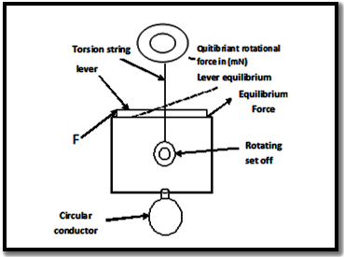
And if the conductor loop has a radius r and consists of N turns the magnitude of torque on it is:
$$T=\frac{1}{µₒ} mB \sin{θ} ………(3)$$
$$B=\frac{8µₒ N I }{5R\sqrt{5}} …………(4)$$
Where R=20cm, N=154 ,
$µₒ=4π*{10}^{-7}$H/m²
m = $πr^{2} µₒ N I_{s}$ ……….(5)

Where r=6cm, N=2 $θ$ = is the angle between A and B.
Practically, it is possible to measure the magnitude of the applied torque by having the loop to the torsion balance, which is showing in Fig. 2.
The magnetic field is produced when the current pass through the loop, and the lever displaced from its equilibrium position by the equilibrium rotational force which its scale give the magnitude of the force F needed for this balance. This process forms a couple with a lever arm L as shown in Fig. 2, where the couple torque is:
$$T=F L …………(5)$$
And when the lever stabilized in its equilibrium position it means the equalization of the couple torque and the torque which is given by eq (3) , where at which the angle $θ=90ᵒ$
Method:
- Connect the electrical circuit of the loop as shown in Fig. 2 and of the Helmholtz coils as shown in Fig. 1.
- Use the coil with 2 turns and measure its radius.
- With no magnetic moment and no magnetic field, set the equilibrant force reading at 0, and then adjust the lever at its equilibrium position.
- For a fixed value of the Helmholtz coils current I_{H} = 1A, change the coil current I from 0 to 5.5 A , and for each of these values return the lever to its equilibrium position recording the required magnitude of force.
- Turn off the currents I_{H} and I_{S}, and balance the equipment as in Fig. 2.
- Make I_{S}= 2A, and repeat step 4.
- Repeat the steps 5 and 6 for another coil recording its radius and NO. of turn.
Calculations;
I_{S}= 2 A
I_{H}  (A) | F  (N) | T=F L  (Nm) | $B=$(8µₒ N I_{H})/(5R$\sqrt{5 }$)
0
0.5
1
.
.
.
3

Plot graph between T (y-axis) and B (x-axis).then calculate (m) experimentally from the graph and theoretically from eq. (5)
I_{H}=2A

I_{S}  (A) | F  (N) | T=(f *L)  (Nm) | $m=$ $(πr^{2} µₒ N I_{s}$ )
0
0.5
1
.
.
.
3

Plot graph between T (y-axis) and m (x-axis) and Calculate (B) experimentally from the graph and compare it with the theoretically given in eq. (4)

Experiment No. (2)
Heisenberg Uncertainty Principle
Apparatus:
- Microwave transmitter and receiver.
- Connecting cables.
- Optical bench.
- Measure scale.
Theory:
When a monochromatic electromagnetic radiation of wavelength radiation of wavelength λ pass through a slit of width d, a diffracted pattern is appeared on a screen or a photographic plate as shown in Fig.1.The minimum intensity occurred at an angles determined by this equation:
$n λ=d \sin{θ_{n}} ………… \left(1\right)$
Where n= 1, 2, 3, … is the order of diffraction.
From the diffraction experiment, the diffracted angle can be calculated as shown:-
$\sin{θ_{n}}= a_{n }/\sqrt{( a^{2}+ b^{2})} …………(2)$
Where (b) is the distance between the slit and the screen (a_{n}) which is shown in Fig.
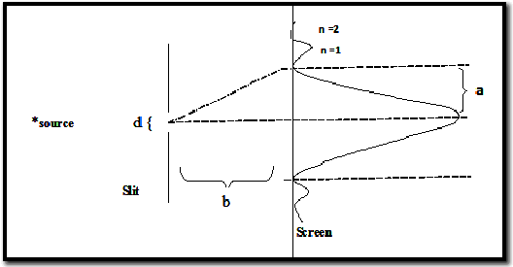
a1 11
a 2

The Heisenberg Uncertainty Principle:
Heisenberg’s uncertainty principle refers to the simultaneous determination of the position and the momentum of the particle and that the uncertainty (∆Y) involved in the measurement of the coordinate of a particle and the uncertainty (∆P) involved in the simultaneous measurement of its momentum are governed by the relationship:
$∆Y.∆P≥\frac{h}{2π}=ћ …………(3)$
Where (h) is the plank’s constant.
The uncertainty in determining the position of photon passing through the slit order on the Y-axis is:
$∆Y=d ………… (4)$
And the uncertainty in its momentum component in the Y-direction for the first order diffraction is:
$∆P=mc\sin{θ} …………(5)$
Where m = h / λc (Debroglie law) is the mass of photon, and c it’s velocity.
Experimental procedure:
A:
1- The experimental set up is shown in Fig.2. P₁, P₂ is the two plates, T is the transmitter . of the microwave with λ= 3.18cm, R is the receiver which is moving on the meter … scale. 2- Make the width of the slit 6 cm 3- Put the receiver at the point (y=0) at which the received radiation intensity is . … .maximum (U=Uₒ), and measure this intensity. 4- Change the position of R and measure the intensity U for each displacement (1 cm) … up.to y=25 cm. 5- Draw the graph between the intensity U and the position y for obtaining the ……diffraction pattern. 6- Measure each of ( b) and( d=∆Y) which are shown in Fig.1. 7- Calculate ∆P_{y} from the equation (2) and (5) and verify the Heisenberg uncertainty ……principle.
B:
1- Reduce the uncertainty in position measurement (∆Y) by decreasing the width of slit to 4 cm.
2- Repeat the steps of A.
C. From the results of A and B discuss the uncertainty principle.

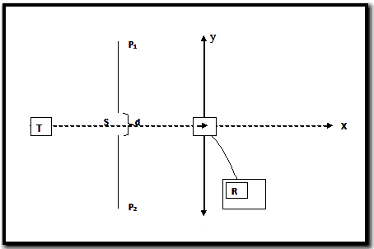
Draw table below:
+y  (cm) | I  (mA) | -y  (cm) | I  (mA)
0  1  2  .  .  . | .  .  .  .  .  .  .  .  0 | 0  1  2  .  .  . | .  .  .  .  .  .  .  .  0
Experiment No. (3)
Specific charge of the electron (e/m)
Principle:
Electrons are accelerated in an electric field and enter a magnetic field at right angles to the direction of motion. The specific charge of the electron is determined from the accelerating voltage, the magnetic field strength and the radius of the electron orbit.
Theory:
When an electron moves in a magnetic field B whose direction is perpendicular to the velocity v of the particle, it is acted on by a force F perpendicular to B and v with a magnitude given by:
$$⃓ F⃓=e v B …………(1)$$
Where e is magnitude of the charge of the electron. This force causes the particle to move in a circle in the plane perpendicular to the field. The force F is equal to the mass of the particle times the centripetal acceleration.
$$e v B =\frac{m v^{2}}{r} …………(2)$$
Where r is the radius of the circle and m is the mass of the electron. If the electron has been accelerated from rest through a potential difference V, then the kinetic energy is equal to the loss of potential energy.
$$\frac{1}{2}m v^{2}=e V …………\left(3\right)$$
Combining equation (2) and (3) gives
$$\frac{e}{m}=\frac{2V}{B^{2}r^{2}} …………\left(4\right)$$
Thus, when the accelerating voltage V, the magnetic field B, and the radius of the circular path r are known, the value of the e/m ratio can be computed and is given in units of coulomb/kg by equation (4) if V is in volts, B in Teslas and r in meters.
Apparatus:
The Cathode ray tube used in this experiment is a special one in which the path of a beam of electrons can be observed directly. The tube is filled with argon gas at a pressure of 10⁻¹ Pa. Electrons emitted by the heated cathode are accelerated by the potential difference applied between the cathode and anode cylinder. Some of the electrons come out in a narrow beam through a circular hole in the centre of the cylinder. This emission is then focused into a narrow beam by the grid of the tube. When electrons of sufficiently high kinetic energy leaving the cathode collide with argon atoms a fraction of the atoms will be ionized. Upon combination of these ions with stray electrons, the argon-arc spectrum is emitted and the characteristic blue colour of the undispersed visible light is observed.
A homogenous magnetic field is produced in the region of the cathode ray tube by a current through two circular coils. Whenever a charged particle, such as an electron in the present experiment, is emitted, the force F given by equation (1) acts on the particle and will deflect it. The particle, therefore, moves under the influence of this force which has a constant magnitude but whose direction is always at right angle to the velocity of the particle. The orbit of the particle is, therefore, a circle.
Calculation of the magnetic field
The magnetic field produced at the position of the electron beam by a current I flowing through the coils must be calculated. For the equipment used in this experiment, there are two circular coils with N turns on each, the coils being connected to contribute equally to the field at the centre. This arrangement is known as a pair of Helmholtz Coils and has the advantage that the field is uniform in the region near the centre. For this particular geometry and constructional details of the apparatus, the relationship between B and I is given by:
B = 0.716 μ_{o} I N / R ………… (5)
Where μ_{o} is the permeability constant which is equal to 4 π x 10⁻⁷ Wb/A-m. , N=140 turns and (R=15cm) is the radius of the coils.

Procedure:
- Measure and record the diameter of the coils, then find the radius R.
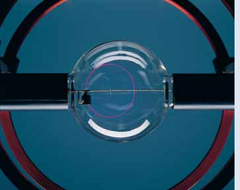
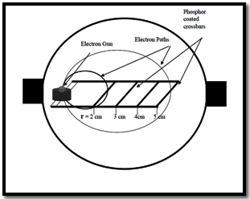

Fig. (1) Fig. (2)
2- Use a regular magnetic compass to determine the plane of the earth's magnetic field at the location of the laboratory. Then set the equipment so that the plane of the Helmholtz Coils lies in the plane of the earth's magnetic field. Explain the importance of this step in your report.
3- The circuit has already been connected for you (see Figure 1). The power supplies to the filament, coil, grid and anode are contained in one pack. Note the following, however.
(i) The knob on the extreme right controls the anode voltage, U (0-500 volts).
(ii) The second knob from the right controls the tube grid voltage. From the way the circuit is connected the grid voltage is negative. The grid voltage focuses the electrons into a narrow beam.
(iii) The multimeter measures the accelerating voltage, V, which is the sum of the anode voltage and the magnitude of the grid voltage.
(iv) The large demonstration ammeter measures the current, I, through the Helmholtz coils.
(v) The radius of the beam “r” is measured by allowing the beam to fall on one of the phosphor coated cross bars which allows the direct measurement of the radius, as shown in Figure 2 above.
(vi) The CR Tube power supply uses high voltage (550 volts) and is capable of delivering high current (350 mA), which can be dangerous.
- Switch on the power supply. This will automatically turn on the filament current. Allow one or two minutes for the filament to heat up.
- Turn the anode knob to apply about 150 volts to the anode, and the grid knob to apply - 30 volts to the grid. (Note that the multimeter will read approximately 180 volts, and this is the accelerating voltage, V). A fine bluish-coloured beam will now be observed.
- Switch on the current to the coils. Adjust the current and observe how the beam bends
over and eventually circles back on itself. It may be necessary to rotate the whole tube to achieve this condition.
- Set the current at some value, say 1.8 A. Adjust the anode voltage to give an
Accelerating voltage V between 150 and 250 volts so that the beam falls on the phosphor-coated crossbars. Before taking your measurements, however, make sure that with the current value chosen you will be able to bend the beam to fall on the 2 cm cross bar. If not, then increase the coil current slightly and decrease the anode voltage until the beam is observed to fall on the cross bar. Keep this value of current
constant in the rest of the experiment. Note the radius of the orbit (2 cm) and the accelerating voltage, V. Adjust the anode voltage to get the circles of radii 3, 4 & 5cm.
After finishing your measurements in step 7, do the following. (i) Turn the current through the coils to zero, reverse the current leads and increase the current. Observe that the beam is deflected in the opposite direction. Why does the beam deflect in the opposite direction?Comment on your observation in your lab report. (ii) Rotate the tube and observe the beam becomes a spiral. Explain why.
- Plot 1/r² versus B², ﬁnd its slope and calculate e/m .
For V_{a} = 150 V , 200V and 250V :
r  (cm) | I  (A) | B  (Tesla) | 1/r² | B²
2.5

3

3.5
.
.
.

Experiment No.(4)
Determination of the Rydberg’s constant and the wave lengths of the most intense spectral lines of hydrogen and helium
Principle:
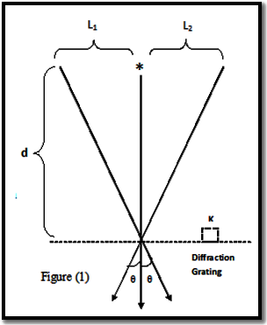
The spectral lines of hydrogen are examined by means of a diffraction grating. The known spectral lines of Hg are used to determine the grating constant. The wave lengths of the visible lines of the Balmer series of H are measured.
Apparatus:
- Tripod base.
- Barrel base.
- Support rod, 40 cm.
- Right- angle clamp.
- Insulating support.
- Object holder.
- Holder for spectral tubes, 1 pair.
- Cover tube for spectral tube.
- Spectral tubes, H& He.
- Diffraction grating, 570 lines / mm
- Connecting cord, 50 kv, 100 cm.
- Meter scale.
- Power supply, 7 kv D.C, 220 V A.C.
Theory and evaluation:
If light of wavelength λ falls on a grating having a grating constant k. it is diffracted. Intensity maxima occur if the angle of diffraction satisfies the condition:

$$n λ=k\sin{θ} ……… (1)$$
$$k=\frac{1}{570}mm$$
From Fig. 1 we have:
$$\sin{θ}=L / \sqrt{L^{2}+b^{2}} ………(2)$$
And hence
$$λ=\frac{k. L}{\sqrt{d^{2}+L^{2}}} ………(3)$$
For the first - order diffraction.
The hydrogen atom spectra involve set of lines located in the visible region of light called the Balmer series. And wavelength of these lines is given by:
$$\frac{1}{λ}=R \left(\frac{1}{n_{f}^{2}}-\frac{1}{n_{i}^{2}}\right) ………(4)$$
In this expression, ni = 3, 4, 5, . . . and n_{f} =2
R is the so-called Rydberg constant,
$$R=\frac{m e^{4}}{8 {εₒ}^{2}h^{3} c } ………(5)$$
Set – Up and procedure:
- Hydrogen spectra and Rydberg’s constant determination:
- The experimental set up is as shown in Fig. 2. The insulating supports are applied to the 7 kv output of the power supply. The meter scale is secured at the height of the slit in the slit in the cover tube, immediately behind the spectral tube.
- The diffraction grating is secured in the object holder so that the diffraction plane is perpendicular to the grating-slit combination.
- The room is darkened to the point where it is still possible to read the meter scale. The power supply apparatus is adjusted to about 5 kv.
- The individual lines (first order)of the spectral lamp are observed by means of the grating and the distance (2L)between equal line is determined with the meter scale.
- Measure distance between two similar lines and calculate ( $λ$) from the equation (2&3).
- Plot the graph between 1/ $λ$ (y-axis) and$\left(\frac{1}{n_{f}^{2}}-\frac{1}{n_{i}^{2}}\right)$ (x-axis).
- Calculate (R) from equation (4).
- Calculate the theoretical value of (R) from the equation (5) and compare your results and the experimental value of (R).
- The Helium (He) spectra :
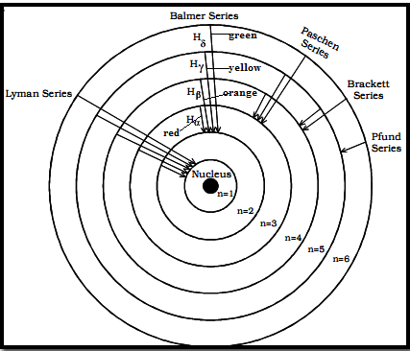
1-Replace the H spectra tube with H one . 2-As in A specify the wavelength of He spectra. 3-istinguish between these values of wavelength and those exists in the scientific references.

`

Fig. 2 Spectral series of hydrogen atom
Draw tabl e below:
Colour | n_{i} | n_{f} | L₁ (mm) | L₂ (mm) | L_{ave} (mm) | λ (mm) | 1/ λ | $$\frac{1}{n_{f}^{2}}-\frac{1}{n_{i}^{2}}$$
Red  Orange  Yellow  Green  Blue  Violet | 3  4  5  6  7  8 | 2  2  2  2  2  2
Experiment No.(5)
Liner absorption coefficient of Aluminum for X-ray by using G.M counter and to calculate the have value thickness.
Apparatus:
- X-ray tube unit.
- G. M. counter.
- Cable for counter tube, 1 m length.
- Digital counter.
- Rate meter.
- Power supply.
- Connecting leads.
THEORY:
If a narrow beam of X-rays of intensity I,, is incident upon an absorber, the intensity I transmitted through thickness (x) of the material is given by :
$I=I_{°}e^{-μx}$ ………… (1)
Where μ, is the linear absorption coefficient, and x the thickness of the absorber in (mm), Fig. 1.
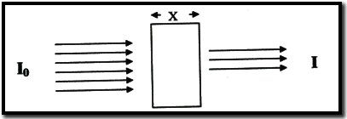
Therefore the graph between In (I◦/I) and (x) will be a straight line which its slope will give the value of (μ).
The half value thickness is thickness of the absorbing medium, which reduces the incident intensity to one half. There for:
$\ln{2= μ{ x}_{1/2}}$
$x_{1/2}=0.693/μ$ ………… (2)
- The experimental procedure:
- Make the connection as follows:
- Put the set of sheets of Aluminum in the place of carrier (17).
- Open the main switch (1) and wait a minute
- Put the indicator of the timer over the (30 min) mark.
- Push the working bottom of the high voltage (12) and note the reading of the voltmeter.
- Adjust the voltage such that the reading of the voltmeter and ammeter are (20 Kv, 0.8 mA) respectively.
- Record the original intensity ( I). of the X-Ray beam without the Aluminum sheets for (30 Sec)
- Record the counts for (30 Sec) for the first thickness of the sheets and repeat it for three times and take the average (I).
- Similarly put other thickness sheets and record down the counts.
- Measure the thickness of each sheet by a micrometer screw.
- Plot a graph between In (I◦/I) and absorber thickness. Find the value of (μ) from the slope graph.
- Plot a graph between (I) and absorber thickness .find the value of (X_{1/2}) from the curve.
X (mm) | I₁ (count/30sec) | I₂  ₍count/30sec) | I_{av} | I_{o}/I_{av.} | ln(I_{o}/ I_{av})
0

0.5

1
.
.
.
3

The key board of the X-ray unit fig .(2):
- On – off switch.
- High voltage connection terminal.
- Emission current connection terminal.
- Timer.
- The circular handle of Gieger-Muller (18) and its indicator (15).
- The circular handle of carrier (17) and its indicator (14).
- Screw for connecting the rotating handles (5,6).
- Electrical circuit beaker.
- Pilot light for high voltage.
- Switch-off the high voltage.
- Control knob for the high voltage range (15kV-42 k V)
- High voltage on-off switch.
- Control knob for emitting current (I) range (0-0.1 mA).
- The indicator of the carriers rotation (17).
- The indicator of the counters rotation (18).
- The pilot light for working the high voltage.
- The carrier (holder).
- Gieger-Muller counter.
- & 20 -Handles for studying the ionization effect of x-ray beam
21- pair of jacks for connecting the G-M counter. 22- The X-ray tube and high voltage system 23- Sliding cover for absorbing the stray radiation produced in the experiment
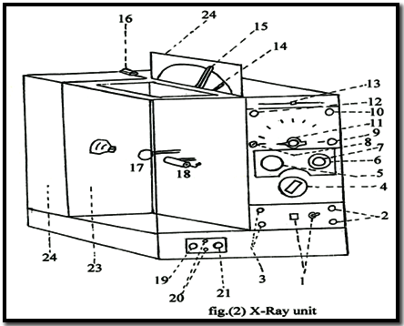
chamber, if its open the high voltage turns off. 24.- The scale plate for knowing the elements.

Experiment No.(6)
To investigate the validity of the relation$I_{a}=K ( V_{g}+Va/µ$) ^{3/2} in a planar triode Characteristic of a triode
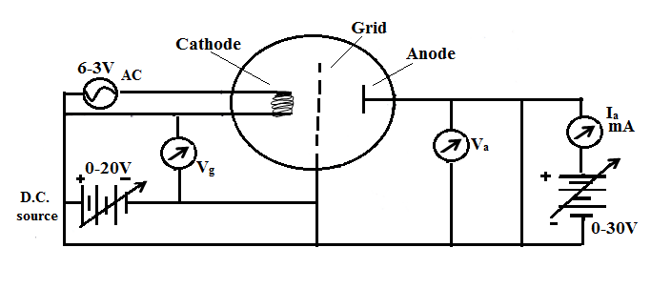
Apparatus:
- A planer triode.
- Power supplier.
- Milli-ammeter.
- Voltmeter.

Theory:
In a triode an additional electrode is introduced between the plate and cathode of a diode. The girl is generally kept closer to the cathode. When the filament is heated to emit electrons, they are attracted by the anode which always maintained at a high +ve potential with respect to the cathode. The grid may be rise to a +ve or –ve potential with respect to the cathode and consequently it will attract or repel the electron coming from the cathode. Thus the filed around filament is produced jointly by the grid and the anode. The space charge limited current for most of the conventional (triode is given by).
$I_{a}=k{\left({V }_{g}+ \frac{V_{a}}{µ}\right)}^{\frac{3}{2}} …………(1)$
Where k is the constant of proportionality, µ the amplification factor I_{a} ,V_{a} anode current, anode potential and grid potential respectively. The above is only a imperial relation and has not been derived theoretically. The aim of the present experiment is to check it is validity for a planer triode. The above relation can be written as:
$${I_{a}}^{\frac{2}{3}}=k^{\frac{2}{3 }} V_{g}+ \frac{k^{\frac{2}{3 }} V_{g}}{µ} ………(2)$$
This equation shows that, with v constant, a graph between I_{a}^{2/3} and V_{a} must be a straight line similarly V_{a} keeping constant a graph between Ia2/3 and V_{a} must be a straight line similarly V_{g} keeping constant .
The experimental procedure:
- Make the connection as shown in Fig. 1.
- Apply a fixed grid potential Vg = -1 volt .
- Note down the anode current for different values of anode voltage between 20 and 200 volts in a interval of 20 volts
- Repeat the experiment with grid potential of – 3 volts.

For V_{g}= -1 volt & V_{g} = -3 volts:
V_{a}  (Volt) | I_{a}  (A) | I_{a}^{2/3} | V_{a}  (Volt) | I_{a}  (A) | I_{a}^{2/3}
20
30
40
.
.
.
200

- Plot a graph between I_{a}^{2/3} (on y axis and (V_{a} on X- axis) ) for each value of V_{g}.
- Applied a fixed anode voltage V_{a} = 50 volts.
- Not dawn the anode current for different values of grid voltage between -1 and -10 volts in interval of 1 volt.
- Repeat step 7 with anode voltage 150 volts.
- Plot a graph between I_{a}^{2/3}(on y axis) and (V_{a} on X- axis).
For V_{a} = 50 volt & V_{a} = 150 volts :

V_{g}  (Volt) | I_{a}  (A) | I_{a}^{2/3}
-1
-2
-3
.
.
-10
Result
From the graph it may be observed that V_{a} verses I_{a}^{2/3} lines are straits but V_{g} verses I_{a}^{2/3} lines are not discussed it,
Experiment No. (7)
Determining the charge of the electron by the Millikan’s oil drop method
Principle:
Charged oil droplets subjected to an electric field and to gravity between the plates of a capacitor are accelerated by application of a voltage. The elementary charge is determined from the velocities in the direction of gravity and in the opposite direction.
Apparatus:
- Millikan apparatus. 2-Power supply. 3-Stop watch. 4- Connecting leads.
Theory:
According to Millikan’s experiment ( first described in 1913 by R.A. Millikan) different indirectly measurable forces act on an electrically charged oil drop moving in the homogeneous electric field of a plate capacitor. When bringing an electrically charged oil droplet with mass m_{oil} and charged Q into the homogeneous field of a plate with the electric intensity E, the following forces act on this droplet.
- Gravitational force (m_{oil.} g).
- Buoyant force (m_{L} . g), (m_{L}= mass of the air displaced by oil drop).
- Electric force QE.
- Stoke’s resisting force 6 π r η v, (η = viscosity of the fluid, r = radius of the droplet, v = relative velocity of sphere and fluid).
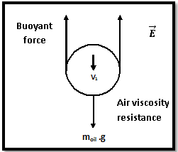
When taking into account the buoyant force. One writes for
m_{oil} - m_{L}=m
And for ρ_{oil} - ρ_{L}= ρ ,
where ρ_{oil} is the density of the oil. ρ_{L} is the density of the air.
Provided that a downward force is to be considered as positive. For a droplet falling through a field-free space with a velocity v₁ the equation of motion is written as the following:
Mg- 6 π r η v₁ = 0
V ρ g - 6 π r η v₁ = 0
$\frac{4 }{3} π r^{3}ρ g- 6 π r η v_{1} = 0 …………\left(1\right) and$ $r=\sqrt{\frac{9 η v_{1}}{2 gρ}}$ ………… (2)
With U voltage between the plates of the ?Millikan chamber, d= plate spacing and
v₂ = rise velocity of a droplet, for a droplet moving upward under the influence of an electric field of field strength E$=\frac{U}{d}$ the equation of motion is :
Mg – QE+ 6 π r η v₂ = 0 $\frac{4 }{3} π r^{3}ρ g-Q\frac{U}{d}+ 6 π r η v_{2} = 0 …………(3)$
Substituting the value of r from eq.2 we obtain:
$Q=\frac{18 π η d (v_{2}+ v_{1}) }{U} \sqrt{\frac{ η v_{1}}{2 g ρ}}$ ………… (4)
Millikan found that for a no. of droplets the values of Q are always the multiples of electrons charge e, so as: Q = n e (n is integer)
METHOD:
- Be sure for the clarity of plates and the acrylic glass cover from the remainder oil drops, if not, you must remove the cover and clear them with alcohol.
- Adjust the microscope by means of knurled screw, so that the graduations are sharply visible.
- Connect the upper plate to the +ve pole of the power supply and the lower plate to the –ve one.
- Atomize oil into the Millikan apparatus by strongly pressing the rubber ball (avoid introduction an excess amount of oil to the apparatus), then observe the droplet falling in the field-free space, (which rises in the microscopic image). When voltage U sets on rotary knob the oil droplets in the electrical field slowly rise (observed as falling drops in the microscopic image), some drops where falls down ( observed as rising drops in the microscopic image) which are the non charged drops.
- Select a slowly falling droplet in the upper third of the viewing field (the voltage U is switched off) and let this droplet passes some measuring marks calculating the time for this, then from this time compute v₁ .
Don’t let this droplet to escape the viewing field.
- Set a voltage U 500 to 600 V on rotary knob, then calculate the time for the droplet to pass some measuring marks, and from which compute v_{2.}
RESULT & CALCULATION:
- Tabulate your reading as in the table below.
- Use equation (4) for calculating Q.
The key board of the Millikan:
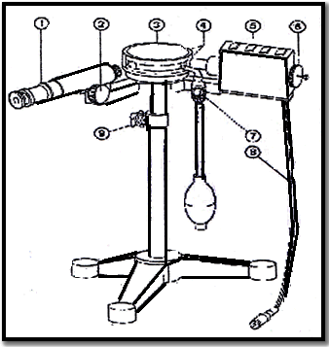
- Measuring microscope with micrometer eyepiece.
- Knurled knob for microscope adjustment.
- Millikan chamber (plate capacitor) with acrylic glass cover.
- Socket pair to connect the d.c voltage for the plate capacitor (can be tapped from socket pair . adjustable via knob.
- Illumination device.
- Knurled knob for lamp adjustment.
- Oil atomizer with rubber ball in resilient holder (one bottle with oil included in scope of delivery).
- Connecting cable for lamb voltage (from multiple socket ).
- Screw for height adjustment (to adapt the microscope to the eye level of the experimenter).
Constants:
d= 0.006m the distance between plates , b = 5 × 10⁻⁵ m the distance between two measuring marks. ρ = 8.85 × 10² kg/m³ the difference between the densities of the oil and air and η = 1.819 × 10⁻⁵ N.s.m⁻²
Droplet | Voltage U  volt | The velocity v₁  m/s | The velocity v₂  m/s | Q | n =Q /e
1  2  3 | 500
Experiment No.(8)
Stefan Boltzmann's Radiation Law
Apparatus:
- Small optical bench.
- Molles thermocouple.
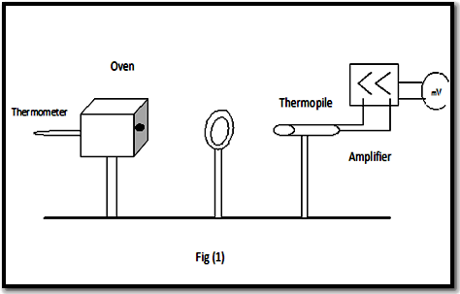
- Microvolt meter.
- Tube oven.
- Tube oven table.
- Black-body attachment.
- Temperature probe.
- Digital temperature measuring devise.
- Measuring junction box.
- Large stand base.
- Leybold multiclamps.
- Connection leads.
Theory:
Stefan Boltzmann ҆s radiation law describes the total emission of a black-body radiator; it states that the total radiation energy emitted by a black body into the space in front of its opening per unit of time is proportional to the fourth power of its temperature.This proportional relationship will be verified experimentally.
The blackened inner walls of an electrically heated tube oven are used as a black body. The emitted radiation will be verified using a thermocouple. A pinhole diagram between the oven and thermocouple restricts the field of view of the thermocouple to the radiation surface of the tube oven and screens environmental stray radiation (oven walls). The intensity of thermal radiation energy U is evaluated from Stefan’s Boltzmann's law of black body:
$$U=σ T^{4} …………\left(1\right)$$
Where T is the temperature in degree Kelvin.
𝜎 Stefan Boltzmann's constant.
U intensity of thermal radiation energy.
Eq. (1) can be written in the form:
$$\ln{U}=\ln{σ }+4 \ln{T} …………\left(2\right)$$
Method:
- Setup the apparatus as shown in Fig. (1).
- Completely insert the black-body attachment in the tube oven, Align the tube opening, the diagram and the thermocouple at one height.
- Wait for at least 5 min. to allow a thermal equilibrium to be established. Then compensate the offset voltage at the microvoltmeter; select the 10⁻³ volt measurement range.
- Heat the tube oven and record the microvoltmeter reading for the respective temperature (T) increase.
- Stop heating the tube oven when the temperature reaches 200 ^{ᵒ}C.
- Plot graph according to equation (2) and then verify Stefan Boltzman’s law.
- Not change the position of the apparatus or your own position when recording the measurement series so that your own body heat does not influences the thermocouple.
T  (cº) | V₁  (mV) | ln V | lnT
80  90  100  .  .  .  200 | Heating

Plot graph between (ln V) on (y-axis) and (lnT) on (x-axis).and calculate Stefan Boltzmann's constant.

