**Cabbage**

**Scientific Name: *Brassica oleracea var*. capitata**

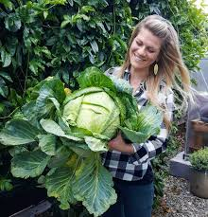

**Cabbage** (***Brassica oleracea* var. capitata**) is a herbaceous plants that belong to mustard family (Brassicaceae), it is biennial in nature and grown commercially as annuals. Cabbage is low in calories and

It is excellent source of vitamin C.

**Description of the plant:**

**-Roots:** Plants have root systems that are fibrous and shallow.About 90 percent of the root mass is in the upper 20–30 cm of soil;some lateral roots can penetrate up to 2 m deep.

**-Stem:** Cabbage has an unbranched stem that remains less than 30cm long.

**-Leaves:** Most cabbage varieties have thick, succulent, alternating leaves, free of hairs and covered **with a waxy coating**, which often gives the leaf surface a gray-green or blue-green color. The outer leaves are green in color and the inner ones are white.

**-Head:** As the plant grows, the leaves increase in number, forming a ball-shaped “head” in the center of the plant. The head is basically a large vegetative terminal bud, formed by overlapping of numerous leaves developing over the growing point of its shortened stem. i

**Flower:** Each flower has four petals set in a perpendicular pattern, as well as four sepals, six stamens, and a superior ovary that is two celled and contains a single stigma and style. Two of the six stamens have shorter filaments. **Plants are cross-pollinated by insects**.

**Fruit:** Is a slique that opens at maturty.

**Seeds:** Brown or black seeds, small and round in shape.

**Recommended Varieties:**

There are many varieties of cabbage differ in their **color , shape , and maturity** such as: white cabbage , green cabbages and red cabbage .Green cabbage is rown more often than the red or Savoy types, but red cabbage has become increasingly popular for color in salads and cooked dishes.

All thevarieties listed here are resistant to **fusarium wilt:**

**1-Green Cabbage:-**

**-Cheers** (75 days to harvest; solid round heads; tolerant to black rot

and thrips)

**-Early Jersey Wakefield** (OP - 63 days; pointed heads; stands well;

resists splitting).

**2-Savoy Cabbage:-**

**-Savoy King** (85 days to harvest; dark, green color; very uniform)

**-Savoy Queen** (88 days; deep green color; good heat tolerance).

**3-Red Cabbage**

**-Red Meteor** (75 days to harvest; firm; good for all seasons)

**-Ruby Ball** (71 days; slow to burst; resists both cold and heat.

**Planting Cabbage:**

**Planting:** Cabbage may be planted by direct-seeding or transplanting of seedlings. If direct seeding is to be used, **about 2 kg of seed** per hectare may be required. Seedlings should be transplanted as soon as they reach the desired size and only well hardened, young, stocky plants should be used. Transplanting isdone on moist soil. The soil around the roots should be firmed and irrigated as soon as possible after the seedlings rare set. Plant population and spacing influence head size,

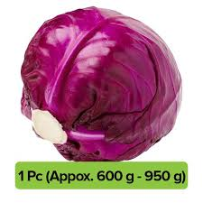 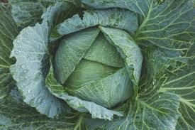 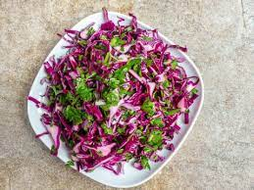

**Management of disease and insect pests:**

**A-Dieses:**

**1-Damping off**

Cause: Fungus

Control:

• Using treated seed

• Sterilizing the seedbed before planting

• Removing infected plants when symptoms appear.

**2-Black Rot**

Cause: Bacteria

Control:-

• Planting tolerant or resistant cultivars

• Using disease-free seed or seed treated with hot water

• Practicing crop rotation

• Control cruciferous weeds

• Avoiding the use of sprinkler irrigation.

**3-Alternaria Leaf spot**

Cause: Fungus

Symptom: small dark spot appear on the leaf surface. As the spot

enlarges.

Control: Alternaria leaf spot is best controlled by applying a Fungicide on a schedule throughout the entire growing season.

**B-Insect pests:** Cabbage is attacked by several insect such as

1- Aphids:

2- Diamond-black moth:

3-Cabbage webworm:

4- Red spider mite:

General control measures: Control measures such as crop. Rotation, using resistant cultivars, using registered chemicals.

  

**Savoy Cabbage Red Cabbage** **Green Cabbage**