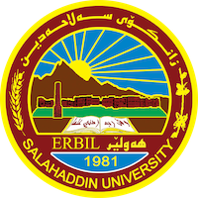
Academic Curriculum Vitae
Personal Information:
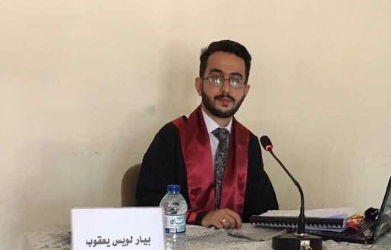
Full Name:BAYAR LOIS YAQOOB SHEER
Academic Title: lecturer Assistant
Email: bayar.yaqoob@su.edu.krd
Mobile:00964 751 4747623

Education:
- Bachelor's, Salahaddin University, College of Fine Arts, Department of Dramatic Arts, Theater Direction Branch, 2012.
- Master, Salahaddin University, College of Fine Arts, Department of Film and Theater, Specialization Theatrical Director, 2017.
- PhD student, Salahaddin University, College of Fine Arts, Department of Cinema and Theatre. Present.
- Employment:
- Teaching assistant, Salahuddin University - College of Fine Arts, from 2012 to 2014.
- Lecturer assistant, Salahuddin University - College of Fine Arts, from 2017 to present.
Qualifications
1- Training courses
- Teaching methods 3 months University of Salahaddin
- General English 11 months Cambridge college
2- Software
- Windows
- Microsoft Word
Excel
Power point
3- Language
- Kurdish Excellent
- Arabic Excellent
- English good
- Assyrian Native
Teaching experience:
I teach under graduate student like; theater directing, personal psychology, research methodology, movement in theater show, theater theories and academic skills, aesthetic.
I supervised undergraduate students in their research projects and practical theses from 2017 to 2023

Professional Social Network Accounts:
Research gate
Bayar L. YAQOOB | Salahaddin University - Erbil, Erbil | SUH | College of Fine Arts | Research profile (researchgate.net)
Linkedin
(3) Bayar L. Yaqoob | LinkedIn
Facebook
Biyar Liwes | Facebook
Google+
Google Account

