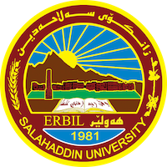
Academic Curriculum Vitae

Personal Information:
Full Name: Beastun Omer Nuri 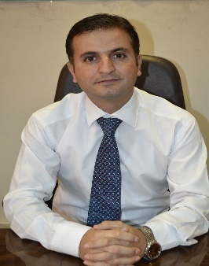
Academic Title: Lecture ( PhD Student
Email: (university email) : beastun>nuri@su.edu.krd
Mobile: 07504547627

Education:
- PhD student
- Master's degree in Political Science, , Faculty of Economics and Political Science, Cairo University, 2014.
- Bachelor's degree, College of Law and Political Science, Department of Political Science, Salahaddin University, in 2007.
- Diploma in the Medical Institute (Department of Health and Society), Technical Institute in Erbil in 2003.

Employment:
First Employment at Erbil Teaching Hospital on 22/6/2005
Second Employment at Salahaddin University 1n 2009 -2014 ) Assistant Research (
Third Employment: Teacher after 2014
Teaching experience:
Teaching methods courses at Salahaddin University, English language courses at the Language Center, Salahaddin University.
Research and publications

-The consistency and shifting of the Turkish foreign policy towards Syria after 2011, Qalaai Zanist Journal, Vol 4, No1,2019.
-Iranian-Syrian relations: a study of the role of Iranian support for the Syrian regime after2011, Vol1, No.223, 2018.
-US Strategy in the Middle East Under Barack Obama (Iran and Syria as an Example), Journal of Law and Politics, Salahaddin University-Erbil, No. (24), June
- Obstacles to sustainable human development in the Kurdistan region of Iraq (a study in educational and educational obstacles), Duhok University Journal, Volume 22, Zamara (1), April 2019, Issue 394.
Conferences and courses attended
- The third international conference on legal issues: held by the Faculty of Law at Ishik University in Erbil on 10/5/2018، The title of the research presented at this conference is (Iranian-Syrian Relations: A Study of the Role of Iranian Support for the Syrian Regime after 2011).
- The first International conference on legal issues: held By the faculty of Law and Political in Duhok University , the title of the research presented at this conference is: Obstacles to sustainable human development in the Kurdistan region of Iraq (a study in educational and educational obstacles), Duhok University Journal, Volume 22, Zamara (1), April 2019, Issue 394.

Funding and academic awards

Professional memberships
- List any membership you hold of any professional body or learned society relevant to your research or other life activities.

Professional Social Network Accounts:

Facebook, twitter ,

It is also recommended to create an academic cover letter for your CV, for further information about the cover letter, please visit below link:
https://career-advice.jobs.ac.uk/cv-and-cover-l I studied the subject (Introduction to the Study of Law) in the Department of Politics, at Salah Al-Din University.
• I studied the two subjects (Economies of Developing Countries) and (Development Problems in Developing Countries) at Knowledge University, Department of International Relations.
• I studied the two subjects (political theory) and (political developments in contemporary Iraq) at Bayan University, Department of International Relations and Diplomacy for the year 2017-2018.
• Service in the medical field for a period of (5) years in Erbil Teaching Hospital in the CCU resuscitation department
• Service at the University of Salah al-Din from the year 2009 in the Faculty of Law and Politics. Department of Political Science so far.
• Member and researcher at the Center for Political and Strategic Studies in the Department of Science and Politics at the College of Law and Political Science.
• Member of the Political Science Association - Arbil.etter-advice/academic-cover-letter/

