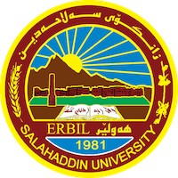
Kurdistan Regional Government
Ministry Higher Education & Scientific Research
Salahaddin University
College of Education
Department of Biology

Bioaccumulation and Biomagnification in invertebrates
A Project Submitted To The Council of The College of Education At Salahaddin University In Partial Fulfillment of The Requirements For The Degree of B.Sc. at Biology Department.

Prepared By
Blnd Akram Aref
Supervised By
Berivan Asaad Latef

April – 2023
Dedication
This study is wholeheartedly dedicated to our beloved parents, who have been our source of inspiration and gave us strength when we thought of giving up, who continually provide their moral, spiritual, emotional, and financial support. To our brothers. sisters, relatives, mentor, friends, classmates and department who shared their words of advice and encouragement to finish this study.

Acknowledgment

(In the name of Allah, most Kindness and most Merciful)
Thanks to Allah to give me, strength and courage to do this work Thanks God for being able to complete this project with success. I would like to thanks my supervisor Berevan Asaad Akram his constant encouragement and guidance.
I would like to thanks the head of Biology Department.
My special thanks to my family, which support and motivate me in all time of my life especially during period of study, and give me possibility of a university education.
Abstract
Bioaccumulation and biomagnification are two different processes take place in organisms along trophic levels in food chain. Bioaccumulation is accumulation of a chemical in the tissue of organisms , This process occurs when ingestion rate exceed than excretion . Bioaccumulation takes place in a single organism over the span of its life, resulting in a higher concentration in older individuals. While, biomagnification refers to the increase in the concentration of non-degradable pollutants or toxic substances at successive trophic levels in a food chain. This happens when a toxic substance consumed by the organisms of a trophic level cannot be metabolized.
Key words: Bioaccumulation, Biomagnification .

Table of contents
Title | No.
1.Introduction | 1
Chapter two:Literature review | 3
2. 2.2. Metal enrichment in phytophagous invertebrates | 3
Earthworm as indicator for bioaccumulation and biomagnification | 3
2.1 Earthworm benefit to ecosystem | 5
2.1.1 Recycling organic material: | 5
2.1.2 Increasing nutrient availability: | 6
2.1.3 Improving soil structure: | 7
2.1.4. Providing food for predators: | 7
2.2 Earthworm benefit to human | 9
2.2.1 Increasing pastoral productivity: | 9
2.2.2 Facilitating and accelerating mine restoration: | 10
Result and discussion | 10
Conclusion | 11
References | 18

Table of figures
Fig.1 Schematic diagram of two biomagnification model A. provid a simplistic hierarchial scheme which places all consumer in subsquint trphic level, B. provid a food web representation where each organism has an associated trophic index. | 11
Fig.2 transfer metals between trophic level (Biomagnification)
Fig.3 Biomagnification in snail via diatery(Black arrow) and respiration (White and black arrow)
Fig.4 Bioaccumulation in Earthworm

CHAPTER ONE
- Introduction
Metals and metalloids are elemental substances that occur naturally in the Earth’s crust, and are variously incorporated into biological systems as structural components or proteins. Imbalances in the environmental concentrations of several metals present a challenge to ecosystems because the species that form part of these ecosystems are often not equipped to regulate internal concentrations of these elements, or employ detoxification mechanisms that serve to biomagnify these elements in the food chain (Mann et al 2011).
Bioaccumulation is Accumulation of a chemical in the tissue of organisms ,The bioaccumulation process occurs when ingestion rate exceed excretion (when uptake rates are faster than lost rates by excretion and biotransformation) . Bioaccumulation takes place in a single organism over the span of its life, resulting in a higher concentration in older individuals. In invertebrate organism the degree of bioaccumulation depends on food web dynamics, availability and persistence of toxicants in the water, and especially on the chemical and physical properties of the toxicants.
While, biomagnification refers to the increase in the concentration of non-degradable pollutants or toxic substances at successive trophic levels in a food chain. This happens when a toxic substance consumed by the organisms of a trophic level cannot be metabolized. When these organisms are consumed by the organisms of higher trophic levels, the toxic substance is passed on to the next higher trophic level. The amount of the toxic substance thus keeps on increasing in successive trophic levels (Fig 1 and 2). Totally means chemicals transfer from lower trophic levels to higher trophic levels within a food web. Causes of Biomagnification Products Used in Agriculture, Industrial Activities, Organic Contaminants and Mining. An example of biomagnification is the accumulation of insecticide DDT which gets accumulated in zooplanktons. Small fishes consume these zooplanktons. Small fishes are consumed by large fish which are finally consumed by fish-eating bird present at the highest position in tropic level. Hence, the organism at the highest trophic level has the maximum accumulation of toxic substances. For example, mercury and DDT often present in industrial wastewaters, can undergo biological magnification (or biomagnification) in the aquatic food chain (Miller et al, 2020).
The aim of the study of my research is to understand the accumulation of substance inside the body of organism in the transferring and movement of the substance in the food web and explain how the organism get the high/low rate of the substance also help us to find out about the substance and the organism that cause the kind of disease .

CHAPTER TWO
Literature review
Bioaccumulation and biomagnification is not only dependent on metal levels in the consumer, but effectively depends on a delicate interplay between internal processes regulating concentrations of both essential and non-essential elements below the concentrations at which toxicosis occurs.
Cadmium is the one metal that has been demonstrated to be biomagnified along terrestrial food chains. herbivorous invertebrates can biomagnify the Cd ingested from their food plants. Some invertebrate predators have developed physiological mechanisms that allow them to avoid accumulating Cd from their prey. An example is the spider Dysdera crocata, which preys upon isopods. Isopods are known to accumulate large body burdens of metals, including Cd; however, when maintained exclusively on a diet of isopods with high body burdens of Cd, D. crocata did not assimilate Cd (Hopkin and Martin, 1985).
Earthworm that ingest soil deliberately, or incidentally, accumulate soil in their intestine. Because the concentrations of metals in ingested soil may be higher compared to the metal concentrations in prey items, the soil can be an important pathway of exposure to predators as well (Rich and Talent, 2009).
The life span of organism is also important when considering the bioaccumulation of metals because it affects the total period of time that an animal is exposed to contaminants. The older an organism is, the longer it has been exposed to any contaminant. Bioaccumulation will have a linear relationship with the exposure time of an organism, particularly when excretion is negligible. Overall, the life-span of an animal is likely to be a more important factor affecting metal burdens in specific predators than gender variation (Sánchez-Chardi et al, 2007).
However, studies investigating the transfer and accumulation of trace metals in phytophagous insects that feed by chewing the plant suggest are complex. For example, the non-essential Pb appears not to be accumulated by phytophagous insects, whilst the essential elements Cu and Zn can both be biomagnified Similar results have been also reported in terrestrial molluscs (Fig 3) (13, 14, 15, 16).
Although, in a study testing of nanomaterial bioaccumulation with freshwater invertebrates was screened and reviewed to find suitable test species with regard to their ecology and physiology, as well as laboratory test systems allowing to investigate the bioavailability/bioaccumulation of nanomaterial’s with the respective species. Bivalvia, gastropoda, isopoda, amphipoda, and branchiopoda were used (Kuehr et al. 2021). One year later, the same group used Invertebrate Species for the Bioavailability and Accumulation Assessment of Manufactured Polymer‐Based Nano‐ and Microplastics. The species include freshwater bivalve Corbicula fluminea, the freshwater amphipod Hyalella azteca, and the terrestrial isopod Porcellio scaber. Results show that no bioaccumulation was observed in H. azteca or P. scaber. In contrast, the measurement of the relative fluorescence of the test items in the soft tissue and the feces of the filter‐feeding bivalve allowed us to derive data that may be useful for the regulatory bioaccumulation assessment of manufactured nano‐ and microplastics. (Kuehr et al. 2022).
On the other hand, Mercury (Hg), and its organic forms, are some of the most hazardous elements, with strong toxicity, persistence, and biological accumulation in aquatic organisms. Hg accumulation in continuous trophic levels (TL) in aquatic food chains remains unclear. In their study, individual invertebrate and fish samples collected from the Yellow River Estuary adjacent sea were grouped into continuous TL ranges, and the bioaccumulations of total Hg (THg) and methylmercury (MeHg) were analyzed. The trophic magnification factor in invertebrates and fish was 1.40 and 1.72 for THg, and 2.56 and 2.17 for MeHg, indicating that both THg and MeHg were significantly biomagnified with increasing TL in both invertebrates and fish through trophic transfer (Qu et al. 2022).
2.2. Metal enrichment in phytophagous invertebrates
Phytophagous insects have an important functional role in the terrestrial ecosystem, because they are primary consumers of plants and transfer energy through terrestrial food webs (Andersen et al., 2002).These primary consumers are preyed upon by other insectivorous organisms and hence they play an important role in accumulating and transferring toxic trace metals to higher trophic levels (Devkota and Schmidt, 2000). The ability to regulate metal uptake shows considerable variation among species. It has been stated that non-essential trace metals such as Cd and Pb are poorly regulated and more effectively biomagnified than essential trace metals such as Cu and Zn (Janssen et al., 1991; Rainbow, 2002). However, studies investigating the transfer and accumulation of trace metals in phytophagous insects that feed by chewing the plant suggest a more complex situation (Irfan dar, 2019:3).
Earthworm as indicator for bioaccumulation and biomagnification
Bioaccumulation can be defined as the uptake of toxicants by living cells. The toxicant can be transported into the cell across the cell membrane and accumulate intracellularly. The accumulated metals are detoxified through cell metabolic cycle .Earthworms have already been used in several studies on environmental contamination by heavy metal, and usually were considered a good bioindicator for soil pollutants. Their biological activities can also influence the accumulation and/or biodegradation of inorganic contaminants including heavy metals (Coelho et al. 2018).
Earthworms are a major part of the total biomass of soil fauna and play a vital role in soil maintenance. They process large amounts of plant and soil material and can accumulate many pollutants that may be present in the soil. Earthworms have been explored as bioaccumulators for many heavy metal species such as Pb, Cu and Zn but limited information is available for mercury uptake and bioaccumulation in earthworms and very few report on the factors that influence the kinetics of Hg uptake by earthworms. It is known however that the uptake of Hg is strongly influenced by the presence of organic matter, hence the influence of ligands are a major factor contributing to the kinetics of mercury uptake in biosystems. the uptake of Hg was influenced by pH, temperature and the presence of HA. (Richardson et al., 2020).
Earthworms could absorb pollutants through the epidermal and gut processes Fig 4 (Zhu et al., 2021). Earthworms eat their way through soil, digest it and deposit it as waste, thereby aerating and mixing the soil. This process enhances the uptake of nutrients in the soil by plants. Earthworms can survive high-level of exposure by regularly crawling out of the exposure mixture (Ernst et al. 2008).
Contamination in pore water is more available to earthworms for dermal uptake and thus uptake of metals is considered to be mainly via the dermal route. A different fraction of the heavy metal contaminants was present in the gut due to dietary intake because ingested materials are buffered to near neutral pH (Kamitani and Kaneko 2007).
The accumulation of trace elements from soil to biota has been studied extensively for many species. Earthworms are more susceptible to metal pollution than many other soil invertebrates. Furthermore, earthworms have a number of characteristics (large size, behaviour and high biomass) which make them highly suitable animals for use as bioindicator organisms for determining the toxicity of chemicals in soils (Pérès et al. 2011).
Soil animals represented by earthworms, springtails and isopods, are key species in breaking down of various dead plants and animal matter into organic and inorganic constituents; they markedly contribute to soil fertility. These animals inhabiting farmland, pastures, and meadows, are possibly exposed to pesticides during various agricultural practices. Their limited ability to escape may result in the bioaccumulation of pesticides that greatly influence soil fertility due to their toxic effects on these animals. As they are typical prey for terrestrial animals such as shrews and birds in higher trophic levels, biomagnification of pesticides via the food web is a concern. Based upon their wide distribution and abundance, earthworms are one of the most important soil animals. The burrowing of many earthworm species in soil causes changes in the soil structure, resulting in the modification of water flow and microbial activity therein. In addition to the ecological importance of the earthworms whose physiology is well understood, pesticide exposure via either the epidermal surface or soil ingestion is suitable for examining the terrestrial eco-toxicity of pesticides (Katagi, and Ose, 2015).
2.1 Earthworm benefit to ecosystem
Earthworm are sometimes known as ecosystem engineers because they significantly modify the physical, chemical and biological properties of the soil profile. This modification can influence the habitat and activities of other organisms with in the soil ecosystem. Earthworm influence the soil ecosystem in a number of ways:
2.1.1 Recycling organic material:
Earthworms, along with bacteria and fungi, decompose organic material. Earthworm do the same in pasture soil, decomposing dung and plant litter and processing2-20 tonnes of organic matter per hectar each year, and recycling leaf litter under orchads and in other forested area
2.1.2 Increasing nutrient availability:
This happen in two ways: by incorporating organic materials in to the soil and by unlocking the nutrient held within dead organisms and plant matter. Nutrients like phosphorus and nitrogen become more readily available to plant after digestion by earthworm and being excreted in earth worms casts.
2.1.3 Improving soil structure:
Earthworm burrows alter the physical structure of the soil. They open up small spaces, known as pores, with in the soil. When earthworm are introduced to soils devoid of them, their burrowing can lead to increase in water infiltration rates of up to 10 times the original amount. This brings water and soluble nutrients down to plant roots.
2.1.4. Providing food for predators:
Earthworms like all creatures, are part of food webs birds are well known predators, but native earthworms are also food for endemic land snails
2.2 Earthworm benefit to human
2.2.1 Increasing pastoral productivity:
Once lumbricid earthworms become established, pastoral productivity increases by 25-30%. Earthworms remove the surface material that can block water from entering the soil.
2.2.2 Facilitating and accelerating mine restoration:
By increasing soil fertility, recycling waster product and providing food resources for predator, earthworm help to restore functioning ecosystem both above and below the ground.

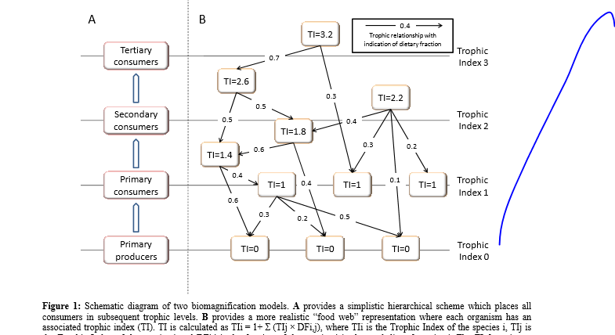

Fig 1: Schematic diagram of two biomagnification model A. provid a simplistic hierarchial scheme which places all consumer in subsquint trphic level, B. provid a food web representation where each organism has an associated trophic index.
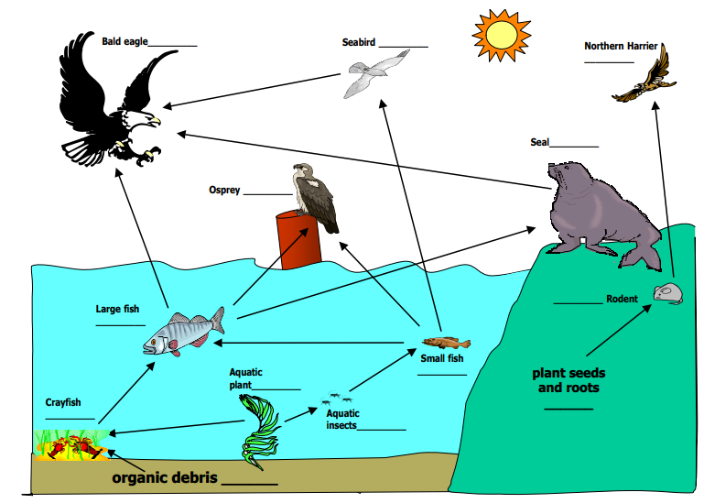

Fig.2 transfer metals between trophic level (Biomagnification)

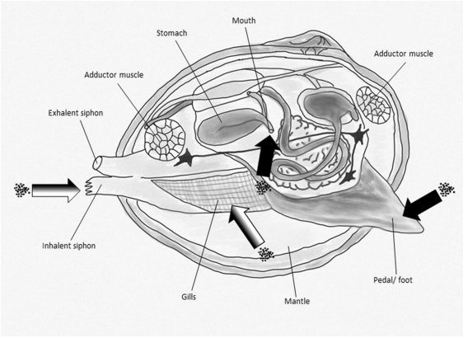

Fig 3: Biomagnification in snail via diatery(Black arrow) and respiration (White and black arrow)
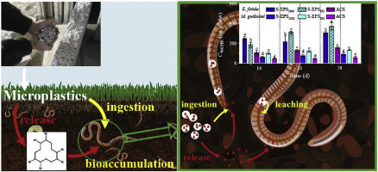
.

Fig 4: Bioaccumulation in Earthworm

Result and discussion
Understanding bioaccumulation and biomagnification is an important part of understanding the natural world. It can dictate what kinds of foods are safe to eat as well as how we regulate pollution or the application of pesticides. Fortunately, within the past two centuries, as humans have increased their population, consumption, and industrial activity.
Biomagnification can be more dangerous than bioaccumulation because it can lead to the accumulation of toxic substances in the tissues of organisms at the top of the food chain, such as humans. These toxins can have a variety of harmful effects on the health of the organisms that consume them, including reproductive failure, behavioral changes, and death. For example, certain pesticides and industrial chemicals can accumulate in fish and shellfish, which are then consumed by humans, leading to potential health problems. Additionally, certain pollutants such as mercury, can also accumulate in the food chain and can have harmful effects on the nervous system and other organs. The result agree with (Li et al, 2022) they approved that biomagnification can also lead to population declines and even extinction of certain species. The accumulation of toxins in the tissues of organisms at the top of the food chain can lead to reduced fertility, increased mortality, and other population-level effects that can ultimately lead to population declines and even extinction.
Conclusion
Bioaccumulation is the gradual accumulation of substances, such as pesticides or other chemicals, in an organism. It occurs when an organism absorbs a substance at a rate faster than that at which the substance is lost or eliminated by catabolism and excretion.
Biomagnification can have serious consequences for the health of animals and humans, as well as for the populations of species and the balance of entire ecosystems.
References
Coelho C, Foret C, Bazin C, Leduc L, Hammada M, Inácio M, Bedell JP (2018) Bioavailability and bioaccumulation of heavy metals of several soils and sediments (from industrialized urban areas) for Eisenia fetida. Sci. Total. Environ. 635: 1317-1330
Ernst G, Zimmermann S, Christie P, Frey B (2008) Mercury, cadmium and lead concentrations in different ecophysiological groups of earthworms in forest soils. Environ Pollut 156:1304–1313
Hopkin SP, Martin MH. Assimilation of zinc, cadmium, lead, copper, and iron by the spider Dysdera crocata, a predator of woodlice. Bull Environ Contam Toxicol 1985; 34: 183-187.
Kamitani T, Kaneko N (2007) Species-specific heavy metal accumulation patterns of earthworms on a floodplain in Japan. Ecotoxicol Environ Saf 66:82–91
Katagi, T. and Ose, k.(2015). Toxicity, bioaccumulation and metabolism of pesticides in the earthworm. J. Pestic. Sci. 40(3), 69–81.
Kuehr, S.; Kosfeld, V. and Schlechtriem, Ch. (2021). Bioaccumulation assessment of nanomaterials using freshwater invertebrate species. Environ Sci Eur 33(9) 1-36
Kuehr, S.; Kosfeld, V. and Schlechtriem, Ch. (2022). Invertebrate Species for the Bioavailability and Accumulation Assessment of Manufactured Polymer‐Based Nano‐ and Microplastics . Environmental Toxicology and Chemistry 41 (4) 961–974.

Li, M.; Zhang, Y.; Feng , S.; Zhang, X.; Xi, Y. and Xianling Xiang,X.(2022). Bioaccumulation and biomagnification effects of nano-TiO₂ in the aquatic food chain. Ecotoxicology; 31(6):1023-1034.
-Mann, R.M; Vijver, M. G, and Willie J.G.M. Peijnenburg , W.J(2011). Metals and Metalloids in Terrestrial Systems: Bioaccumulation, Biomagnification an Subsequent Adverse Effects.J. Ecological Impacts of Toxic Chemicals, 2011, 43-62
Miller ME, Hamann M, Kroon FJ (2020) Bioaccumulation and biomagnification of microplastics in marine organisms: A review and meta-analysis of current data. PLoS ONE 15(10): e0240792. https://doi.org/10.1371/journal. pone.0240792

Pérès, G.; Vandenbulcke, F.; Guernion, M.; Hedde, M.; Beguiristain , Th.; Douay,F.; Houot, S.; Piron, D.; Richard, A.; Bispo, A.; Grand, C.; Laurence Galsomies, L. and Daniel Cluzeau, D.(2011). Earthworm indicators as tools for soil monitoring, characterization and risk assessment. An example from the national Bioindicator programme (France). Pedobiologia 54 (S77-S87).
Qu, P.; Pang, M.; Wang, P.; Ma, X.; Zhang, ZH.; Wang, Z. and Gong, Y. (2022) Bioaccumulation of mercury along continuous fauna trophic levels in the Yellow River Estuary and adjacent sea indicated by nitrogen stable isotopes. Journal of Hazardous Materials 432, 1-12.
Rich CN, Talent LG. Soil ingestion may be an important route for the uptake of contaminants by some reptiles. Environ Toxicol Chem 2009; 28: 311-315.

Richardson, J. B.; Görres, J. H. and Sizmur, T.(2020). Synthesis of earthworm trace metal uptake and bioaccumulation data: Role of soil concentration, earthworm ecophysiology, and experimental design. J. Environmental Pollution 262.
Sánchez-Chardi A, López-Fuster MJ, Nadal J. Bioaccumulation of lead, mercury, and cadmium in the greater whitetoothed shrew, Crocidura russula, from the Ebro Delta (NE Spain): sex- and age-dependent variation. Environ Pollut 2007; 145: 7-14.
Zhu, Y.; Jia , Y.; Liu , M.; Yang , L.; Yi , Sh.; Feng , X. and Lingyan Zhu , L.(2021). Mechanisms for tissue-specific accumulation and phase I/II transformation of 6:2 fluorotelomer phosphate diester in earthworm (M. guillelmi). Environ Int. 2021 Jun;151:106451

