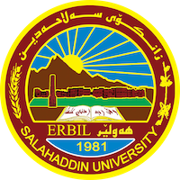
Academic Curriculum Vitae
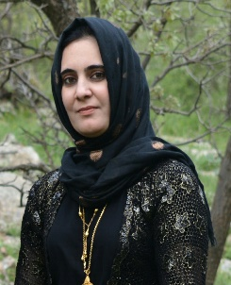
Personal Information:
Full Name: Bery Muhammed Rahman
Academic Title: Assistant Lecturer
Email: bery.rahman@su.edu.krd
Mobile: +9647504053645

Education:
From- To | Degree | College-University | Country
2015 to date | M. Sc. in Analytical Chemistry, Department of Chemistry | College of Science- University of Salahaddin | Iraq
2003-2007 | B.Sc. Chemistry, Department of Chemistry, | College of Science- University of Salahaddin | Iraq

Employment:
Assignments and Posts:
From- To | Post | Department -College | University
2015 to date | Assistant Lecture | Chemistry Department-College of Science | Salahaddin University
2018 | Member of Examination Committee | Chemistry Department-College of Science | Salahaddin University

Teaching experience:
- Teaching Activities
From- To | Post | Department -College | University
2015-present | Assistant Lecture | Geology Department-College of Science | Salahaddin University
2017-present | Assistant Lecture | Environmental science Department-College of Science  +Biology Department-College of Science | Salahaddin University
2018-present | Assistant Lecture | Chemistry Department-College of Science +Geology Department-College of Science | Salahaddin University
2019-present | Assistant Lecture | Environmental science Department-College of Science | Salahaddin University
2020- present | Assistant Lecture | Chemistry Department-College of Science | Salahaddin University
2021-present | Assistant Lecture | Chemistry Department-College of Science | Salahaddin University
2022 -present | Assistant Lecture | Chemistry Department-College of Science  +physic department -college of science | Salahaddin University
2023 -present | Assistant Lecture | Chemistry Department-College of Science | Salahaddin University

Research and publications
Published articles, papers and researches:
      - Batch and Flow Injection Analysis Spectrophotometric Determination of Amoxicillin using N-bromosuccinimide and Indigo Carmine (American Chemical Science Journal 5 (3), 214-223)
      - Batch and Flow Injection Spectrophotometric Determination of Amoxicillin in Pharmaceutical Formulations (ICNS 2016, 81‏)

Conferences and courses attended

Professional memberships
1- A member of the Kurdistan Teachers Union
2- Member of the Kurdistan Chemistry Syndicate

Professional Social Network Accounts:
ORCID ID: 0000-0001-8885-8295
Academic Profile: https://academics.su.edu.krd/profile-admin/index.php?p=education
LinkedIn: https://www.linkedin.com/in/m-sc-beri-mohammad-muhammed-02191aa3/
Scholar Account: https://scholar.google.com/citations?view_op=list_works&hl=ar&user=5ltLNr0AAAAJ
Research gate: https://www.researchgate.net/profile/Bery-Muhammed
Orcid: https://orcid.org/0009-0007-1577-2678

